AI SMART REVISION ASSISTANT
A Memory Decay Based Intelligent Study System
Artificial Intelligence / BYOP Project Report

Submitted by:
Name: Anjali Sonkar
Registration Number: 25BCE10750
Program: Bachelor of Technology (B.Tech)
University: VIT Bhopal University
Year: 2025-2026
__________________________________________________________________________________________

Abstract
In the modern academic environment, students are required to learn and retain a vast amount of information. However, human memory naturally fades over time if knowledge is not revised regularly. Many learners revise topics randomly or only shortly before examinations, which often results in inefficient learning and poor long-term retention.
This project presents an AI Smart Revision Assistant, an intelligent study system designed to predict how quickly a student may forget a concept and automatically schedule revision tasks. The system acts as a lightweight learning companion that encourages regular revision and active recall.
The assistant uses a mathematical memory decay model inspired by the forgetting curve to estimate retention levels over time. Based on these predictions, the system identifies concepts that require revision and generates simple quiz questions to reinforce understanding.
The project demonstrates how Artificial Intelligence principles such as intelligent agents, predictive modelling, and adaptive learning can be applied to improve study efficiency. By recommending timely revision and encouraging active recall through quizzes, the proposed system helps learners strengthen long-term knowledge retention.
__________________________________________________________________________________________

1. Introduction
Learning new information is only one part of the educational process. The ability to retain and recall information over time is equally important. However, students often forget previously studied material when it is not revisited regularly.
Research in cognitive psychology shows that memory gradually declines after learning, a phenomenon commonly referred to as the forgetting curve. Without proper revision strategies, learners tend to lose a large portion of the information they initially acquire.
Traditional study methods rely heavily on intuition. Students usually decide what to revise based on personal judgment rather than structured analysis. This approach often leads to inefficient study habits where some topics are revised too frequently while others are neglected.
Artificial Intelligence offers powerful tools to address this challenge. By modelling patterns of memory decay and analyzing study behaviour, intelligent systems can recommend the optimal time for revision.
The AI Smart Revision Assistant developed in this project functions as a personalized learning companion. The system tracks concepts studied by the user, predicts when those concepts are likely to be forgotten, and generates revision questions accordingly. This approach encourages consistent study habits and improves long-term learning outcomes.
__________________________________________________________________________________________

2. Problem Statement
Students commonly experience several difficulties in their learning process:
- Forgetting concepts after studying them once
- Lack of a structured revision schedule
- Uncertainty about which topics require immediate attention
- Inefficient study practices such as last-minute revision before exams
Most existing study tools focus primarily on storing notes or flashcards. While these tools can help organize information, they do not actively predict when revision should occur.
Therefore, there is a need for an intelligent system that can:
- Track study activities
- Predict memory decay over time
- Identify concepts that require revision
- Reinforce knowledge through quizzes
The AI Smart Revision Assistant addresses these challenges by combining memory modelling with automated revision scheduling.
__________________________________________________________________________________________

3. Objectives of the Project
- To develop an AI-based study assistant that improves revision efficiency
- To simulate human memory decay using a mathematical forgetting curve
- To automatically identify concepts that require revision
- To generate questions for concept reinforcement
- To provide performance statistics for learners
__________________________________________________________________________________________

4. Literature Review
The concept of memory decay has been widely studied in cognitive psychology. One of the earliest researchers to analyze this phenomenon was Hermann Ebbinghaus, who introduced the concept of the forgetting curve. His experiments demonstrated that memory retention decreases exponentially after learning if the information is not reviewed.
Modern learning platforms often implement spaced repetition techniques, where revision sessions are scheduled at increasing intervals. These methods significantly improve long-term retention.
However, many existing systems require complex user interaction or rely on sophisticated algorithms that may be difficult to implement in small educational projects.
The goal of this project is to provide a simple yet effective AI-based solution that models memory decay and automatically schedules revision tasks using lightweight algorithms.
__________________________________________________________________________________________

5. Proposed System
The proposed system is an AI Smart Revision Assistant designed to support students in organizing their revision process.
The system performs the following functions:
- Stores concepts studied by the learner
- Predicts memory retention levels over time
- Identifies concepts that require revision
- Generates quiz questions for practice
- Updates revision schedules based on learner performance
The system operates as an intelligent agent, continuously observing study data, predicting future retention levels, and recommending appropriate revision actions.
__________________________________________________________________________________________

6. System Architecture
Overall Workflow
- User Input
- Command Line Interface
- Study Data Storage
- Memory Prediction Model
- Revision Scheduler
- Question Generator
- Quiz Evaluation
- Performance Statistics
This modular architecture ensures that each component handles a specific responsibility within the learning system.

Module Mapping to Implementation Files
Module | File | Responsibility
CLI Controller | main.py | Menu, program flow, quizzes, summaries
Data Storage | data_store.py | CSV read/write, create file, update rows
Memory Model | memory_model.py | Forgetting curve R(t)=e^(-kt), difficulty rates
Revision Scheduler | scheduler.py | Revision rule (threshold + forced due date)
Question Generator | question_generator.py | Template-based quiz questions
Quiz Evaluator | quiz_evaluator.py | Manual scoring + optional keyword auto-check
Statistics | stats.json | Tracks attempts/correct/revisions/concepts
__________________________________________________________________________________________

7. Methodology

7.1 Data Collection
The system records study information such as:
- Topic
- Concept
- Difficulty Level
- Date Studied
- Last Revision Date
This data is stored in a CSV file which acts as the system's knowledge base.

7.2 Memory Prediction Model
The system estimates memory retention using the exponential decay formula:
R(t) = e^(-k t)
Where:
- R(t) represents the predicted retention level
- t represents the number of days since the last review
- k represents the forgetting rate
Concept difficulty influences how quickly memory fades.

7.3 Revision Scheduling
The system schedules revision when predicted retention drops below 60%.
Concepts that require revision are displayed to the user along with generated quiz questions.

7.4 Question Generation
The system generates simple question templates such as:
- What is X?
- Explain the concept of X.
- Define X.

7.5 Performance Adaptation
After the learner answers quiz questions:
- Correct answers delay the next revision (scheduled later)
- Incorrect answers schedule earlier revision (sooner reinforcement)
This allows the system to adapt based on user performance.
__________________________________________________________________________________________

8. Technologies Used
Technology | Purpose
Python | Core programming language
CSV | Study data storage
JSON | Performance statistics
Mathematical Models | Memory prediction
Rule-based logic | Revision scheduling
Pandas / NumPy | Data handling and CSV operations
__________________________________________________________________________________________

9. Implementation
The project was implemented using modular Python scripts.
Main modules include:
- main.py – user interface and program flow
- data_store.py – data storage and retrieval
- memory_model.py – memory decay calculations
- scheduler.py – revision scheduling logic
- question_generator.py – quiz question generation
- quiz_evaluator.py – answer evaluation and feedback
This modular design improves readability and maintainability.
__________________________________________________________________________________________

10. Results
The system was tested using several Artificial Intelligence concepts.
Example revision tasks generated by the system include:
- Regression — Predicted Retention: 52%
- Overfitting — Predicted Retention: 48%
Performance summary:
- Concepts Studied: 10
- Revisions Completed: 6
- Average Retention: 78%
These results demonstrate that the system successfully identifies concepts requiring revision and supports learning through interactive quizzes.
__________________________________________________________________________________________

11. Advantages
- Encourages consistent revision habits
- Improves long-term memory retention
- Helps students organize their study process
- Provides a personalized learning assistant
- Uses simple and interpretable AI techniques
__________________________________________________________________________________________

12. Limitations
- Forgetting rates are predefined and may not perfectly match all learners
- Question generation uses basic templates
- The current interface is command-line based
__________________________________________________________________________________________

13. Future Scope
Possible future improvements include:
- Personalized memory models using machine learning
- Natural language processing for answer evaluation
- Graphical user interface for better usability
- Mobile application integration
__________________________________________________________________________________________

14. Conclusion
The AI Smart Revision Assistant demonstrates how Artificial Intelligence techniques can be applied to improve learning efficiency. By modelling memory decay and automatically scheduling revision sessions, the system helps learners retain knowledge more effectively.
The project highlights how even simple AI approaches can create practical educational tools that support students in maintaining long-term understanding of academic concepts.
__________________________________________________________________________________________

15. References
- Hermann Ebbinghaus — Research on the Forgetting Curve
- Artificial Intelligence: A Modern Approach — Stuart Russell & Peter Norvig
- Python Official Documentation
- Research articles on spaced repetition learning systems
__________________________________________________________________________________________

16. Screenshots
Insert your screenshots below (or in an appendix). Suggested figure captions:
- Figure 1: Program Main Interface
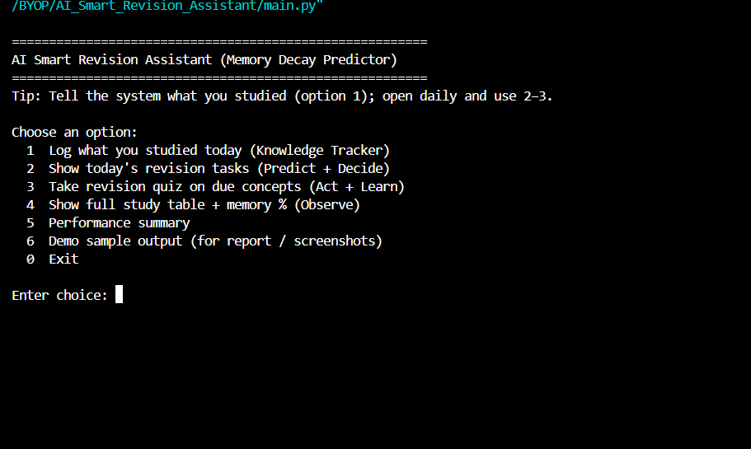
- Figure 2: Adding Study Concepts
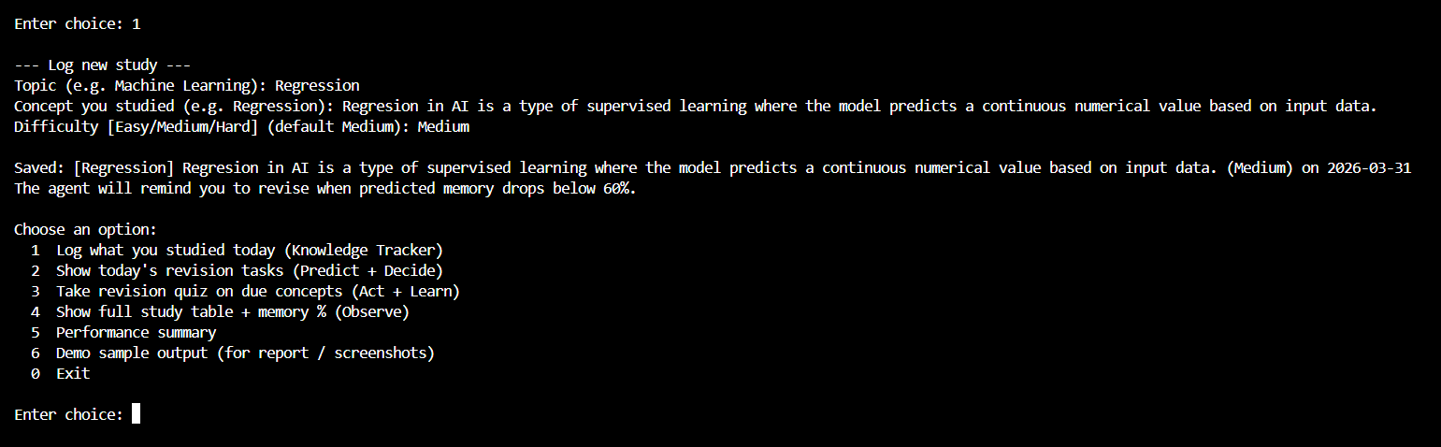
- Figure 3: Revision Task Prediction
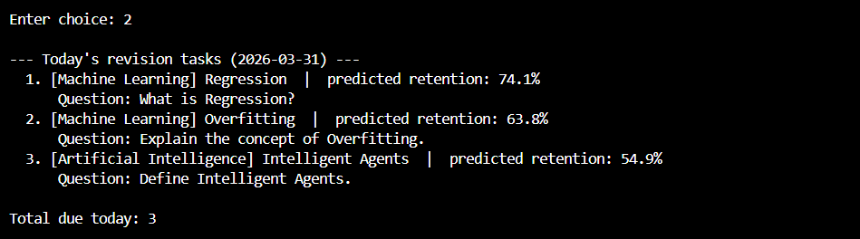
- Figure 4: Quiz Question Generation
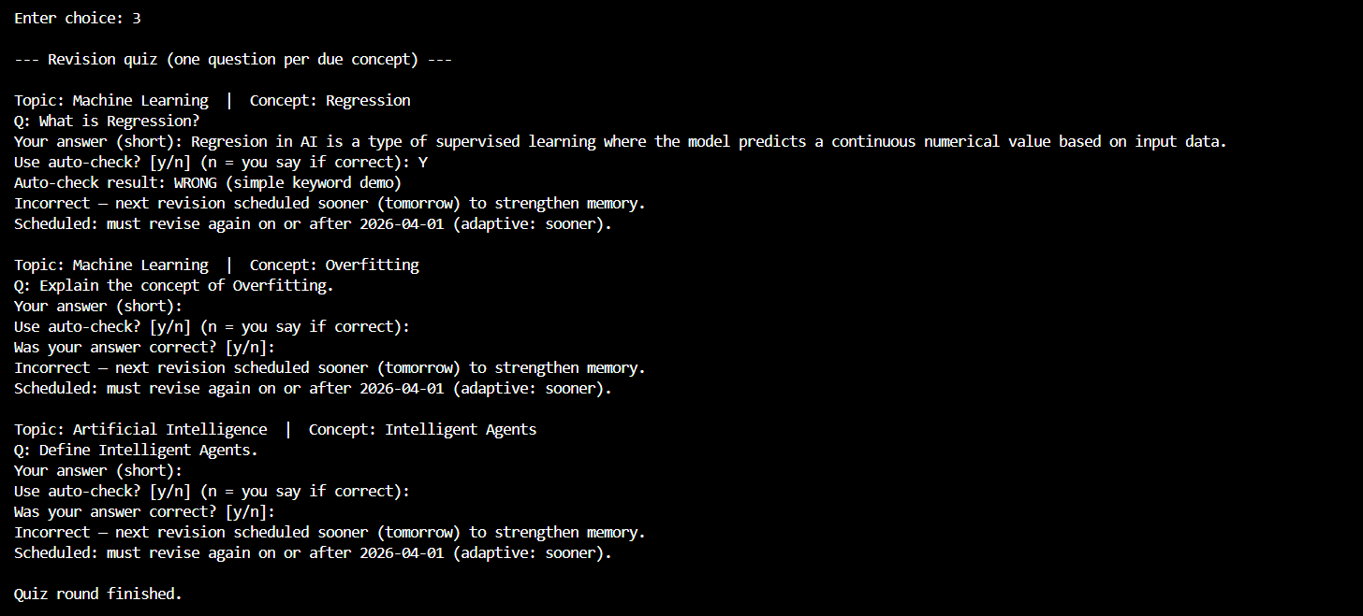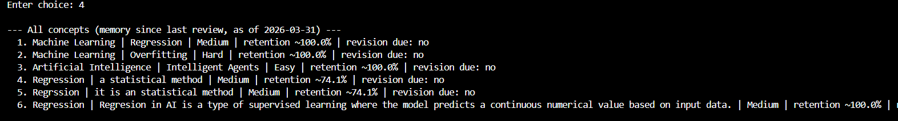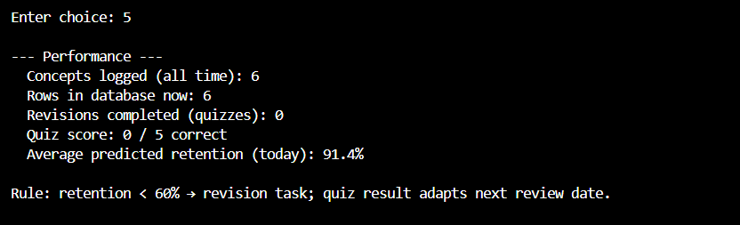
- Figure 5: Performance Statistics Output

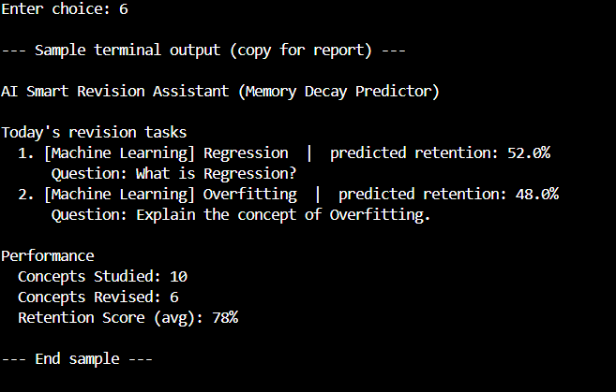
__________________________________________________________________________________________

17. Appendix

17.1 Sample Study Data
Topic | Concept | Difficulty | Date Studied
AI | Regression | Medium | 2026
AI | Overfitting | Hard | 2026

17.2 Program Execution
python main.py

