Installation Process

Installation Document for RPi4 Setup

1. RPi Imager Installation
- Open Raspberry Pi Imager and follow these steps:
  - Select Choose OS.
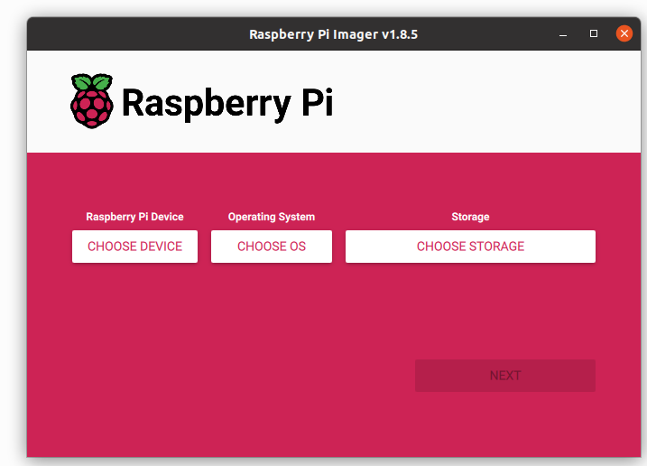
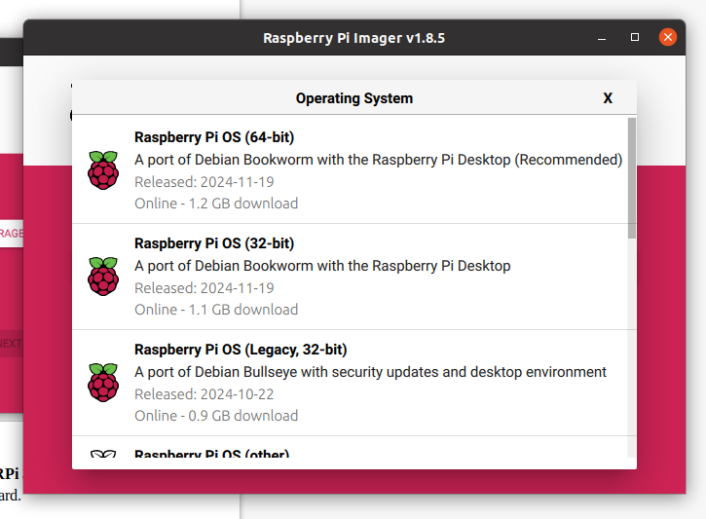
  - Navigate to Other general-purpose OS.
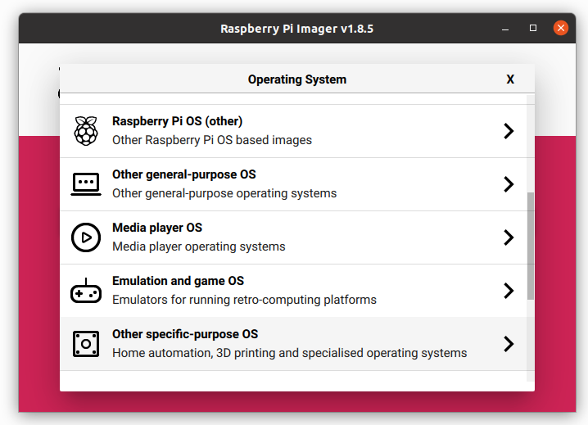
  - Select Ubuntu and choose Ubuntu Server 20.04.4 LTS (RPi 3/4/400) (64-bit).
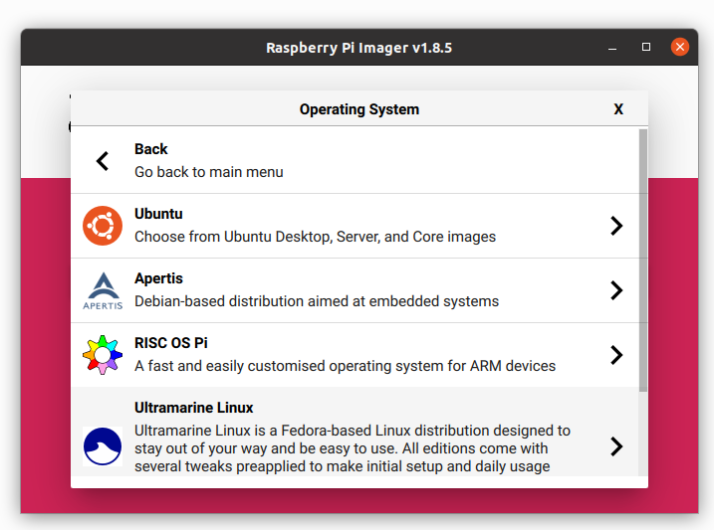

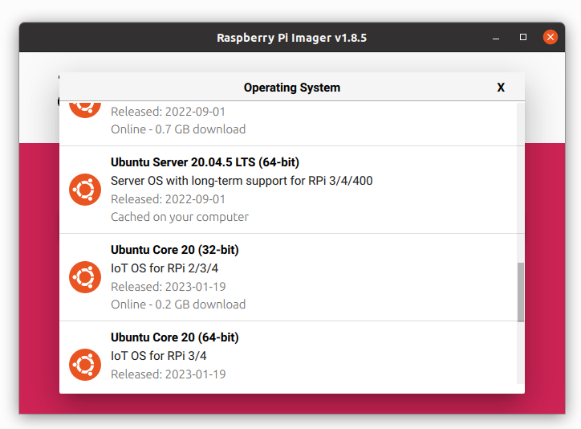
  - Click on Choose Storage and select the 128GB memory card.
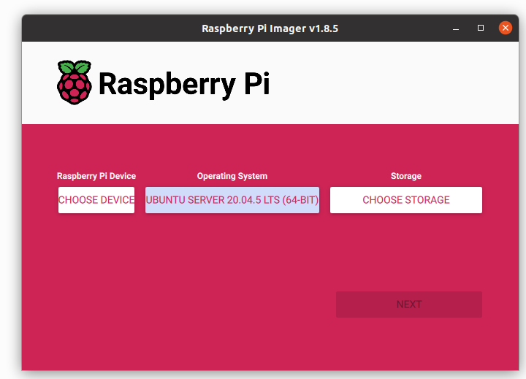
  - Click Write and wait for the process to complete.

2. Desktop Installation
- Insert the SD card into the Raspberry Pi 4.
- Connect the RPi4 to a monitor using an HDMI cable.
- Once the Pi boots, the login window appears. Enter the following credentials:
  - Username: ubuntu
  - Password: ubuntu
- Change the password to Welcome1 for all autonomous bots (Flunkey).
- Update the system:
sudo apt update
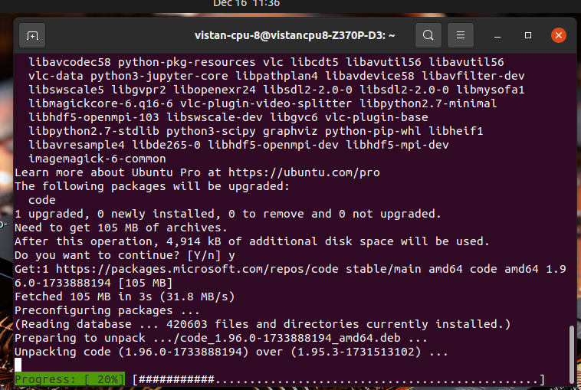
- If there are errors, follow these steps to resolve:
  - Remove any lock files:
sudo rm /var/lib/apt/lists/lock
sudo rm /var/cache/apt/archives/lock
sudo rm /var/lib/dpkg/lock
  - Try upgrading:
sudo apt upgrade
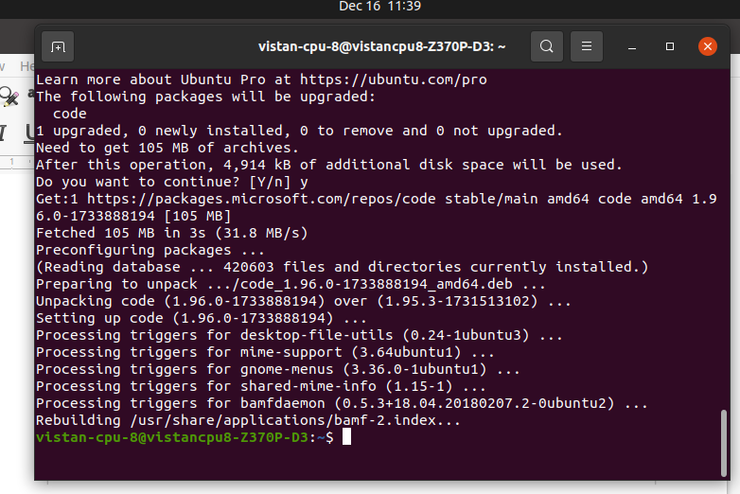
  - If errors persist, remove the lock frontend and configure dpkg:
sudo rm /var/lib/dpkg/lock-frontend
sudo dpkg --configure -a
- Install Desktop Environment:
  - To install Ubuntu MATE Desktop, run:
sudo apt-get install ubuntu-mate-desktop
  - During installation, choose lightdm as the display manager.
(select a display manager during the install – usually between gmd3 and lightdm. I usually prefer lightdm but you can choose whichever you prefer)
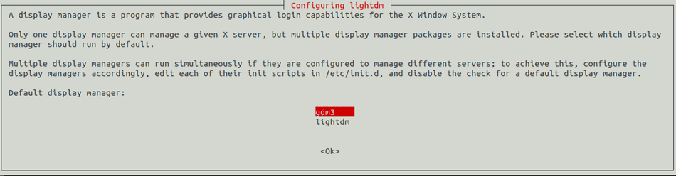
  - Once installed, start the desktop environment with:
startx
  - After the installation process is finished, you may have to reboot.
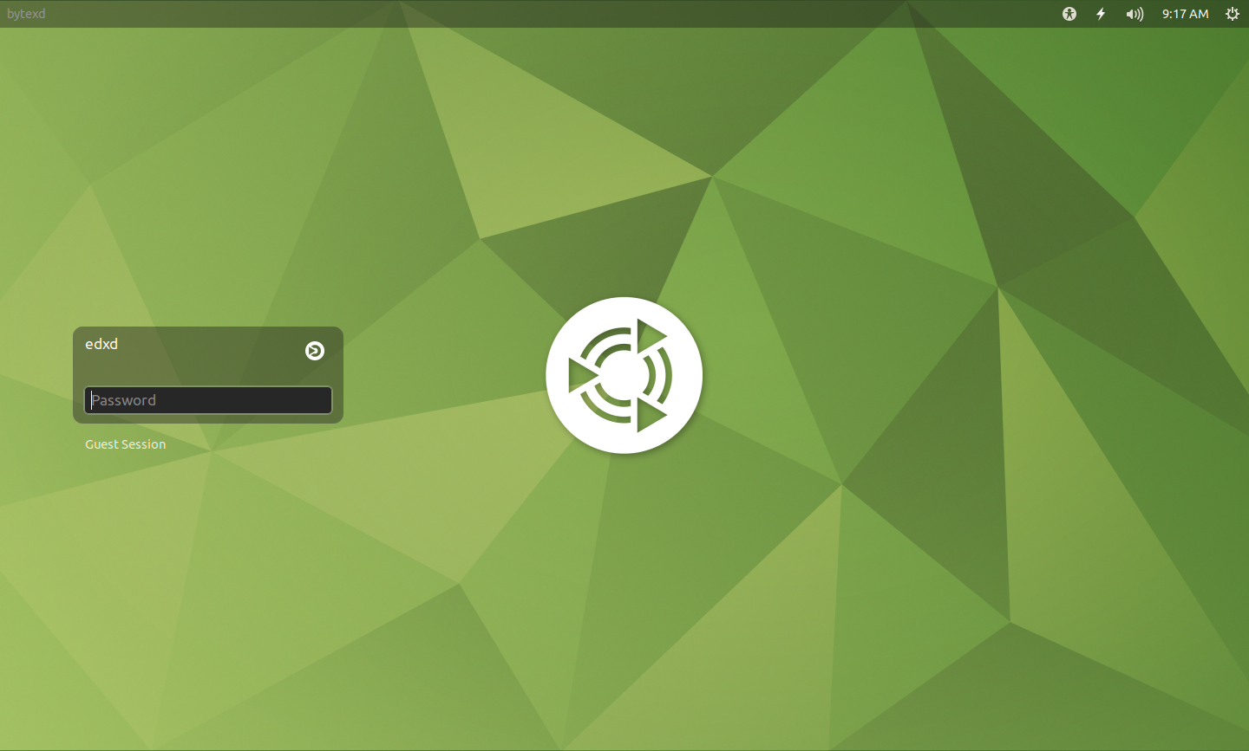
Enter login Password(Welcome1) to Login.

3. Removing Multiple Desktop Environments
- If additional desktop environments were installed (e.g., Ubuntu Desktop), remove them by following these steps:
  - Navigate to the directory containing desktop session files:
cd /usr/share/xsessions/
  - List all available desktop sessions:
ls
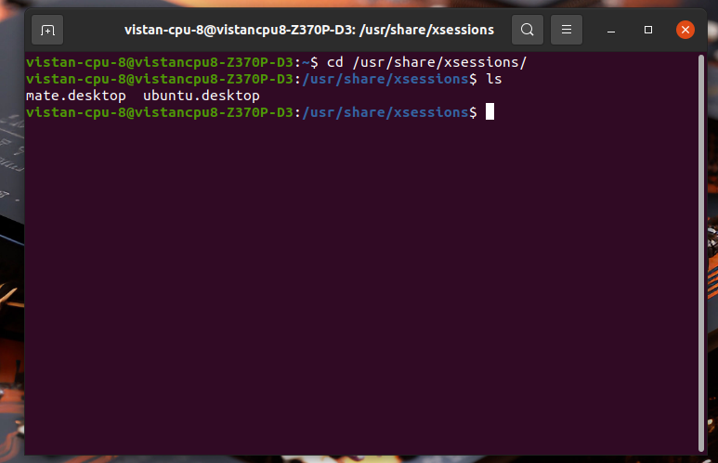
  - Remove the unwanted ubuntu.desktop file:
sudo rm ubuntu.desktop
  - Restart the Pi to see the changes.
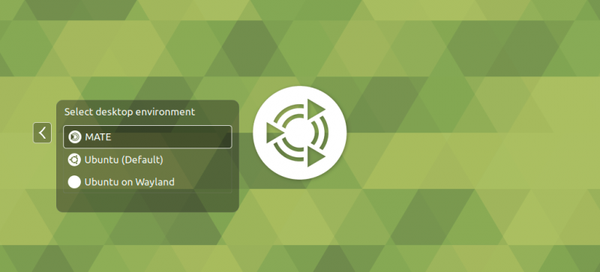

4. Setting Up Auto-login
- Open User and Groups Settings and select the user.
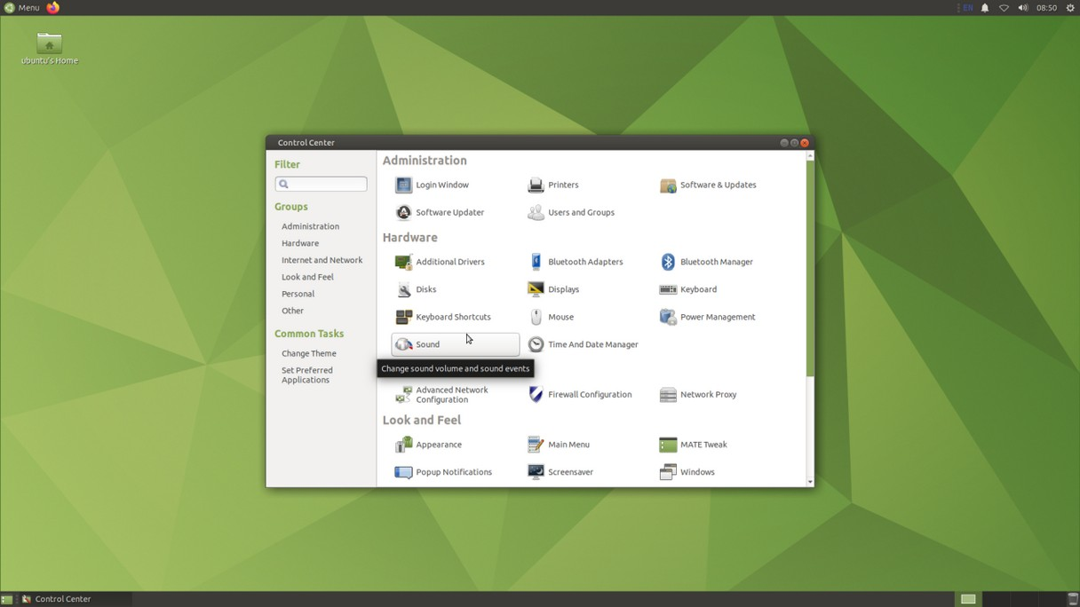
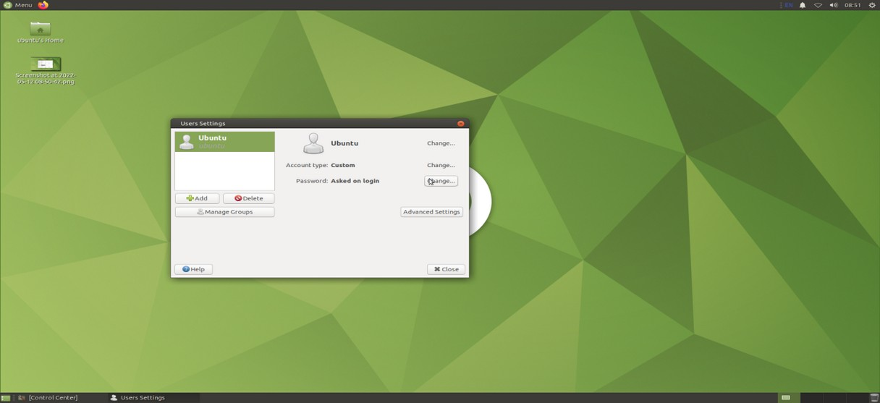
- Under Password Settings, choose Don't ask for password on login. Enter the current password Welcome1.
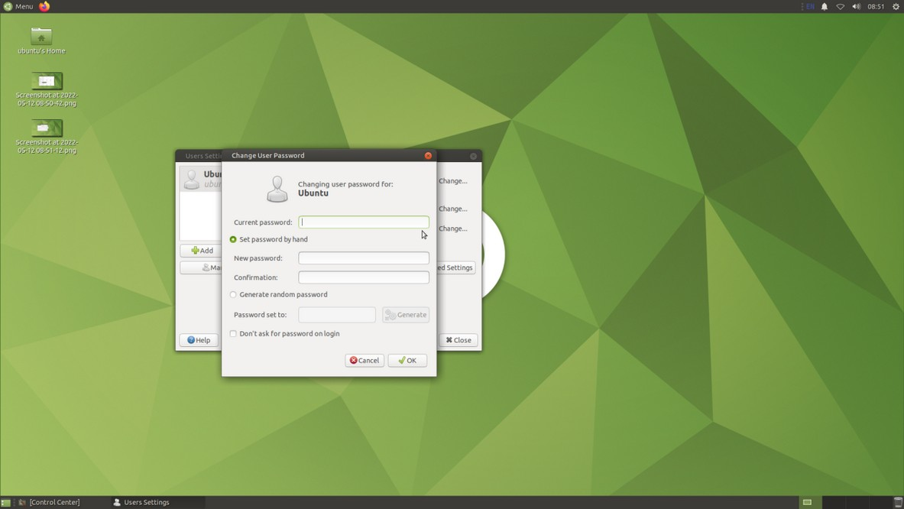
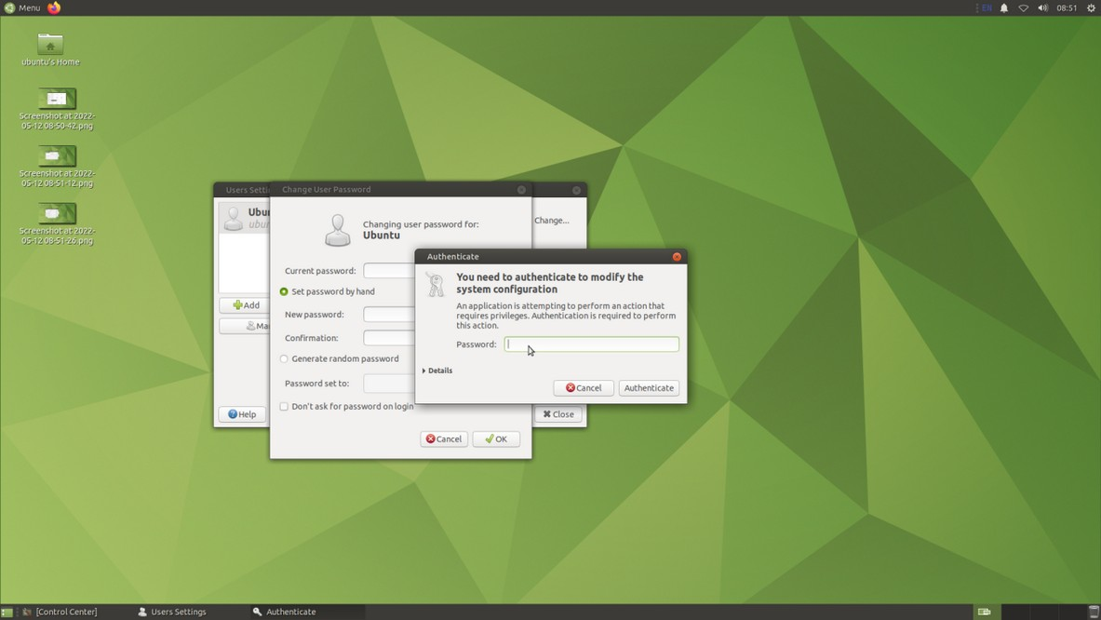
- Navigate to the LightDM configuration directory:
cd /usr/share/lightdm/lightdm.conf.d/
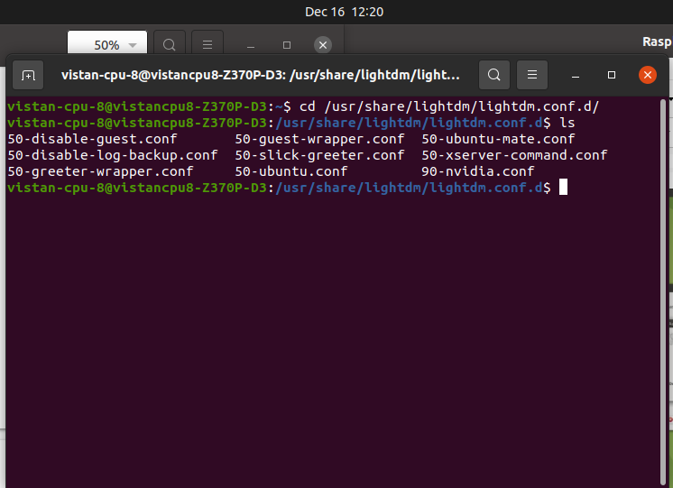
- Edit the 50-slick-greeter.conf file:
sudo nano 50-slick-greeter.conf
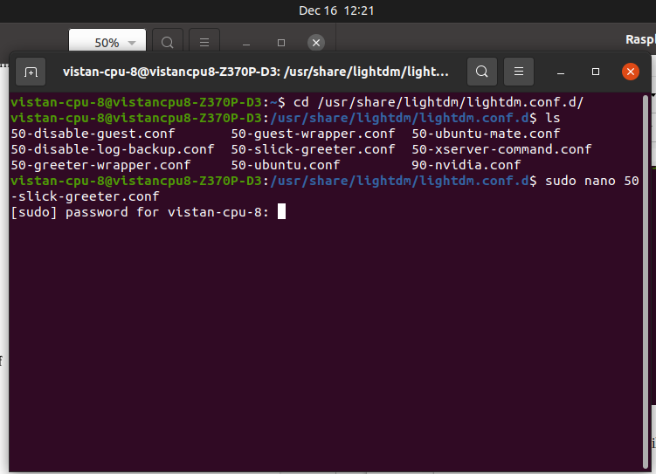
- Add the following line and save:
autologin-user=ubuntu
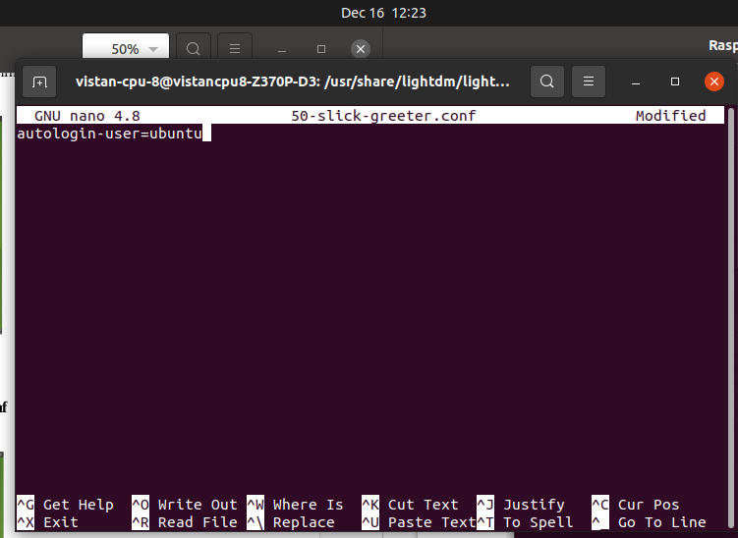
- Restart the Pi to enable auto-login.
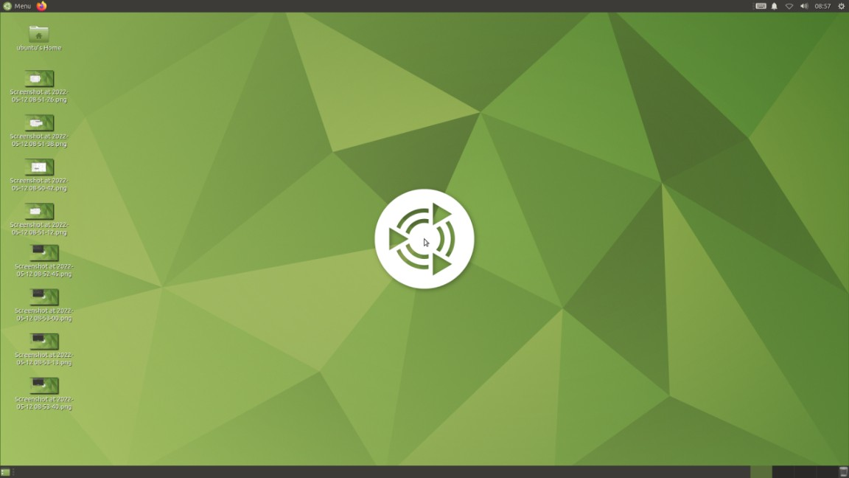

5. ROS Installation
- Follow the official ROS installation guide for Noetic on Ubuntu 20.04: ROS Noetic Installation Guide
- Run the following commands:
sudo sh -c 'echo "deb http://packages.ros.org/ros/ubuntu $(lsb_release -sc) main" > /etc/apt/sources.list.d/ros-latest.list'
sudo apt install curl
curl -s https://raw.githubusercontent.com/ros/rosdistro/master/ros.asc | sudo apt-key add -
sudo apt update
sudo apt install ros-noetic-desktop-full
source /opt/ros/noetic/setup.bash
echo "source /opt/ros/noetic/setup.bash" >> ~/.bashrc
source ~/.bashrc
sudo apt install python3-rosdep python3-rosinstall python3-rosinstall-generator python3-wstool build-essential
sudo apt install python3-rosdep
sudo rosdep init
rosdep update
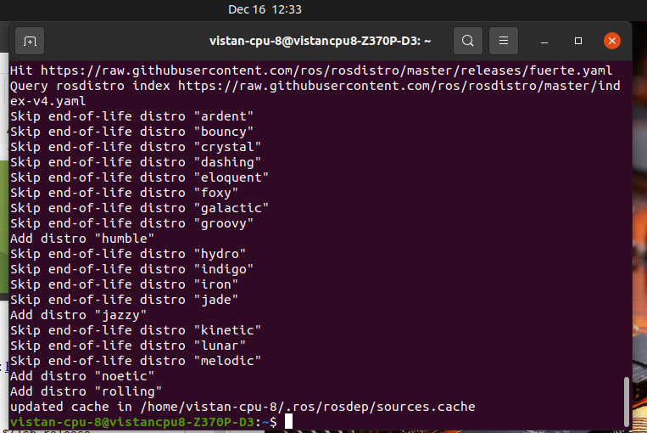
- To verify ROS installation:
roscd
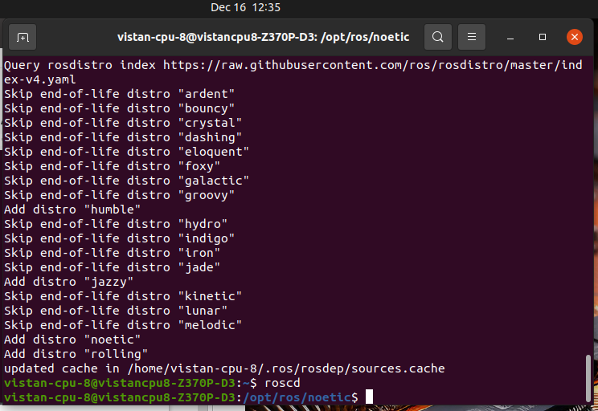

6. Creating a ROS Workspace
- Create a workspace directory:
mkdir -p ~/catkin_ws/src
cd ~/catkin_ws
catkin_make
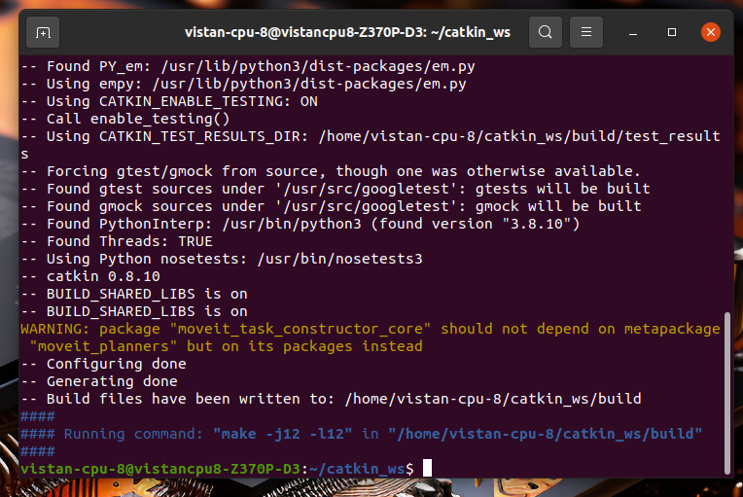
- Modify .bashrc to source the workspace:
sudo nano ~/.bashrc
Add the following line at the end:
source ~/catkin_ws/devel/setup.bash
- Save and close the file (CTRL+X), then restart the terminal.
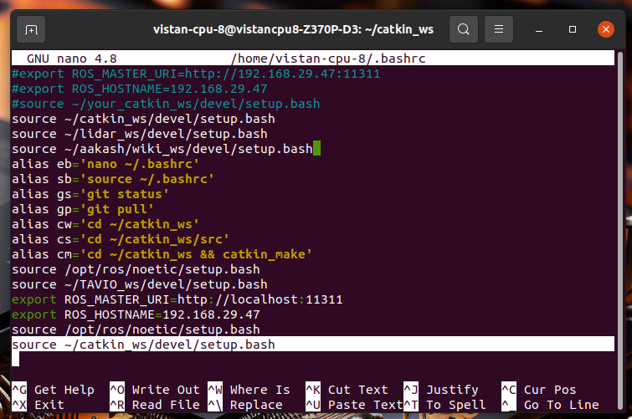

7. Copying the Source Folder and YDLidar-SDK
- Copy the src folder and Ydlidar-SDK from the USB drive (blue-office) into the ~/catkin_ws/src folder.

8. Installing YDLidar-SDK
- Navigate to the Ydlidar-SDK directory:
cd ~/catkin_ws/src/Ydlidar-SDK/build
- Run CMake to configure the SDK:
cmake ..

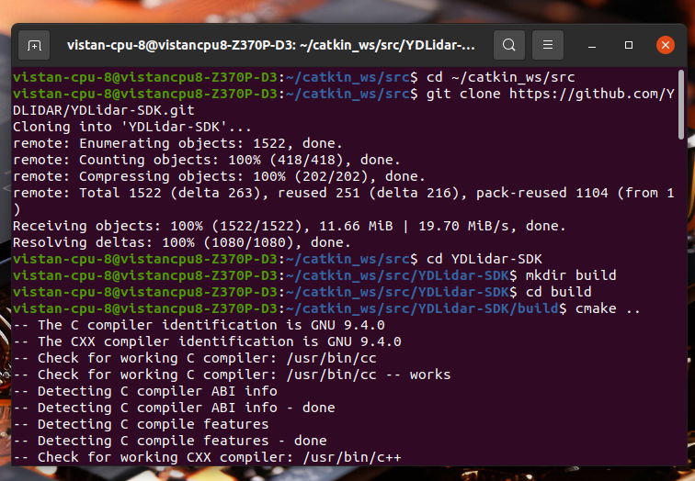
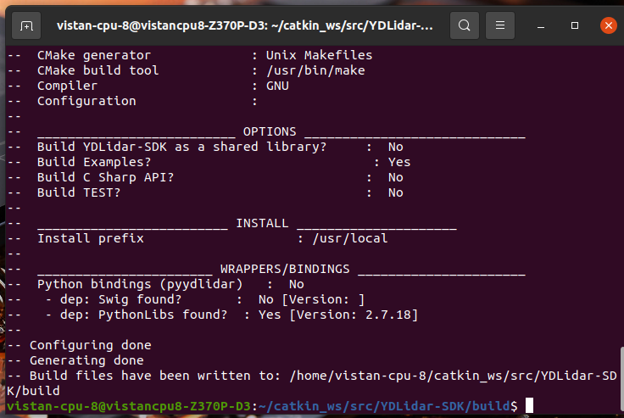
If you encounter errors, delete the CMakeCache.txt file and try again.
- After successful configuration, build the SDK:
make
sudo make install
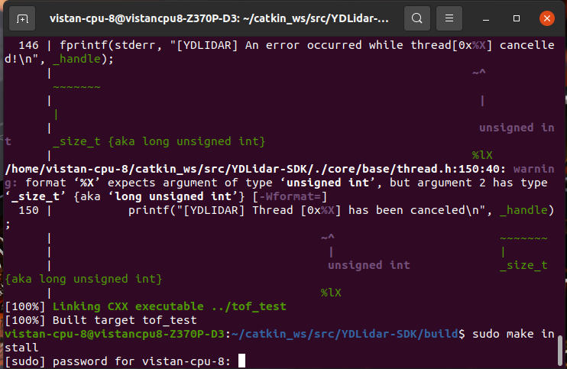

9. Running catkin_make
- Build the workspace:
cd ~/catkin_ws
catkin_make
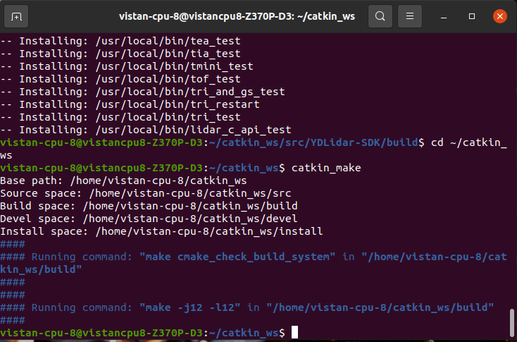
- Install dependencies if there are errors:
rosdep install --from-paths ~/catkin_ws/src --ignore-src -r -y
- Re-run catkin_make to complete the process.

10. Wi-Fi Settings
- Navigate to Wi-Fi Settings and select the desired network.
- Modify the settings by clicking on the gear icon, and select All users may connect to this network.
- Save the changes.

11. SSH Connection
- Find the IP address of the Raspberry Pi:
hostname -I
- On your laptop, use SSH to connect to the Raspberry Pi:
ssh ubuntu@<RPI_IP_ADDRESS>
example: ssh ubuntu@192.168.43.18

12. USB Permissions
- To ensure USB ports (e.g., for Arduino or Lidar) work correctly, create the following udev rules:
  - First rule (50-myusb.rules):
sudo nano /etc/udev/rules.d/50-myusb.rules
Add:
ACTION=="add", KERNEL=="ttyACM[0-9]*", ATTRS{idProduct}=="003d", MODE="0666", ATTRS{idVendor}=="2341"
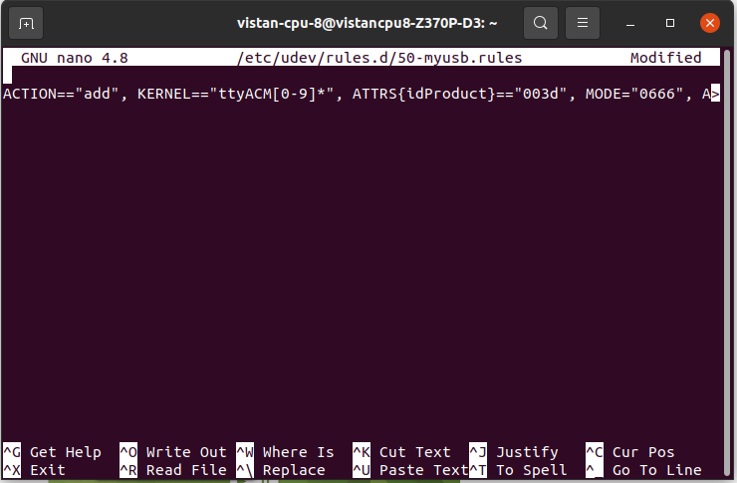
  - Second rule (ydlidar-2303.rules):
sudo nano /etc/udev/rules.d/ydlidar-2303.rules
Add:
KERNEL=="ttyUSB*", ATTRS{idVendor}=="067b", ATTRS{idProduct}=="2303", MODE:="0666", GROUP:="dialout", SYMLINK+="ydlidar"
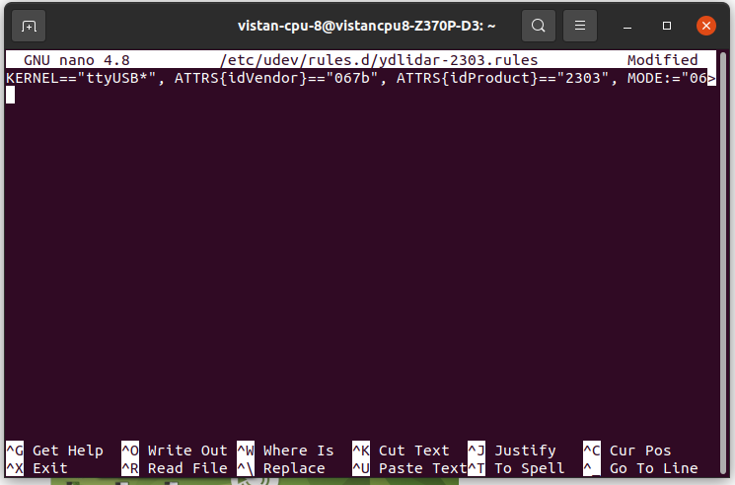
  - Third rule (ydlidar-V2.rules):
sudo nano /etc/udev/rules.d/ydlidar-V2.rules
Add:
KERNEL=="ttyACM*", ATTRS{idVendor}=="0483", MODE:="0666", GROUP:="dialout", SYMLINK+="ydlidar", ATTRS{idProduct}=="5740"
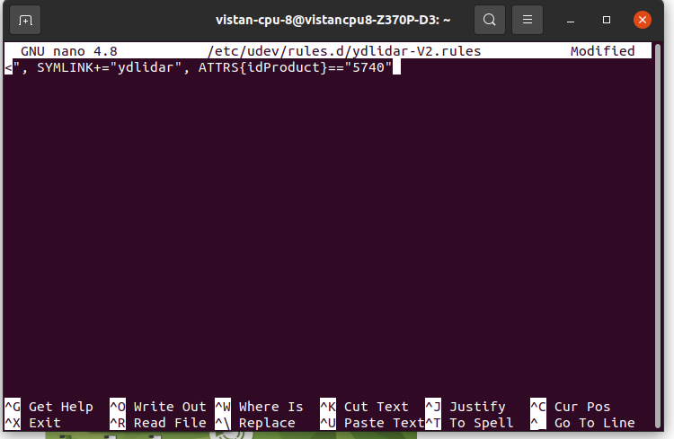
  - Fourth rule (ydlidar.rules):
sudo nano /etc/udev/rules.d/ydlidar.rules
Add:
KERNEL=="ttyUSB*", ATTRS{idVendor}=="10c4", MODE:="0666", GROUP:="dialout", SYMLINK+="ydlidar", ATTRS{idProduct}=="ea60"
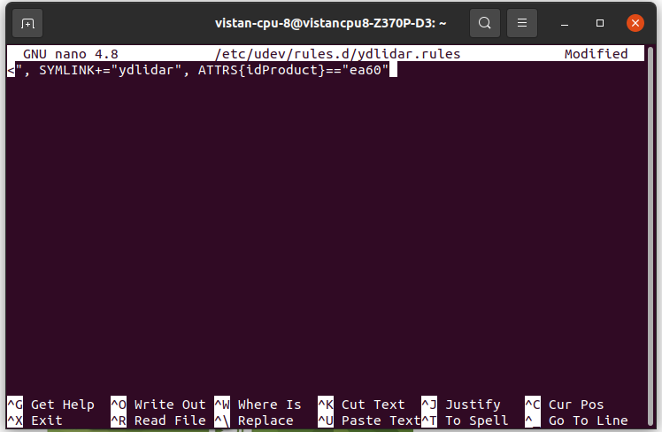
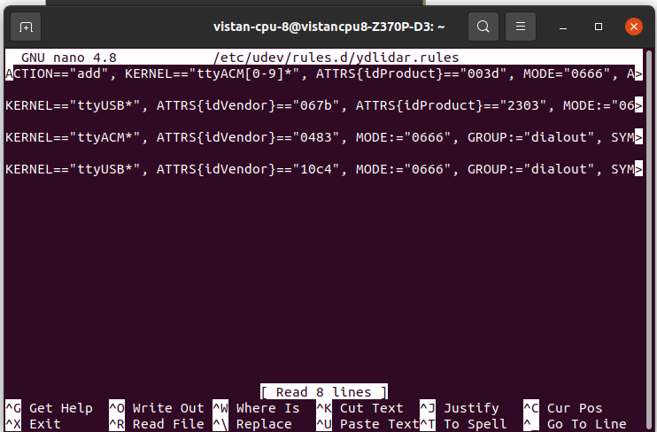
- After creating the rules, save and exit each file (CTRL+X), and restart the system for the changes to take effect.

