PROCEDURE FOR MAPPING AND NAVIGATION

SSH Connection Setup:
- Connect to Wi-Fi:
  - While connecting the Wi-Fi to the controller (Raspberry Pi), check the controller's IP address using a network scanner app. It may look like 192.168.xx.xx.
- Check System IP:
  - Open the terminal and check the system's IP address with the command:
ifconfig
Example output: 192.168.1.5.
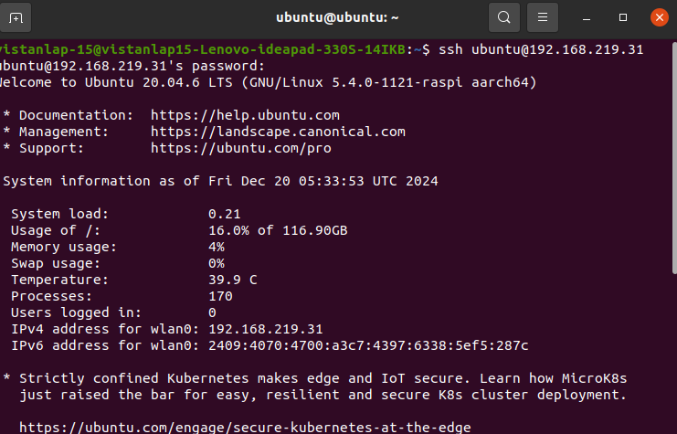
- Edit .bashrc:
  - Open another terminal and edit the .bashrc file:
sudo nano ~/.bashrc
  - Add the following lines for ROS IP and ROS Master URI:
export ROS_IP=192.168.1.5
export ROS_MASTER_URI=http://192.168.1.37:11311/
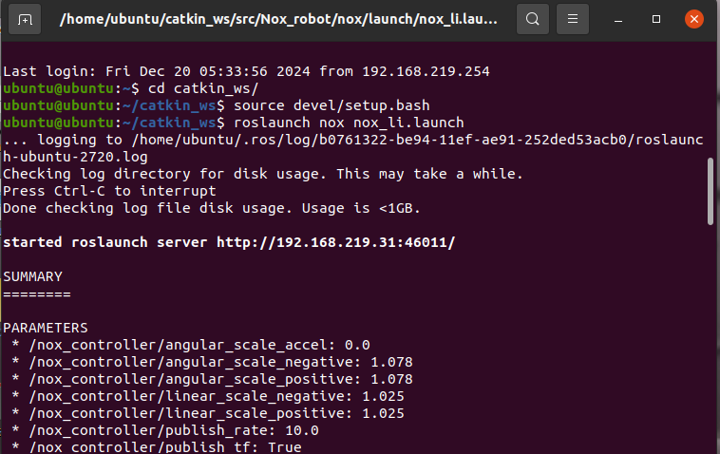
- Connect to Another Device:
  - Use the following SSH command to connect to another device:
ssh ubuntu@192.168.1.37
Enter the device password.
- Set ROS IP and Master URI for the Connected Device:
  - Edit the .bashrc file on the connected device and set the ROS IP and Master URI:
export ROS_IP=192.168.1.37 # Device's IP
export ROS_MASTER_URI=http://192.168.1.37:11311/ # Controller's IP
  - Save and exit (Ctrl+S to save, Ctrl+X to quit).
  - Run the following command to source the .bashrc file:
source ~/.bashrc
- Access Files:
  - Open the file manager and go to Other Locations → sftp://192.168.1.37/ to access the device's files using the device name and password.
  - Navigate to the catkin_ws/src/yd_lidar/launch/ directory and open x2.launch.
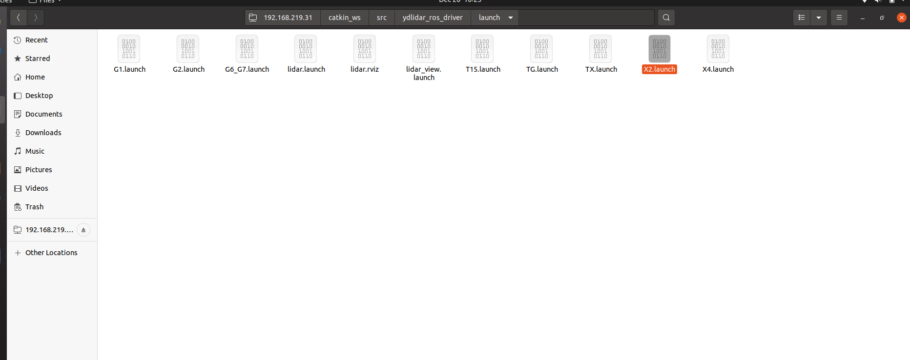

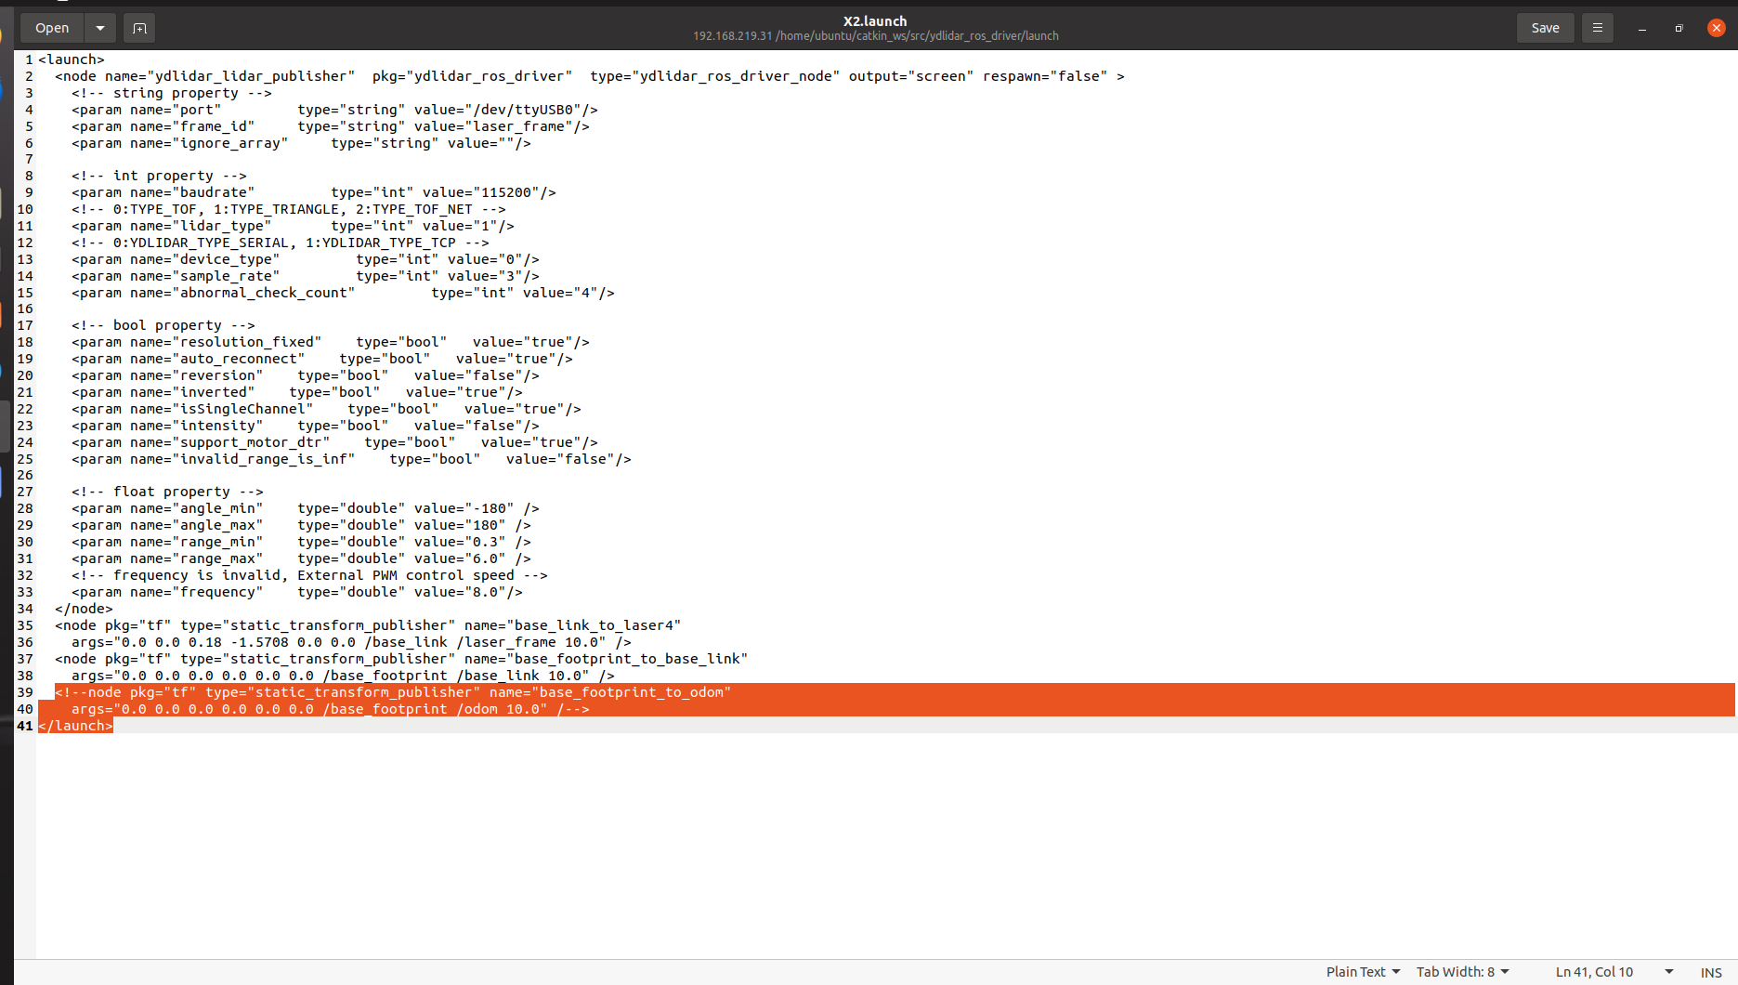

Mapping Procedure
With LiDAR, several mapping techniques can be used. The procedure remains similar, but the algorithm may vary. The three main mapping techniques are:
- GMapping
- Hector Mapping
- Cartographer Mapping

GMapping:
- Overview: GMapping is an older technique but still widely used. It creates maps using odometry data and is often used in our projects.
- SLAM (Simultaneous Localization and Mapping): SLAM is the technique used to estimate the current location and create a map in an unknown environment.

Setup for GMapping:
- SSH into Device:
ssh ubuntu@192.168.xx.xx
Enter the password.
- Navigate to Workspace:
cd catkin_ws/
source devel/setup.bash
- Uncomment x2.launch:
  - Go to the following directory: catkin_ws/src/ydlider_ros.driver/launch/
  - Uncomment the necessary lines in x2.launch.

- Run Mapping Commands:
  - Step 1: Launch the LiDAR and ROS serial:
roslaunch nox_li.launch

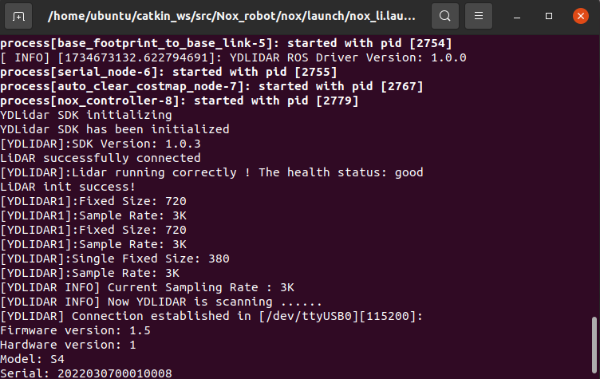
  - Step 2: Launch GMapping:
    - Open a new terminal, and enter:
roslaunch turtlebot3_slam turtlebot3_gmapping.launch
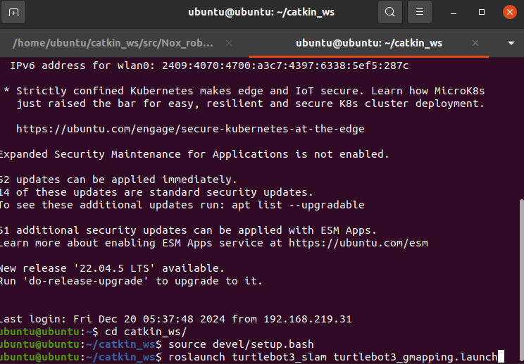
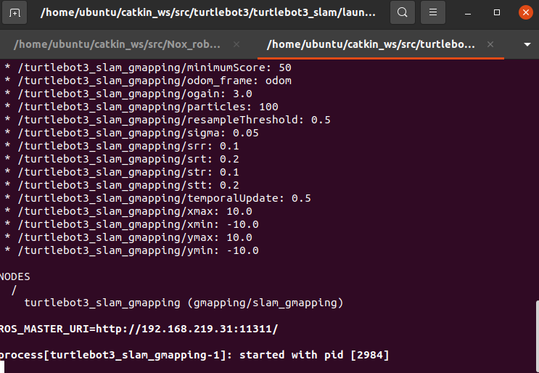
  - Step 3: Run the teleoperation node:
    - Enter the following command to control the robot:
rosrun teleop_twist_keyboard teleop_twist_keyboard.py
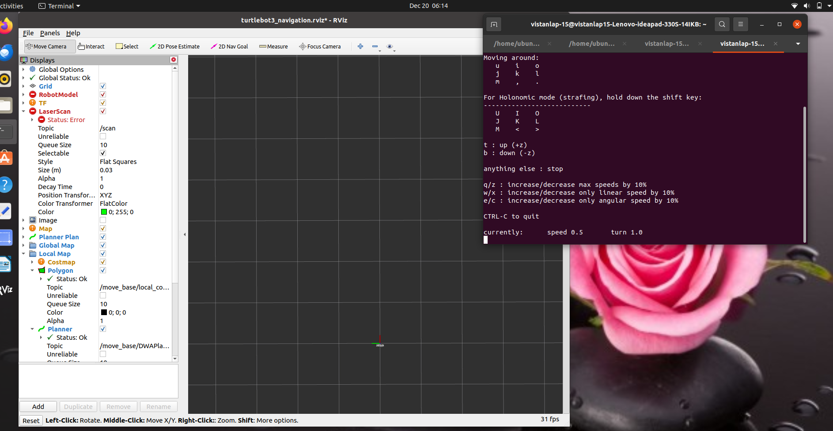
  - Step 4: Open RViz to visualize the map:
rviz
In RViz, click Add → By Topic → Laser Scan → OK, then repeat to add Map and TF displays.
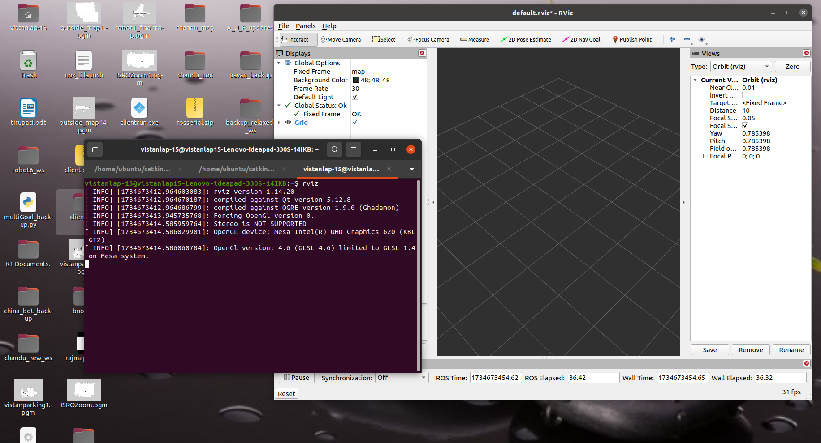
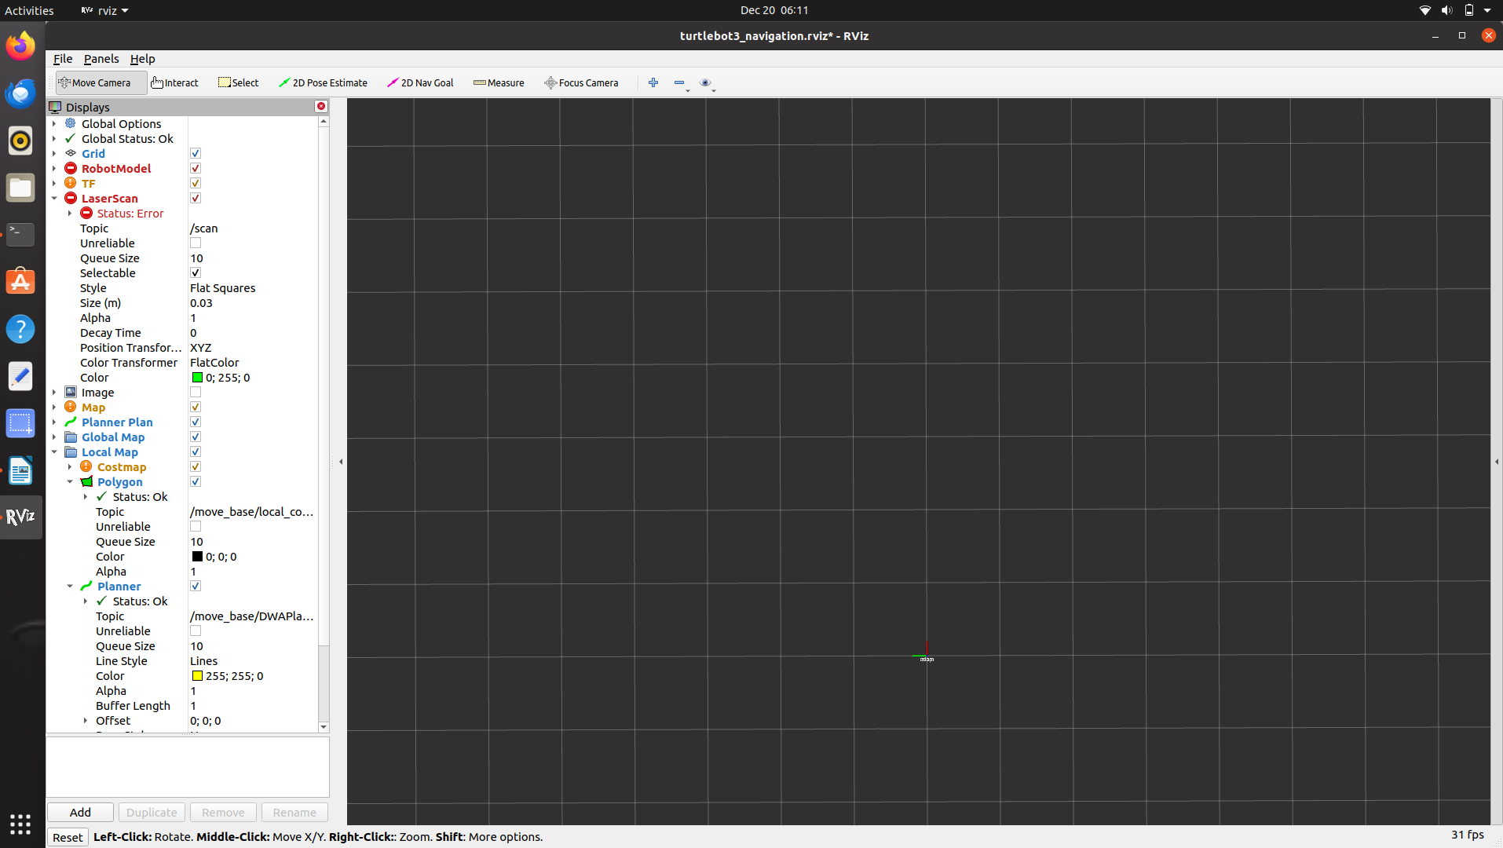
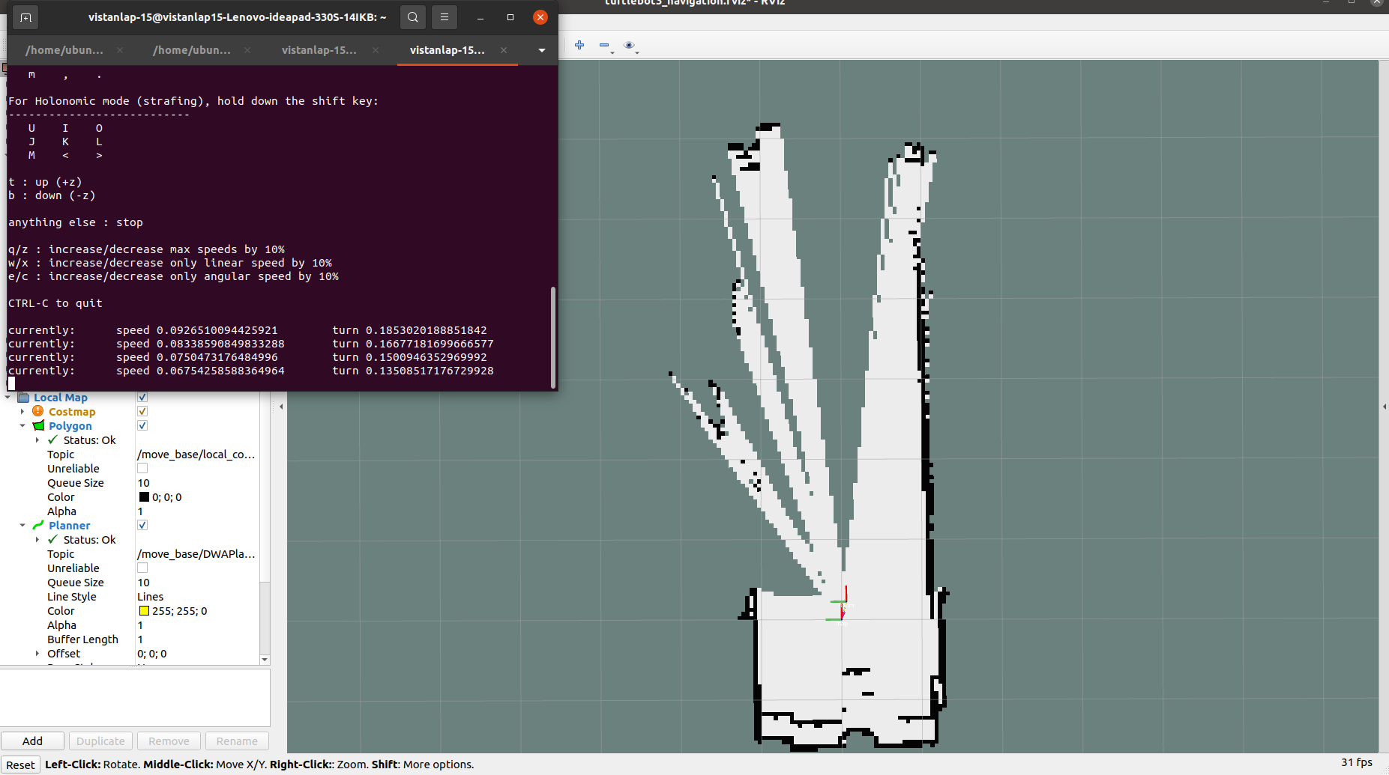
  - Control the Robot: Use the following keyboard commands to control the robot:
    - I - Forward
    - > - Backward
    - L - Right
    - J - Left
    - Z - Decrease speed
    - Q - Increase speed
  - As the robot moves, the map will be updated. Continue moving the robot to scan the entire environment (e.g., room or restaurant). Once the scan is complete, save the map using:
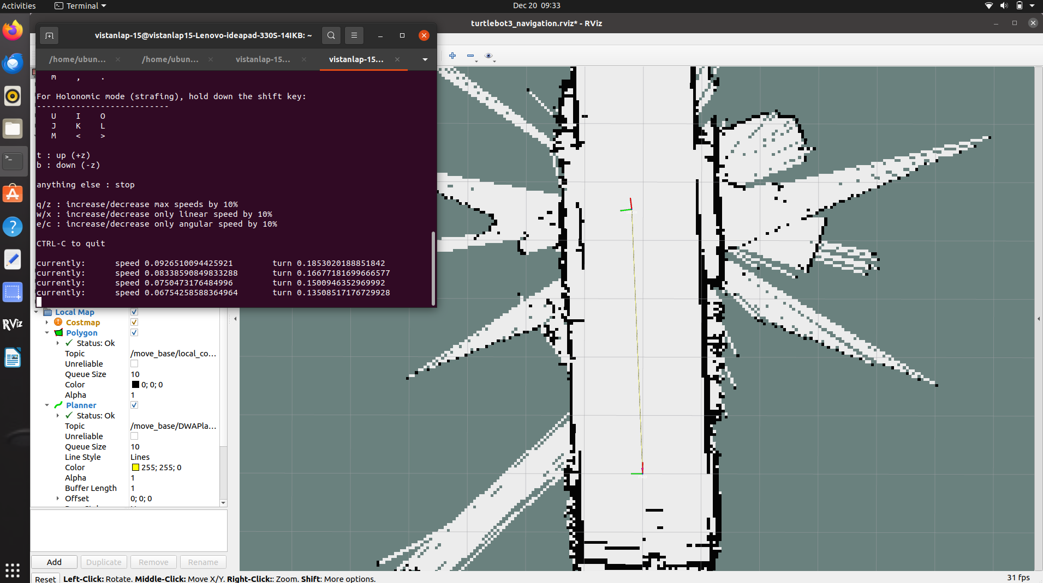

rosrun map_server map_saver -f map_name
This will save the map as both a PNG and YAML file.
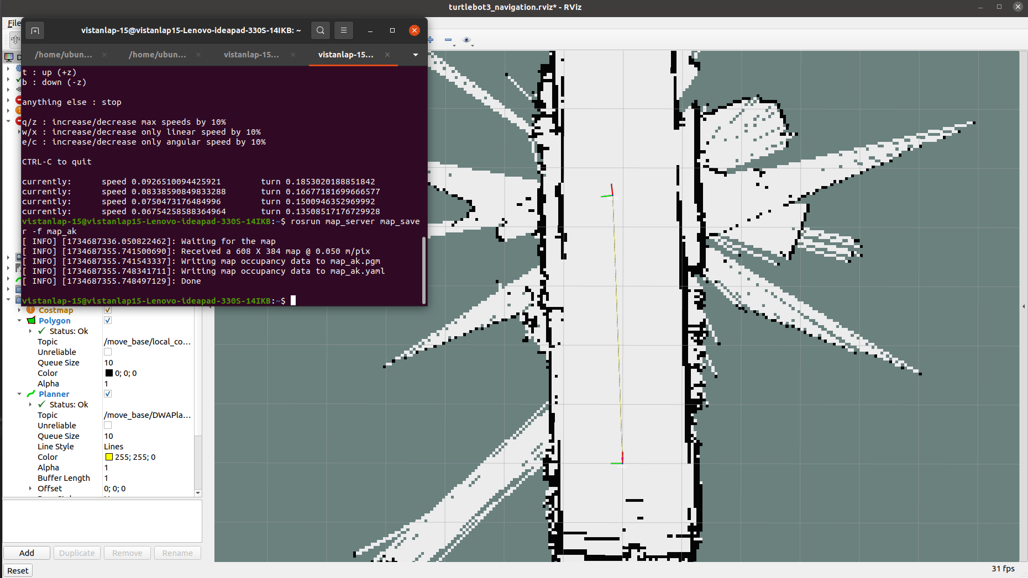

Testing and Navigation of the Map
- Upload the Saved Map:
  - Access the robot's files via SFTP at sftp://192.168.xx.xx/ and navigate to the catkin_ws/src/nox_robot/nox/map directory.
  - Paste the saved map files (map_name.png and map_name.yaml) in the map folder.
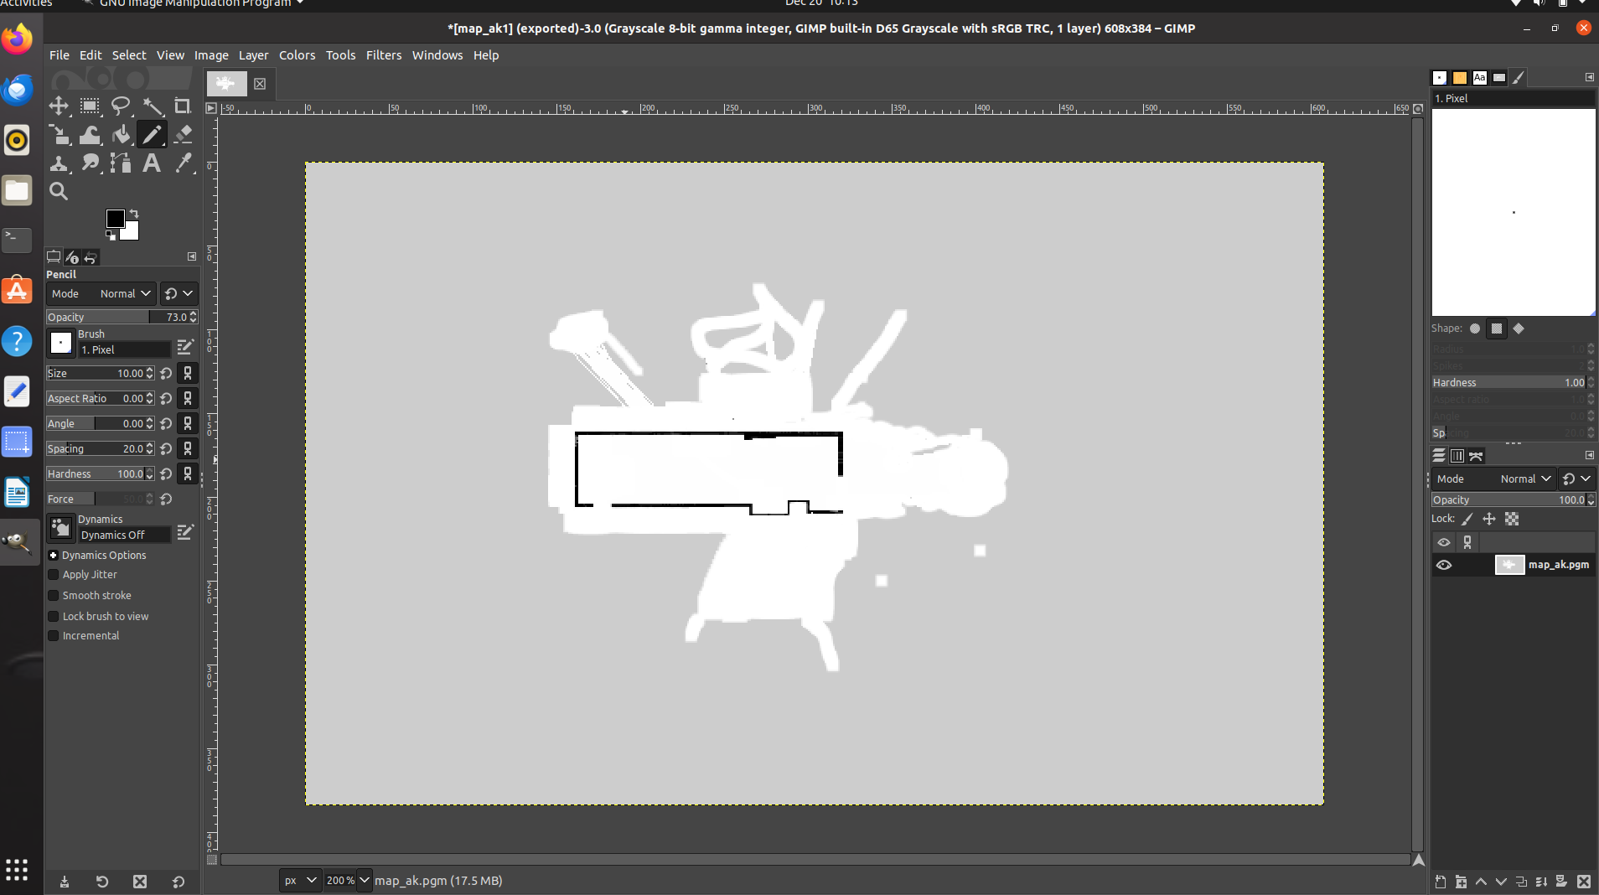
- Edit Launch File:
  - Go to catkin_ws/src/nox_robot/nox/launch and update the launch file with the name of the saved map (e.g., map_name.yaml).
- SSH into the Robot:
  - Open a terminal and SSH into the robot:
ssh ubuntu@192.168.xx.xx
Enter the password.

- Navigate to the Workspace:
cd catkin_ws/
source devel/setup.bash
- Start Navigation:
  - Run the following command to launch navigation:
roslaunch nox nox_navi.launch
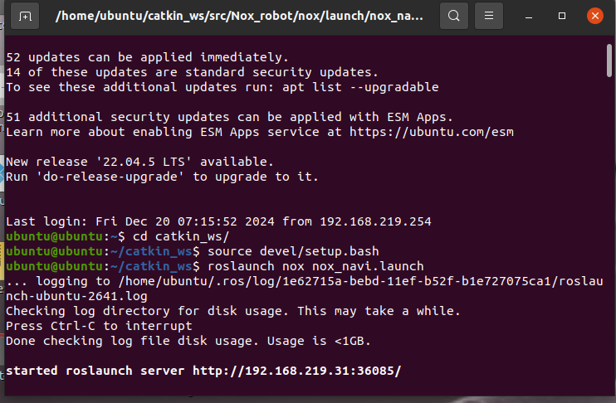
- Open RViz:
  - Launch RViz to visualize the map:
rviz
  - Go to File → Recent Files → Navigation and start controlling the robot. The robot will move between different points (e.g., home location to table, table to home), and the coordinates will be recorded.

