AUTONOMOUS BOT

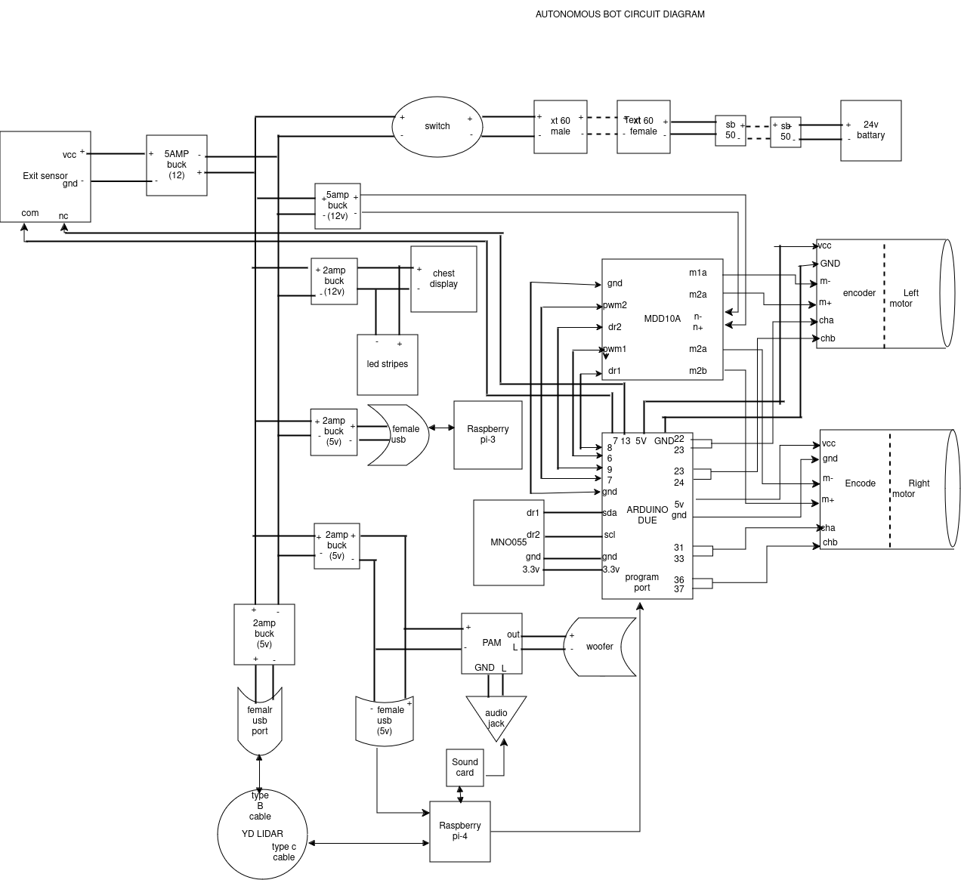

Components List:
- Arduino Due
- Raspberry Pi-4
- DC Motor
- MDD10A Motor Driver
- Raspberry Pi-3
- YD -Lidar
- BNO055 Sensor
- Exit Sensor
- Buck Converter(LM2596)
- Led stripes
- Switch
- 24V Battery
- Encoders(OE-28/OE-37)
- USB Connector
- Chest Display
- Sound Card
- Audio Jack
- PAM
- woofer
- Connector (XT-60, SB-50)

ARDUINO DUE

Microcontroller | AT91SAM3X8E
Operating Voltage | 3.3V
Input Voltage (recommended) | 7-12V
Input Voltage (limits) | 6-16V
Digital I/O Pins | 54 (of which 12 provide PWM output)
Analog Input Pins | 12
Analog Output Pins | 2 (DAC)
Total DC Output Current on all I/O lines | 130 mA
DC Current for 3.3V Pin | 800 mA
DC Current for 5V Pin | 800 mA
Flash Memory | 512 KB all available for the user applications
SRAM | 96 KB (two banks: 64KB and 32KB)
Clock Speed | 84 MHz
Length | 101.52 mm
Width | 53.3 mm
Weight | 36 g
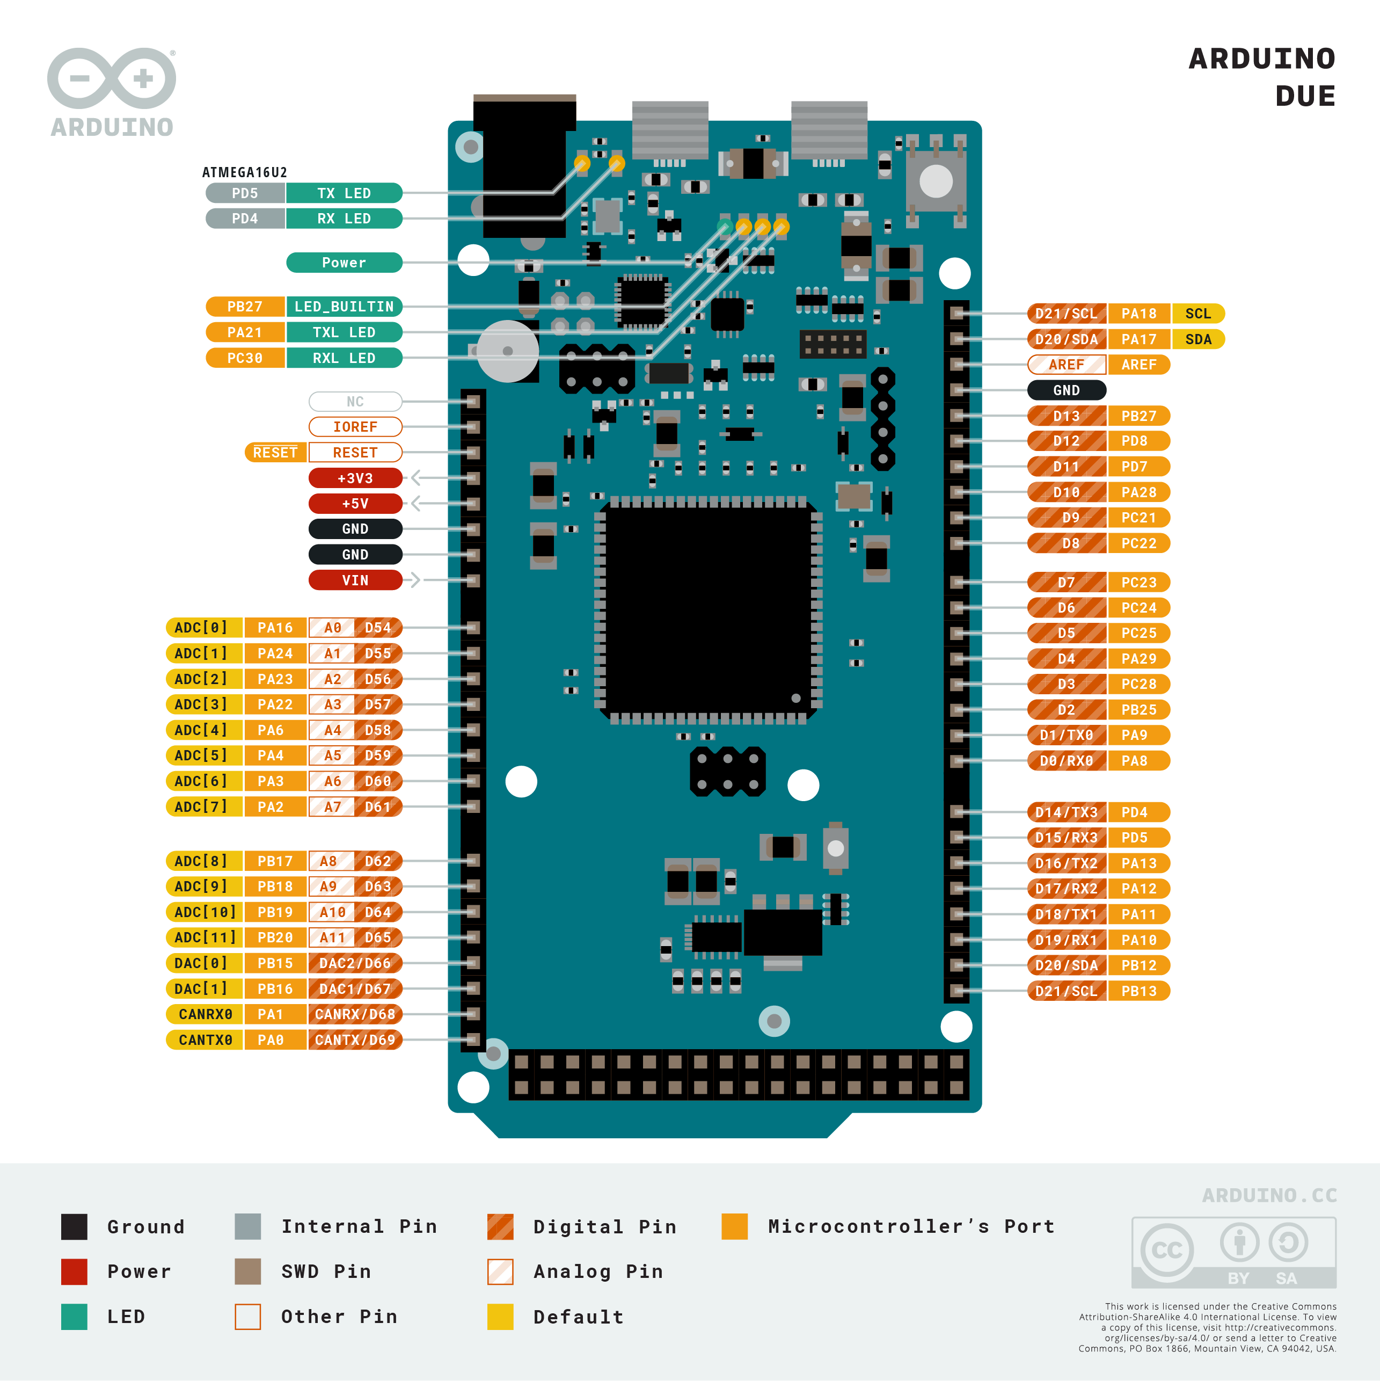

The Arduino Due is a microcontroller board based on the Atmel SAM3X8E ARM Cortex-M3 CPU. It is the first Arduino board based on a 32-bit ARM core microcontroller. It has 54 digital input/output pins (of which 12 can be used as PWM outputs), 12 analog inputs, 4 UARTs (hardware serial ports), a 84 MHz clock, an USB OTG capable connection, 2 DAC (digital to analog), 2 TWI, a power jack, an SPI header, a JTAG header, a reset button and an erase button.

Arduino Due is used for real-time control of motors and sensors because microcontrollers are faster for these tasks.
Purpose:
- Real-time motor and sensor control tasks, which are faster on microcontrollers.
- Interfaces with the Motor Driver using PWM and direction pins.
- Communicates with sensors like the BNO055 and encoders.

Raspberry Pi-4

Specification: More advanced single-board computer with better processing power than Pi 3.
- Purpose:
- Handles tasks requiring higher processing, such as:
  - LIDAR Sensor Data for real-time mapping and obstacle detection.
  - Audio Processing through the sound card and audio output system.
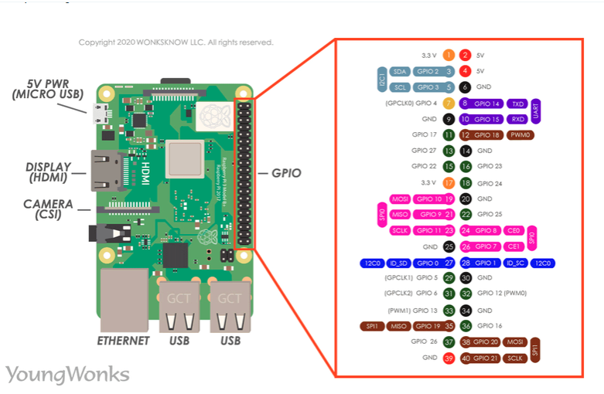

DC Motor

Left and Right DC Motors
- Specification: High-torque DC motors with encoders.
- Purpose: Provides the bot’s propulsion (forward, backward, and turning).
- Encoders: Attached to the motors to provide feedback on:
  - Position: Tracks wheel rotation for distance measurement.
  - Speed: Enables precise control of motor speed.
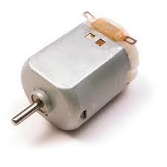

MDD10A Motor Driver
The Motor Driver acts as an interface between the Arduino Due and the DC motor.
- The Arduino Due sends control signals to the motor driver, which then regulates the voltage and current supplied to the motor.
- The motor driver allows:
  - Speed Control using PWM (Pulse Width Modulation).
  - Direction Control using Direction Pins.

Connection Diagram
Assume we are using the MDD10A motor driver (as shown in your circuit) for simplicity.

MDD10A Motor Driver Pins:
- PWM1 and PWM2: Control the motor speed using PWM signals.
- DIR1 and DIR2: Control motor direction (HIGH/LOW signal).
- M1A, M1B: Output pins for Motor 1.
- M2A, M2B: Output pins for Motor 2.
- GND and VCC: Power supply connections.

Steps to Connect the DC Motor with Arduino Due

1. Power Connections
- Connect the VCC of the motor driver to a 12V/24V Power Supply (based on your motor specification).
- Connect the GND of the power supply to the motor driver GND.
- Connect the GND of the motor driver to the GND pin of the Arduino Due to ensure a common ground.

2. Motor Connections
- Connect the DC motor terminals to the motor driver output pins:
  - M1A and M1B → Motor 1 terminals
  - M2A and M2B → Motor 2 terminals (if you are using two motors).

3. Control Connections to Arduino Due
- Connect the PWM pins of the motor driver to Arduino Due PWM-enabled pins (e.g., Pin 7 and Pin 8):
  - PWM1 → Pin 7
  - PWM2 → Pin 8
- Connect the Direction Pins (DIR1 and DIR2) of the motor driver to digital pins on the Arduino Due:
  - DIR1 → Pin 9
  - DIR2 → Pin 10
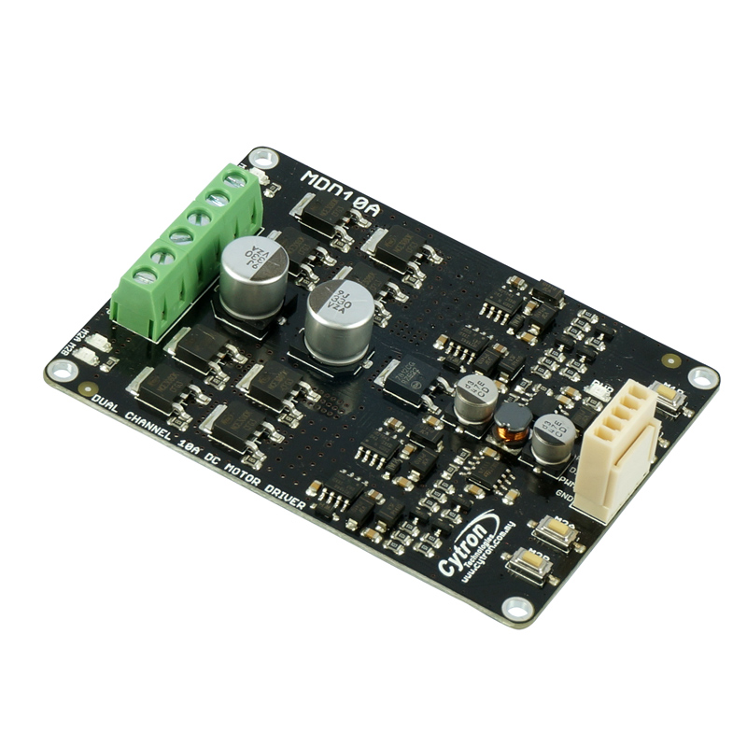
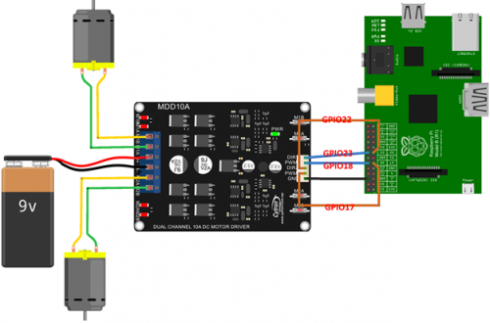

Raspberry Pi-3

Quad Core 1.2GHz Broadcom BCM2837 64bit CPU
- 1GB RAM
- BCM43438 wireless LAN and Bluetooth Low Energy (BLE) on board
- 100 Base Ethernet
- 40-pin extended GPIO
- 4 USB 2 ports
- 4 Pole stereo output and composite video port
- Full size HDMI
- CSI camera port for connecting a Raspberry Pi camera
- DSI display port for connecting a Raspberry Pi touchscreen display
- Micro SD port for loading your operating system and storing data
- Upgraded switched Micro USB power source up to 2.5A

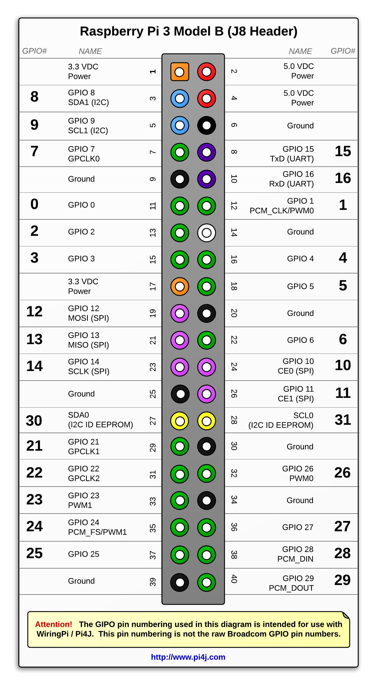

YDLidar

YD LIDAR Sensor
- Specification: A 360° LIDAR sensor connected via a Type-C cable.
- Purpose:
  - Scans the environment to detect obstacles and create a 2D/3D map for navigation.
  - Feeds data to Raspberry Pi 4 for real-time processing.
Exit Sensor
Specification: Basic sensor to detect the completion of a task or arrival at a specific endpoint.
- Purpose: Acts as a trigger for stopping or transitioning the bot to a new task.
Chest Display
Purpose: Displays system information, such as battery voltage, navigation status, or error messages.
Sound Card
Specification: External sound card connected to Raspberry Pi 4.
- Purpose: Processes audio signals for playback.

PAM (Power Amplifier Module)
Specification: Amplifies audio signals for driving speakers/woofers.
- Purpose: Ensures clear and loud audio output.

Woofer
Purpose: Outputs alerts, instructions, or other sound-based feedback.

Connector

USB Ports
- Used to connect peripherals like sensors or provide additional power.

Type-C Cable
- Connects the YD LIDAR Sensor to the Raspberry Pi 4 for power and data transfer.
XT60 Male/Female Connectors
  - Specification: High-current connectors commonly used for batteries.
  - Purpose: Enables secure connections for the 24V battery to the circuit.

BNO055 Sensor

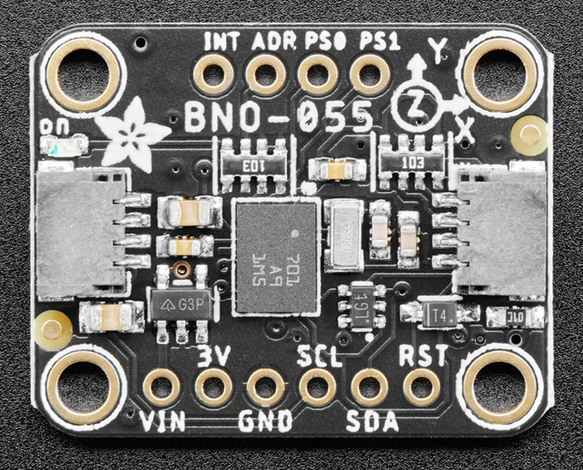
VIN: 3.3-5.0V power supply input
3VO: 3.3V output from the on-board linear voltage regulator, you can grab up to about 50mA as necessary
GND: The common/GND pin for power and logic

SCL - I2C clock pin, connect to your microcontrollers I2C clock line. This pin can be used with 3V or 5V logic, and there's a 10K pullup on this pin.
SDA - I2C data pin, connect to your microcontrollers I2C data line. This pin can be used with 3V or 5V logic, and there's a 10K pullup on this pin.
Default address of the BNO055 device is 0101001b(0x29) and alternate addr is 0x28.

Purpose of BNO055
- Absolute Orientation:
  - The BNO055 combines accelerometer, gyroscope, and magnetometer data internally to provide Euler angles (yaw, pitch, roll) or quaternions.
  - This removes the need for manual sensor fusion, reducing the processing load on the Raspberry Pi or Arduino Due.
- Stabilization:
  - The gyroscope data helps stabilize the bot by detecting tilts, rotations, and angular velocities.
  - For example, when the bot turns, the BNO055 provides precise rotation angles for smooth and accurate motion control.
- Navigation:
  - The magnetometer acts as a digital compass, helping the bot determine its heading (North, South, East, West).
  - Combined with encoder data, the bot can accurately navigate to its destination.

Buck Converter(LM2596)

Buck converters are DC-to-DC voltage regulators that step down voltage efficiently.To isolate power for different components and avoid overloading a single power source.
5AMP Buck Converter (-12V)
  - Specification: Steps down 24V to 12V, supports a current output of 5A.
  - Purpose: Provides 12V power to medium-voltage devices like the Motor Driver (MDD10A), Chest Display, and sensors.
2AMP Buck Converter (5V)
  - Specification: Steps down 12V/24V to 5V, with a current output of 2A.
  - Purpose: Supplies power to:
    - Raspberry Pi 3 and 4 (primary controllers)
    - USB Ports for peripherals like the LIDAR Sensor and Exit Sensor
    - BNO055 Sensor
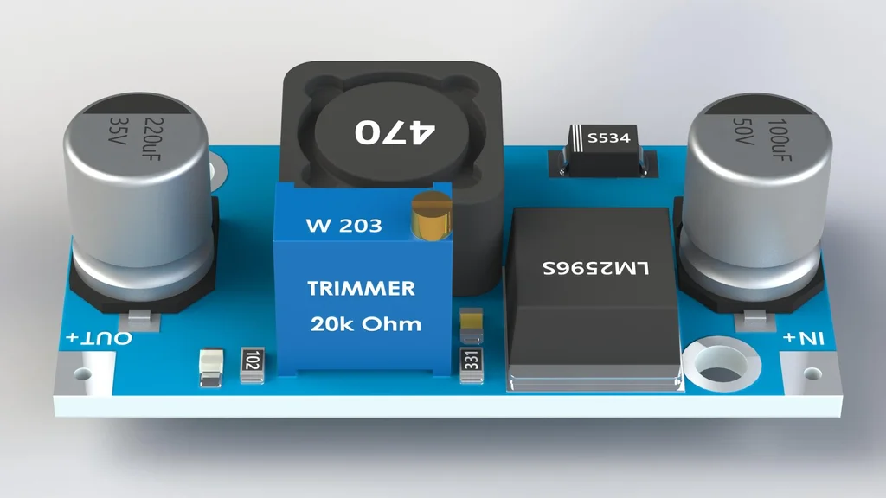

24V Battery

- The 24V battery connects to the motor driver’s VCC and GND pins.
- The motor driver then supplies power to the left and right motors.
The 24V battery is connected to multiple buck converters to provide lower voltages:
- 12V Buck Converter: Powers the MDD10A motor driver and other 12V components like LED displays.
- 5V Buck Converters: Step down to 5V for the Raspberry Pi, sensors, and auxiliary USB ports.
Encoders(OE-28 Hall Effect Two Channel Magnetic Encoder)
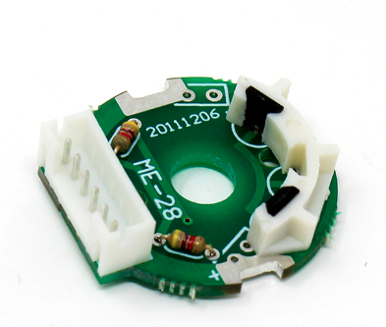

Encoder Pinouts:

Pin | Description
VCC | Power supply (+5V)
GND | Ground
CHA | Channel A signal output
CHB | Channel B signal output
M- | Motor negative terminal
M+ | Motor positive terminal

The encoder outputs two square wave signals (CHA and CHB) as the motor rotates.
- The signals are 90° out of phase:
- If CHA leads CHB, the motor is rotating in one direction (e.g., clockwise).
- If CHB leads CHA, the motor is rotating in the opposite direction (e.g., counterclockwise).

