HARDWARE CONNECTION

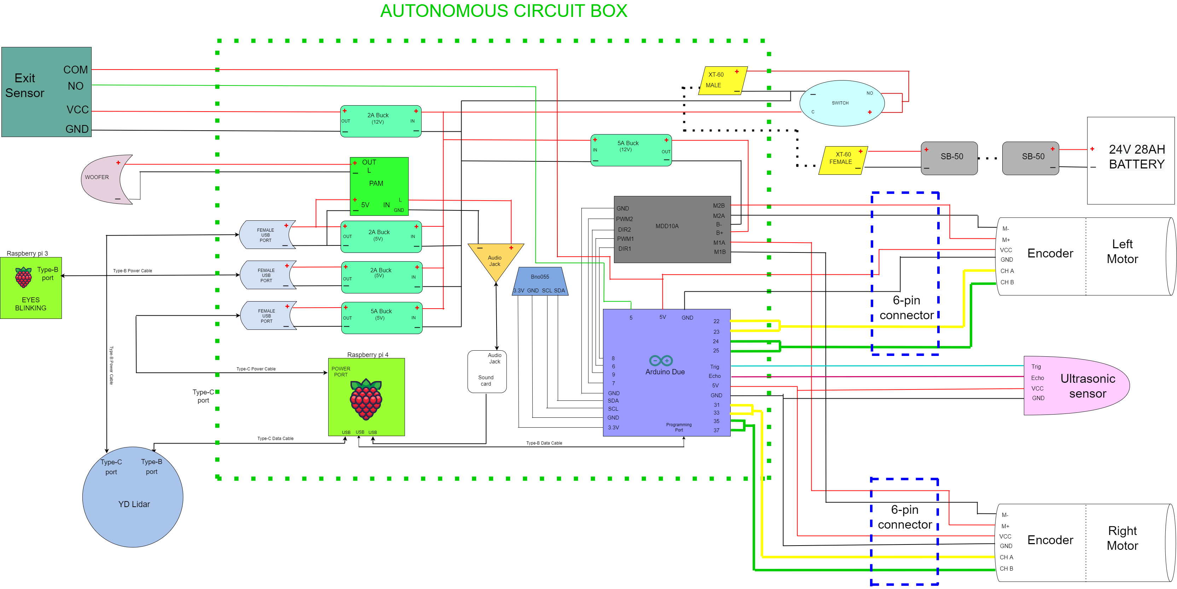

1. Raspberry Pi 4 - 8GB (Main Controller)
- Power:
  - Powered via 5V output from the 2nd 5Amp Buck Converter.
  - Uses a Type-C power cable for input power.
  - A 5V DC fan is connected to Raspberry Pi GPIO pins for cooling the processor.
- Connections:
  - USB Port: Connects to the Arduino Due using a Type-B data cable.
  - USB Port: Connects to LiDAR (YDLidar or RPLidar A1) for mapping and obstacle detection.
  - Communicates with Raspberry Pi 3 for coordinating eye-blinking and other auxiliary tasks.

2. Raspberry Pi 3 - 2GB
- Power:
  - Powered via 5V output from the 1st 2Amp Buck Converter.
  - Uses a Type-B power cable for input power.
- Connections:
  - Connected to the 3.5-inch TFT Display for eye-blinking animations.

3. Arduino Due (Sensor and Motor Controller)
- Power:
  - Powered through 5V pin from one of the 2Amp Buck Converters.
- Connections:
  - BNO055 (IMU Sensor):
    - 3.3V → Arduino 3.3V
    - GND → Arduino GND
    - SCL → Arduino I2C Clock Pin
    - SDA → Arduino I2C Data Pin
    - Used for orientation and motion sensing.
  - Exit Sensor:
    - VCC → 12V from the 3rd 2Amp Buck Converter
    - GND → 3rd 2Amp Buck Converter's GND
    - COM → Arduino Due's 5V Pin
    - NO → Digital Pin on Arduino Due (check Arduino code for exact pin).
  - Ultrasonic Sensor:
    - VCC → 5V pin on Arduino Due
    - GND → GND pin on Arduino Due
    - Trig → Digital Pin (specified in Arduino code)
    - Echo → Digital Pin (specified in Arduino code).
  - Encoders (OE-37):
    - CHA and CHB Pins → Digital Pins on Arduino Due (for motor feedback).
    - Powered via 5V from Arduino or buck converter.
    - Used for calculating motor ticks and position feedback.
  - MDD10A Motor Driver:
    - Power: Powered by 12V from the 1st 5Amp Buck Converter.
    - DIR1/DIR2 Pins → Digital Pins on Arduino Due (to control motor direction).
    - PWM Pins → PWM pins on Arduino Due (to control motor speed).
    - GND: Common ground shared with Arduino and power supply.
  - Motors:
    - Left and Right Motors are connected to the MDD10A Motor Driver outputs (M1A/M1B, M2A/M2B).
    - Motor encoders are connected back to the Arduino Due for feedback.

4. MDD10A Motor Driver
- Power:
  - Input: 12V power supplied from the 1st 5Amp Buck Converter.
  - Ground shared with the common GND.
- Inputs:
  - Controlled by Arduino Due's PWM pins (speed) and DIR pins (direction).
- Outputs:
  - Left Motor → Connected to M1A and M1B.
  - Right Motor → Connected to M2A and M2B.

5. Buck Converters
- 1st 5Amp Buck Converter:
  - Input: 24V from the main battery.
  - Output: 12V for the MDD10A Motor Driver.
- 2nd 5Amp Buck Converter:
  - Input: 24V from the battery.
  - Output: 5V for the Raspberry Pi 4 (via USB Type-C).
- 1st 2Amp Buck Converter:
  - Input: 24V from the battery.
  - Output: 5V for the Raspberry Pi 3 (via USB Type-B power cable).
- 2nd 2Amp Buck Converter:
  - Input: 24V from the battery.
  - Output: 5V for the LiDAR and PAM Audio Amplifier.
- 3rd 2Amp Buck Converter:
  - Input: 24V from the battery.
  - Output: 12V for the Exit Sensor.

6. LiDAR (YDLidar or RPLidar A1)
- Power:
  - Powered via the 2nd 2Amp Buck Converter (5V output).
- Connections:
  - Type-B Power Cable: Connected to the LiDAR's power input.
  - Type-C Data Cable: Connects to the USB 3.0 port on Raspberry Pi 4.
  - Provides distance measurements for navigation and object detection.

7. PAM Audio Amplifier
- Power:
  - Powered by the 2nd 2Amp Buck Converter (5V output).
- Connections:
  - Audio Jack:
    - Input: Audio signals from Raspberry Pi 4.
    - Red (L) and Ground (ꓕ) wires connect to PAM input.
  - Output:
    - PAM output connects to the Woofer (Red for Positive, Black for Negative).

8. Woofer
- Connections:
  - Input: Connected to the PAM output through a 2-pin connector.
  - Provides external sound output for audio functionalities.

9. Motors (Planetary Gear Motors)
- Power:
  - Motors are powered via MDD10A Motor Driver outputs.
- Encoders:
  - CHA and CHB pins of encoders are connected to Arduino Due.
  - Provides position and speed feedback for precise motor control.

10. 3.5-inch TFT Display
- Connections:
  - Connected directly to the Raspberry Pi 3 GPIO pins.
  - Displays the blinking eye animations.

11. Exit Sensor
- Power:
  - Powered via the 3rd 2Amp Buck Converter (12V output).
- Connections:
  - VCC → 12V output from Buck Converter.
  - GND → GND.
  - COM → 5V on Arduino Due.
  - NO → Digital Pin on Arduino Due for status monitoring.

12. Ultrasonic Sensor
- Power:
  - VCC → 5V pin on Arduino Due.
  - GND → GND pin on Arduino Due.
- Data:
  - Trig → Digital Pin on Arduino Due (signal trigger).
  - Echo → Digital Pin on Arduino Due (signal response).

