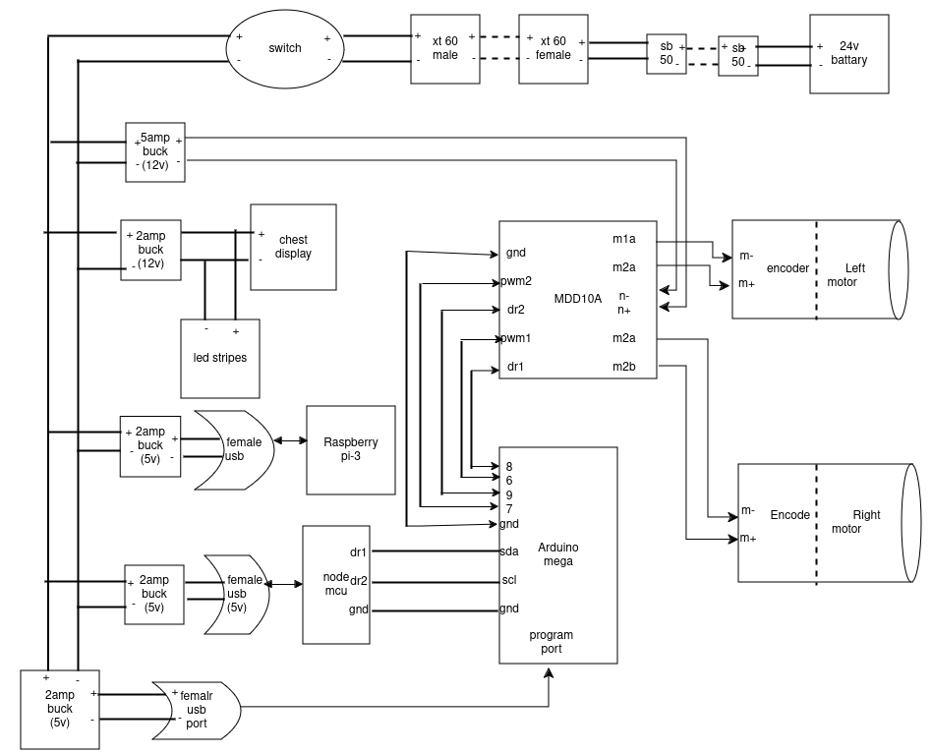
MANUAL BOT

Component List
- Raspberry Pi-3 (1)
- Node MCU (1)
- Arduino Mega(1)
- Encoders(2)
- DC Motor
- MDD10A Motor Driver
- Buck Converters(2amp/5amp. as per Requirements)
- Chest Display
- 24v Battery
- Led Stripes
- Connector(female usb port, XT-60/50 etc).
- Switch

Raspberry Pi-3
- It is a micro-controllers which has inbuilt Audio Jack, Power Jack, USB Ports and with 2GB Storage.
- It is mainly used for storing the code of blinking of Eyses.
- In this Circuit, we have to dump separate OS to perform the EYES blinking.
- We used Raspberry Pi 3 because the processing speed is very fast compare to others.
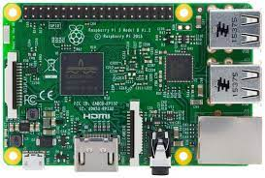

Node MCU

- Node MCU is microcontroller with built-in WI-FI(ESP8266), Allowing for wireless communication and IOT functionalities.
- ESP8266 Peripheral Includes:
  - 17 GPIOs
  - SPI
  - I2C
  - I2S Interface with DMA
  - UART
  - 10 bit ADC
  - ESP8266 supports interrupts in any GPIO, except GPIO16.
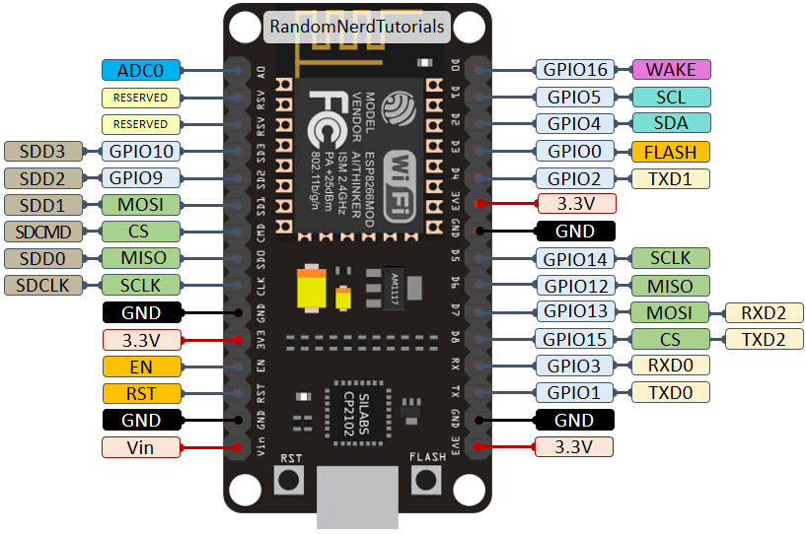

Arduino Mega
- Arduino Mega is based on Atmega2560 Microcontroller, an 8-bit AVR Architecture based MCU from ATMEL. Its is available in a 100 pin Quad Flat Package.
- It is Designed and developed to provide more number of IO Lines(both Digital and Analog), more flash memory and more RAM .
- It serves as the main controller for hardware interfaces like the Motor Drivers and other
peripherals. Arduino Handles:
- Input Signal from Encoders
- PWM signals for motor control.
- Communication with Raspberry Pi and Node MCU.

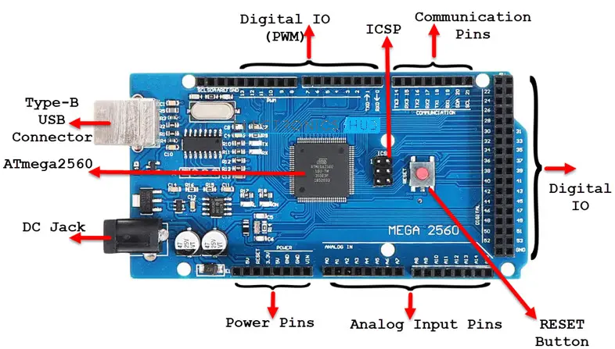
Encoders

- OE-28 Hall Effect Two-Channel Magnetic Encoder is a type of sensor used to detect rotational position and speed of a motor shaft or rotating Body.
- The OE-28 Encoder is connected to both the Left motor and right Motor.
- Output from the encoders feedback to the Arduino Mega.
- The Arduino uses this data to:
  - Monitor Motor Speed.
  - Ensure both Motors rotate at Synchronized Speeds for Straight-line Motion.
  - Detect direction of Motor.
  - Provide Feedback to correct deviations or implement precise control.
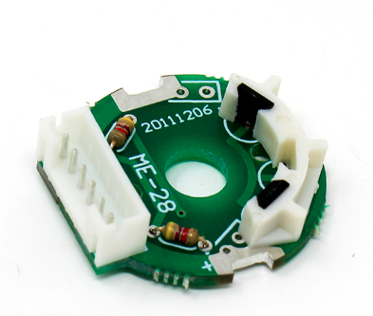

Pin | Description
VCC | Power supply (+5V)
GND | Ground
CHA | Channel A signal output
CHB | Channel B signal output
M- | Motor negative terminal
M+ | Motor positive terminal

DC Motor
- Two 12v DC motors are used to drive the bot’s wheels(left and Right Motor).
- The Motors receive power from the MDD10A motor Driver, which interfaces with the Arduino Mega for Control.
- Encoders are attached to the motor shaft to provide real-time feedback for precise Movement control.
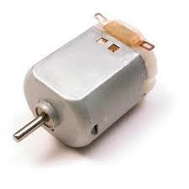

MDD10A Motor Driver

MDD10A Motor Driver Pins:
  - PWM1 and PWM2: Control the motor speed using PWM signals.
  - DIR1 and DIR2: Control motor direction (HIGH/LOW signal).
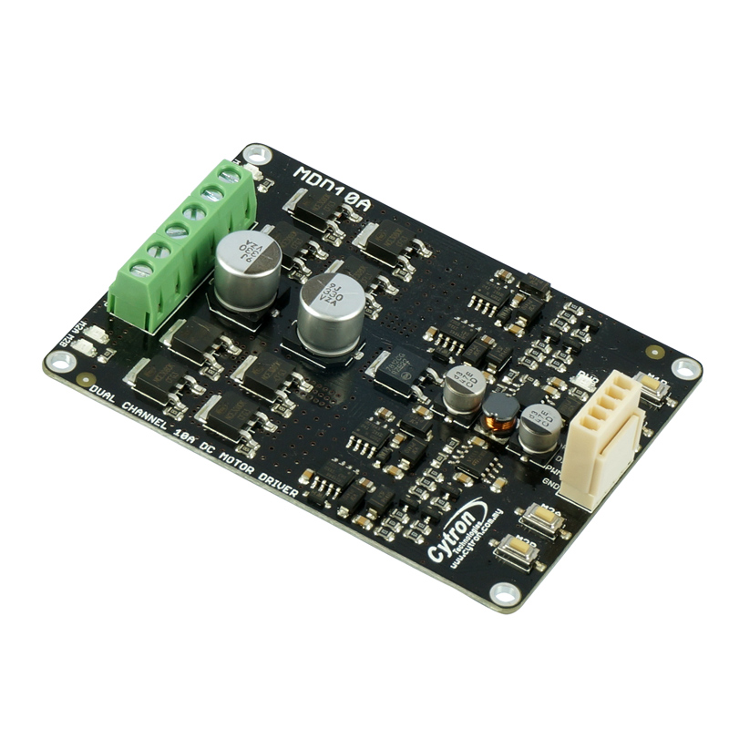
  - M1A, M1B: Output pins for Motor 1.
  - M2A, M2B: Output pins for Motor 2.
  - GND and VCC: Power supply connections.

Buck Converters
- Buck Converters are DC-DC voltage regulators that step down voltage efficiently. To isolate Power for different components and avoid overloading a single power source.
- 5AMP Buck Converters
  - Specification: Step down 24V to 12V, supports a current output of 5A.
  - Purpose: Provides 12V Power to medium-voltage device like the motor Driver(MDD10A),chest Display And Sensor.
- 2AMP Buck Converter(5v)
  - Specification: Steps down 12V/24V to 5V, with a current output of 2A.
  - Purpose: Supplies power to:
  - Raspberry Pi-3.
  - USB Ports for peripherals like the LIDAR Sensor and Exit Sensor and BNO055 Sensor.
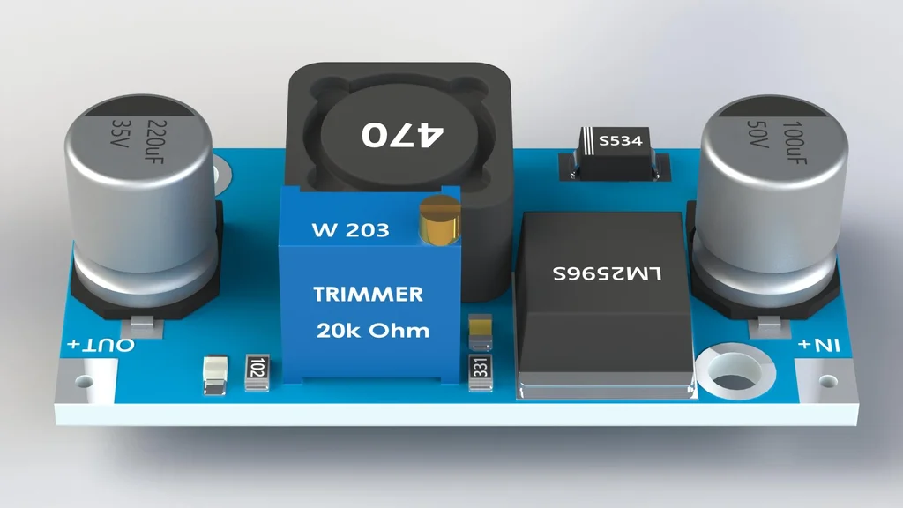

Chest Display

- The chest display is powered through the 2A Buck Converter which steps down the voltage from the 12V supply to 5V. Suitable for the display.
- Connection to Raspberry Pi/Arduino : The display is connected to the Raspberry Pi-3 or Arduino Mega, whcih processes the data and sends information to the screen.

- Data Display: The MCU collect data (e.g. motor status, battery level etc) and send it to the display to show real-time information to the user.

24V Battery

- The 24V battery serves as the primary power source for the mannual bot, Supplying energy to high- demand components like motors, controllers and displays.
- Its ensures efficient power distributions, supporting the Motors Via the MDD10A Motor Driver and Enabling stable voltage regulation through Buck Converter for 12V and 5V Device.
- The higher voltage reduces current draw, minimizes energy loss and extends operational runtime, making it ideal for Powering the Bot’s performance and stability.
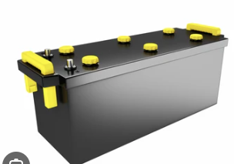

Switch
- Push Button is a simple switch to control some aspect of a machine or process.
- When pressed, either close or open the electrical circuits to which they are attached.
- In simple Terms:
  - we are using bore for water in home, if we press ON, it turns on and start running and if we press OFF, it will turn off and stop working.
  - It has two colors, RED indicates STOP and GREEN indicates START.
