PROCEDURE FOR MAPPING AND NAVIGATION

SSH:

- While connecting the Wifi to the controller (Raspberry pi), check the IP of the controller.(using network scanner app).
IP adress may be 192.168.xx.xx.
- After that, take the terminal and check the system IP adress.
IP address command is --> ifconfig
EX: 198.168.1.5
- After that, take the another terminal, Goto bashrc file.
Command : sudo nano ~/.bashrc
Enter the ROS IP and ROS Master Ip
EX: export ROS_IP=192.168.1.5
export ROS_MASTER_URI=http://192.168.1.37:11311/
- After that, take the another terminal,
command ssh device@device ip adress
EX: ssh ubuntu@198.168.1.37
device password: xxxx
next enter the bashrc file command.
And enter the ROS IP adress are Same (device adress).
EX: export ROS_IP=192.168.1.37 ( laptop IP)
export ROS_MASTER_URI=http://192.168.1.37:11311/ (BOT IP)
and save the adress and quit. (save- ctrl+s, quit- ctrl+x)
and source.
And do Source
command : source ~/.bashrc

- Take files--> other location--> device adress(sftp://192.168.1.37/)
and enter device name and password.
- Files open --> location adress --> catkin workspace-->src-->yd_lidar-->launch-->x2.launch

Mapping :

- With lidar , we have few mapping techniques. The procedure is same but the algorithm used for mapping may vary.
1. Gmapping
2. Hector mapping
3. Cartographer mapping

Gmapping :
- It is older mapping technique , but it still holds the great response.
- We managed to map our projects mostly with gmapping.
Note: gmapping will consider the odometry data for mapping.

The SLAM (Simultaneous Localization and Mapping) is a technique to draw a map by estimating current location in an arbitrary space
Learning about Gmapping package summary
Hardware requirement and Node slam_node

First open the terminal

IP Adress : ssh ubuntu@ip(192.168.xx.xx)
Password :

After that, we need to go in our workspace
So Enter : cd catkin_ws/
next : source devel/setup.bash

we need to launch 4 steps for Mapping : So follow the commands

Before this, we need to uncomment X2.launch file and the path is given below.

Home/catin_ws/src/ydlider_ros.driver/launch/x2.launch

After uncommenting this, follow the below steps for Mapping

STEP-1 : Enter below command

ros launch nox_li.launch (lider and rosserial is on)

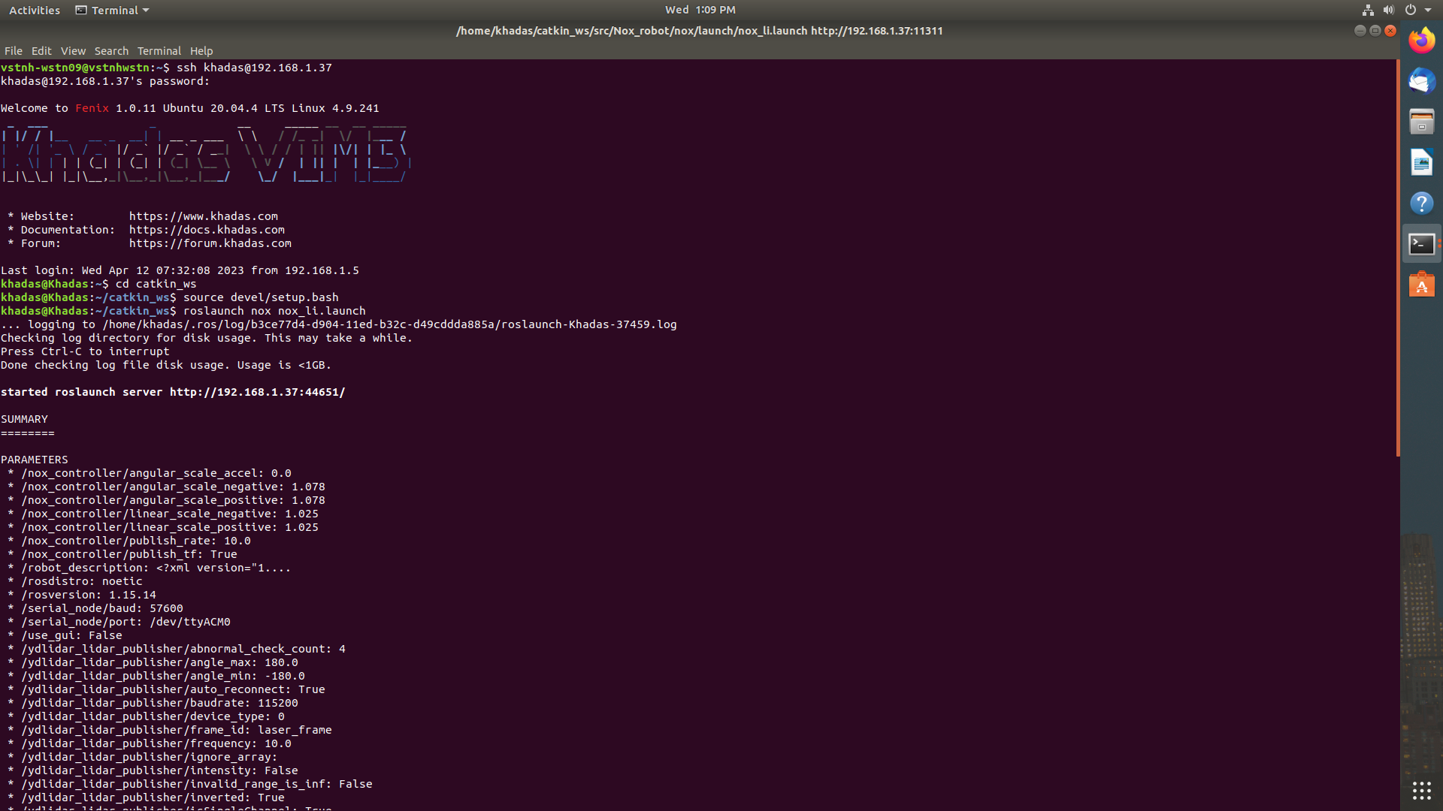

STEP-2:

Next launching the GMAPPING.

Select new terminal and enter
Login id :
Password :
Next : cd catkin_ws
Next : source devel/setup.bash

Enter : roslaunch turtlebot3_slam turtlebot3_gmapping.launch
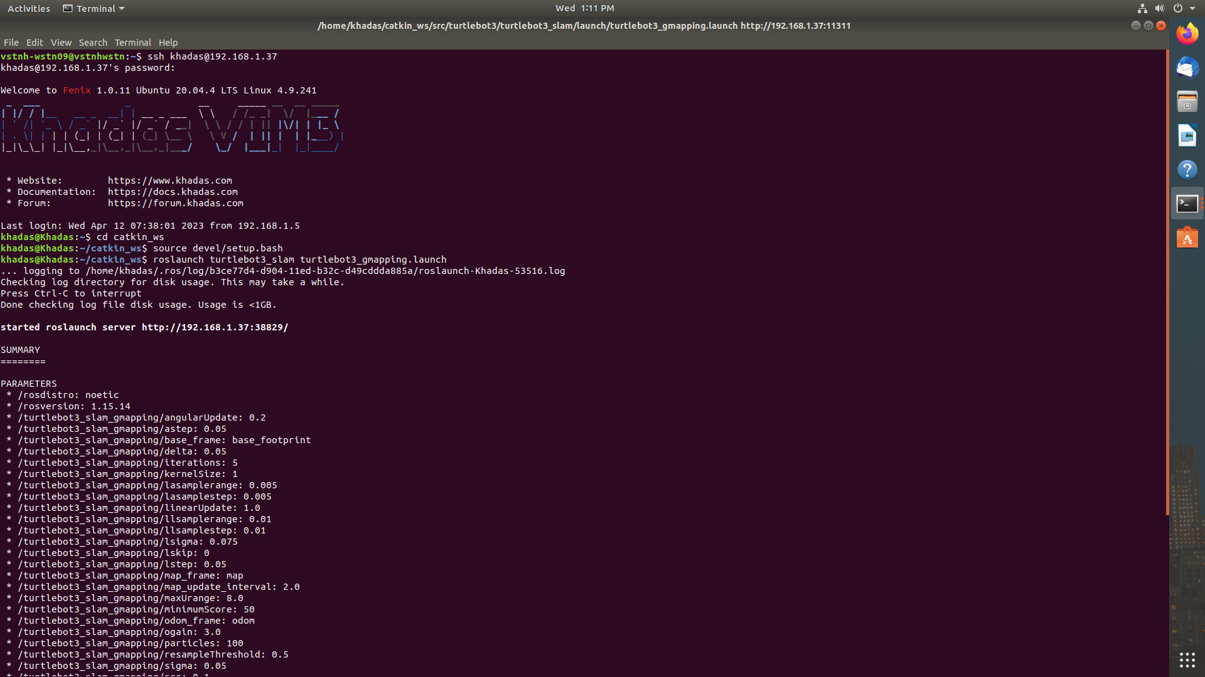

STEP-3:

Next run the teleoperation node for operating
For this type below command

Enter : rosrun teleop_twist_keyboard teleop_twist_keyboard.py

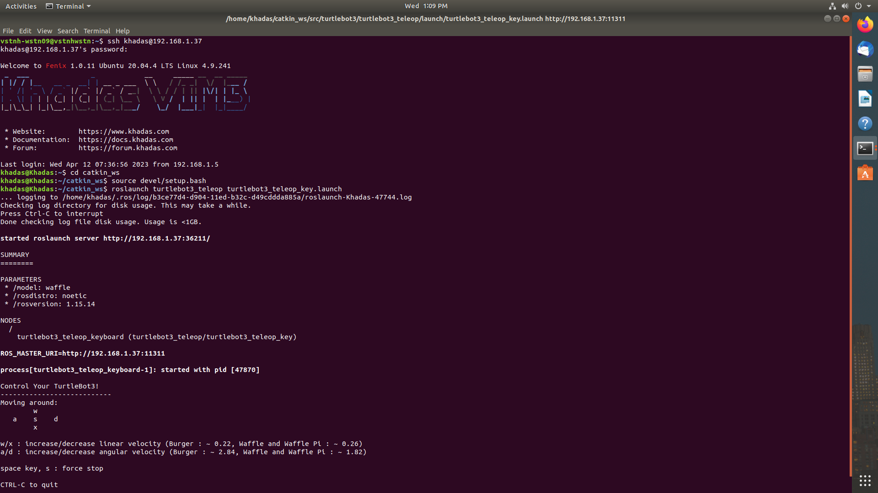

STEP-4:

Next open the Rviz using the following command. It will be used for generating

the map.

Enter : rviz

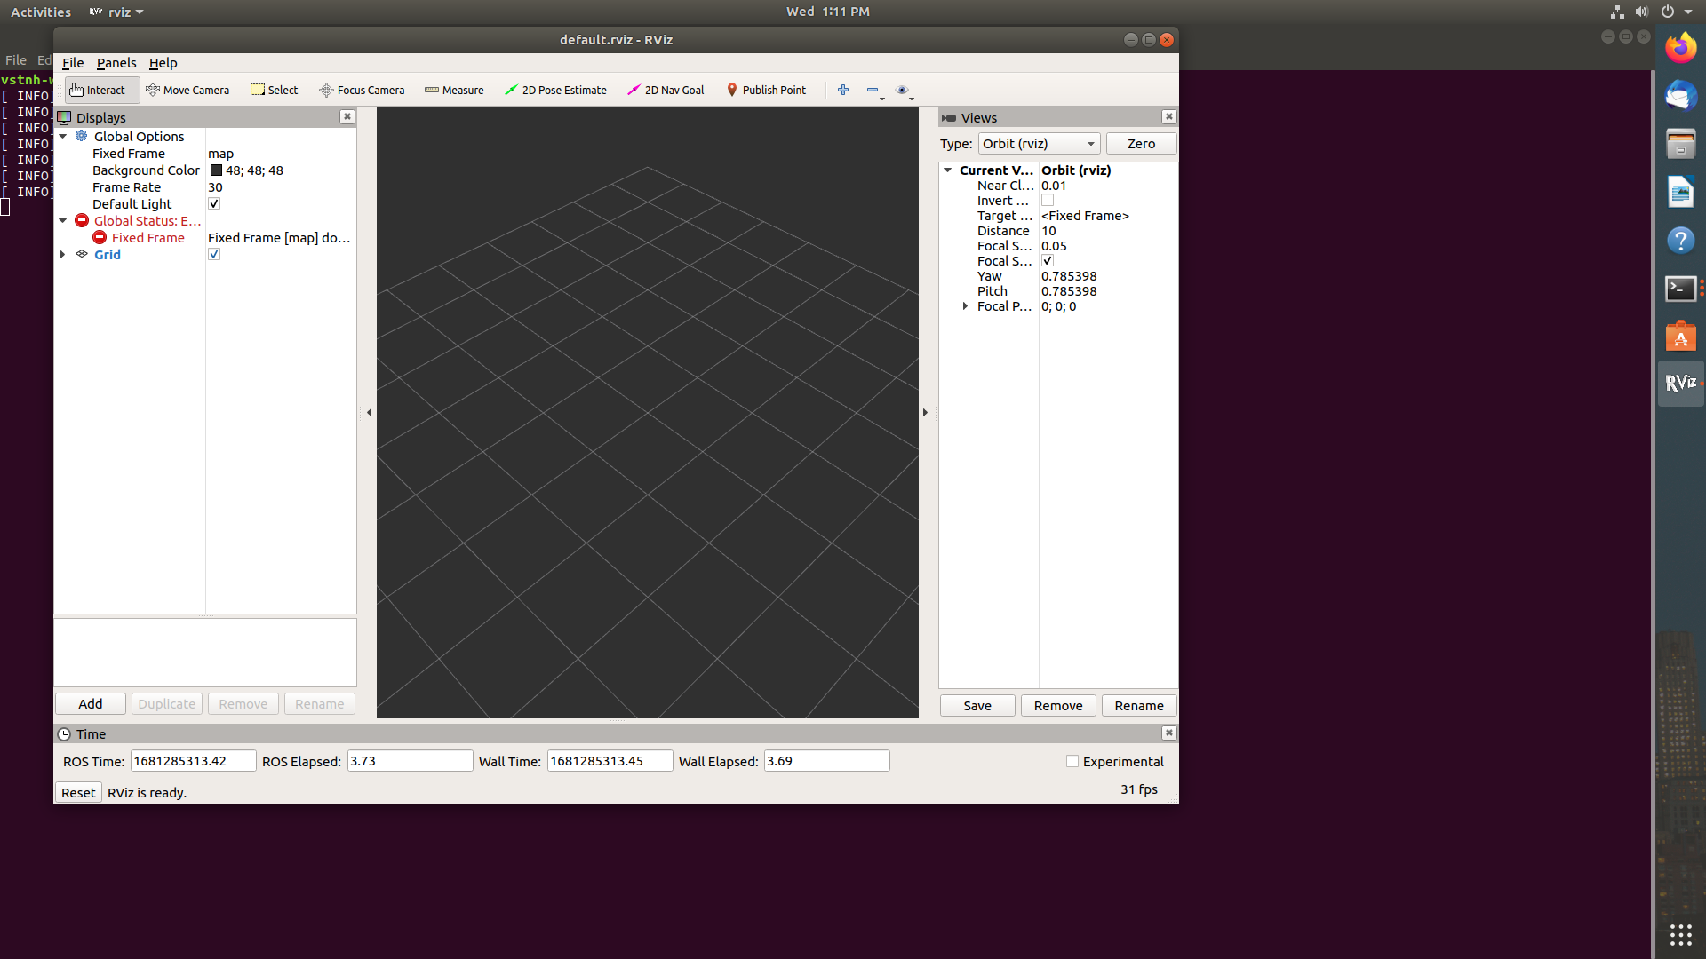

Click add-->by topic-->laser scan-->ok.
Click add-->by topic-->map-->ok.
Click add-->by display-->tf-->ok.

First testing teleoperation node
I -> Forword
> -> Backword
l -> Right
J -> Left
Z -> Decreasing the speed
Q -> Incresing the speed

Then slowly move the BOT by pressing the “I” button and automatically the map will be updated. Continue the same process and scan the entire room or restaurant. So that the LIDAR will scan the objects and it will generate the map.

After that save the map using below command.

rosrun map_server map_saver -f map_name

The map will be save in both it png file and yaml file.

TESTING AND NAVIGATION OF MAP

For this, we need to follow the below steps :

The map which is saved is to be uploaded in BOT’s file.
For this we need to access BOT’s files. For this
Go to files --> other locations --> Enter IP of BOT’s
sftp://192.168.xx.xx and connect.

After that we can access BOT’s files. Go to
192.168.xx.xx--> catkin_ws --> src --> nox_robot --> nox --> map

In map files, we need to paste our map in map folder
i.e., sampath.png file and sampath.yaml file.

Then copy the sampath.yaml name and paste in launch file
Home --> catkin_ws --> src --> nox_robot --> nox --> launch

Before this, we need to comment X2.launch file and the path is given below.

Home/catin_ws/src/ydlider_ros.driver/launch/x2.launch

After commenting this, follow the below steps for Map Testing

Then follow the below steps :

First open the terminal
IP Adress : ssh ubuntu@ip(192.168.xx.xx)
Password : xxxxxxxx

After that, we need to go in our workspace
So Enter : cd catkin_ws/
next : source devel/setup.bash

STEP-1 : Enter below command

roslaunch nox nox_navi.launch

STEP-2:

Enter : rviz ( It will open map )

Goto files --> Recent files --> Navigation

--> Then move the Robot from one place to another place by giving the directions. So that the BOT automaticaly move.
--> By these, we can get the points (coordinates).
--> Try with different positions i.e., home locations to tables and tables to home locations.
and also from table-1 to different tables and note down the points which are obtained from the map.

- The points( coordinates ) which are obtained from the navigation will be updated in XL file or pyhon file.
- Take the readings from home location to different tables and different tables to home location.
- Take the readings from Tables to Tables.
- Take the readings from jonts positions.
- Note down the points and paste in XL file or python file.
- Cordinates can be obtained in 3 different ways,
- Coordinates CSV files
- Coordinates.csv
- Coordinates.csv stores the joints coordinates between home location and table.
- Coordinates_nz.csv
- Coordinates_nz.csv stores the joints between tables while coordinates.csv stores the joints between home location and tables.
- Tables.csv
- These coordinaters will be taken from Table-Table

TESTING WITH ROBOT :

Check the server IP and update in python file.
Enter server IP in Google or Mozilla and login to that network
username :
passoword :

It will show how many bots will be available, select the required bot and click enter.
It will display how many tables will be available i.e., 1.2.3.4....
click the required bot and enter ready to serve, so that the BOT will move to the destination ( to the table location ) .
And there is also a EXIT sensor which will automatically move to the destination if we press the Exit button without giving the 0-Table or home location.

The procedure for SKYVVY BOT is same as above but will do with HOTSPOT & ROUTER with LAN.

