Sensitive Data Exposure Detection System
Monitoring unencrypted sensitive data transmissions and flagging potential vulnerabilities
Project Report
SUBMITTED BY
Anjali Verma (Roll No: [2400320100197])
Degree: Bachelor of Technology (B.Tech)
Branch: Computer Science & Engineering / Cyber Security
Academic Year: 2026 – 2027
GitHub Repository : https://github.com/anjali04-verma/sensitive-data-exposure-detector
UNDER THE GUIDANCE OF
[Internal Faculty Guide — Sarath G]
Status: 3rd Year Project Specification
Date of Submission: [01-10-2026]

Abstract
Sensitive data such as passwords, payment card numbers and session tokens is frequently sent over networks in plaintext. Anyone positioned on the network path can read it, which makes this a classic man-in-the-middle exposure and falls under OWASP A02:2021, Cryptographic Failures. This project implements a defensive monitoring tool that captures network traffic in an isolated virtual lab, detects sensitive data sent over unencrypted protocols (HTTP, FTP and similar), masks every finding so that raw secrets are never stored, assigns a severity, and presents the results on a web dashboard. A companion scanner checks a web server for configuration weaknesses: no HTTP-to-HTTPS redirect, missing HSTS header, cookies without Secure/HttpOnly flags, and login forms served over HTTP.
In testing, the detector identified plaintext passwords, card numbers, HTTP Basic credentials, e-mail addresses, PAN numbers and FTP logins. Luhn validation eliminated false positives on random 16-digit numbers, deduplication reduced the event log from 13 rows to 5 for the same traffic, and a cookie-flag fix reduced scanner findings from 5 to 3.

1. Introduction and Problem Statement
Protocols such as HTTP, FTP, Telnet, POP3, IMAP and SMTP (without TLS) transmit credentials and data without encryption. A single captured packet can reveal a login, a card number or an API key. Organisations often do not know which internal systems still use such protocols. The goal of this project is to detect these exposures automatically and report them with clear remediation advice.

1.1 Objectives
- Capture live traffic and identify unencrypted protocols.
- Detect sensitive data using pattern matching plus validation to reduce false positives.
- Store only masked values so the tool itself does not become a data-leak risk.
- Score findings by severity and present them on a dashboard with CSV export.
- Scan a web server for transport-security misconfigurations.

1.2 Scope
The system is defensive only and was run solely inside an isolated lab built from virtual machines owned by the author. It detects the absence of encryption; it does not decrypt or break TLS traffic.

2. System Architecture
Packets arriving on the lab network are captured with Scapy (using the Npcap driver on Windows). A port filter keeps only traffic to or from known plaintext services. The detection engine applies regular-expression rules and validators to each payload. Matches are masked, deduplicated and written to a SQLite database. A separate scanner writes configuration findings into the same database, and a Streamlit dashboard reads from it.
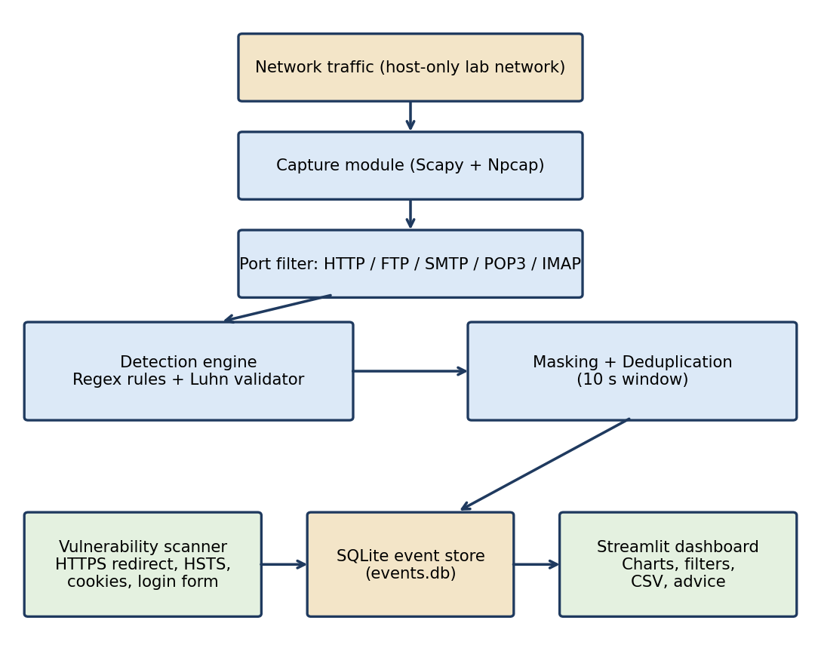
Figure 1: System architecture

3. Lab Setup

3.1 Environment
Component | Details
Hypervisor | Oracle VirtualBox
Server VM | Windows Server 2022 (evaluation), runs the fake services and the sensor
Client | Host PC (Windows), used only to generate test traffic
Network | VirtualBox Host-Only network 192.168.56.0/24 (host 192.168.56.1, VM 192.168.56.102) plus a NAT adapter for downloads
Software | Python 3.11, Scapy, Npcap, PyYAML, pandas, Streamlit, requests, pyftpdlib, pytest

3.2 Vulnerable test services
A single Python script (fake_server.py) provides an HTTP login page on port 80 and an FTP server on port 21 with a test account. Both transmit data in plaintext on purpose. Only test values were used (for example the card number 4111 1111 1111 1111 and the password Secret123); no real credentials or card numbers were ever used.
Traffic was always generated from the host PC rather than from inside the VM, because Windows loopback traffic does not pass through the normal network adapter and would not be visible to the sensor.
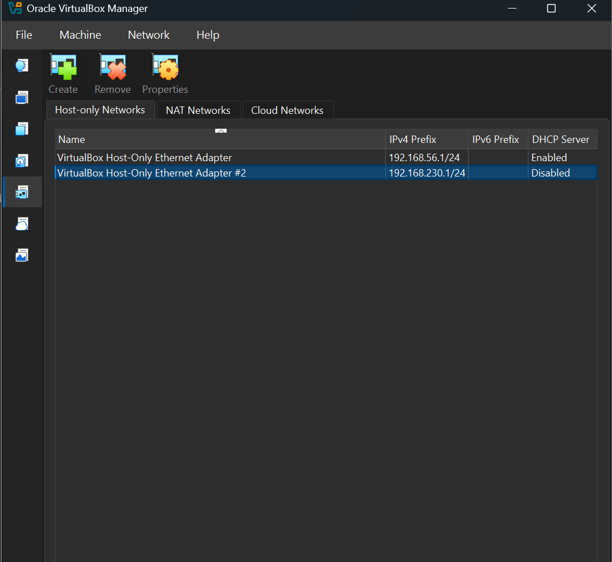
Figure 2: VirtualBox host-only network and VM adapter settings
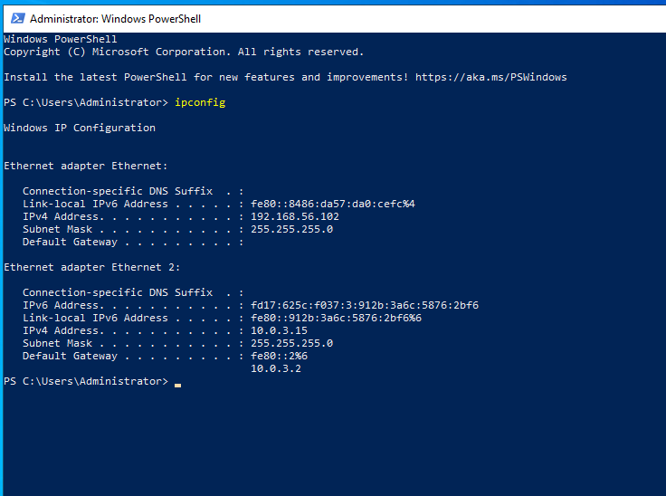
Figure 3: ipconfig output on the VM showing 192.168.56.102

4. Implementation

4.1 Packet capture
The sensor selects the adapter whose IP starts with 192.168.56. automatically, so it never sniffs the NAT adapter. Only TCP packets with a payload on ports 80, 8080, 21, 23, 25, 110 and 143 are inspected.

4.2 Detection rules and severity
Data type | Method | Severity
Password in form | Regex on password= / passwd= / pwd= | Critical
Credit card | Regex for 13-19 digits + Luhn checksum | Critical
HTTP Basic auth | Regex on Authorization: Basic header | Critical
FTP login | Regex on USER / PASS command lines | Critical
AWS access key | AKIA followed by 16 characters | High
JWT token | eyJ... three-part token | High
PAN (India) | 5 letters, 4 digits, 1 letter | High
E-mail address | Regex | Medium

4.3 Masking
Every finding is masked before it is printed or stored: the first two and last two characters are kept and the rest are replaced by asterisks (Secret123 becomes Se*****23). The raw secret is never written to disk, so the database and CSV exports are safe to share.

4.4 Deduplication
One HTTP request can be split over several packets, and clients may retry, so the same finding was sometimes recorded several times. A finding with the same source, destination, type and masked sample seen within the last 10 seconds is now skipped.

4.5 Vulnerability scanner
scanner.py sends a request to the target and checks the response. Results are stored in the same database with the source labelled scanner, and each run replaces the previous scanner results.
Check | Severity if failed
No redirect from HTTP to HTTPS | Medium
Missing Strict-Transport-Security (HSTS) header | Low
Cookie without Secure flag | Medium
Cookie without HttpOnly flag | Medium
Password form served over HTTP | High

4.6 Dashboard
The Streamlit dashboard reads events.db and refreshes itself every 5 seconds. It shows a colour-coded status banner, summary cards (total findings, Critical, High, hosts involved) and a 0-100 risk score weighted by severity. Three tabs present the data: live traffic findings (timeline, data-type chart, severity bars, remediation advice per protocol and the full event log with CSV export), server scan findings with a fix guide, and a short explanation of how the pipeline works. A sidebar provides severity and protocol filters and a reset button for demos.
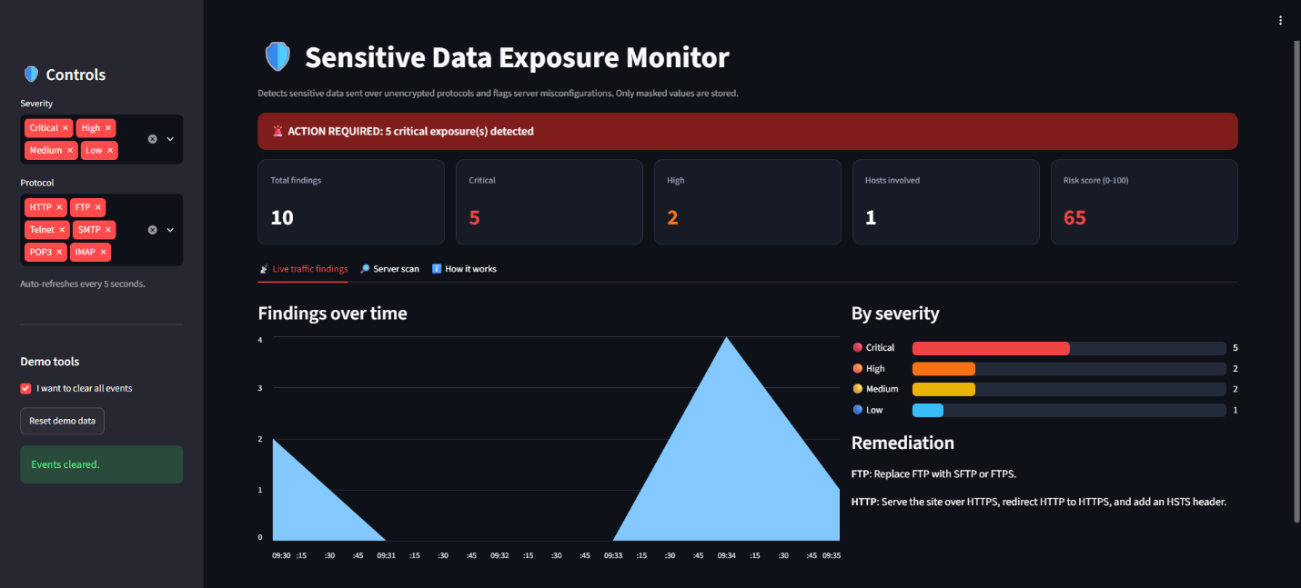
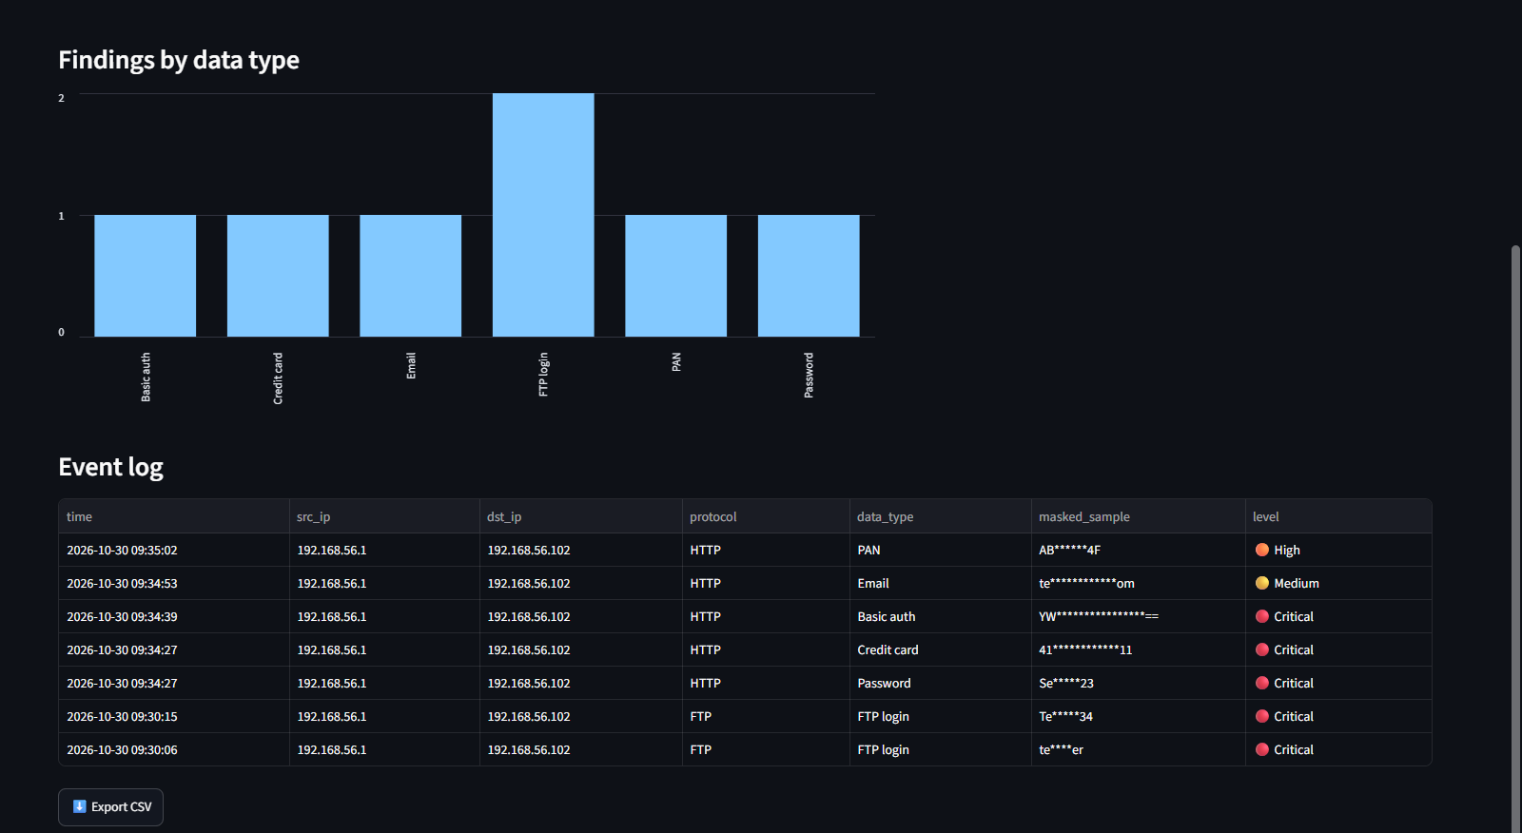
Figure 4: Dashboard overview (status banner, cards, charts)

5. Testing and Results

5.1 Live detection
The following requests were sent from the host PC to the VM, and the detector flagged each one with a masked sample:
Test traffic | Detected as | Masked sample | Severity
POST password=Secret123 | Password | Se*****23 | Critical
POST card=4111111111111111 | Credit card | 41************11 | Critical
curl -u admin:pass123 | Basic auth | YW****************== | Critical
POST email=test@example.com | Email | te************om | Medium
POST card=5555555555554444 | Credit card | 55************44 | Critical
POST pan=ABCDE1234F | PAN | AB******4F | High
FTP login (testuser) | FTP login | (USER/PASS lines) | Critical
POST order=1234567890123456 | Not flagged (fails Luhn) | - | -

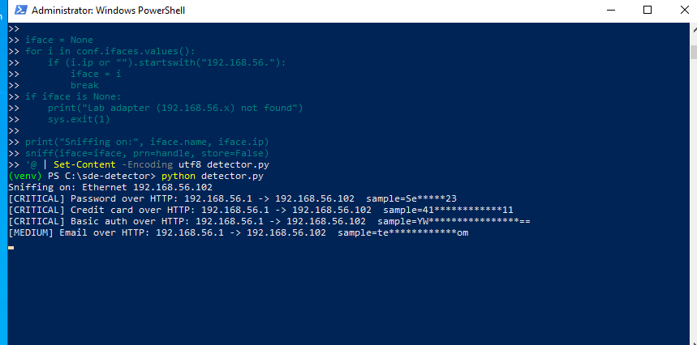
Figure 5: Detector console output showing masked alerts
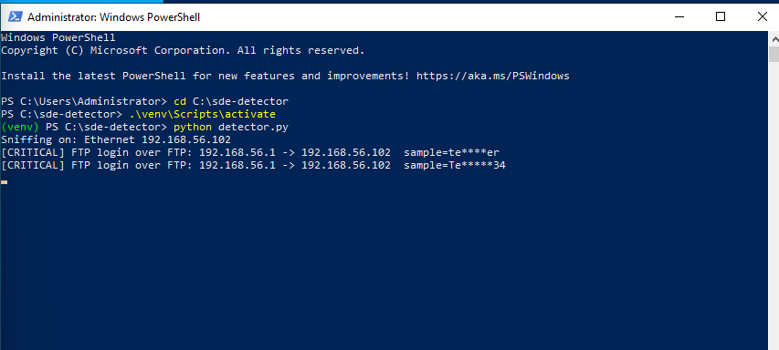
Figure 6: FTP credentials detected in plaintext

5.2 Effect of deduplication
Stage | Events recorded for the same traffic
Before deduplication | 13 rows (card repeated 3 times, PAN twice)
After deduplication | 5 rows (each finding once, plus 3 scanner findings)

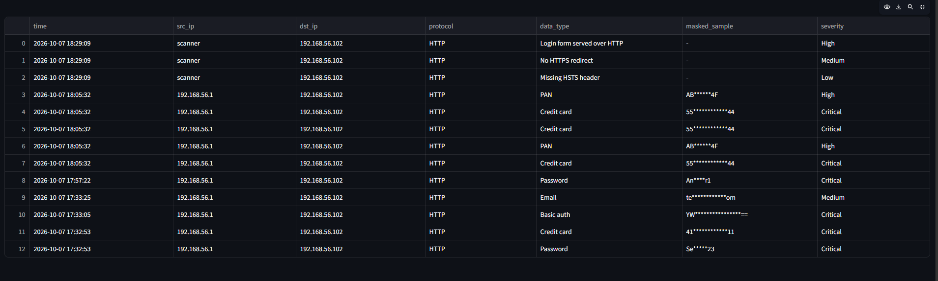
Figure 7: Event log before deduplication (13 rows)
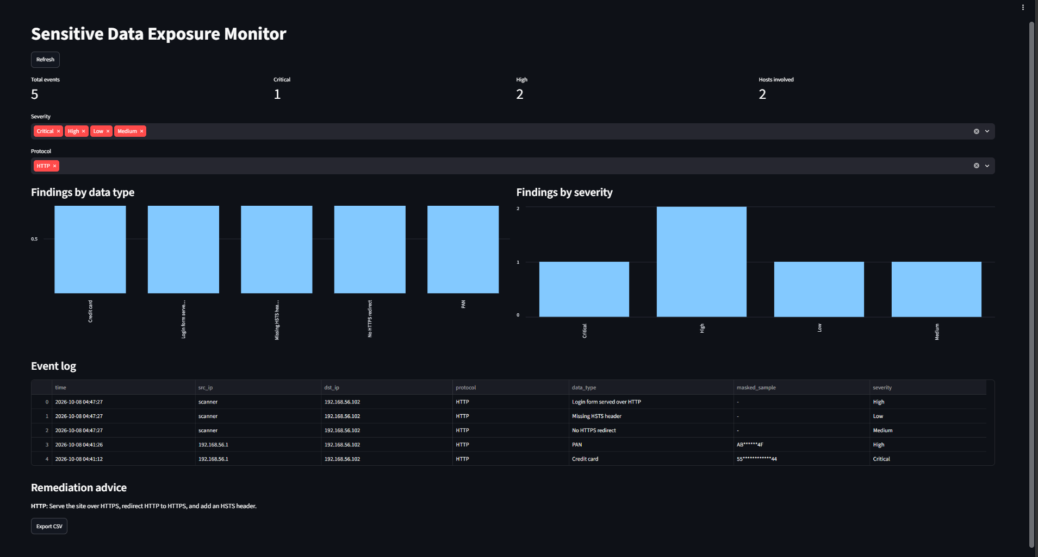
Figure 8: Event log after deduplication (5 rows)

5.3 Scanner: before and after remediation
The test server first set a session cookie without flags. After adding Secure and HttpOnly to the cookie, the scanner was run again.
Finding | Before | After
No HTTPS redirect | Present | Present
Missing HSTS header | Present | Present
Cookie lacks Secure flag | Present | Fixed
Cookie lacks HttpOnly flag | Present | Fixed
Login form over HTTP | Present | Present
Total findings | 5 | 3
The remaining three findings can only be resolved by deploying HTTPS on the server, which was outside the scope of this lab.
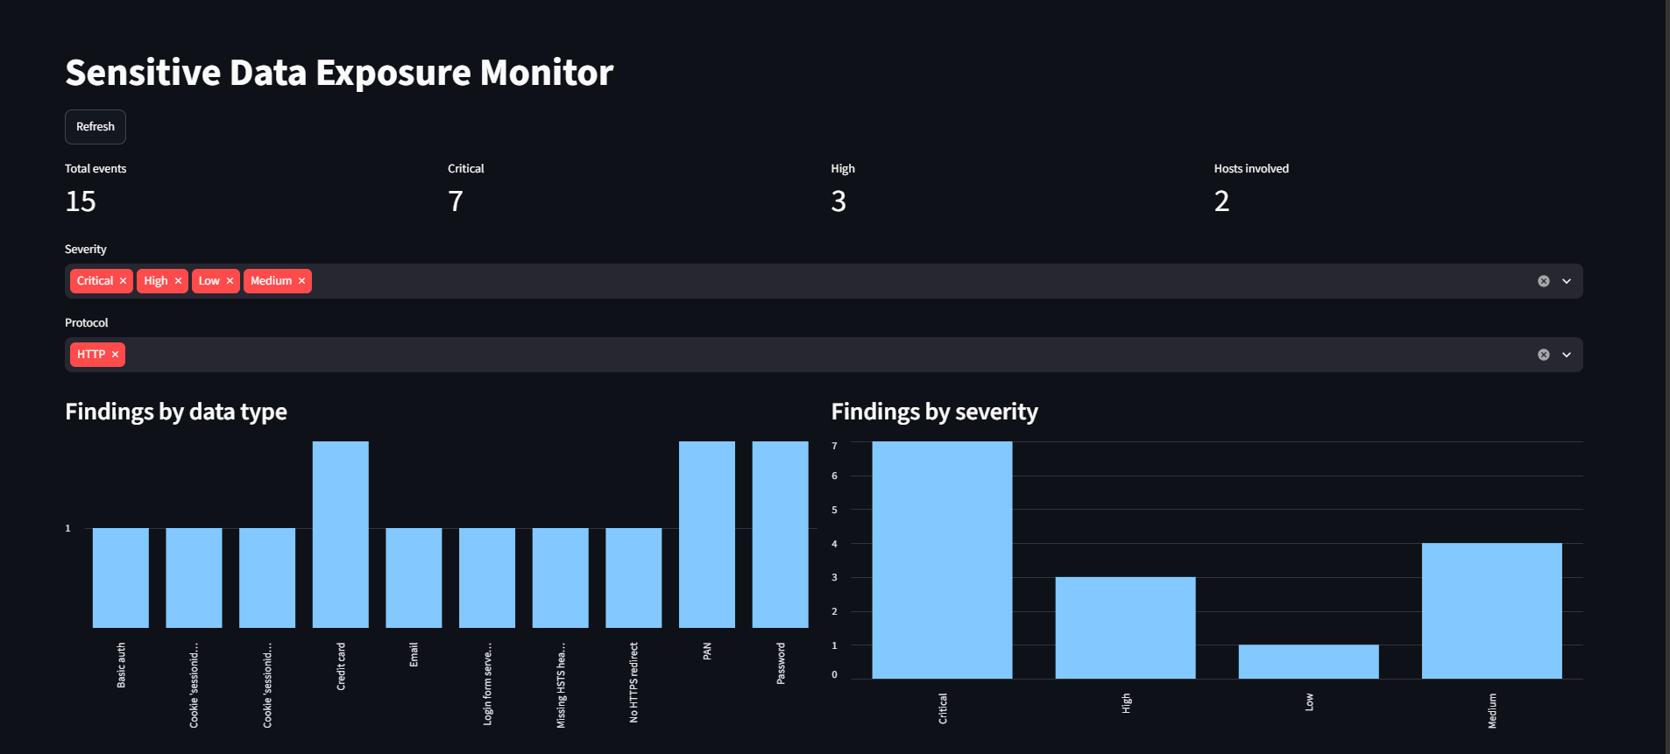
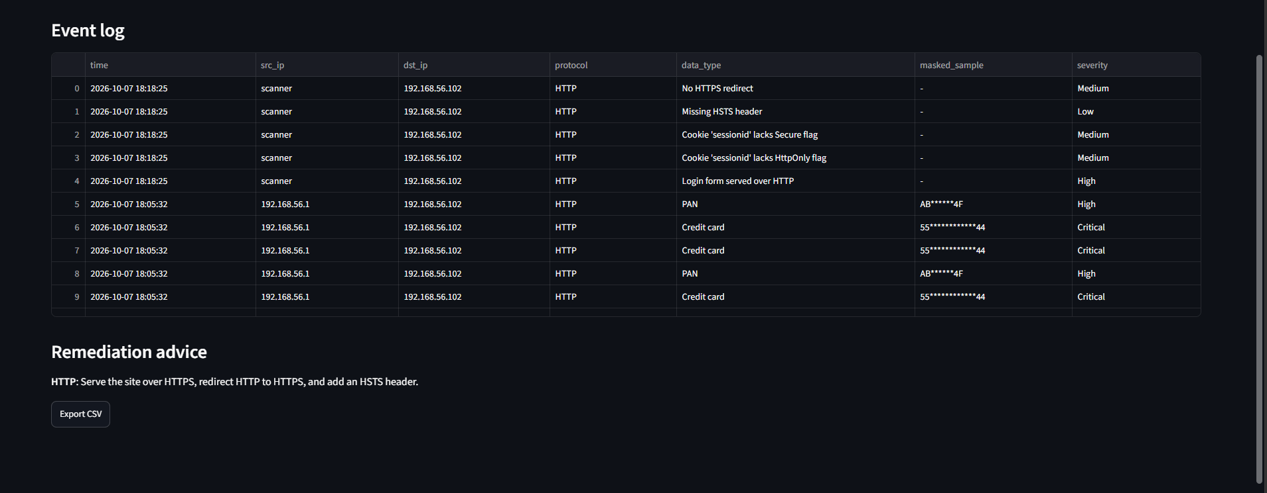
Figure 9: Dashboard with 5 scanner findings (before fix)
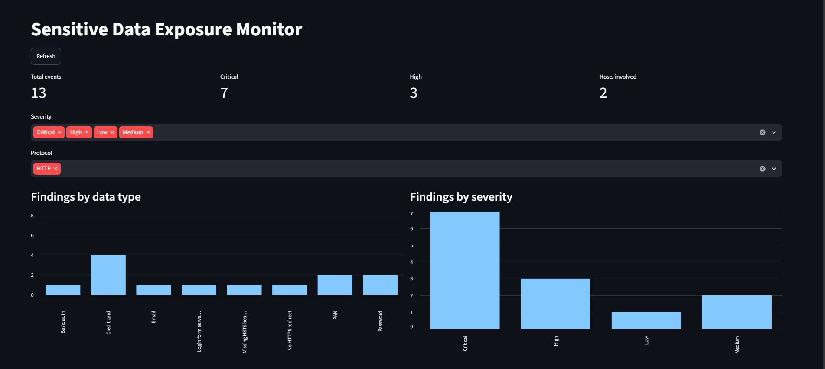
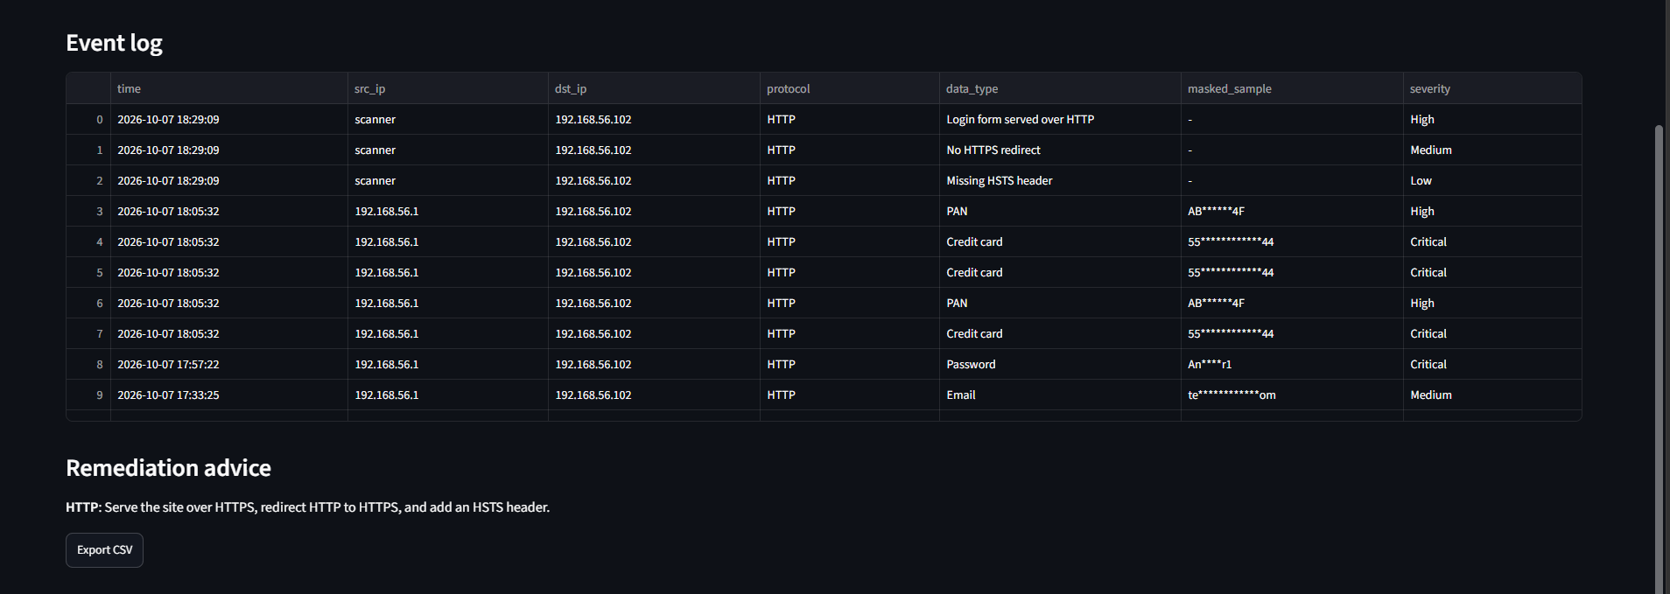
Figure 10: Dashboard with 3 scanner findings (after fix)

5.4 Accuracy of card detection
A synthetic test set of 100 Luhn-valid card numbers and 100 random non-Luhn 16-digit numbers was used. Four unit tests for the Luhn and masking functions also passed under pytest.
Metric | Result
True positives / False negatives | 100 / 0
False positives / True negatives | 0 / 100
Precision | 100.00%
Recall | 100.00%
False positives with regex only (no Luhn) | 100 of 100
False positives with Luhn | 0 of 100
Unit tests (pytest) | 4 passed
These numbers come from synthetic data and test only the Luhn check, so they show the benefit of validation rather than real-world accuracy. Results on live production traffic would differ.
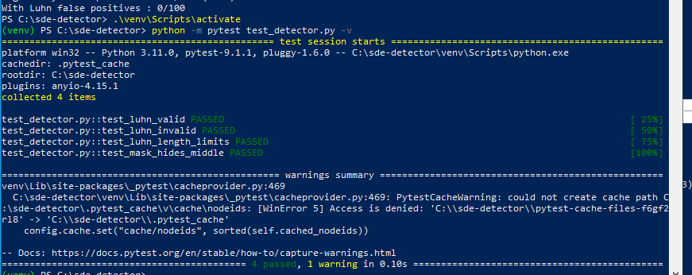
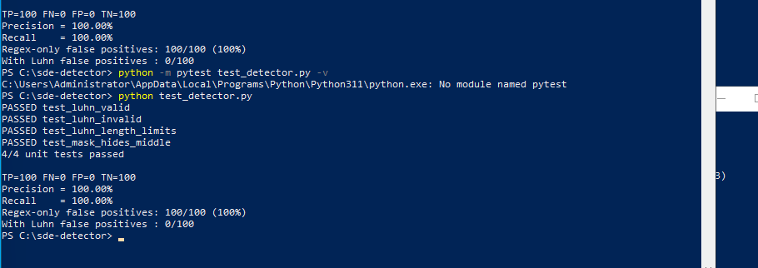
Figure 11: pytest and precision/recall output
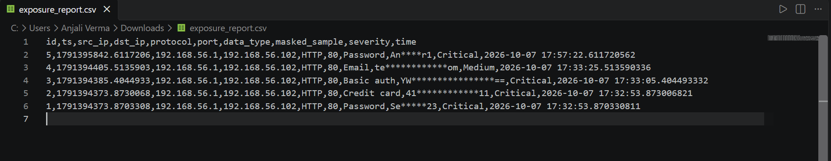
Figure 12: Exported CSV containing only masked values

6. Limitations
- Encrypted (TLS) traffic cannot be inspected. The tool reports the absence of encryption and does not attempt to break it.
- Regular expressions can produce false positives and false negatives. Validators (Luhn) help for cards but not for passwords, e-mails or PAN-like strings.
- Each packet is scanned independently. A secret split across two packets can be missed, because TCP stream reassembly is not yet implemented.
- Detection of passwords depends on common field names such as password= and pwd=.
- Only a fixed list of well-known ports is monitored; plaintext services on non-standard ports are not seen.
- The test data is synthetic and the lab is small, so no performance or high-throughput benchmarking was done.
- The scanner checks a single URL and does not crawl the site.

7. Ethics and Legal Notice
- All traffic was captured inside an isolated virtual lab owned by the author. Capturing traffic on networks without written authorisation may be illegal.
- Only fake credentials and standard test card numbers were used.
- Findings are masked, so raw credentials are never stored or exported.
- In a real deployment the dashboard and database should be protected with authentication, access control and encryption, and users should be told that monitoring takes place.
- Relevant frameworks to consider: OWASP A02:2021, PCI-DSS, GDPR and India's Digital Personal Data Protection Act.

8. Future Work
- TCP stream reassembly so that secrets split across packets are detected, and merging of FTP USER/PASS pairs into a single finding.
- Active TLS checks: protocol versions, weak ciphers and certificate expiry.
- Ingestion of Zeek or Suricata logs and integration with a SIEM.
- Email or Slack alerting for Critical findings.
- Machine-learning or entropy-based detection of unknown secrets and API keys.
- A mitmproxy add-on for web-application testing, and static scanning for hard-coded secrets.

9. Conclusion
The project demonstrates an end-to-end pipeline that captures traffic, detects sensitive data sent without encryption, masks and stores the findings safely, flags server misconfigurations, and presents everything on a dashboard. Validation, masking and deduplication reduced noise and made the output safe to share. The listed limitations, mainly TLS visibility and per-packet scanning, define the next steps.

Appendix A: Project files
File | Purpose
fake_server.py | Plaintext HTTP and FTP test services
detector.py | Packet capture, detection, masking, deduplication, SQLite storage
scanner.py | HTTPS redirect, HSTS, cookie and login-form checks
dashboard.py | Streamlit dashboard with filters, charts and CSV export
test_detector.py | Unit tests and precision/recall evaluation
events.db | SQLite database of masked findings

Appendix B: How to run
python fake_server.py
python detector.py (Administrator PowerShell)
python scanner.py http://192.168.56.102
streamlit run dashboard.py --server.address 0.0.0.0
python -m pytest test_detector.py -v

