**Website hosting**

**Website link=**

[**https://anjali-bucket-**](https://anjali-bucket-) **demo1.s3.amazonaws.com/website+demo/RegiPage/RegistreationPage.html**

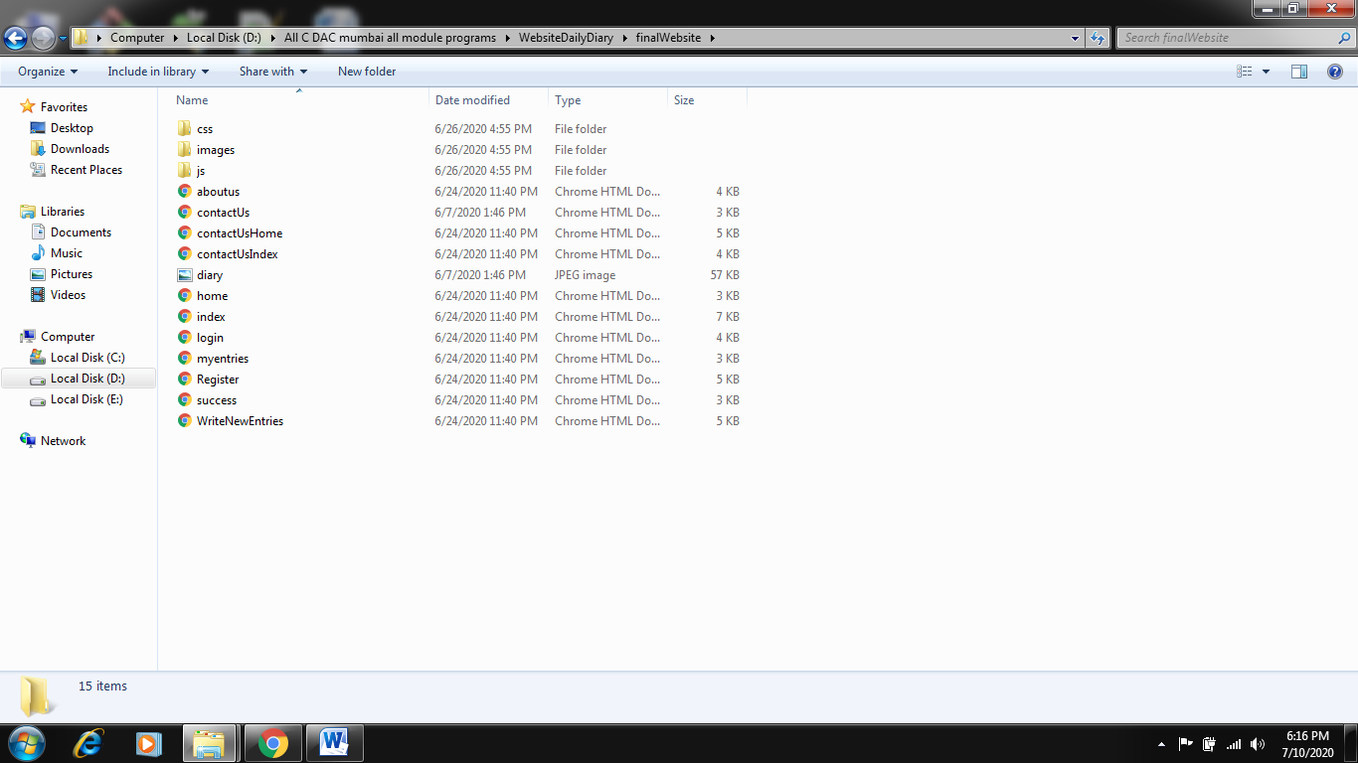

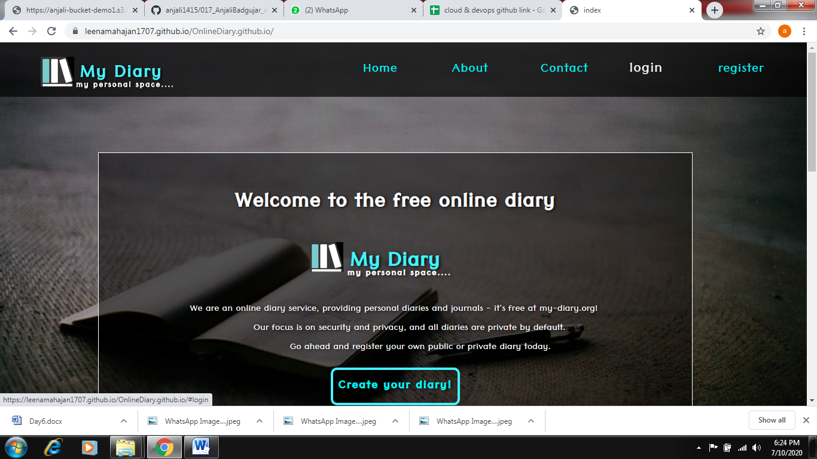

**Process of website hosting**

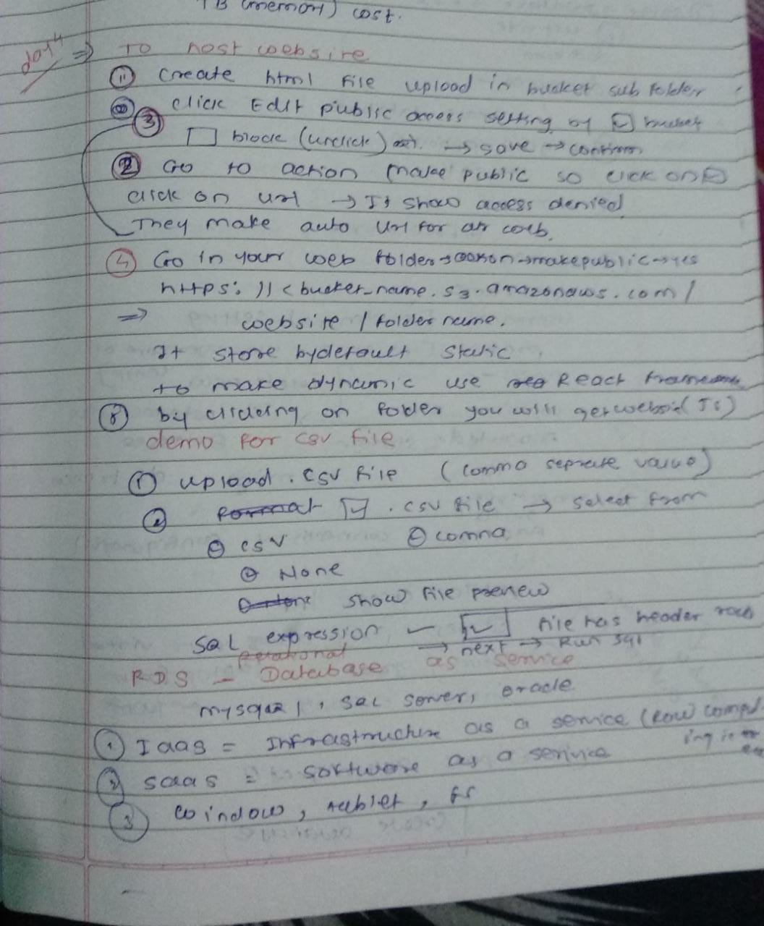

**Difference between ec2 and s3 bucket**

