Data Visualization Using Power BI –Oil by country
DATE:
EXP NO:6B
EXP NO:

AIM: To Load the data into PowerBI and transform the data and visualize it to get insights

ALGORITHM:

Step 1: Input Data Loading
- Read the dataset from oil-by-country.csv.
- The dataset contains information about oil production by country and year.
Example columns:
- Country
- Year
- Oil Production
Example dataset rows:
- Saudi Arabia, 2020, 10,500
- United States, 2020, 11,300
- Russia, 2020, 10,100
- Canada, 2020, 4,700
- Iraq, 2020, 4,000

Step 2: Country Filter Check
- Check the slicer selection for Country.
- Default selection: All Countries.
- Retain all rows matching the selected countries in Filtered_Data.
- If the user selects specific countries, only those countries are retained.

Step 3: KPI Total Oil Production Calculation
- Sum all values in the Oil Production column from Filtered_Data.
Formula:
Total Oil Production = Σ Oil Production
For example:
10,500 + 11,300 + 10,100 + 4,700 + 4,000
= 40,600
- Display the KPI value in a formatted form such as 40.6K.

Step 4: Bar Chart Calculation — Oil Production by Country
- Group Filtered_Data by Country.
- Calculate the total oil production for each country.
Example:
United States = 11,300
Saudi Arabia = 10,500
Russia = 10,100
Canada = 4,700
Iraq = 4,000
- Sort countries in descending order according to oil production.
Result:
United States
Saudi Arabia
Russia
Canada
Iraq
- Render a vertical/horizontal bar chart showing oil production by country.

Step 5: Line Chart Calculation — Oil Production Over Time
- Group Filtered_Data by Year.
- Calculate total oil production for each year.
Example:
2018 → 38,500
2019 → 39,700
2020 → 40,600
2021 → 42,100
2022 → 43,500
- Sort the years in ascending order.
- Plot:
X-axis → Year
Y-axis → Oil Production
- Render a line chart to show the oil production trend over time.

Step 6: Donut Chart Calculation — Oil Production Share by Country
- Group Filtered_Data by Country.
- Calculate the percentage contribution of each country.
Formula:
Country Share = (Country Oil Production / Total Oil Production) × 100
For example, if total production is 40,600:
United States = (11,300 / 40,600) × 100 = 27.83%

Saudi Arabia = (10,500 / 40,600) × 100 = 25.86%

Russia = (10,100 / 40,600) × 100 = 24.88%

Canada = (4,700 / 40,600) × 100 = 11.58%

Iraq = (4,000 / 40,600) × 100 = 9.85%
- Render a donut chart showing each country's contribution.
- Display the Total Oil Production in the center.

Step 7: Top Oil-Producing Country Calculation
- Group the filtered data by Country.
- Calculate total oil production for each country.
- Find the country with the maximum production.
Formula:
Top Country = Country with MAX(Total Oil Production)
Example:
Top Oil-Producing Country = United States
Production = 11,300
Display this as a KPI card.

Step 8: Dashboard Render
Render the following dashboard components:
KPI Cards
- Total Oil Production
- Top Oil-Producing Country
- Top Country's Production
Bar Chart
- Oil Production by Country
Line Chart
- Oil Production Trend by Year
Donut Chart
- Oil Production Share by Country
Country Slicer
- List of available countries
- Allow users to select one or multiple countries.

OUTPUT:

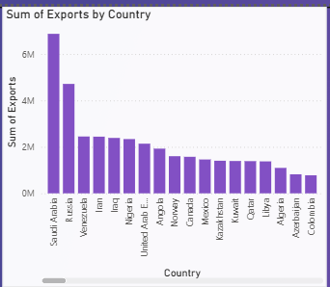

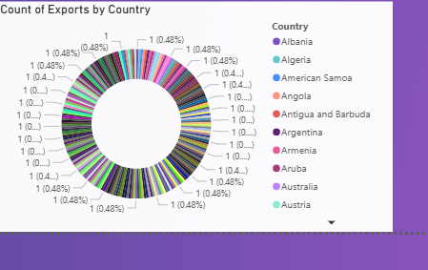
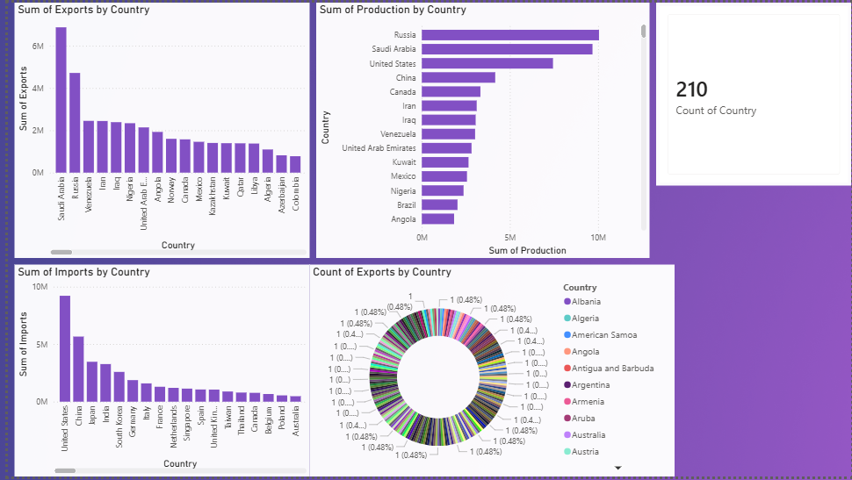

RESULT:

