DATA VISUALIZATION USING TABLEAU
DATE:
EXP NO:7B
EXP NO:7B

AIM: To connect, analyze, visualize, and create interactive dashboards using Tableau for effective business intelligence and data analytics.

ALGORITHM:

Step 1: Data Loading
- Connect the Oil by Country dataset to Tableau.
- Verify the imported fields such as:
  - Country
  - Year
  - Oil Production
- The dataset contains oil production information for different countries across different years.
- Verify that the Year and Oil Production fields are correctly recognized by Tableau.

Step 2: Country-wise Oil Production Bar Chart
- Create a worksheet for country-wise oil production.
- Place Country on Columns.
- Place Oil Production on Rows.
- Select the Bar Chart visualization.
- Enable data labels to display the oil production value for each country.
- Sort the countries in descending order based on oil production.

Step 3: Country-wise Oil Production Visualization
- Create a worksheet using Country and Oil Production.
- Aggregate Oil Production using SUM.
- Visualize the contribution of each country using a Pie Chart.
- Place Country in the Color section.
- Place SUM(Oil Production) in the Angle section.
- Display country names and corresponding oil production values as labels.

Step 4: Oil Production Trend
- Create a Line Chart using Year and Oil Production.
- Place Year on Columns.
- Place Oil Production on Rows.
- Aggregate Oil Production using SUM.
- Enable labels where required.
- Use the line chart to observe the changes in global oil production over time.

Step 5: Oil Production Percentage
- Create a calculated field named Percentage.
- Calculate the percentage contribution of each country to total oil production.
Formula:
SUM([Oil Production]) / TOTAL(SUM([Oil Production])) * 100
- Display Country, Oil Production, and Percentage in a worksheet.
- Format the Percentage field as a percentage.

Step 6: Country Filter
- Add Country to the Filters shelf.
- Select one or more countries.
- For example, select Saudi Arabia and United States.
- Observe the updated oil production values and visualizations based on the selected countries.

Step 7: Minimum Oil Production Parameter
- Create a parameter named Minimum Oil Production.
- Set the required minimum oil production value.
- Apply the parameter to display only countries whose oil production meets or exceeds the selected value.
- For example, when Minimum Oil Production = 5,000, display only countries producing 5,000 or more units of oil.

Step 8: Dashboard Creation
- Create a new Tableau Dashboard.
- Add the following visualizations:
  - Country-wise Oil Production Bar Chart
  - Country Contribution Pie Chart
  - Oil Production Trend Line Chart
  - Oil Production Percentage
- Arrange the worksheets clearly.
- Add the Country filter and Minimum Oil Production parameter.
- Format the dashboard with suitable titles, labels, legends, and units.

Step 9: Story Creation
- Create a Tableau Story using the completed dashboard.
- Add story points for:
- Overall Oil Production
- Country-wise Oil Production Analysis
- Oil Production Trend Over Time
- Top Oil-Producing Countries
- Final Oil Production Analysis
- Present the visual insights using the Tableau Story.

Step 10: Analysis
- Analyze the charts to identify the countries with the highest and lowest oil production.
- Compare oil production among different countries.
- Observe the trend of oil production across different years.
- Identify countries contributing the largest percentage of total oil production.
- Observe how the Country filter dynamically changes the visualizations.
- Observe how the Minimum Oil Production parameter changes the displayed countries.
- Use the dashboard and story to summarize the overall oil production performance and country-wise contribution.

OUTPUT:
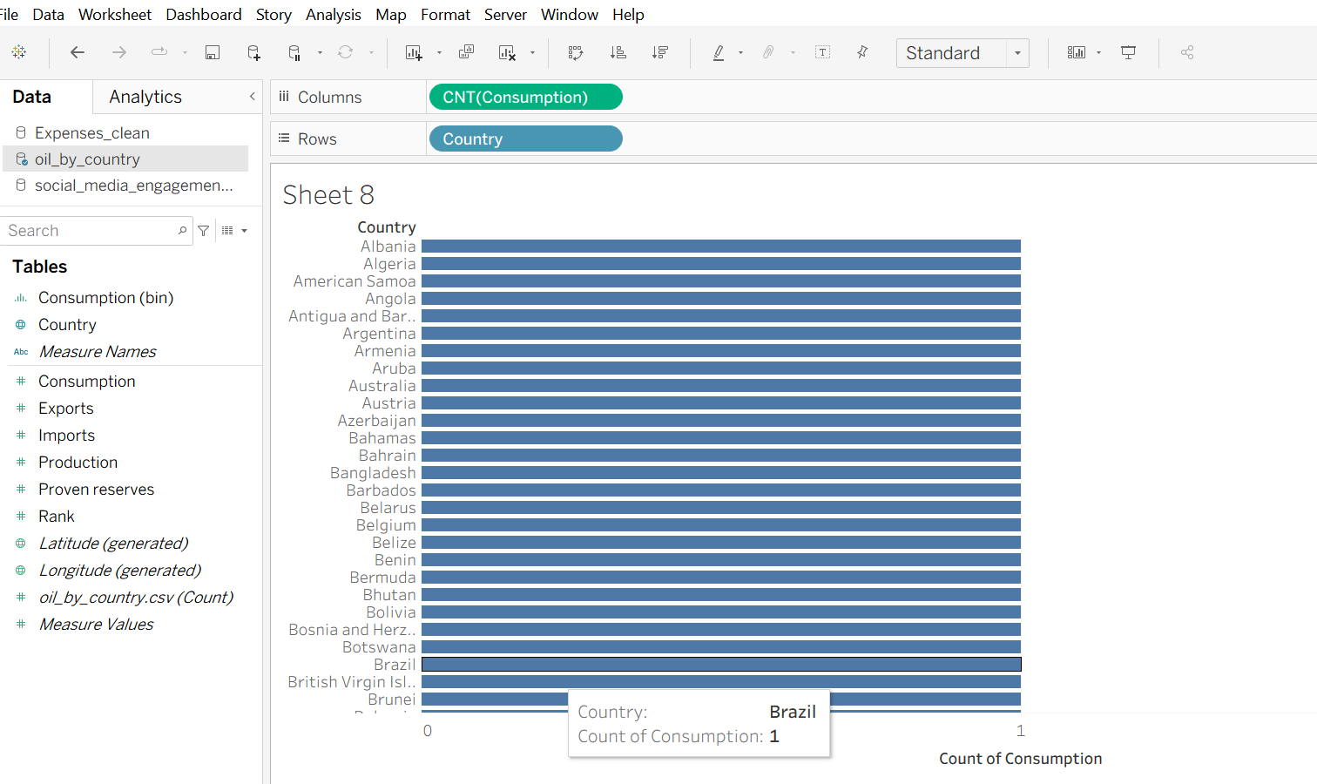
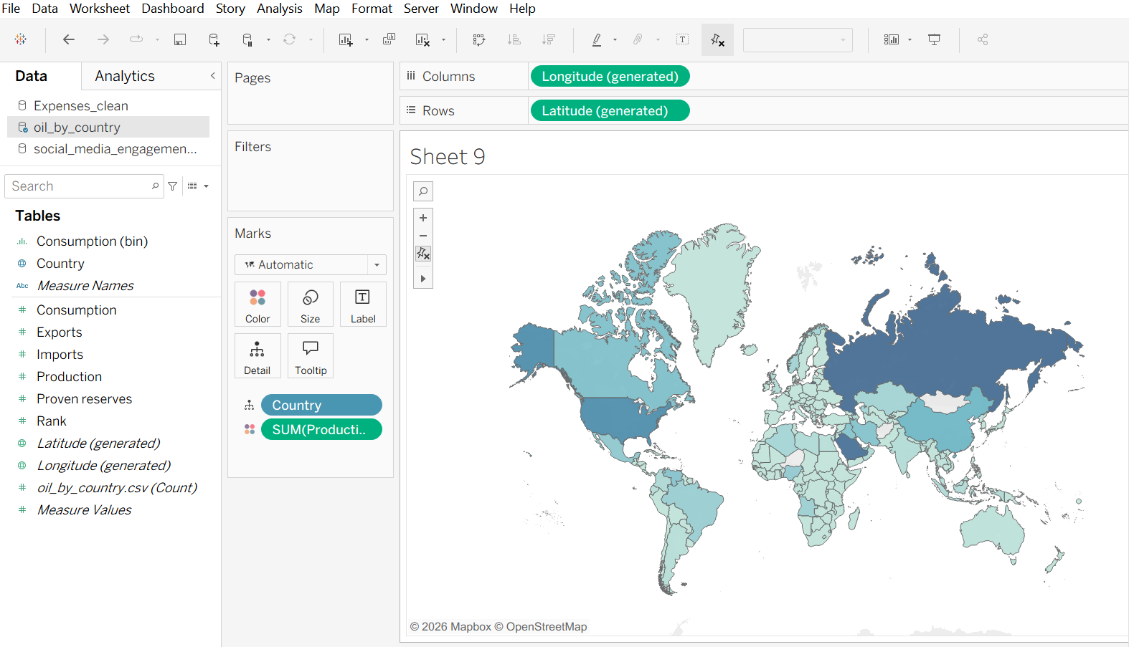

RESULT:

