Ex.no:6 | DATA VISUALIZATION USING POWER BI (HOTEL BOOKING)

Aim:
To clean, preprocess, and transform the raw hotel_bookings dataset, load the clean data model into Power BI, and build an interactive visual dashboard to analyze booking trends, cancellation patterns, guest demographics, and pricing metrics.

Algorithm:
- Import Dataset: Load hotel_bookings.csv into your environment.
- Deduplication: Identify and delete duplicate rows across all fields
- Drop High-Missing Columns: Remove the company column due to excessive missing/null data.

Impute Missing Values:
Replace missing values in agent with 0 (or median). Replace missing values in country with "PRT" (mode). Replace missing values in children with 0.

Handle Data Type & Syntax Errors:

Replace text anomalies (like "NA" strings) in numeric columns (children, adr) with
0 to prevent load errors.

Format reservation_status_date as Date, children / agent as Whole Number, and adr as Decimal.

- Load Clean Data: Load the cleaned table into Power BI Desktop via Get Data > Text/CSV (or click Apply & Close from Power Query Editor).

Create Core Metric:
Right-click the table name → Select New Measure.
Define measure: Total Bookings = COUNTROWS(hotel_bookings)

Output:

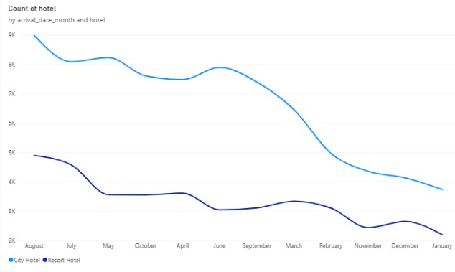

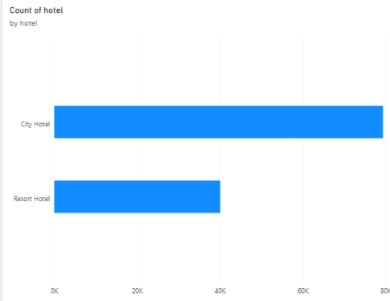

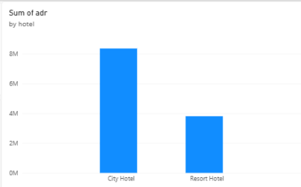

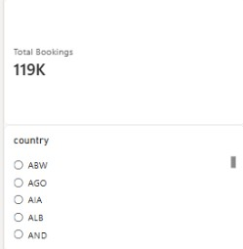

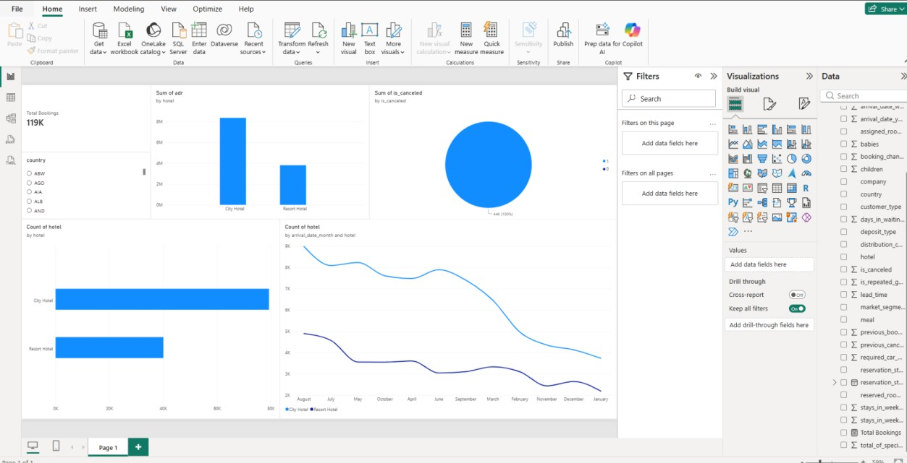

Result:

