**TASK1**

[no,district,+ve cases,death rates,curred rates, 1st dose vaccine, 2nd dose vaccine]

covid_data=[

[1,'Eranakulam',34000,2000,23000,20000,2000],

[2,'Idukki',14000,3000,25000,30000,1000],

[3,'Thrissur',24000,4000,33000,24000,2500],

[4,'Pathanamthitta',20000,2000,45000,22000,1500],

[5,'Kozhikode',44000,5000,12000,21000,500],

[6,'Kottayam',27000,1500,27000,14000,1000],

[7,'Kollam',14000,2500,25000,18000,2700]

]

1. Find which district having highest +ve case?

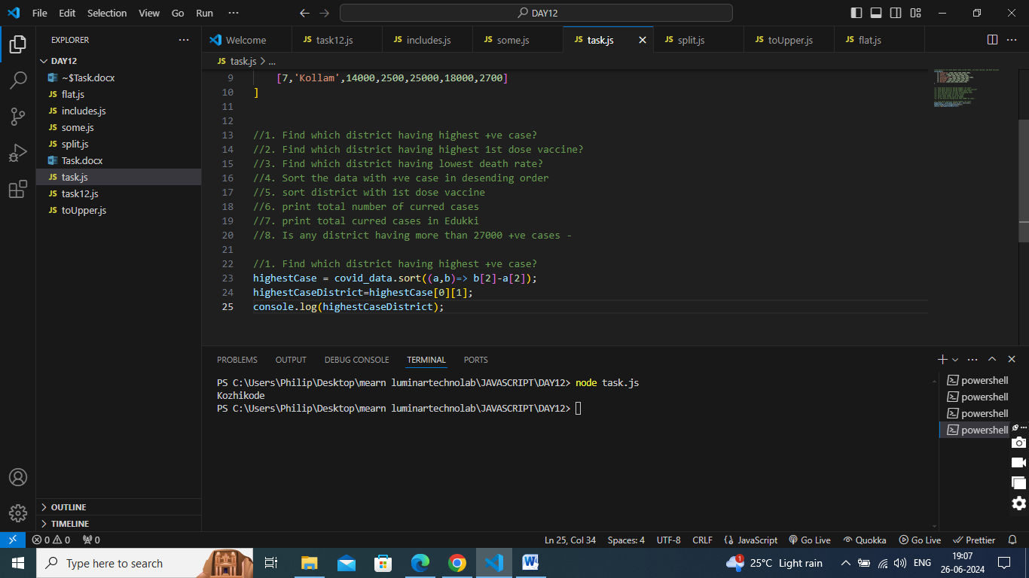

1. Find which district having highest 1st dose vaccine?

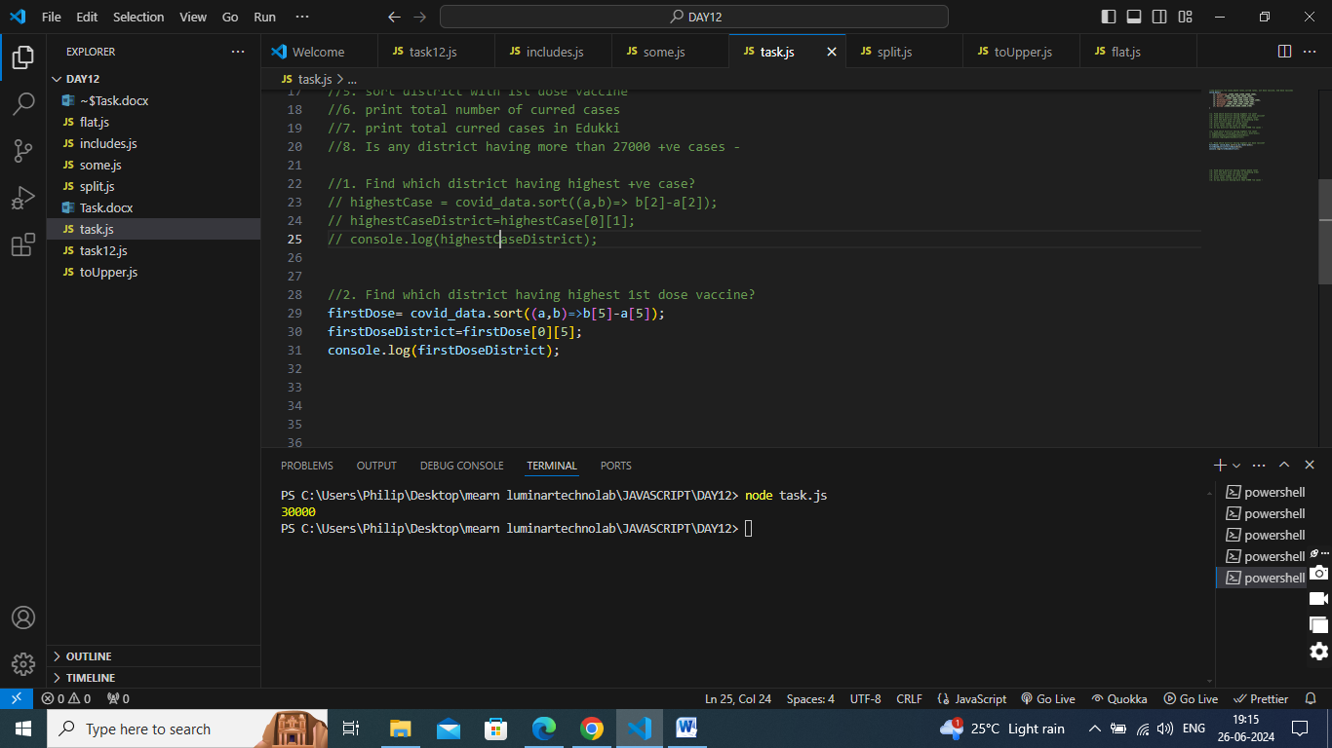

1. Find which district having lowest death rate?

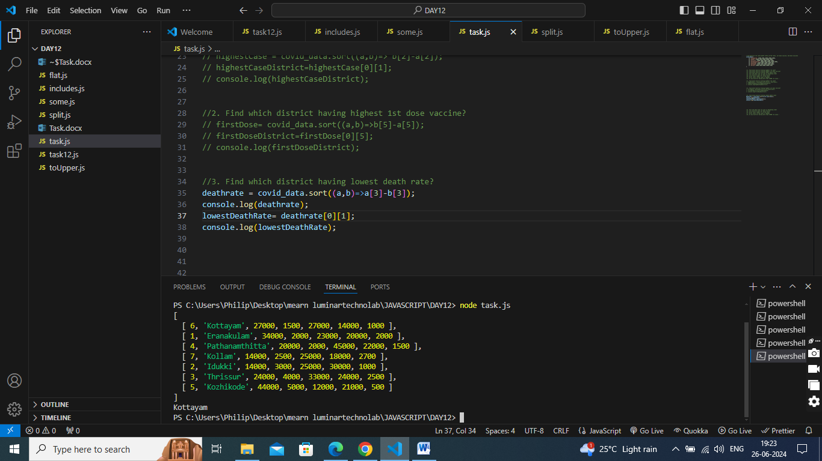

1. Sort the data with +ve case in desending order

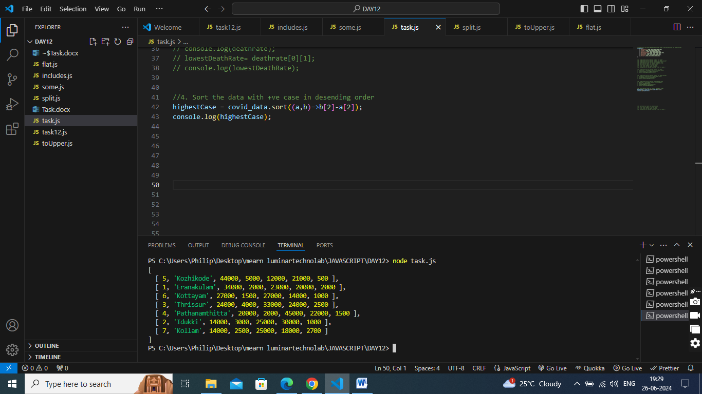

1. sort district with 1st dose vaccine

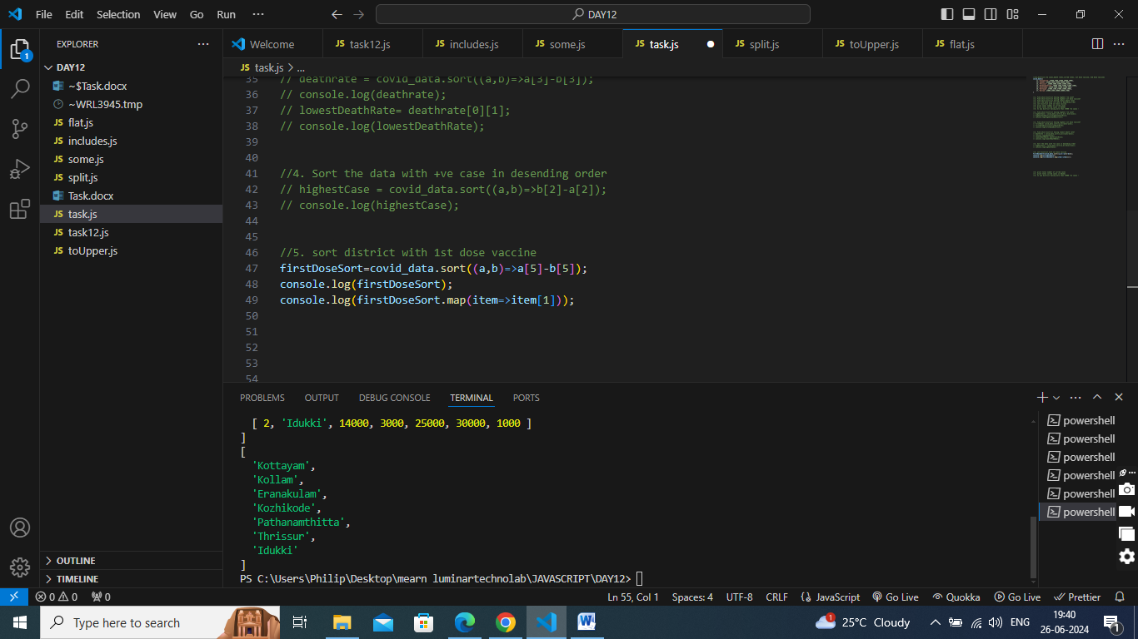

1. print total number of curred cases

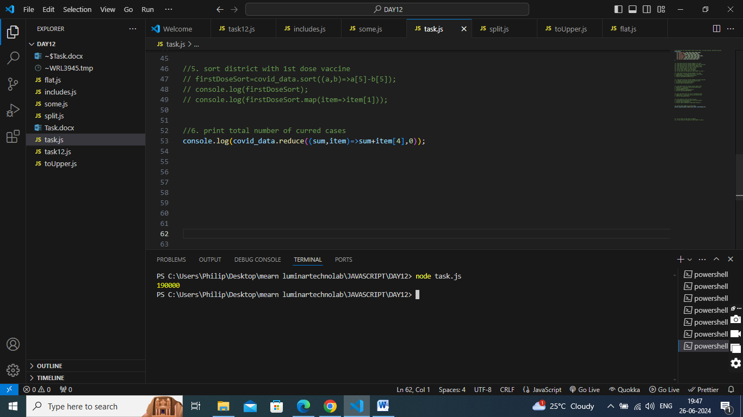

1. print total curred cases in Edukki

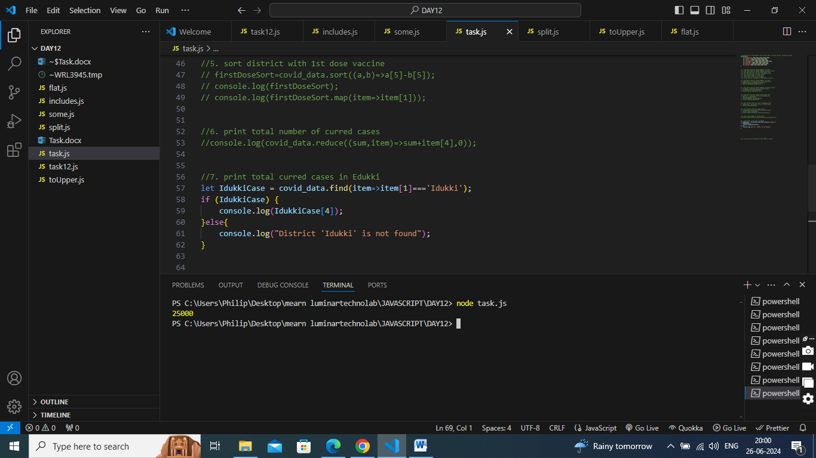

1. Is any district having more than 27000 +ve cases –

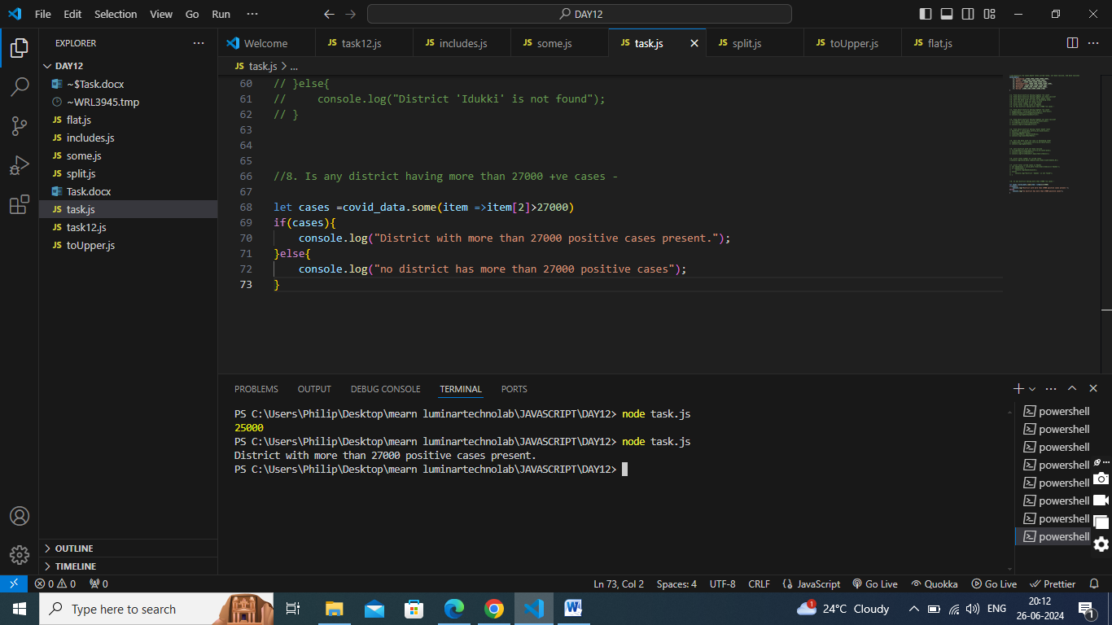

**TASK2**

//[id,name,price,stock]

products=[

[1,'Hide and seek',50,20],

[2,'lays',20,80],

[3,'oreo',40,100],

[4,'parleG',25,10],

[5,'tiger',20,0],

[6,'unibic',60,20],

[7,'good day',70,20]

]

1. Display all products name

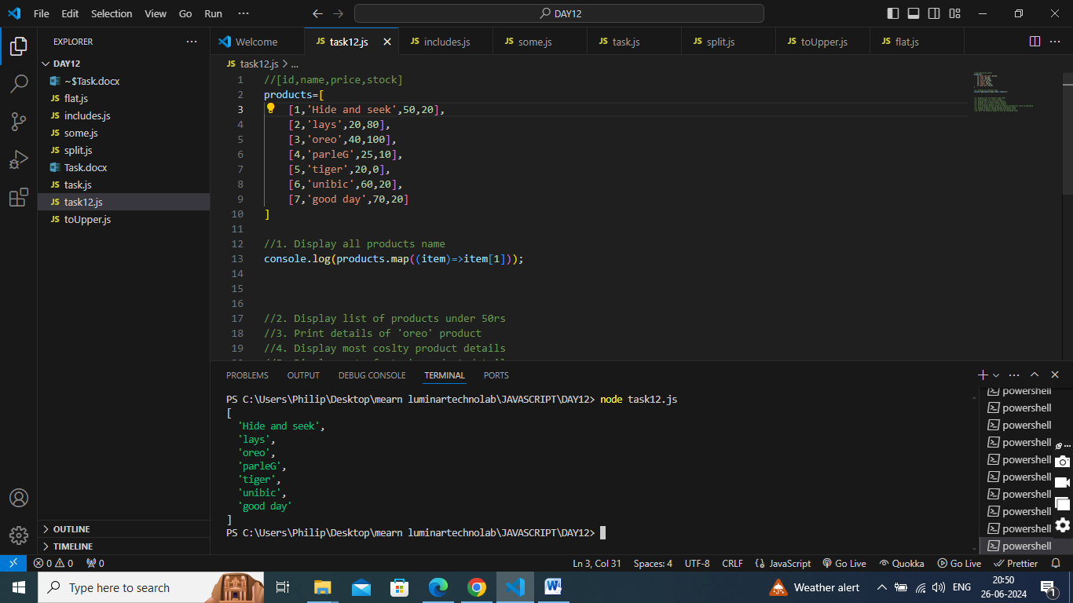

1. Display list of products under 50rs

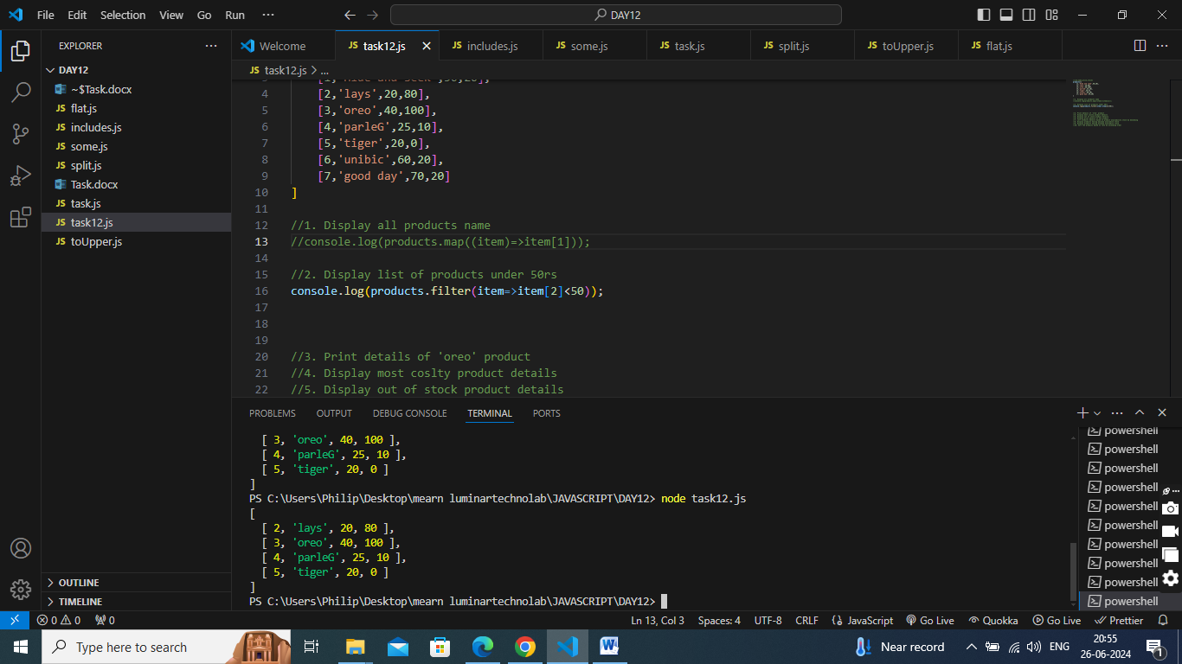

1. Print details of 'oreo' product

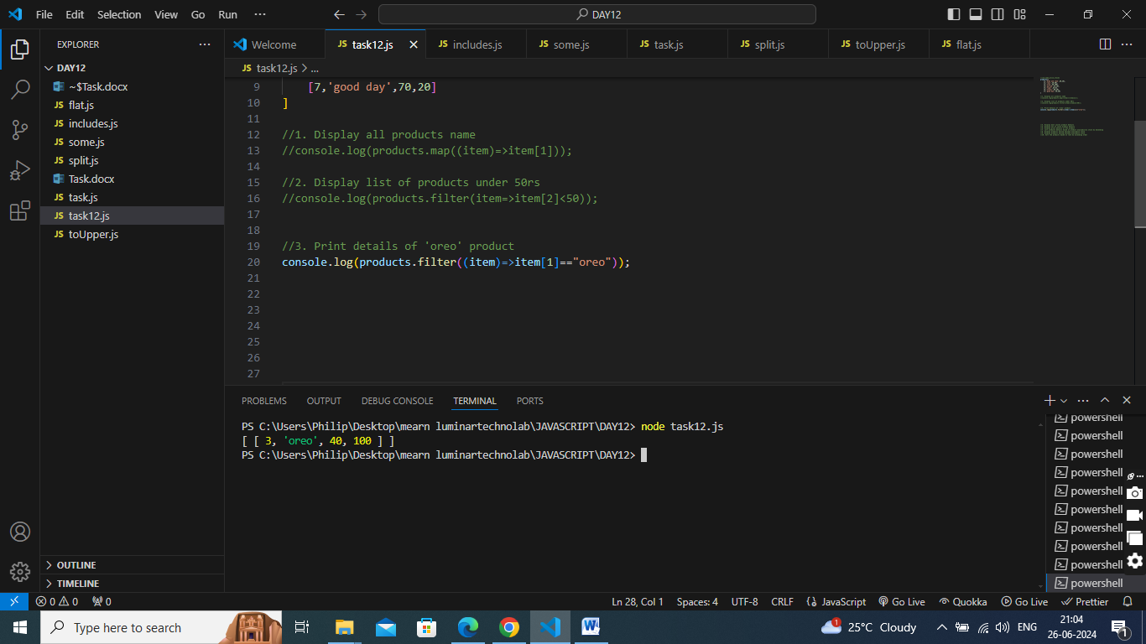

1. Display most coslty product details

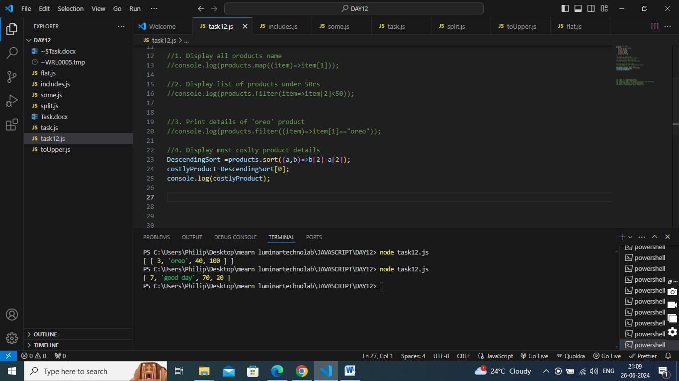

1. Display out of stock product details

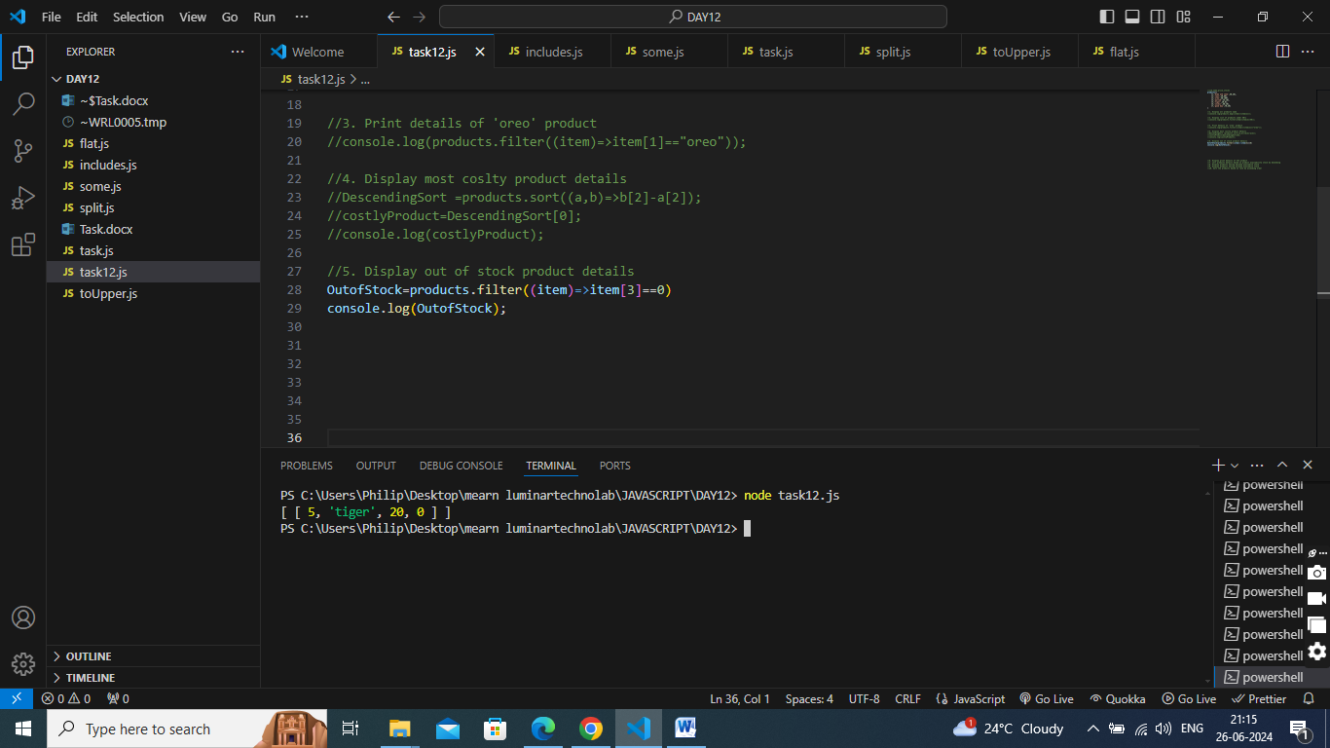

1. Display print details of 4th product

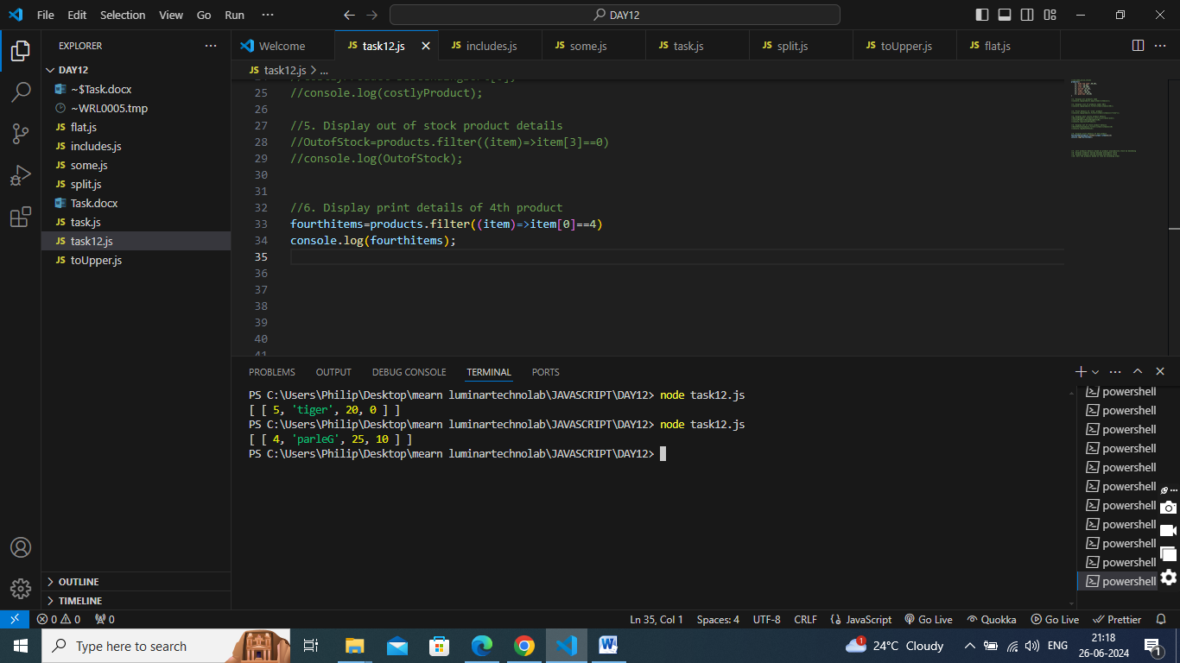

1. sort products details based on product availability stock by desending

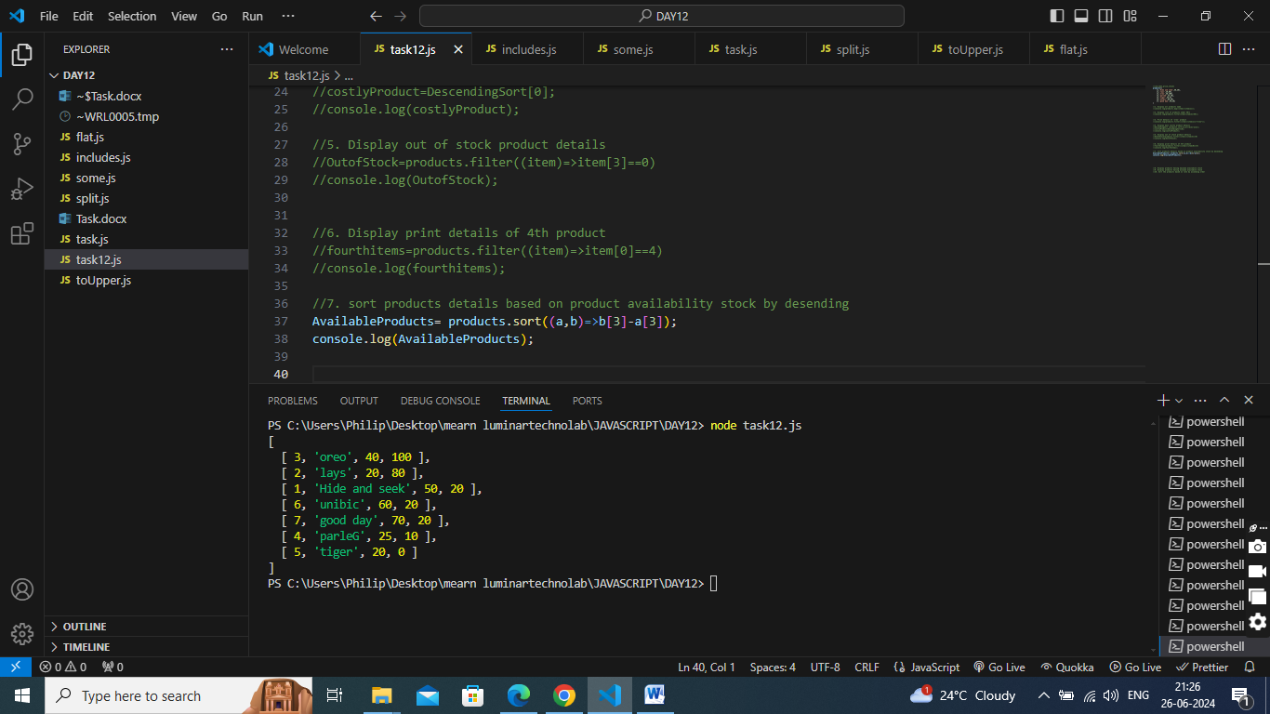

1. Display products having maximum availabile stock

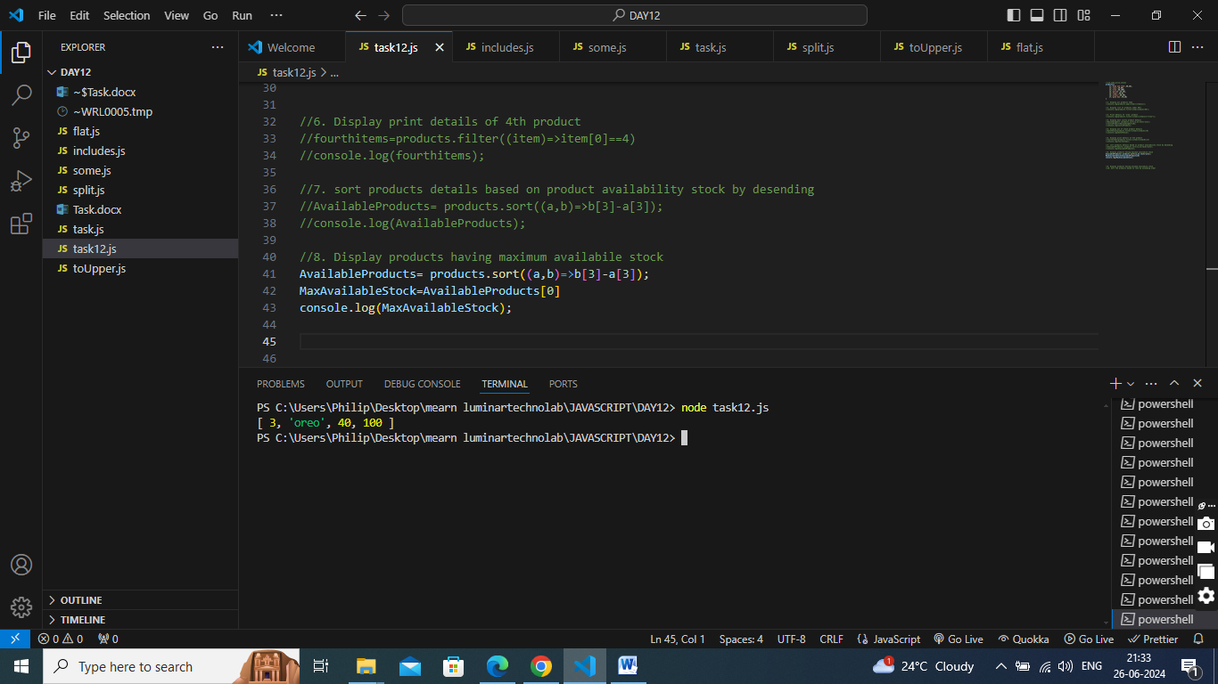

1. Display products having minimum availabile stock

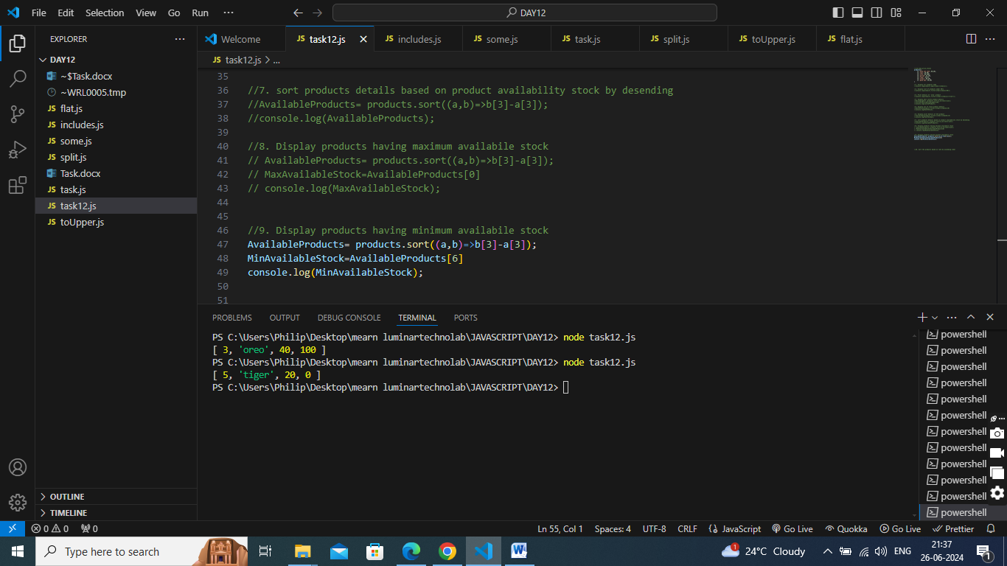

1. Sort the products based on rate by ascending order

