**TASK**

//Create a student object having properties as id,name,course,totalmark,year

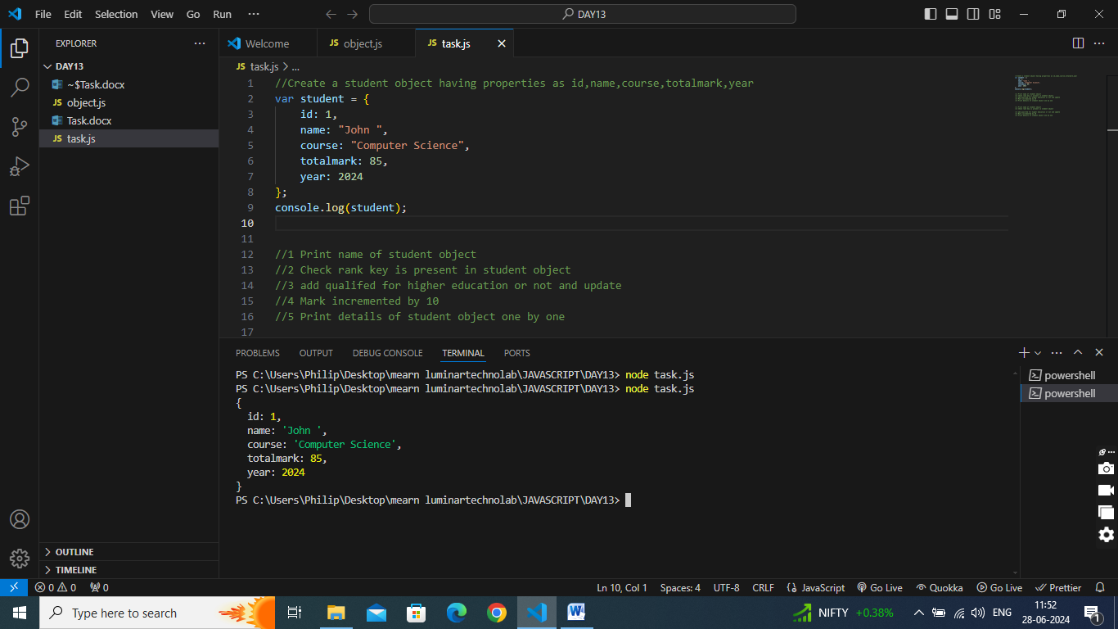

1. Print name of student object

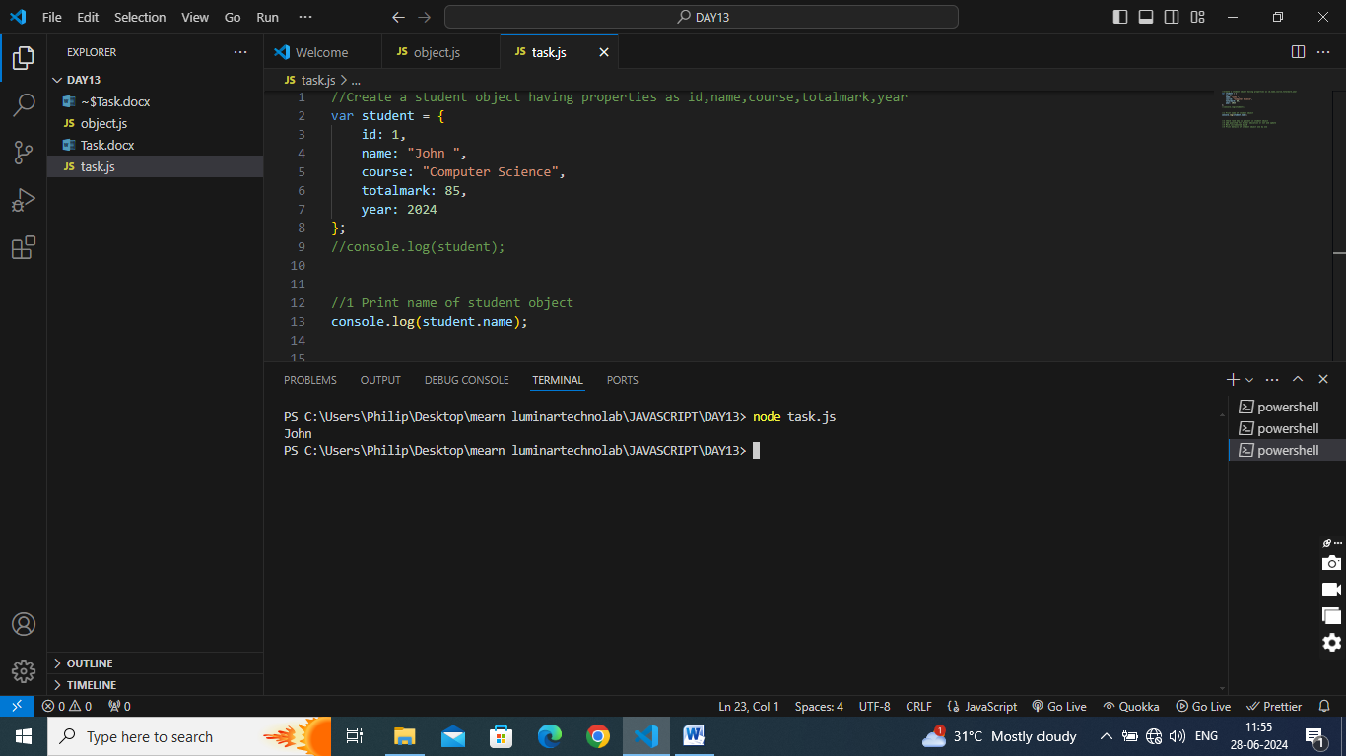

1. Check rank key is present in student object

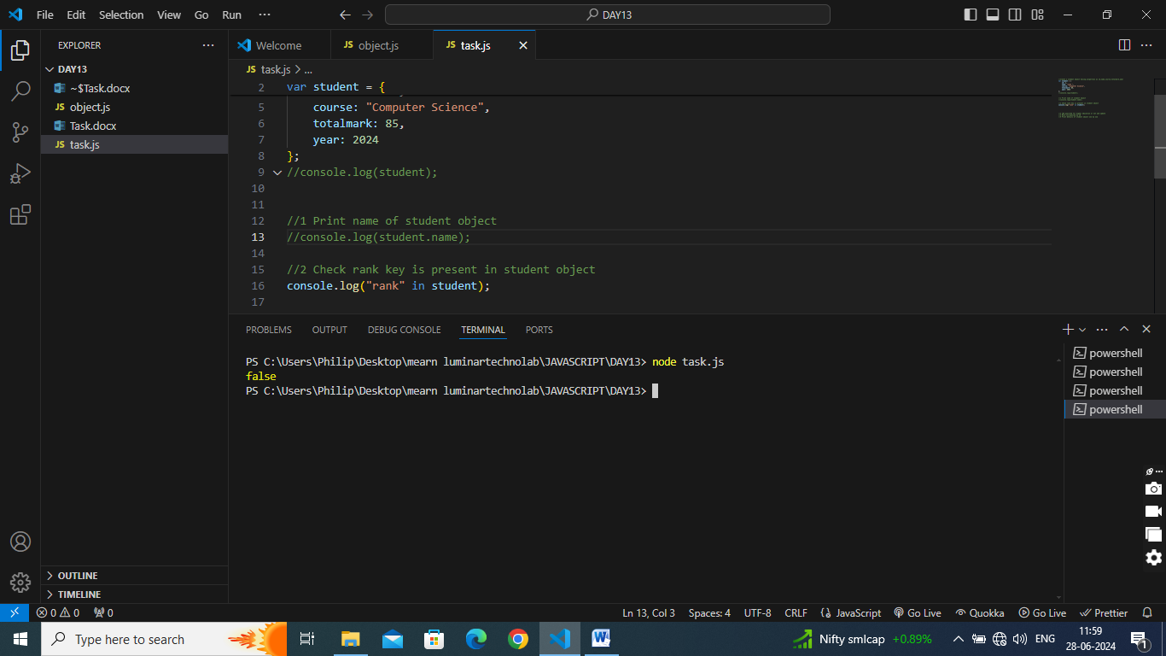

1. add qualifed for higher education or not and update

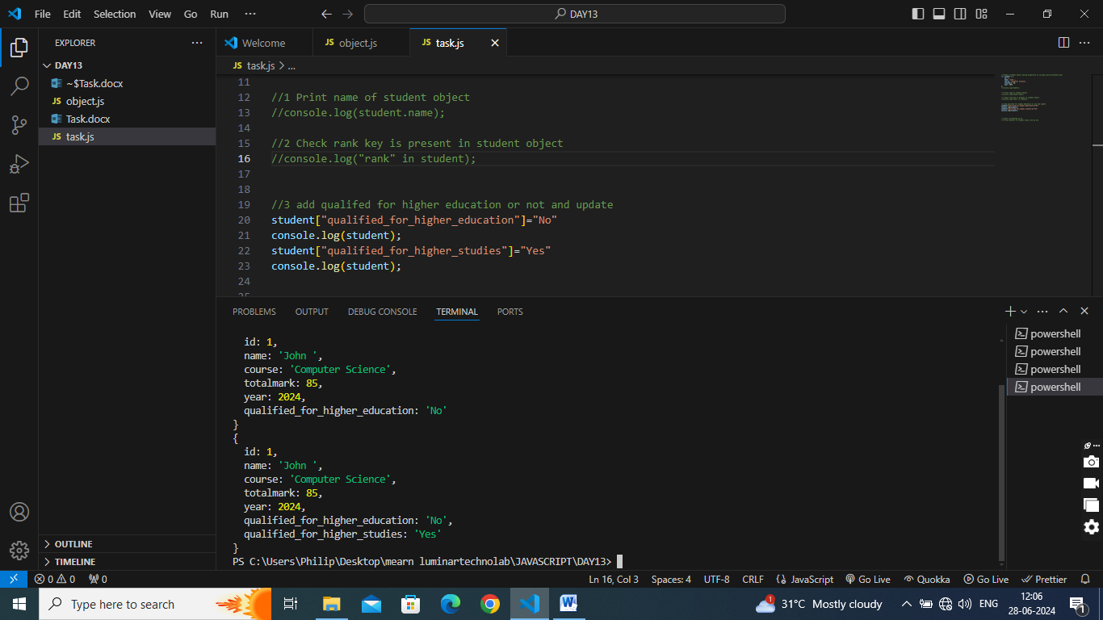

1. Mark incremented by 10

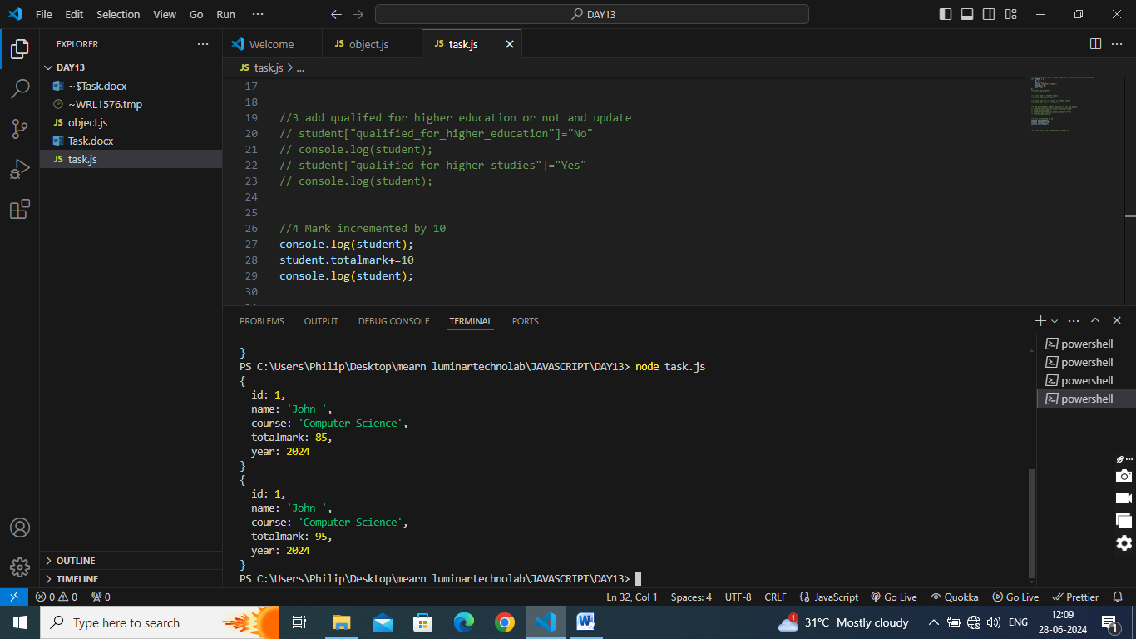

1. Print details of student object one by one

