**TASK**

const countries = [

{ name: 'United States', population: 331002651, continent: 'North America', capital: 'Washington, D.C.' },

{ name: 'China', population: 1439323776, continent: 'Asia', capital: 'Beijing' },

{ name: 'Brazil', population: 212559417, continent: 'South America', capital: 'Brasília' },

{ name: 'United Kingdom', population: 67886011, continent: 'Europe', capital: 'London' },

{ name: 'South Africa', population: 59308690, continent: 'Africa', capital: 'Pretoria, Cape Town, Bloemfontein' },

];

// 1. Print the names of all countries.

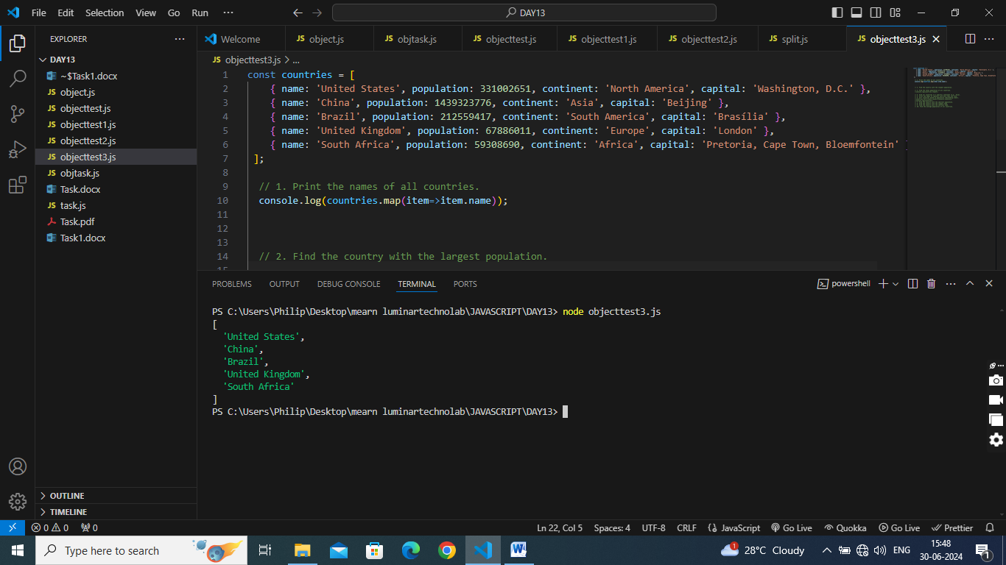

// 2. Find the country with the largest population.

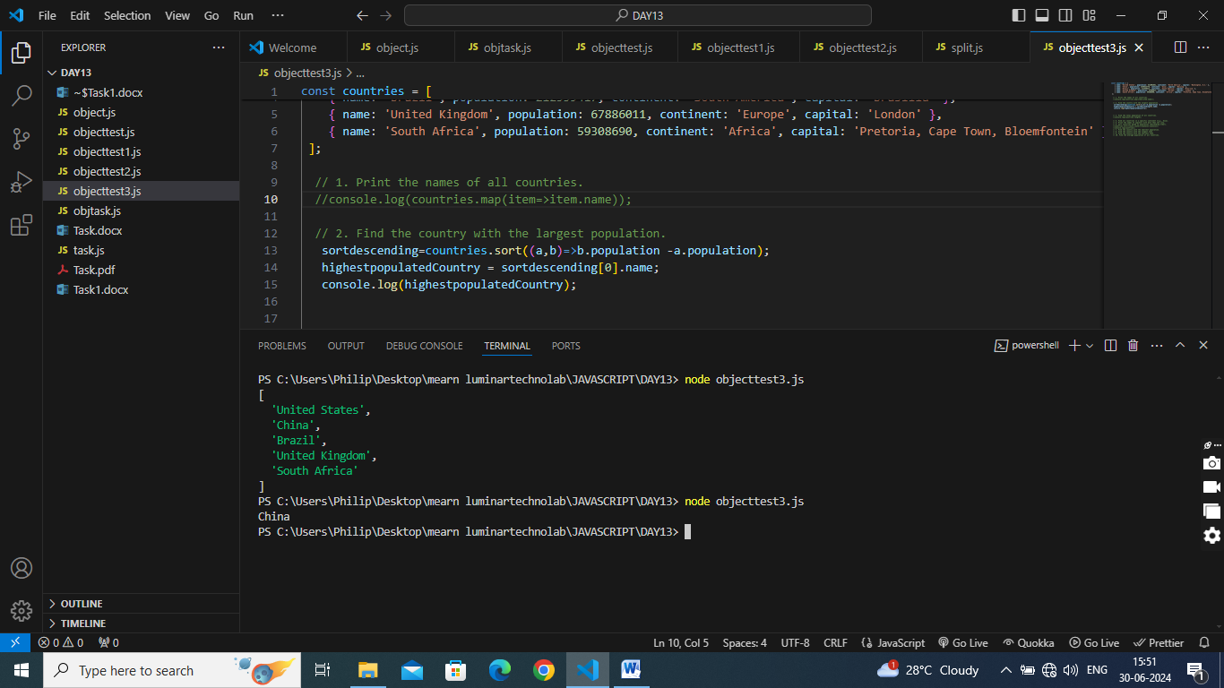

// 3. Find the total population of all countries.

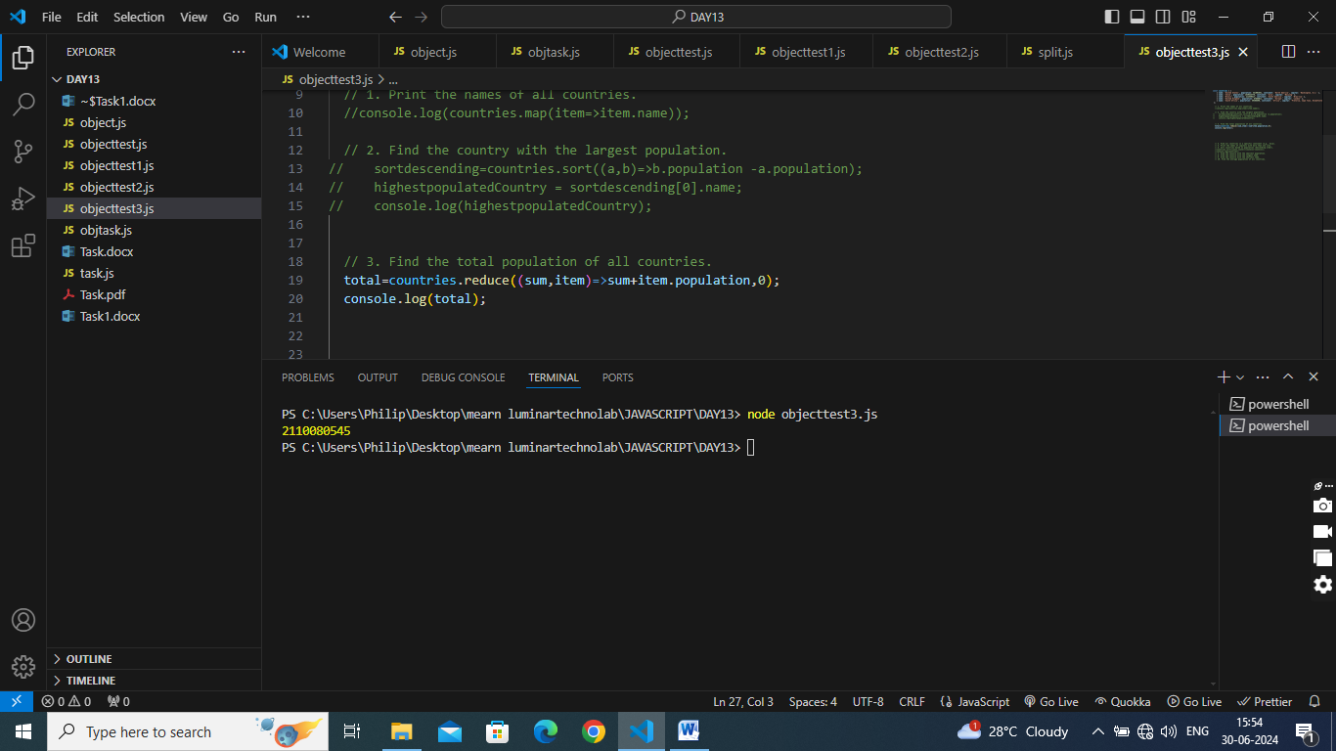

// 4. Find all countries in a specific continent (e.g., Asia).

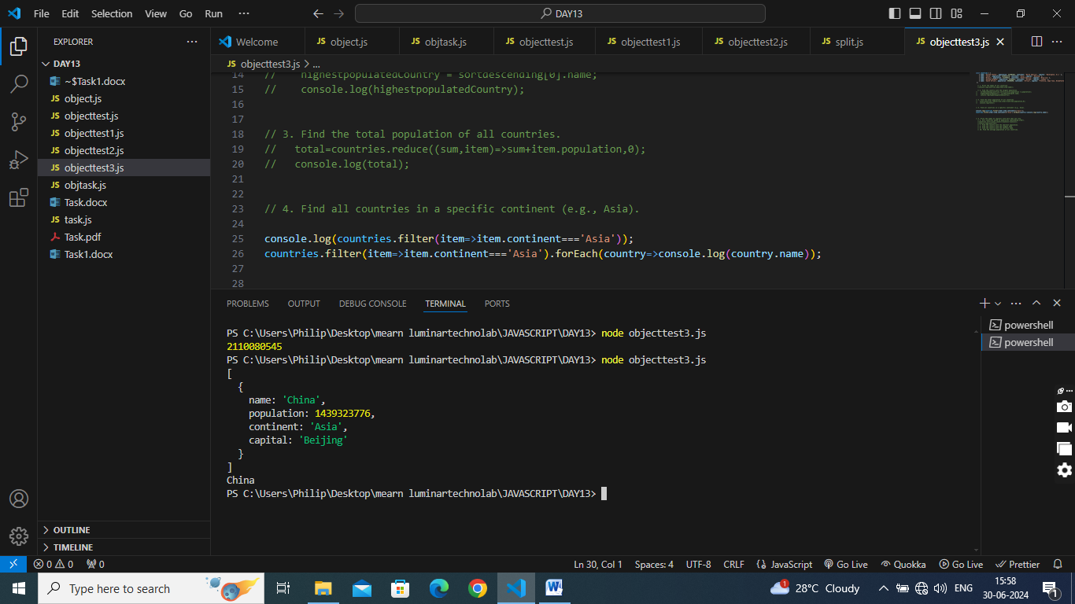

// 5. Print the names of capitals with more than one city.

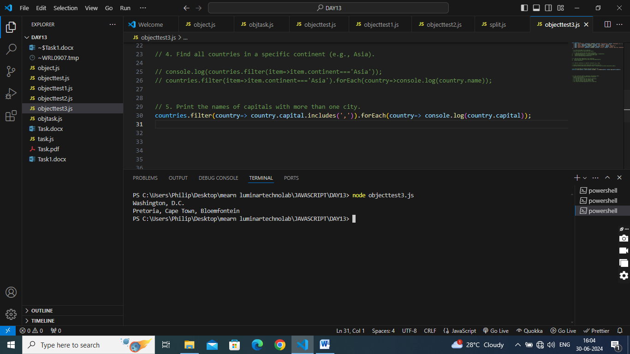

// 6. Sort countries based on population (descending order).

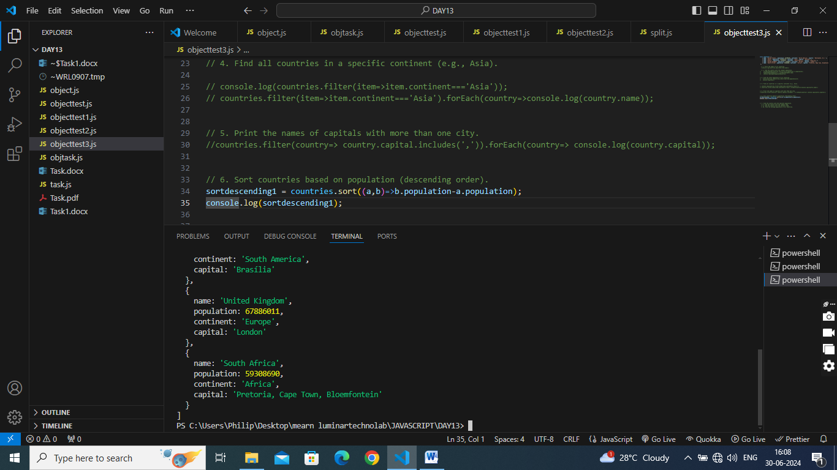

// 7. Find the country with the smallest population.

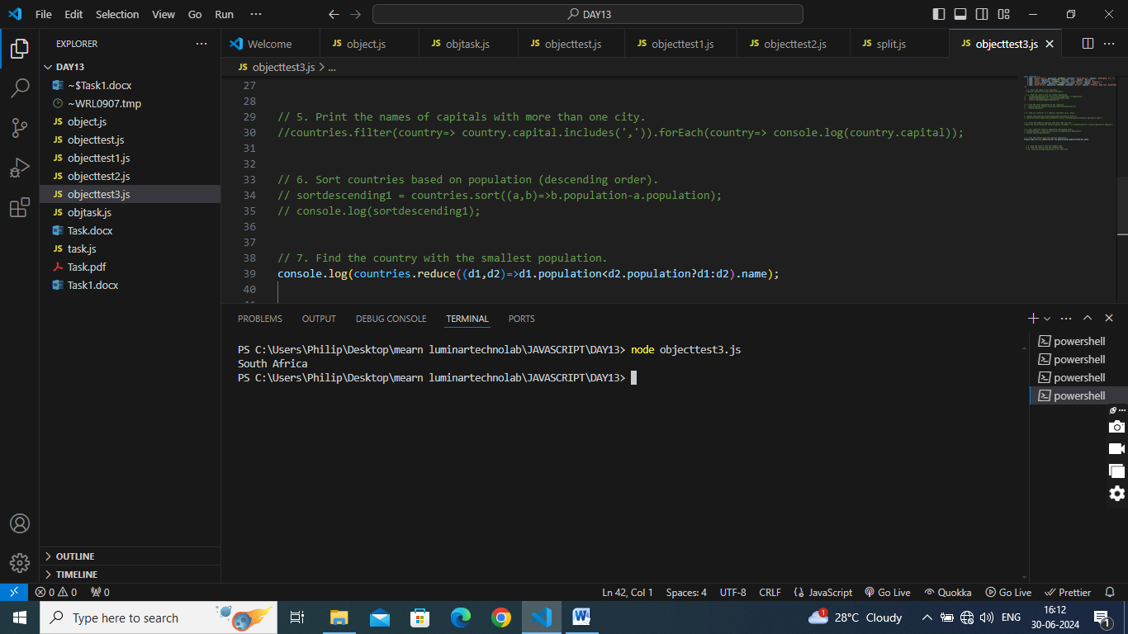

// 8. Find the country with the longest name.

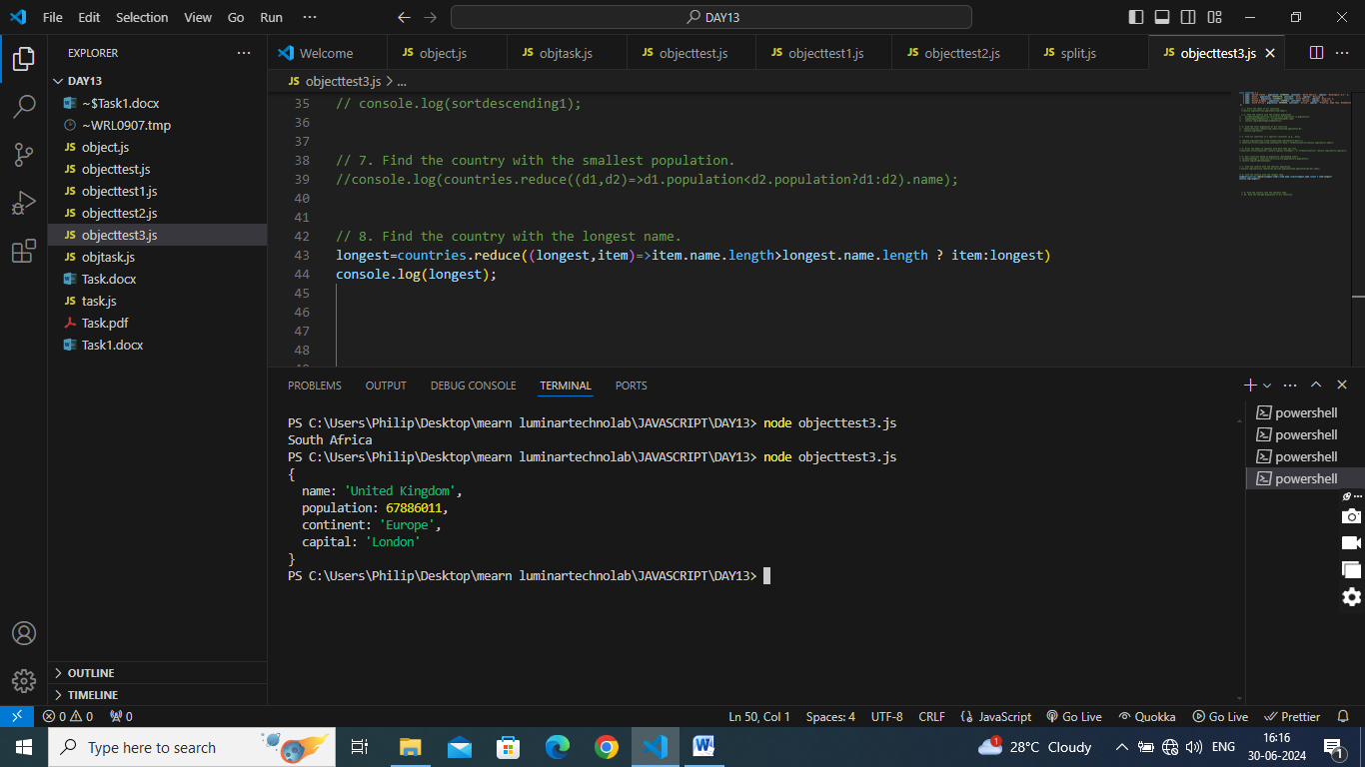

// 9. Find the country with the shortest name.

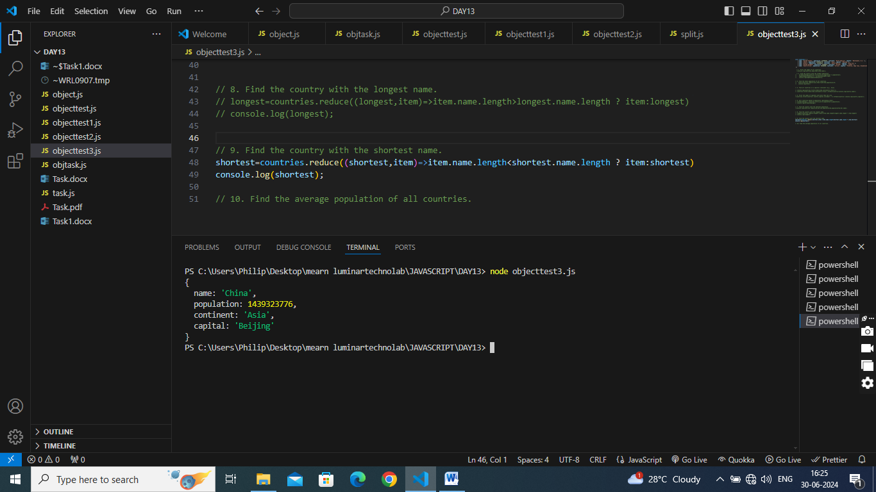

// 10. Find the average population of all countries.

