**TASK 2 :**

accounts=[

{

acno:1000,ac_type:'savings',balance:45000,transaction:[

{

to:1001,amount:6000,msg:'ebil', mode:'gpay'

},

{

to:1002,amount:2000,msg:'emi', mode:'neft'

},

{

to:1003,amount:1000,msg:'recharge', mode:'phonepe'

},

]

},

{

acno:1001,ac_type:'current',balance:30000,transaction:[

{

to:1000,amount:1000,msg:'grossary', mode:'gpay'

},

{

to:1001,amount:5000,msg:'ebil', mode:'gpay'

},

{

to:1002,amount:2000,msg:'emi', mode:'neft'

},

{

to:1003,amount:1000,msg:'recharge', mode:'phonepe'

},

]

},

{

acno:1002,ac_type:'fixed',balance:100000,transaction:[

{

to:1000,amount:5000,msg:'ebil', mode:'gpay'

},

{

to:1001,amount:2000,msg:'emi', mode:'neft'

},

{

to:1003,amount:1000,msg:'recharge', mode:'phonepe'

},

]

},

{

acno:1003,ac_type:'savings',balance:30000,transaction:[

{

to:1001,amount:7000,msg:'ebil', mode:'gpay'

},

{

to:1002,amount:2000,msg:'emi', mode:'neft'

},

{

to:1000,amount:1000,msg:'recharge', mode:'phonepe'

},

]

}

]

//1 total number of accounts

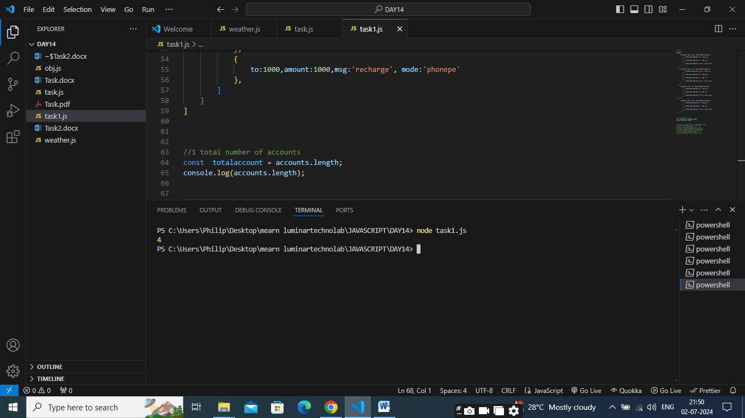

//2 print account number whose account type is savings

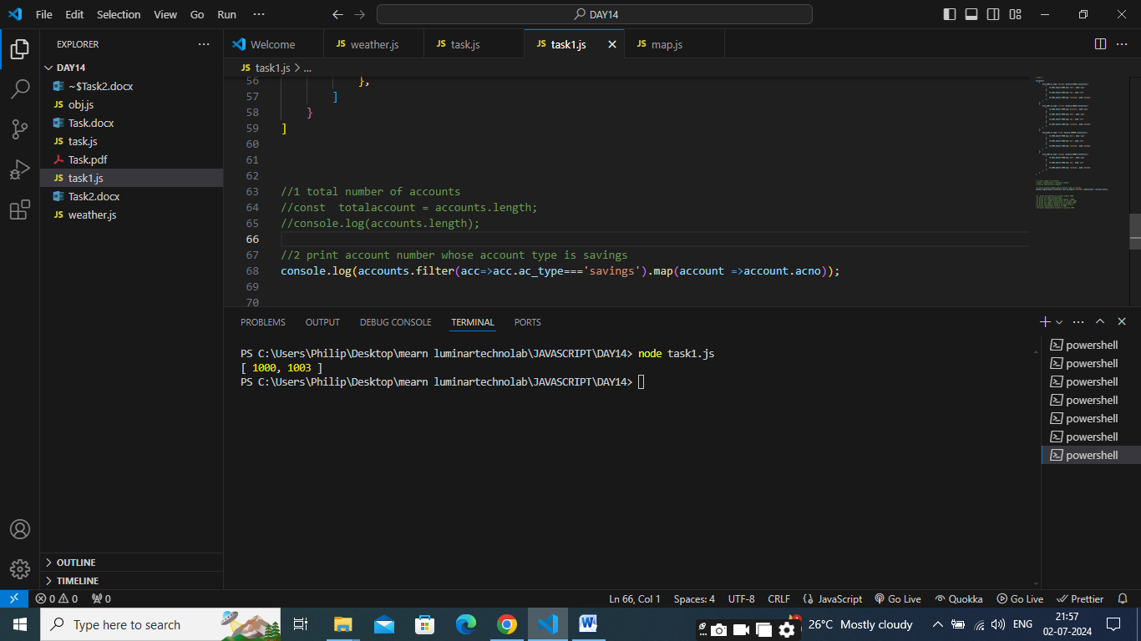

//3 print the balance of account number 1000

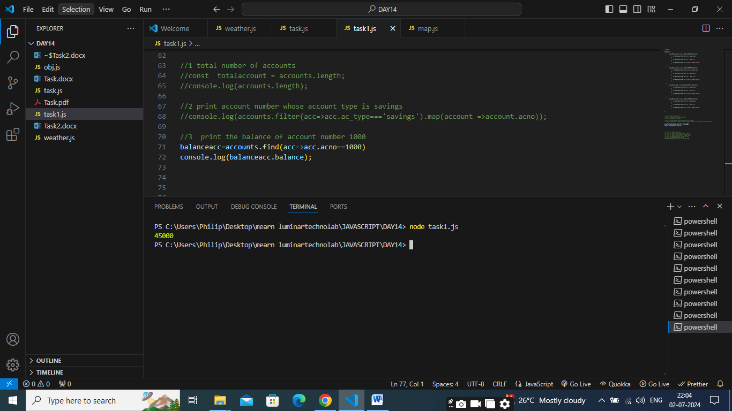

//4 print all gpay transactions

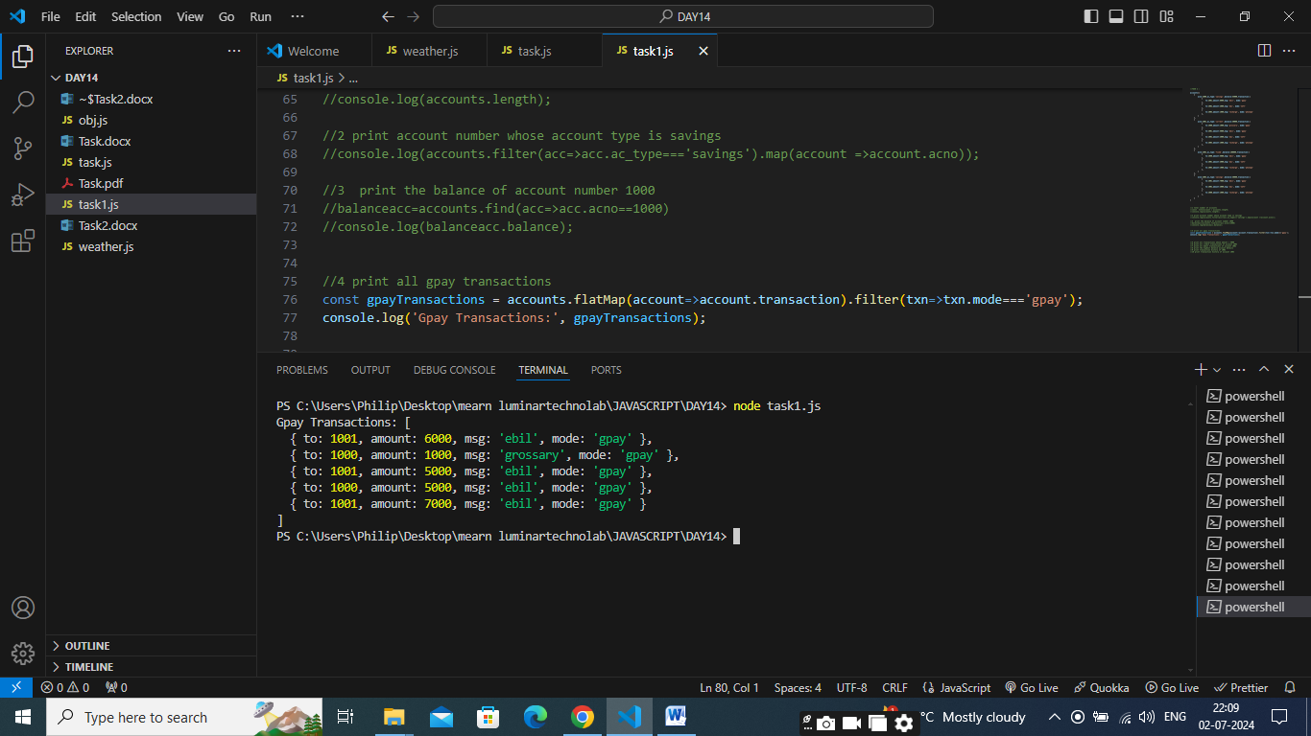

//5 print all transactions whose amount > 5000

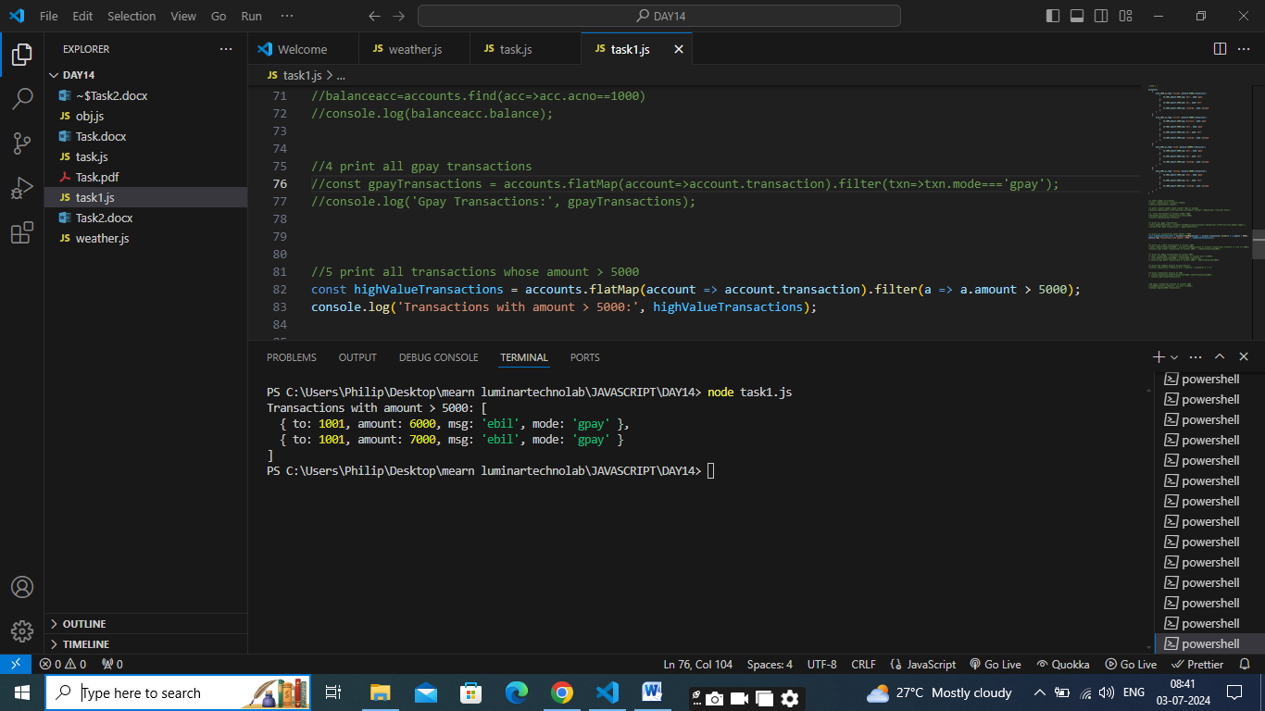

//6 print all credit transactions of account 1002

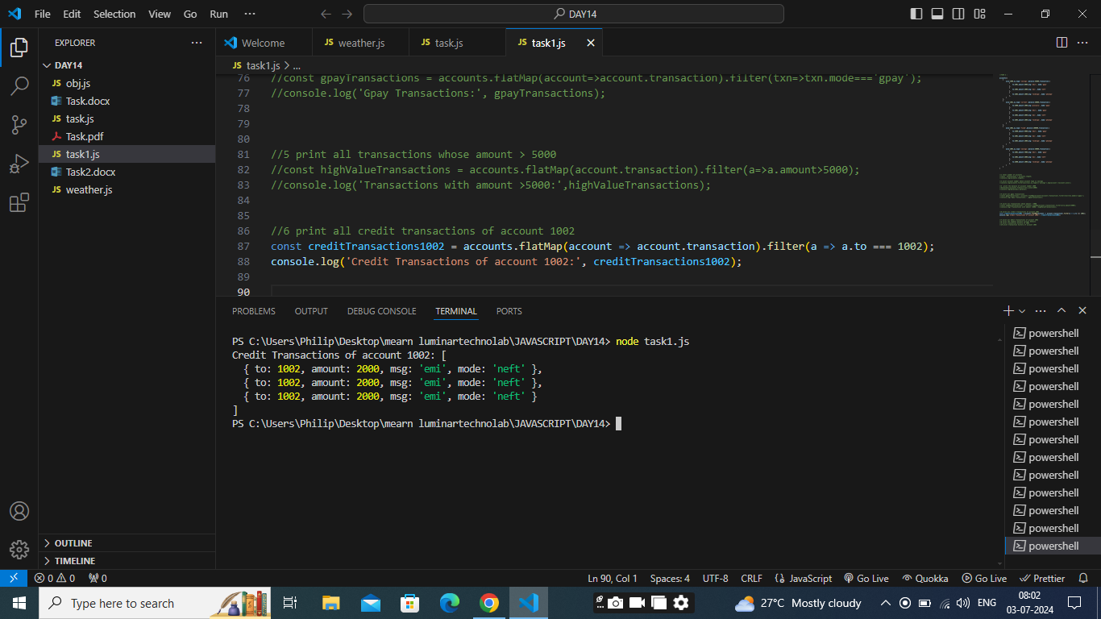

//7 print all debit transactions of account 1002

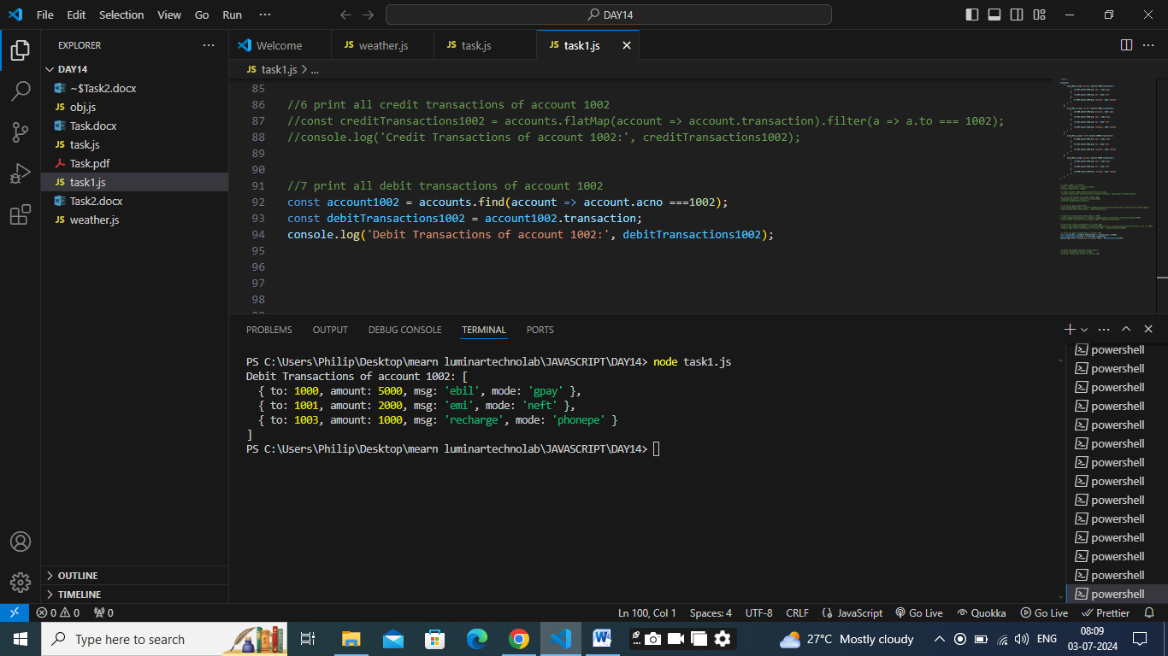

//8 print the highest balance account details

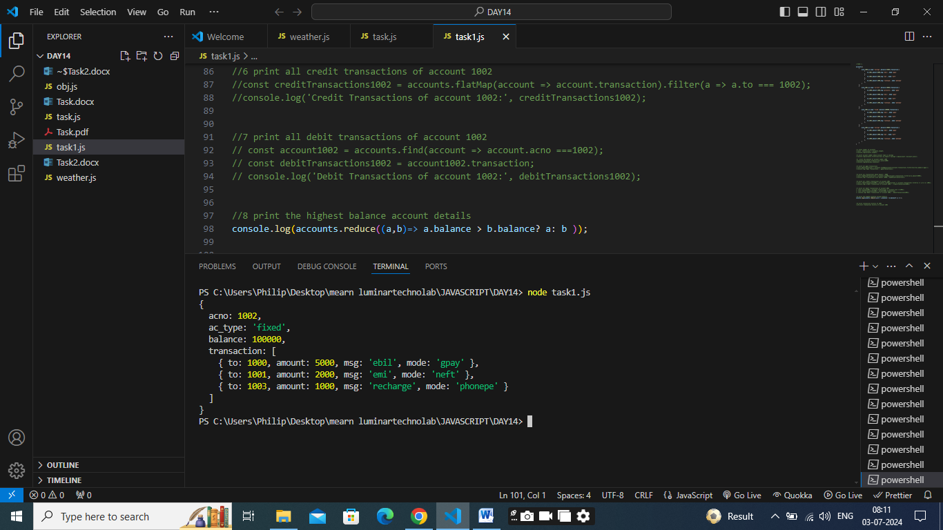

//9 print transaction history of 1002

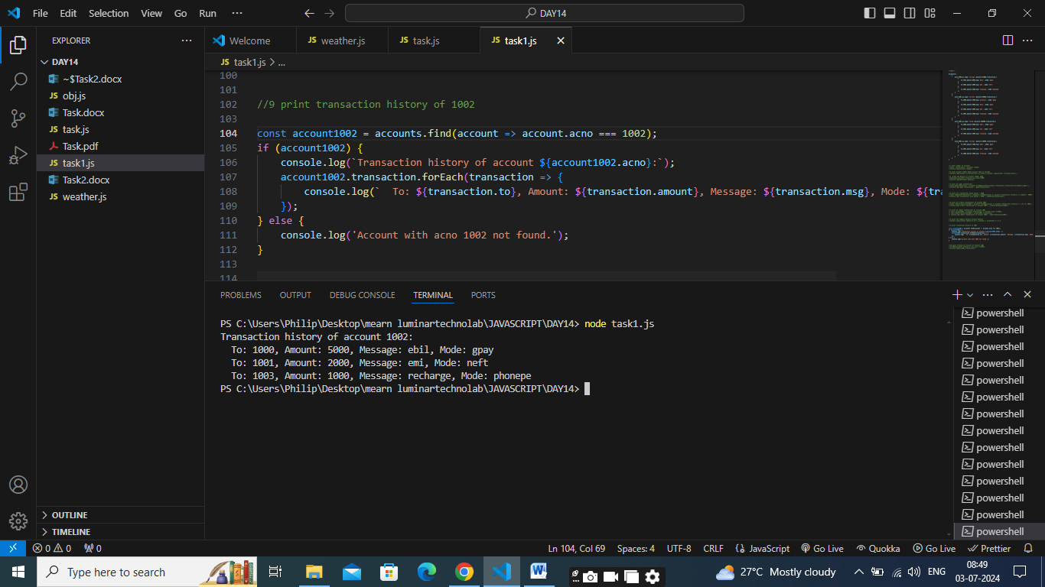

//10 print transaction history of account 1003

