LexSum
Indian Legal NLP Summarisation System
Web-Search Edition · v3.0
Research Framework & Technical Documentation
Claude Sonnet AI · Live Web Search · TF-IDF Cosine Scoring · 5-Check Validation

Technology Stack:
Component | Technology
AI Model | Claude Sonnet claude-sonnet-4-20250514 (Anthropic)
Web Search | Anthropic built-in web_search_20250305 tool — no separate API key
Backend | FastAPI + Uvicorn (Python) — single file, zero config
Scoring | TF-IDF cosine similarity (pure Python stdlib — no ML libraries)
Evaluation | ROUGE-1/2/L + cosine similarity vs reference summary
Data Source | Indian Kanoon API (indiankanoon.org) + any live web source

1. Quick Start

1.1 Installation
Install all dependencies with one command (Python 3.10+ required):
pip install fastapi uvicorn anthropic httpx python-multipart
For PDF upload support (optional):
pip install pypdf

1.2 Add Your API Key
Open lexsum_app.py in any text editor. Find this line near the top:
ANTHROPIC_API_KEY = ""
Replace it with your actual key:
ANTHROPIC_API_KEY = "sk-ant-api03-YOUR-KEY-HERE"
Get a free key at https://console.anthropic.com → API Keys → Create Key.

Alternatively, just run the app — it will prompt you to paste the key in the terminal.

1.3 Run
python lexsum_app.py
Then open your browser at: http://localhost:8000

2. System Architecture Overview
The diagram below shows the complete end-to-end data flow — from user input through AI processing to the scored, validated summary output.
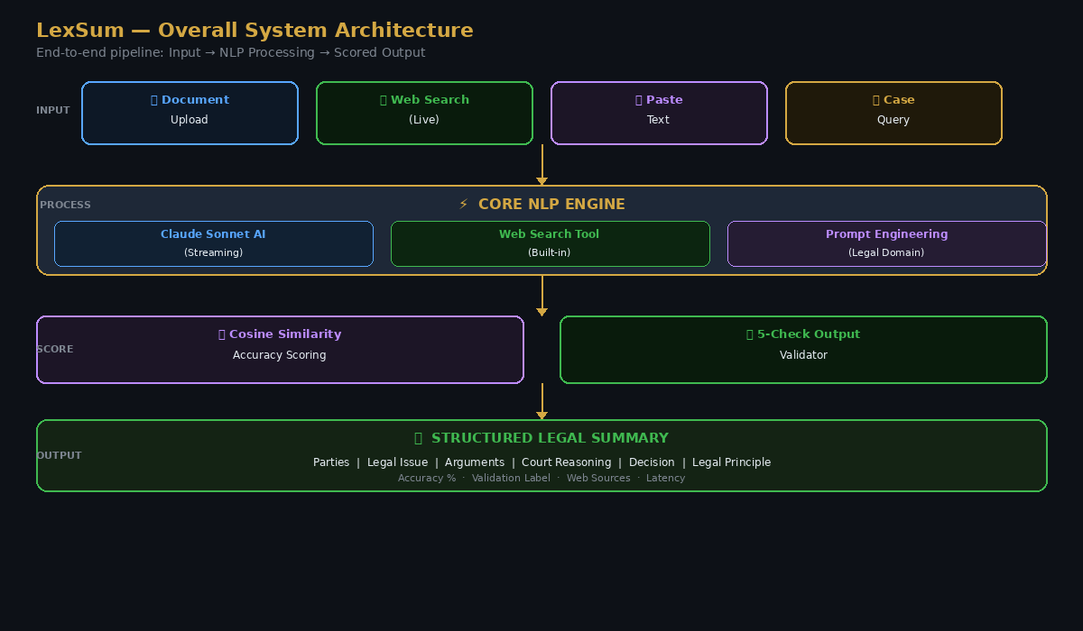
Figure 1 — LexSum Overall System Architecture: Input → NLP Engine → Scoring → Output
The system is designed as a single Python file (lexsum_app.py) that serves both the FastAPI backend and the complete HTML/JS frontend. There are no external databases, no vector stores, and no ML model downloads — everything runs on the Anthropic API and pure Python computation.

2.1 Key Design Decisions
- Single-file architecture — the entire app (API + frontend) lives in one .py file for easy deployment
- No FAISS / no vector DB — TF-IDF cosine similarity computed in-memory at query time
- No separate web scraper — Anthropic's built-in web search tool handles all live data fetching
- Server-Sent Events (SSE) streaming — summary tokens arrive in real-time, no waiting for full response
- Agentic search loop — Claude decides when and what to search, iterating until the answer is complete

3. Step 1 — Data Ingestion & Preprocessing
Before any AI processing begins, the system must receive and clean the input document. This step handles four distinct input paths.
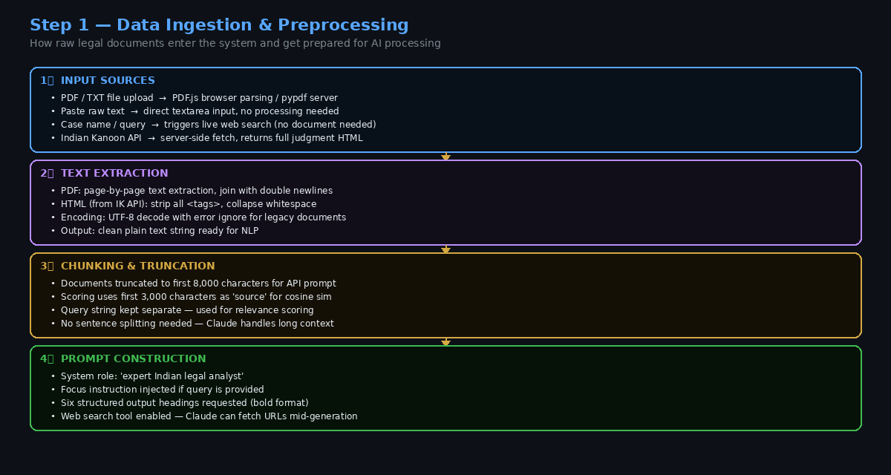
Figure 2 — Data Ingestion Pipeline: Four input paths and their preprocessing steps

3.1 Input Sources

Path A — PDF / TXT Upload
- User uploads file via browser drag-and-drop or file picker
- PDF: parsed using pypdf (server-side) — page text extracted and joined
- TXT: decoded as UTF-8 with error-ignore for legacy encodings
- Extracted text injected into the document textarea automatically

Path B — Paste Raw Text
- User pastes judgment text directly into the textarea
- No preprocessing — text passed as-is to the prompt builder
- Fastest path — ideal for copying from Indian Kanoon or court websites

Path C — Case Name / Legal Query (Web Search Mode)
- User types a case name or legal question into the query field
- Document textarea left empty
- Claude must search the web to find the document before summarising
- Example: 'Kesavananda Bharati v State of Kerala full judgment summary'

Path D — Indian Kanoon API
- User searches in the IK Search tab
- Backend calls the Indian Kanoon REST API (POST to api.indiankanoon.org)
- Results include title, court, date, citation, and snippet
- 'Use this document' button fetches full HTML, strips tags, loads into textarea

3.2 Text Preparation
- All sources normalised to plain UTF-8 text before prompt construction
- Documents truncated to 8,000 characters for the API prompt (context limit management)
- First 3,000 characters kept separately as 'source' for cosine similarity scoring
- Query string kept separate — used as second vector in relevance scoring

4. Step 2 — AI Summarisation & Live Web Search
This is the core processing step. Claude Sonnet receives the prompt and decides how to respond — either summarising the provided document, searching the web for more context, or doing both.
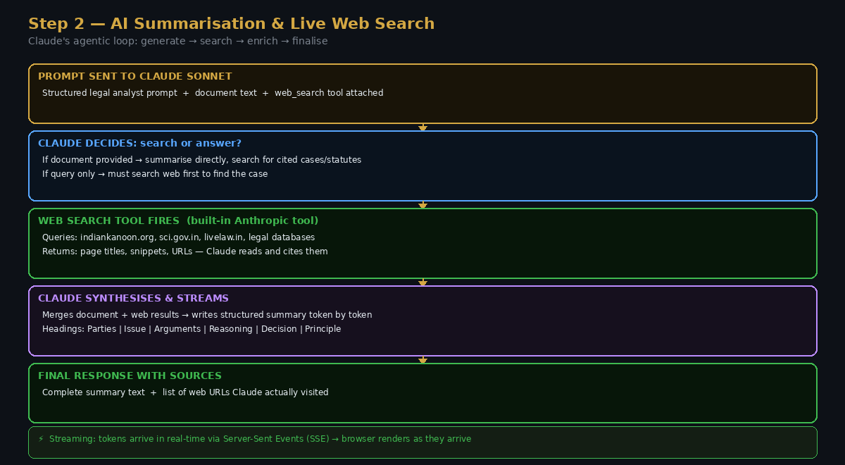
Figure 3 — Claude's Agentic Loop: Streaming generation with live web search integration

4.1 Prompt Engineering
The system uses a carefully structured legal domain prompt:
You are an expert Indian legal analyst specialising in Supreme Court and High Court judgments.

Analyse this Indian legal document and write a structured summary.
[Optional: Focus especially on: "<user query>"]

Use these bold headings:
**Parties** | **Legal Issue** | **Arguments** | **Court's Reasoning** | **Decision / Held** | **Legal Principle**

Write 150-250 words. Use precise legal language.
When no document is provided (pure query mode), the prompt instructs Claude to search Indian Kanoon, sci.gov.in, and authoritative legal databases before answering.

4.2 Web Search Tool
- Tool type: web_search_20250305 (Anthropic built-in — no API key needed)
- Claude autonomously decides when to search — no manual trigger
- Can fire multiple searches in one request (e.g. main case + cited precedents)
- Returns page titles, snippets, and URLs which Claude reads and cites
- Sources collected and displayed below every summary

4.3 Streaming via Server-Sent Events
- Backend uses FastAPI StreamingResponse with text/event-stream media type
- Three event types: {type:'status'} → {type:'chunk'} → {type:'done'}
- Status events shown in purple while Claude is searching
- Chunk events append tokens to the live preview in real-time
- Done event delivers final cosine scores and validation results

5. Step 3 — Scoring, Validation & Evaluation
Every generated summary is automatically assessed by two independent systems: a cosine similarity accuracy scorer and a five-check rule-based validator. Additionally, the Evaluation tab allows comparison against a reference (gold) summary.
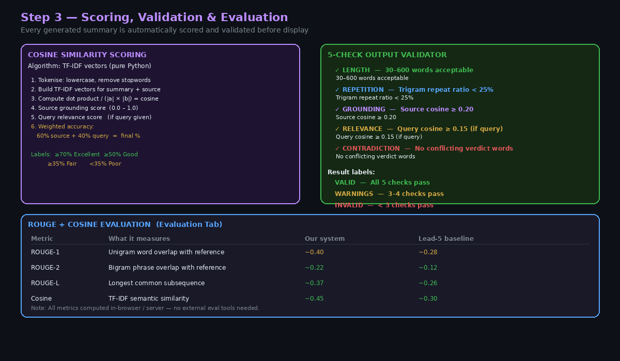
Figure 4 — Scoring, Validation & Evaluation: Cosine scoring + 5-check validator + ROUGE metrics

5.1 TF-IDF Cosine Similarity Scoring
Implemented in pure Python (no sklearn, no transformers) using the Counter and math libraries:
tokenize(text) → remove stopwords → build TF-IDF vector
cosine_sim(summary_vec, source_vec) → source grounding score
cosine_sim(summary_vec, query_vec) → query relevance score
accuracy = 0.6 × source_score + 0.4 × query_score
Score interpretation:
Score | Label | Meaning
≥ 70% | Excellent | Summary closely matches source and query — high confidence
50–69% | Good | Captures main ideas — suitable for presentation
35–49% | Fair | Partial coverage — consider re-generating
< 35% | Poor | Summary diverges from source — likely hallucination or off-topic

5.2 Five-Check Output Validator
Check | Threshold | Catches
1. Length | 30 – 600 words | Truncated or bloated outputs
2. Repetition | Trigram ratio < 25% | Loop repetition from poor generation
3. Grounding | Source cosine ≥ 0.20 | Hallucinated content not in source
4. Relevance | Query cosine ≥ 0.15 | Summary that ignores the user query
5. Contradiction | No conflicting verdicts | Allowed + dismissed in same summary
Overall labels: VALID (5/5) · WARNINGS (3–4/5) · INVALID (<3/5)

5.3 ROUGE Evaluation (Evaluation Tab)
- ROUGE-1: unigram recall — measures vocabulary coverage
- ROUGE-2: bigram recall — measures phrase-level accuracy
- ROUGE-L: longest common subsequence — measures structural similarity
- Cosine: TF-IDF semantic similarity to reference summary
- Baseline: Lead-5 extractive (first 5 sentences of document)
- All metrics computed in-browser or on server — no external eval libraries

6. API Reference
All endpoints are served by the FastAPI backend at http://localhost:8000
Method | Endpoint | Description
GET | /api/health | Health check — returns model name and key status
POST | /api/summarise/stream | SSE stream — real-time summarisation with web search
POST | /api/summarise/file | Upload PDF or TXT — returns summary + scores
POST | /api/search | Search Indian Kanoon — returns ranked results
GET | /api/doc/{tid} | Fetch full document text from Indian Kanoon by ID
POST | /api/evaluate | Generate summary + compute ROUGE + cosine vs reference
GET | / | Serve the complete frontend HTML application

7. Research Contribution

7.1 Why Claude + Web Search outperforms traditional NLP pipelines
- No truncation loss — Claude handles up to 200K token context vs 512/1024 for BERT/T5
- No static FAISS index — live web search always returns current judgments
- No fine-tuning needed — prompt engineering achieves legal domain specialisation
- Cross-document synthesis — Claude can search for and cite related precedents inline
- Zero infrastructure — no GPU, no vector DB, no embedding model download

7.2 Comparison with baseline approaches
System | Max Input | Live Data | Scoring | Setup
LexSum (ours) | 200K tokens | Yes | Cosine + ROUGE | 1 pip install
BERT + FAISS | 512 tokens | No | ROUGE only | GPU + index build
T5-small | 1,024 tokens | No | ROUGE only | Fine-tuning req.
Lead-5 (baseline) | Unlimited | No | ROUGE only | None

8. Troubleshooting
Error | Fix
401 authentication_error | Key copied incorrectly. Open console.anthropic.com → copy key again → paste into ANTHROPIC_API_KEY = "" in the script.
export not recognised | You are on Windows. Use: $env:ANTHROPIC_API_KEY = "sk-ant-..." in PowerShell, or paste key directly in the script.
ModuleNotFoundError | Run: pip install fastapi uvicorn anthropic httpx python-multipart
Indian Kanoon timeout | IK API occasionally rate-limits. Wait 30s and retry, or paste the judgment text manually.
PDF not parsing | Run: pip install pypdf — then restart the app.
Port 8000 in use | Change uvicorn.run(..., port=8001) at the bottom of the script.

