**ENEMY AIRCRAFT DETECTION SIMULATOR**

**A PROJECT REPORT**

Submitted in partial fulfilment of the requirements for the

Award of the degree of

**BACHELOR OF TECHNOLOGY**

In

**COMPUTER SCIENCE & ENGINEERING/ARTIFICIAL INTELLIGENCE & DATASCIENCE**

Submitted By Under the Supervision of Vanshita Jain (21EMCCS122)Mr. Arvind Sharma Anjali Sharma (21EMCAD006) (Assistant Professor) Khushi Jangid (21EMCAD028)



**BIKANER TECHNICAL UNIVERSITY, BIKANER**



**MODERN INSTITUTE OF TECHNOLOGY & RESEARCH CENTRE ALWAR**

JUNE, 2024

**BIKANER TECHNICAL UNIVERSITY, RAJASTHAN**

**CERTIFICATE**

Certified that this project report **“ENEMY AIRCRAFT DETECTION SIMULATOR”** is the original work of **“VANSHITA JAIN , ANJALI SHARMA , KHUSHI JANGID”** student(s) of B. Tech. Third Year VI Semester (Computer science & Engineering Branch) who carried out the project work under my supervision.

**SIGNATURE SIGNATURE**

Prof. Dr. J.R Arun Kumar Mr. Arvind Sharma

**HEAD OF THE DEPARTMENT ASSISTANT PROF.** Department of CSE & AI Department of CSE & AI MITRC MITRC

**ACKNOWLEDGEMENT**

Firstly, we would like to express our gratitude to our advisor for the beneficial comments and remarks. We express our sincere thanks to **Prof. S. K. Sharma (Director)** of the Modern Institute of Technology & Research Centre, Alwar.

We pay our deep sense of gratitude to **Prof. J.R Arun Kumar**, **(HOD)** of Department of CSE and AI, Modern Institute of Technology & Research Centre, Alwar for encouraging us to the highest peak and providing us the opportunity to present the Project.

We acknowledge a deep sense of gratitude to IDT Co-Ordinator **Mr. Dipayan Kumar Ghosh** and Supervisor **Mr. Arvind Sharma** (Asst. Professor), Department of Computer Science & Engineering, Modern Institute of Technology & Research Centre, Alwar (Rajasthan) for his constant support and guidance during this work. His honesty, thoroughness, and perseverance have been a constant source of inspiration for us. We would like to thank our institute and faculty members without them this project would have been a distant reality, we also extend our heartfelt thanks to our families and well-wishers. Finally, but not least, our parents are also an important inspiration for us. With due respect, we express our gratitude to them.

|  |  |
| --- | --- |
| Vanshita Jain | 21EMCCS122 |
| Anjali Sharma | 21EMCAD006 |
| Khushi Jangid | 21EMCAD028 |
|  |  |

**CONTENTS**

**TITLE PAGE NO**

CERTIFICATE i ACKNOWLEDGEMENT ii CONTENTS iii-iv LIST OF FIGURES v LIST OF TABLES vi ABSTRACT vii

**CHAPTER 1: INTRODUCTION 1-3**

1.1 What Is Vsat 1

1.2 Problem Description 3

**CHAPTER 2: PROBLEM STATEMENT 4-6**

**CHAPTER 3: UML DIAGRAMS 7-12**

3.1 Component diagram 1

3.2 Deployment diagram 2

3.3 Object diagram 3

3.4 Communication diagram 4

3.5 State diagram 5

3.6 Use case diagram 6

3.7 Sequence diagram 7

3.8 Activity diagram 8

**CHAPTER 4: TECHNOLOGY STACK 13-31**

**CHAPTER 5: CODE IMPLEMENTATION 34-35**

**CHAPTER 6: PROJECT OUTPUT SCREEN SHOTS 37-40**

**CHAPTER 7: CONCLUSIONS AND FUTRE SCOPE 41-42**

7.1 Conclusion 41

7.2 Future Scope 42

**REFERENCES 43**

**LIST OF FIGURES**

|  |  |  |
| --- | --- | --- |
| **FIGURE NO.**  Figure 1 | **TITLE**  UML diagram | **PAGE NO**  2 |
| Figure 2 | Home page | 2 |
| Figure 3 | About page | 8 |
| Figure 4 | Learn Radar page |  |
| Figure 5 | Enemy Detection page |  |
|  |  |  |
|  |  |  |
|  |  |  |
|  |  |  |
|  |  |  |
|  |  |  |
|  |  |  |
|  |  |  |
|  |  |  |
|  |  |  |
|  |  |  |
|  |  |  |
|  |  |  |
|  |  |  |
|  |  |  |
|  |  |  |

**ABSTRACT**

Detection of Enemy Fighter Planes are crucial. Positive aircraft identification plays a crucial role in ensuring the security of the airspace, the safety of the populace, state resources and military establishments. Aircraft identification aids in air traffic management by positively identifying each aircraft entering monitored airspace. Manual binoculars identify aircraft by shape and engine sound. The Enemy Detection System for Aircrafts uses RGB Sensor. Automatic aircraft recognition analyses images to identify targets. Automatic aircraft recognition relies on image extraction of an aircraft's silhouette and contour. Aircraft identification requires effective feature usage. The qualities must be independent of the object's position and orientation and include enough data to differentiate one object from another. However, the aircraft's geometric distortion, which might include shift, scale, and rotation, is often encountered, therefore image patterns must be extracted despite this distortion. Employs color-based motion detection to identify potential threats within the aircraft's vicinity. Sensor captures real-time environmental data, and through image processing techniques, specific characteristics indicative of potential enemy aircraft are isolated. Triggers a response mechanism, alertingthe aircraft’s pilot to the potential threat. The response can include visual indicators, alarms or tailored notifications.

**CHAPTER 1**

**INTRODUCTION**

**1.1 Background and Importance**

In the contemporary defense landscape, rapid identification and tracking of potential aerial threats are critical to national security. Traditional radar systems, while reliable, often fall short in terms of precision and real-time adaptability. The advancement of image processing and machine learning technologies presents an opportunity to enhance threat detection capabilities, particularly in complex and dynamic environments.

The Enemy Detection System (EDS) for Aircrafts is designed to leverage these advancements, providing real-time data to pilots and enabling quicker and more informed decisions. By integrating RGB sensors and advanced image processing techniques, the system aims to detect potential threats based on specific visual characteristics, offering a modern complement to traditional radar systems.

**1.2 Objectives of the Enemy Detection System**

The EDS aims to achieve the following objectives:

* **Real-Time Detection:** Identify potential enemy aircraft using RGB sensors and color-based detection algorithms.
* **Detailed Tracking:** Provide comprehensive information, including speed, direction, aspect angle, and closure rate of detected threats.
* **Enhanced Situational Awareness:** Integrate visual indicators and intuitive user interfaces to assist pilots in threat assessment and decision-making.
* **Expandability:** Provide a foundation for future enhancements, such as three-dimensional detection and machine learning integration for broader threat identification.

**CHAPTER 2**

**PROBLEM STATEMENT**

Events such as that which occurred in America on the 11th of September 2001 terrorist attack and the Simon Mann 2004 incident of aircraft caught trying to smuggle weapons are significant incidents driving the need for positive aircraft identification. Most ground-based surveillance systems rely on aircraft detection and recognition by the use of radar systems and flight plans obtained from aviation authorities to designate aircraft entering monitored air space as a friend or a foe. When the radar system detects an object in the air space, the object or aircraft identification code is used to compare with authorized flights provided. The challenge arises when the aircraft cannot be positively identified using the given identification code against that from the transponder system.

### ****2.1 System Operation****

### **2.1.1 Search Mode**

In Search Mode, the EDS continuously scans the aircraft's surroundings for potential threats. This mode employs color-based motion detection algorithms to identify areas of interest, focusing on specific visual characteristics that indicate the presence of enemy aircraft.

#### **Operation**

* The system captures real-time video data using RGB sensors.
* It converts the RGB data to HSV format to isolate specific color ranges.
* Regions that match the color criteria are highlighted, and alerts are triggered.

In a scenario where the system is set to detect objects with a yellow hue, the RGB sensors capture the environment, and the image processing algorithms highlight and alert any detected yellow objects that may represent enemy aircraft.

**2.1.2 Track Mode**

Once a potential enemy is identified in Search Mode, Track Mode takes over to provide detailed tracking information. This mode calculates critical metrics such as the object's speed, direction, aspect angle, and closure rate, offering comprehensive data to the pilot.

#### **Operation**

* The system calculates the object's speed based on its movement across frames.
* It determines the direction and angle of the object relative to the aircraft.
* Continuous updates ensure real-time tracking and accurate data.

#### **Outputs**

* **Speed:** The average speed of the detected object.
* **Direction:** The direction from which the object is approaching.
* **Aspect Angle:** The angle between the object's current position and the aircraft.
* **Closure Rate:** The rate at which the detected object is approaching the aircraft.

#### **Example**

For a detected object moving across the frame, the system calculates its speed in pixels per second, its angle relative to the aircraft's position, and its closure rate, providing the pilot with detailed tracking information.

**2.2 Requirements**

### **2.2.1 RGB Sensors**

RGB sensors capture real-time environmental data by measuring the intensity of red, green, and blue light. This data is processed to detect specific color signatures, which helps in identifying potential threats.

#### **Functionality**

* **Capture:** Records real-time video data.
* **Conversion:** Converts RGB data to HSV format for better color range detection.

#### **Application**

* **Detection:** Identifies potential threats based on predefined color characteristics.
* **Example:** Detecting objects with a yellow hue indicative of enemy aircraft.

### **2.2.2 Software and Hardware Requirements**

#### **Software**

* **Python**: Primary language for development.
* **OpenCV**: For image processing and computer vision tasks.
* **Flask**: Web framework for the application interface.
* **NumPy**: For numerical operations.

#### **Hardware**

* **RGB Sensors**: For capturing real-time video data.
* **Infrared Sensors**: For depth information.
* **Processing Unit**: Capable of handling real-time image processing.

**2.3 Technology & Concepts used**

### **2.3.1 Image Processing Techniques**

Image processing converts RGB data to HSV format, where specific color ranges are isolated to highlight potential threats. This involves creating binary masks and bounding boxes to pinpoint areas of interest.

#### **Methods**

* **HSV Conversion:** Converts RGB images to HSV to isolate specific hues.
* **Color Filtering:** Applies thresholds to identify and highlight regions matching the color criteria.
* **Motion Detection:** Identifies movement by comparing consecutive frames.

#### **Objective**

* **Isolate and Identify:** Detect potential threats based on color characteristics.

### **2.3.2 Vector Algebra**

Vector algebra is employed to calculate relative positions and movements of detected objects. By representing the aircraft and enemy positions as vectors, the system can determine distances, directions, and angles accurately.

#### **Application**

* **Position Calculation:** Determines the enemy's position relative to the aircraft.
* **Movement Analysis:** Calculates the distance and direction of movement.

### **2.2.3 Trigonometry**

Trigonometry is used to calculate angles and directions between the aircraft and detected objects. This helps in determining the aspect angle and understanding the enemy's orientation relative to the aircraft.

#### **Application**

* **Angle Calculation:** Determines the angle between the aircraft and the detected object.
* **Direction Analysis:** Provides directional data to the pilot.

### **2.3.4 Object Detection and Tracking Algorithms**

Advanced object detection and tracking algorithms analyze the RGB data to identify and track potential threats. These algorithms continuously update the object's position and movement, ensuring accurate real-time tracking.

#### **Application**

* **Detection:** Identifies potential threats in the video feed.
* **Tracking:** Continuously updates the object's position and calculates its speed, direction, and closure rate.

### **2.3.5 Animations**

Animations enhance the user interface by providing intuitive visual feedback on detected threats. This includes highlighting detected objects, indicating their movement, and displaying relevant data.

#### **Features**

* **Highlighting:** Visual indicators for detected threats.
* **Movement Tracking:** Animated trails to show object movement.
* **Data Display:** Real-time updates on speed, direction, and angle.

## **2.4. Current System Limitations**

### **2.4.1 Horizontal Axis Limitation**

Currently, the EDS is limited to detecting and tracking threats on a horizontal plane. This limitation restricts the system's ability to identify threats that are above or below the aircraft.

#### **Impact**

* **Limited Detection Range:** Only covers threats on the same horizontal level.
* **Potential Blind Spots:** Misses threats approaching from different vertical angles.

### **2.4.2 Dependency on Specific Color**

The current system relies on detecting specific colors to identify potential threats. This dependency can lead to inaccuracies if the enemy aircraft's color does not match the predefined criteria.

#### **Impact**

* **False Negatives:** Potential threats may be missed if their color does not match the detection criteria.
* **Limited Flexibility:** The system is not adaptable to varying threat characteristics.

**CHAPTER 3**

**UML DIAGRAMS**

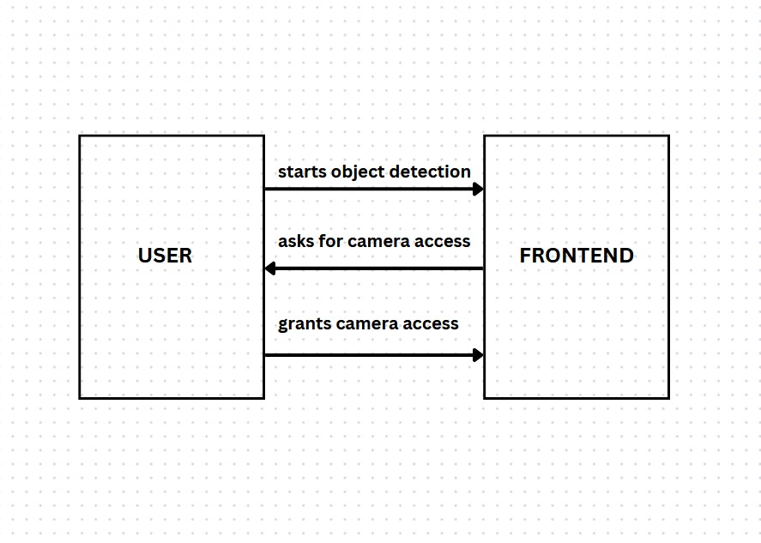

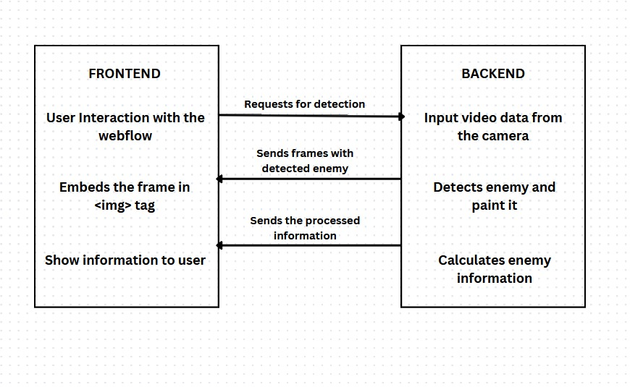

.

**CHAPTER 4**

**TECHNOLOGY STACK**

**Introduction**

The Enemy Detection System for Aircrafts leverages a robust and modern technology stack to ensure real-time detection and tracking of potential threats. The integration of Flask, React, OpenCV, HTML, JavaScript, and CSS creates a seamless and efficient system that combines powerful backend processing with a dynamic and intuitive frontend interface.

1. OpenCV
2. Flask
3. React JS
4. Java Script
5. HTML
6. CSS

**OpenCV:** OpenCV (Open Source Computer Vision Library) is a powerful tool for computer vision and image processing tasks.

It provides a wide range of functions for real-time image and video processing, such as object detection, face recognition, and image transformations. OpenCV is widely used in applications like surveillance, robotics, and medical imaging due to its efficiency and ease of use.

**Flask:** Flask is a lightweight and flexible web framework for Python. It's designed to be simple and easy to use, making it perfect for small to medium-sized web applications. Flask allows developers to build web servers and handle web requests with minimal setup, using its straightforward routing system and integration with other libraries for database handling, user authentication, and more.

**React JS**: React JS is a popular JavaScript library for building user interfaces, particularly single-page applications. Developed by Facebook, React allows developers to create reusable UI components that manage their own state. This makes it easy to build complex, interactive user interfaces with a clear and efficient structure, improving both development speed and application performance.

**JavaScript**: JavaScript is a versatile programming language commonly used for adding interactivity and dynamic behavior to web pages. It runs in the browser and enables features like form validation, dynamic content updates, and interactive graphics. JavaScript is an essential part of modern web development.

.**HTML**: HTML (Hyper Text Markup Language) is the standard language for creating web pages and web applications. It provides the basic structure of a webpage, using elements and tags to define headings, paragraphs, links, images, and other content. HTML is the foundation of web development, allowing browsers to render and display content in a structured format.

**CSS**: CSS (Cascading Style Sheets) is used to style and layout web pages. It controls the visual appearance of HTML elements, such as colors, fonts, spacing, and positioning. CSS allows developers to create visually appealing and consistent designs across multiple web pages, enhancing the user experience and making web applications look professional and polished.

**CHAPTER 5**

**CODE IMPLEMENTATION**

**Backend:**

from flask import Flask, render_template, Response, request

from flask_cors import CORS

import numpy as np

from PIL import Image

import math

import cv2

import time

from collections import deque

app = Flask(__name__)

CORS(app)

def get_limits(color):

'''Returns the upper and lower limits for a given color in HSV'''

c = np.uint8([[color]]) # BGR values

hsvC = cv2.cvtColor(c, cv2.COLOR_BGR2HSV)

hue = hsvC[0][0][0] # Get the hue value

if hue >= 165: # Upper limit for divided yellow hue

lowerLimit = np.array([hue - 7, 150, 150])

upperLimit = np.array([180, 255, 255])

elif hue <= 15: # Lower limit for divided yellow hue

lowerLimit = np.array([0, 150, 150])

upperLimit = np.array([hue + 7, 255, 255])

else:

lowerLimit = np.array([hue - 7, 150, 150])

upperLimit = np.array([hue + 7, 255, 255])

return lowerLimit, upperLimit

def generate_frames():

yellow = [0, 255, 255] # Enemy characteristic

cap = cv2.VideoCapture(0)

if not cap.isOpened():

print("Error: Could not open camera.")

return

# Load and resize the radar background image

background = cv2.imread('Screenshot 2024-07-05 at 19-51-06 Green Grid Images Free Photos PNG Stickers Wallpapers & Backgrounds - rawpixel.png')

if background is None:

print("Error: Could not load radar background image.")

return

background = cv2.resize(background, (640, 480)) # Resize to match webcam resolution

prevPosition = None

prev_time = time.time()

speed_history = deque(maxlen=10) # Store last 10 speeds

while True:

ret, frame = cap.read()

if not ret:

print("Error: Could not read frame.")

break

# Convert frames from BGR to HSV

hsvImage = cv2.cvtColor(frame, cv2.COLOR_BGR2HSV)

lowerLimit, upperLimit = get_limits(color=yellow)

# Create a binary mask that highlights the regions of an image that fall within a specified color range

mask = cv2.inRange(hsvImage, lowerLimit, upperLimit)

# Creates an image object from array

mask_ = Image.fromarray(mask)

bbox = mask_.getbbox()

# Overlay detection results on the background

detection_layer = np.zeros_like(background) # Create a blank layer for detections

if bbox is not None:

x1, y1, x2, y2 = bbox

# Create a rectangle around the detected object

detection_layer = cv2.rectangle(detection_layer, (x1, y1), (x2, y2), (0, 0, 255), 5)

# Find the midpoint of the object detected

midpoint = [(x1 + x2) // 2, (y1 + y2) // 2]

# Calculate the distance between prev position and this curr position of enemy

curr_time = time.time()

if prevPosition is not None:

dist = np.sqrt((midpoint[0] - prevPosition[0]) ** 2 + (midpoint[1] - prevPosition[1]) ** 2)

time_diff = curr_time - prev_time

if time_diff > 0:

speed = dist / time_diff

speed_history.append(speed)

prevPosition = midpoint

prev_time = curr_time

# Calculate the angle between enemy and aircraft

w, h = 320, 480 # Update to match half of background dimensions

aircraft = [w, h]

enemy = midpoint

thetaRad = math.atan2((enemy[0] - aircraft[0]), (aircraft[1] - enemy[1]))

angleDeg = math.degrees(thetaRad)

if angleDeg < 0:

angleDeg += 360

# Calculate the moving average speed

avg_speed = np.mean(speed_history) if speed_history else 0

# Print for debugging

print(f"Enemy at angle: {angleDeg:.2f} degrees, Speed: {avg_speed:.2f} pixels/sec")

# Create a circle around the enemy

# detection_layer = cv2.circle(detection_layer, midpoint, 5, (0, 0, 255), -1)

# Overlay speed and angle on the detection layer

cv2.putText(detection_layer, f"Speed: {avg_speed:.2f} px/s", (10, 30), cv2.FONT_HERSHEY_SIMPLEX, 0.8, (255, 255, 255), 2)

cv2.putText(detection_layer, f"Angle: {angleDeg:.2f} degrees", (10, 60), cv2.FONT_HERSHEY_SIMPLEX, 0.8, (255, 255, 255), 2)

# Combine background with detection overlay

combined_frame = cv2.addWeighted(background, 1.0, detection_layer, 1.0, 0)

ret, buffer = cv2.imencode('.jpg', combined_frame)

if not ret:

print("Error: Frame encoding failed.")

break

frame = buffer.tobytes()

yield (b'--frame\r\n'

b'Content-Type: image/jpeg\r\n\r\n' + frame + b'\r\n')

cap.release()

cv2.destroyAllWindows()

@app.route('/video_feed')

def video_feed():

return Response(generate_frames(), mimetype='multipart/x-mixed-replace; boundary=frame')

if __name__ == '__main__':

app.run(debug=True)

**Backend-Frontend Integration**

import React from 'react';

import VideoFeed from '../components/VideoFeed';

function ObjectDetection() {

return (

<VideoFeed/>

);

}

export default ObjectDetection;

**Home Page**

import React, { useReducer } from "react";

import DescriptionBox from "../components/descriptionBox.js";

import VideoFeed from "../components/VideoFeed.js";

import Button1 from "../components/button1.js"

import '../styles/homePage.css'

import homePageImage1 from "../assets/images/f34.png"

import homePageImage2 from "../assets/images/f19.png";

import homePageiVideo from "../assets/videos/planeVideo1.mp4";

import { gsap } from 'gsap'

import { useRef } from "react";

import { ScrollTrigger } from "gsap/ScrollTrigger.js";

import { useEffect } from "react";

import { getActiveElement } from "@testing-library/user-event/dist/utils";

gsap.registerPlugin(ScrollTrigger);

const HomePage = () => {

useEffect(() => {

const html = document.documentElement;

const canvas = document.querySelector('canvas');

const context = canvas.getContext('2d');

const currentFrame = (index) => {

return require(`../assets/images/scrollImages/frames${index.toString().padStart(4, '0')}.png`);

};

const frameCount = 73

const preloadImages = () => {

for (let i = 1; i < frameCount; i++) {

const img = new Image();

img.src = currentFrame(i);

}

};

const img = new Image();

img.src = currentFrame(1)

// When the image is loaded, draw it on the canvas

img.onload = () => {

// Calculate the aspect ratio of the image

const aspectRatio = img.width / img.height;

// Set the canvas dimensions to match the aspect ratio of the image

canvas.width = img.width;

canvas.height = img.height;

// Calculate the scaled width and height to fit the canvas

const scaledWidth = canvas.width;

const scaledHeight = canvas.width / aspectRatio;

// Clear the canvas and draw the img with the new dimensions

context.clearRect(0, 0, canvas.width, canvas.height);

context.drawImage(img, 0,0, canvas.width, canvas.height);

};

const updateImage = index => {

img.src = currentFrame(index);

context.drawImage(img, 0, 0);

}

window.addEventListener('scroll', () => {

const scrollTop = html.scrollTop;

const maxScrollTop = html.scrollHeight - window.innerHeight;

const scrollFraction = scrollTop / maxScrollTop;

const frameIndex = Math.min(

frameCount - 1,

Math.floor(scrollFraction * frameCount)

)

requestAnimationFrame(() => updateImage(frameIndex + 1))

})

preloadImages()

}, []);

return (

<>

<div className="adjustPicture">

<img src={homePageImage1}></img>

<div className="textContainer">

<h1 className="title">The Sky Gaurdians</h1>

<h3>An enemy detection simulator</h3>

</div>

</div>

<div className="adjustScroll">

{/* <img src={homePageImage2}></img> */}

<canvas className="scroll-canvas">

</canvas>

<DescriptionBox title="Real-time Enemy Tracking" data='The simulator pro tracking of enemy aircraft using RGB sensors, allowing users to monitor their position accurately.'/>

<DescriptionBox title="Directional Awareness" data='With the use of RGB sensors, users can determine the direction from which the enemy aircraft is approaching, enhancing situational awareness.'/>

<DescriptionBox title="Speed Detection" data='The simulator accurately measures the speed of enemy aircraft, enabling users to anticipate their movements and take appropriate actions.'/>

</div>

<div className="adjustPicture">

<video autoPlay loop muted src={homePageiVideo}></video>

<Button1/>

</div>

</>

)

}

export default HomePage

**About Page**

import React from "react";

import coolPlane from "../assets/videos/cool plane.mp4"

// import coolPlane from "./assets/videos/coolPlane"

import "../styles/aboutPage.css"

import enemyPlane from "../assets/videos/enemy detection sam.mp4"

import SpanAnimation from "../components/spanAnimation";

const AboutPage = () => {

return (

<>

<div className="video-container">

<video className="cool-plane-video" autoPlay loop src={coolPlane}></video>

<div className="about-descr">

<h1 className="aboutTitle">About</h1>

<SpanAnimation />

<h2>The enemy detection simulator provides following information about threat</h2>

<br></br>

<h1>- Aspect angle</h1>

<h1>- Direction</h1>

<h1>- Airspeed</h1>

<h1>- Closure Rate</h1>

</div>

</div>

<div className="about-second-page">

<div className="second-text-container">

<h1 className="aboutTitle">Working </h1>

<SpanAnimation />

<p>

The system works in two modes:<br></br>

<br></br>

- Search mode<br></br>

- Track mode<br></br>

<br></br>

In Search mode, The system will run an object detection algo to locate the enemy. At this point the location of the potential threats will be showed to the pilot.<br></br>

Note: there may be multiple threats <br></br><br></br>

In the Track mode: The system provides more information about one of the “interesting” target, which produces most suspicion

</p>

</div>

<div className="enemy-video-container">

<video className="video-enemy" autoPlay loop src={enemyPlane}></video>

</div>

</div>

</>

)

}

export default AboutPage

**CHAPTER 6**

**PROJECT OUTPUT SCREENSHOTS**

**Home page:**

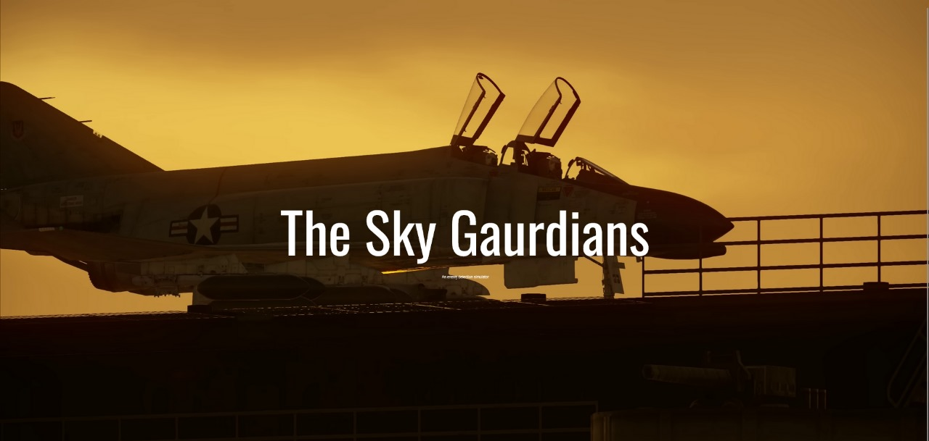

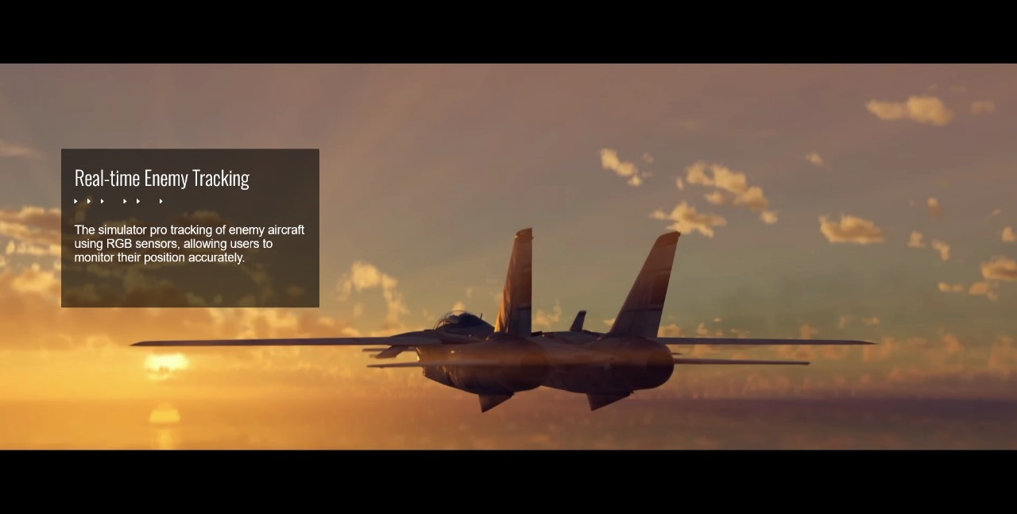

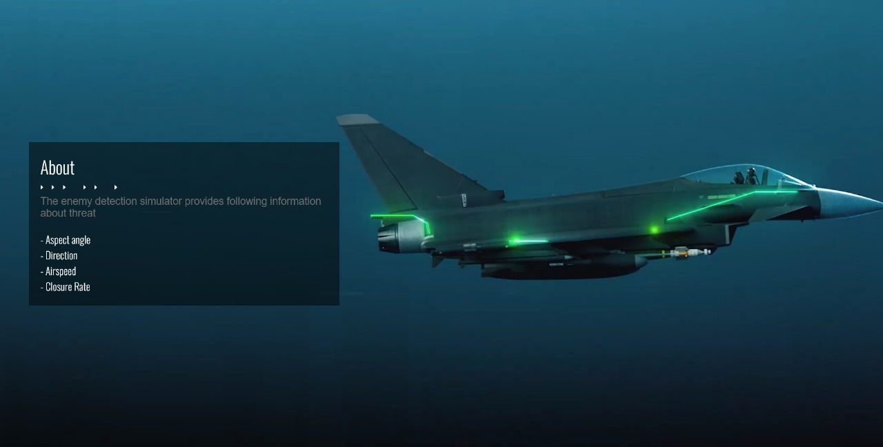**About Page**

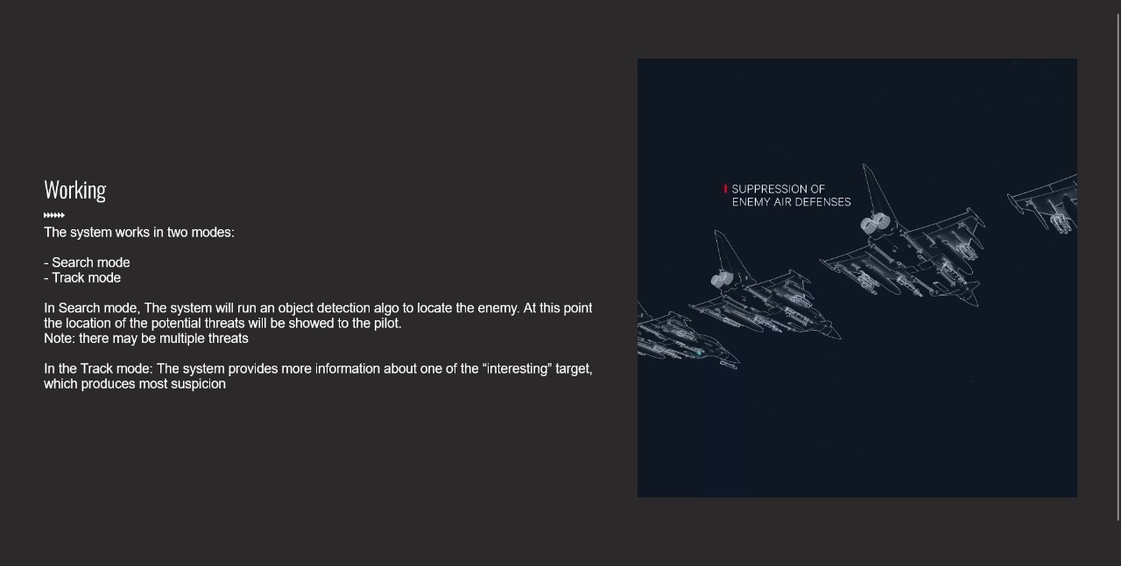

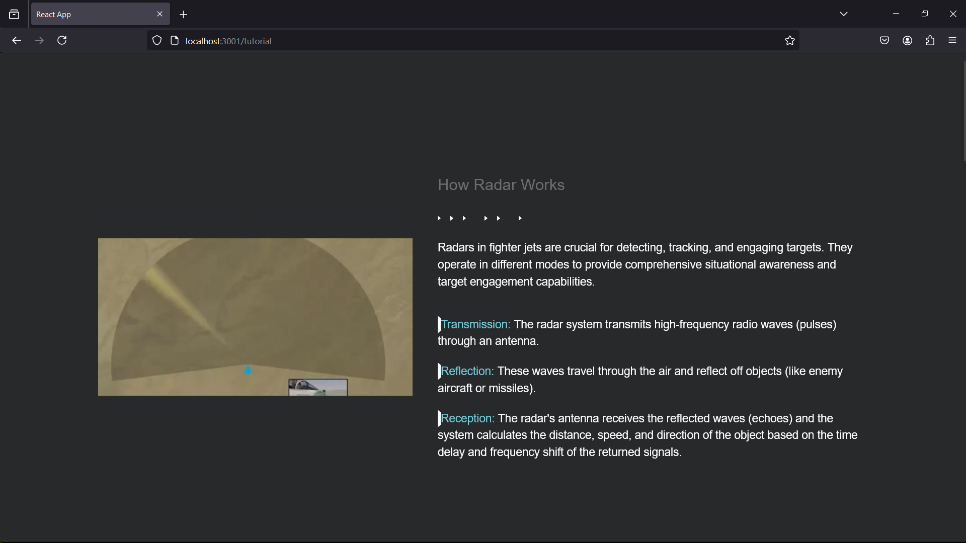**Learn Radar Page**

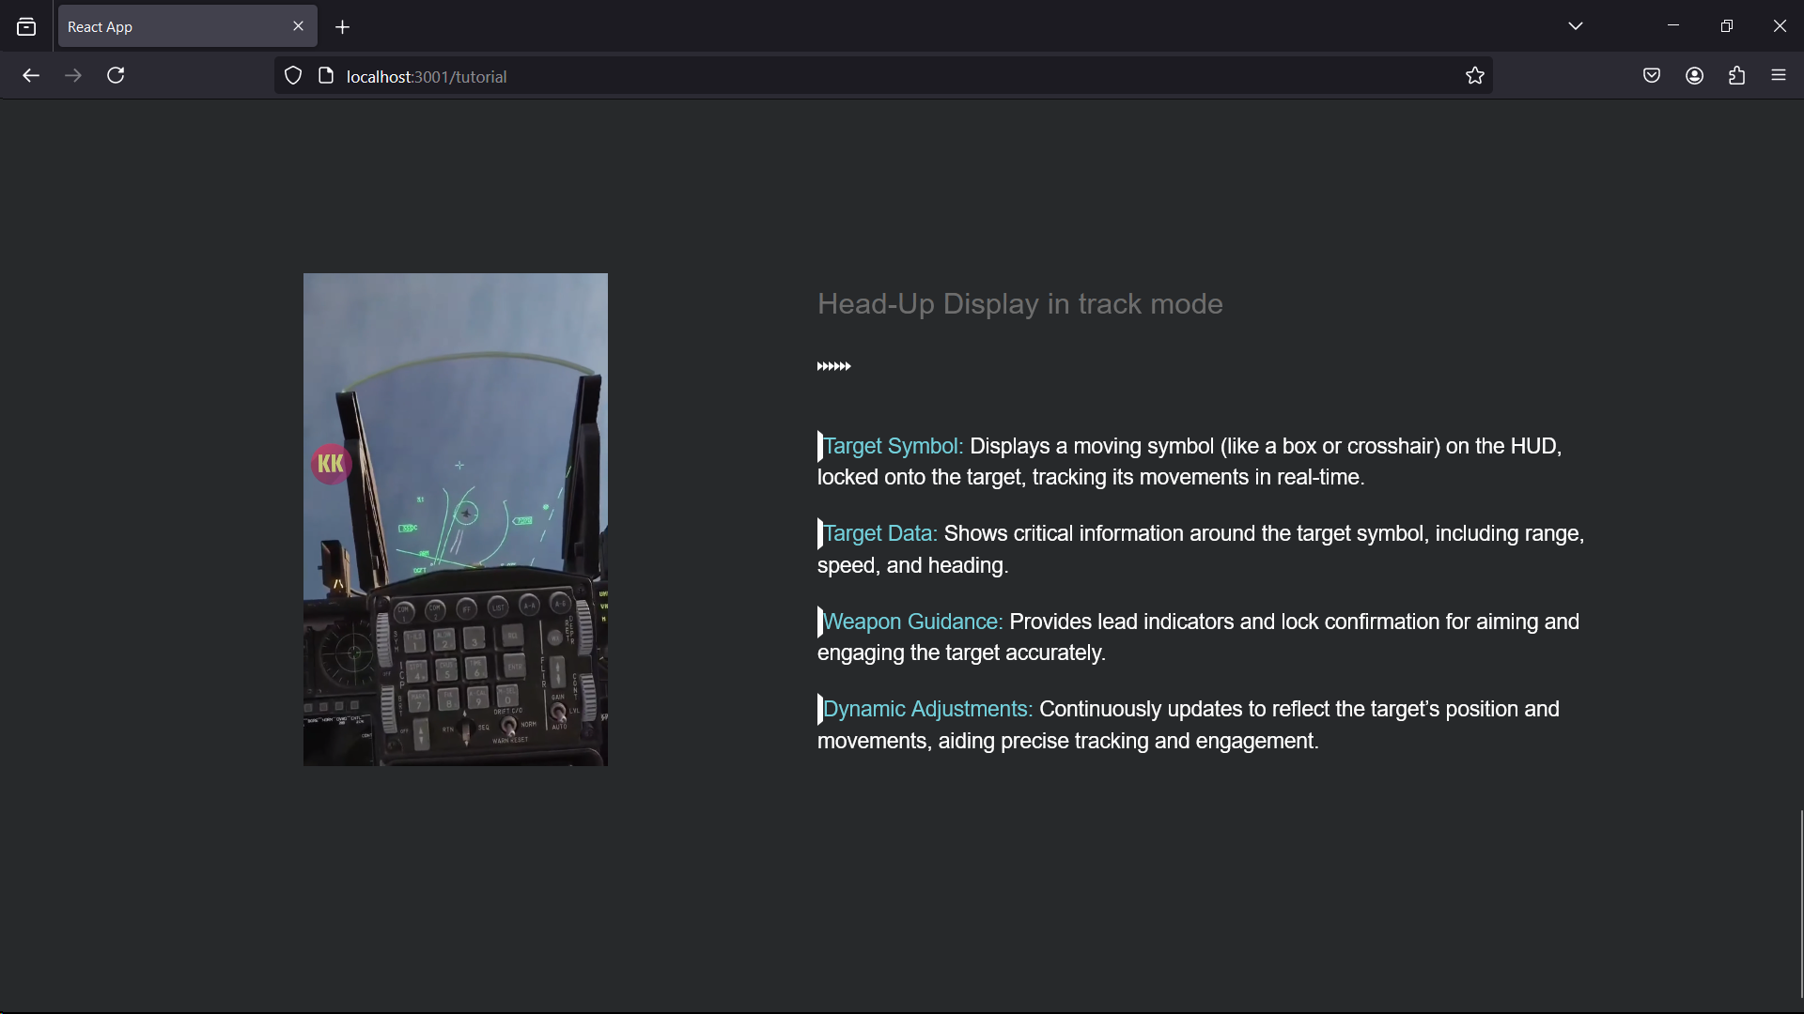

**Object Detection Page**

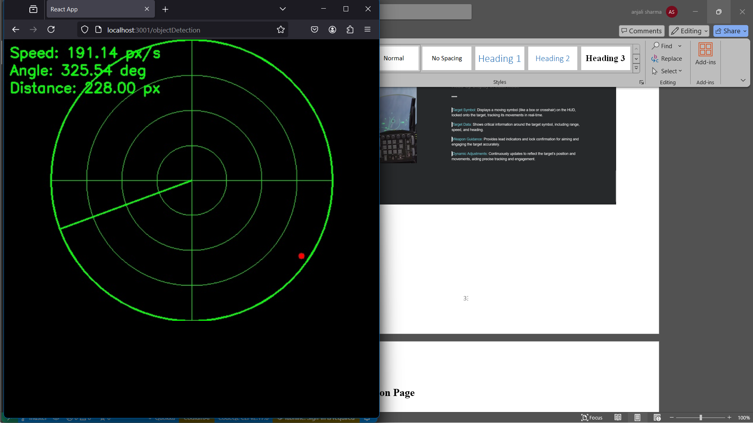

**CHAPTER 7**

**CONCLUSION AND FUTURE SCOPE**

**Conclusion**

The Enemy Detection System for Aircrafts exemplifies a leap forward in threat detection technology, harnessing advanced image processing, real-time data analysis, and a user-friendly interface to ensure effective monitoring of potential aerial threats. By leveraging RGB sensors, the system provides precise information on enemy aircraft speed, direction, aspect angle, and closure rate. The combination of vector algebra, trigonometry, and modern object detection algorithms delivers a robust platform for enhancing situational awareness and security for pilots and aircraft.

The current system operates efficiently in a horizontal plane, focusing on color-based detection to track and analyze enemy movement. It overlays this information on a radar-like background, simulating a real-world scenario that enhances the user experience. Additionally, the system uses Flask for the backend, React for the frontend, OpenCV for computer vision, and standard web technologies such as HTML, CSS, and JavaScript.

**Future Scope**

Looking ahead, the Enemy Detection System holds promising potential for growth and sophistication. Several areas for future development can transform this technology into a more comprehensive and versatile solution:

#### **1. Enhanced Detection and Classification**

**1.1 Machine Learning and AI Integration**

* **Advanced Recognition**: Implement machine learning models to identify various types of enemy aircraft, including drones and stealth vehicles, beyond the current color-based detection.
* **Behavior Analysis**: Utilize AI to analyze the behavior and trajectory of threats, predicting potential moves and enhancing response strategies.
* **Adaptive Detection**: Train AI models to adapt to different environments and lighting conditions, improving detection accuracy.

**1.2 Multispectral and Hyperspectral Imaging**

* **Infrared and Thermal Sensors**: Integrate these sensors to detect threats in low-visibility conditions and differentiate between heat signatures of enemy aircraft and other objects.
* **Expanded Detection Range**: Use hyperspectral imaging to identify materials and features of enemy aircraft that are not visible in the RGB spectrum.

#### **2. Advanced Tracking and Analysis**

**2.1 3D Object Detection**

* **Depth Perception**: Incorporate depth sensors like LiDAR to provide a three-dimensional view, enhancing the accuracy of threat positioning and tracking.
* **Real-Time 3D Mapping**: Develop capabilities for creating real-time 3D maps of the surroundings, improving spatial awareness.

**2.2 Predictive Analytics and Trajectory Estimation**

* **Predictive Modeling**: Use data analytics to forecast the future paths of detected threats, allowing for proactive measures.
* **Vector Analysis**: Enhance speed and direction analysis by factoring in altitude changes and complex maneuvers.

#### **3. User Interface Innovations**

**3.1 Augmented Reality (AR)**

* **AR HUDs (Heads-Up Displays)**: Integrate AR to overlay threat information directly onto the pilot's view, providing intuitive and immediate situational awareness.
* **Interactive Elements**: Enable pilots to interact with AR interfaces to access detailed threat data and control system responses.

**3.2 Customizable Dashboards**

* **Personalization**: Allow users to customize the information displayed according to their preferences and operational needs.
* **Enhanced Visualization**: Use advanced graphics and visual cues (e.g., heatmaps, dynamic models) to represent threat data more effectively.

#### **4. Scalability and Integration**

**4.1 Cloud and Edge Computing**

* **Cloud-Based Analytics**: Leverage cloud platforms for data storage, processing, and machine learning, enabling scalable and real-time analysis.
* **Edge Processing**: Implement edge computing to process data locally on the aircraft, reducing latency and ensuring real-time threat detection.

**4.2 Sensor Fusion**

* **Combined Sensors**: Fuse data from multiple sensors (e.g., radar, sonar, infrared) to create a comprehensive threat detection system.
* **Integrated Defense Systems**: Connect with broader defense systems for coordinated responses to detected threats.

#### **5. Expanded Applications**

**5.1 Civilian and Commercial Uses**

* **Air Traffic Management**: Adapt the system for use in civilian air traffic control, helping to monitor and manage aircraft to prevent collisions.
* **Wildlife Hazard Detection**: Use the technology to detect and track wildlife around airports, reducing the risk of animal strikes.

**5.2 Military and Defense**

* **Surveillance Drones**: Equip UAVs and drones with the system for enhanced surveillance and reconnaissance in military operations.
* **Combat Integration**: Integrate with combat aircraft systems to provide real-time threat detection and assist in tactical decision-making.

**5.3 Autonomous Vehicles**

* **Autonomous Aircraft**: Equip autonomous aircraft with the system to ensure they can detect and avoid threats independently.
* **UAV Applications**: Enhance UAV operations in both civilian and military contexts by providing advanced detection and navigation capabilities.

**6.1 Cybersecurity Measures**

* **Data Encryption**: Ensure all data transmitted and stored by the system is encrypted to protect against unauthorized access.
* **Access Control**: Implement robust access controls and authentication mechanisms to secure sensitive information.

**6.2 Regulatory Compliance**

* **Aviation Standards**: Ensure compliance with international aviation safety standards and regulations for reliable and safe operation.
* **Data Privacy**: Adhere to data privacy laws to protect user information and maintain trust.

**REFERENCES**

1. <https://migflug.com/jetflights/how-fighter-jets-target-and-lock-on-enemy-jets/#:~:text=The%20main%20technology%20that%20a,in%20a%20zig%2Dzag%20pattern>
2. <https://www.iiss.org/online-analysis//military-balance/2019/03/f-35-situational-awareness>
3. <https://www.eurofighter.com/>
4. <https://youtube.com/shorts/fW5OD0aMpf0?si=a_mobYYBBsEn5EN9>
5. https://youtube.com/shorts/fW5OD0aMpf0?si=a_mobYYBBsEn5EN9