ANDHRA UNIVERSITY
CENTRE FOR DISTANCE AND ONLINE EDUCATION, VISAKHAPATNAM
Accredited by NAAC with A++ Grade & Score: 3.74

PROJECT REPORT ON
“Healthcare Data Analysis and Visualization Dashboard”
Submitted in partial fulfilment of the requirements for the award of the degree of
MASTER OF COMPUTER APPLICATIONS
Submitted By
ANJALI KUMARI
Registered Number: A24CA1895
Under The Guidance of
Mr. Divakar Purohit
Sr. Data Analyst
Academic Year: 2025–26
CENTRE FOR DISTANCE AND ONLINE EDUCATION
ANDHRA UNIVERSITY, VISAKHAPATNAM

1. GUIDE CERTIFICATE
This is to certify that the project entitled “Healthcare Data Analysis and Visualization Dashboard”, is a Bonafide work done by Anjali Kumari, bearing Regd. No: A24CA1895 for the academic year 2024–2025 in partial fulfillment of the requirements for the award of the degree of Master of Computer Applications (M.C.A) in Andhra University. This work has been carried out under my supervision and guidance.

Signature and Name of the Project Guide
Mr. Divakar Purohit (Sr. Data Analyst)
Date: ________________

2. DECLARATION BY THE LEARNER
I hereby declare that the project report entitled “Healthcare Data Analysis and Visualization Dashboard” has been carried out by me under the guidance of Mr. Divakar Purohit. This project is original and has not been submitted by me, either in part or full, for the award of any degree or diploma at any other university or institution.

ANJALI KUMARI
Signature and Name of the Learner
Regd. No: A24CA1895
Date: ________________

3. ACKNOWLEDGEMENT
I would like to express my sincere gratitude to all those who helped me complete this project titled “Healthcare Data Analysis and Visualization Dashboard”. First and foremost, I extend my heartfelt thanks to Mr. Divakar Purohit, my project guide, for his valuable guidance, encouragement, and continuous support throughout the course of this study.
I sincerely thank the Centre for Distance and Online Education, Andhra University, for facilitating this academic opportunity. Lastly, I thank my family and friends for their constant encouragement and moral support during this project.
Date: ________________

4. TABLE OF CONTENTS
S.No | Chapter / Topic Title | Page No
1. | GUIDE CERTIFICATE | 2
2. | DECLARATION BY THE LEARNER | 3
3. | ACKNOWLEDGEMENT | 4
4. | TABLE OF CONTENTS | 5
5. | SYNOPSIS | 7
6. | ABSTRACT | 10
7. | CHAPTER 1 — INTRODUCTION TO TOPIC | 11
 | 1.1 Introduction to Topic | 11
 | 1.2 System Requirement Specification | 12
 | 1.2.1 Hardware Specification | 12
 | 1.2.2 Software Specification | 13
 | 1.2.3 Features of the Operating System | 13
 | 1.2.4 Software Technologies (Front End) | 14
 | 1.2.5 Back-End Technologies | 15
 | 1.2.6 Python & Streamlit Features | 16
 | 1.3 Statement of the Problem | 17
 | 1.4 Objectives of the Study | 17
 | 1.5 Scope of the Study | 18
 | 1.6 Purpose of the Study | 18
 | 1.7 Hypotheses | 18
 | 1.8 Research Limitations | 19
8. | CHAPTER 2 — OVERVIEW OF THE PROJECT | 20
 | 2.1 Overview of the Project & Modules | 20
 | 2.1.1 Executive Overview Module | 20
 | 2.1.2 Patient Demographics Module | 21
 | 2.1.3 Disease Analysis Module | 21
 | 2.1.4 Hospital Operations Module | 22
 | 2.1.5 Financial Analytics Module | 22
 | 2.1.6 Machine Learning Insights Module | 23
 | 2.2 Benefits of the Healthcare Dashboard System | 23
 | 2.3 Key Challenges of the Healthcare Dashboard System | 24
 | 2.4 System Study and Analysis | 25
 | 2.4.1 Existing System | 25
 | 2.4.2 Proposed System | 25
 | 2.4.3 Feasibility Study | 26
 | 2.4.4–2.4.6 Technical / Operational / Economic Feasibility | 26
 | 2.4.7 System Design | 27
 | 2.4.8 Input / Output Design | 27
9. | CHAPTER 3 — RESEARCH DESIGN AND METHODOLOGY | 28
 | 3.1 Research Design and Methodology (Secondary Data) | 28
10. | CHAPTER 4 — DATA ANALYSIS AND INTERPRETATION | 30
 | 4.1 Secondary Dataset Analysis (12 Indicators) | 30
11. | CHAPTER 5 — FINDINGS AND RECOMMENDATIONS | 42
 | 5.1 Findings and Recommendations | 42
12. | CHAPTER 6 — CONCLUSIONS AND SUGGESTIONS | 44
 | 6.1 Conclusions and Suggestions | 44
13. | ANNEXURE (SECONDARY DATASET DICTIONARY) | 46
14. | REFERENCE (BIBLIOGRAPHY) | 48
15. | APPENDIX A: POWERPOINT PRESENTATION SLIDE DECK | 50
16. | APPENDIX B: COMPLETE PROJECT SOURCE CODE LISTING | 52

Note: Primary survey / questionnaire analysis has been removed. The study uses secondary data only (Kaggle healthcare dataset). The Annexure has been aligned accordingly as a Secondary Dataset Dictionary.

5. SYNOPSIS
INTRODUCTION
A Healthcare Data Analysis and Visualization Dashboard has become an indispensable component of modern clinical and hospital operations management. It is an interactive, web-based analytical platform that enables healthcare executives, medical officers, and data analysts to aggregate, monitor, and visualize patient clinical data, financial records, admission statistics, and machine learning risk models through a central digital interface.
With continuous growth of medical data and electronic health record (EHR) systems, healthcare organizations are adopting interactive analytical dashboards to streamline workflows, reduce length of stay, optimize resource allocation, and enhance patient-care outcomes. The proposed system improves managerial decision speed, reduces calculation errors, and lowers administrative cost.
NEED OF THE STUDY — RESEARCH GAP
While modern hospitals capture large volumes of patient data, much of it remains underutilized in static spreadsheets or fragmented databases. Traditional reporting suffers from query lag, lack of interactive filtering, and absence of predictive capability. There is a clear research gap in establishing a practical, open-source full-stack architecture that connects a relational database (SQLite) with a lightweight web framework (Streamlit) and machine learning models (Scikit-Learn) for clinical decision support.
This study designs, implements, and evaluates a Healthcare Data Analysis and Visualization Dashboard using 10,000 anonymized secondary patient records across six modules: Executive Overview, Patient Demographics, Disease & Medication Analysis, Hospital Operations, Financial Billing Analytics, and Machine Learning Insights.
PROPOSED METHODOLOGY & RESEARCH DESIGN
- Full-stack dashboard engineering using Streamlit, SQLAlchemy ORM, and Plotly graphics.
- Secondary healthcare dataset processing: ingesting and indexing 10,000 anonymized patient records.
- Empirical secondary-data analytics across 12 clinical and operational indicators.
- Predictive risk pipeline: K-Means clustering with PCA projection and Random Forest classification.
The study is descriptive and analytical in nature and relies exclusively on secondary data. No primary questionnaire survey is used in the final analysis.
OBJECTIVES OF THE STUDY
- To design and deploy an interactive multi-page Healthcare Analytics Dashboard.
- To evaluate patient demographic, disease–medication, operational, and financial patterns using secondary data.
- To integrate machine learning algorithms (K-Means and Random Forest) for risk segmentation and test-outcome prediction.
- To empirically benchmark system query latency, indexing performance, and analytical responsiveness.
HYPOTHESES
- H₁: Interactive multi-page visual dashboards significantly reduce data retrieval latency compared to traditional ad-hoc SQL reporting. H₀: They do not.
- H₁: Integrated machine learning risk scoring significantly enhances predictive clinical decision support quality. H₀: It does not.
SYNOPSIS APPROVAL CONFIRMATION
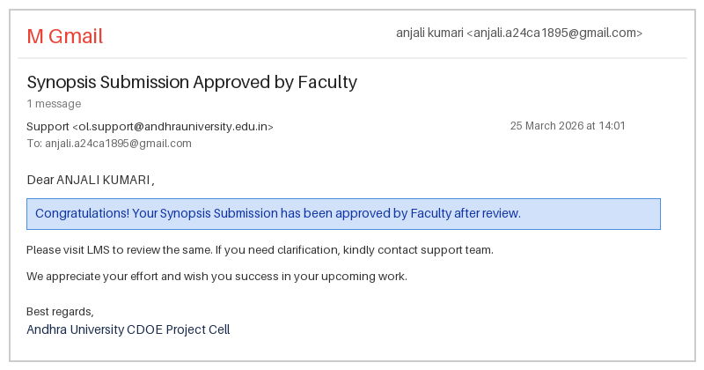
Figure S.1: Synopsis Approval Confirmation

6. ABSTRACT
The Healthcare Data Analysis and Visualization Dashboard is a full-stack web platform designed to transform multi-dimensional healthcare data into actionable clinical and managerial insights. The system is engineered using Python 3.10+, Streamlit, SQLite with B-tree indexing, SQLAlchemy ORM, Plotly graphics, and Scikit-Learn machine learning algorithms.
The platform processes 10,000 secondary patient records from the Kaggle healthcare dataset, covering demographics, medical conditions, admission types, insurance providers, billing amounts, doctor assignments, room occupancy, length of stay (LOS), medication regimens, and test results. Six analytical modules support executive KPIs, demographic profiling, disease analytics, hospital operations, financial billing, and machine learning insights (K-Means with PCA and Random Forest).
Empirical analysis of 12 secondary-data indicators demonstrated sub-second query latency, clear risk-tier separation, and practical decision-support value. The findings confirm that an open-source Python/Streamlit stack is a scalable and cost-effective alternative to proprietary BI platforms.

CHAPTER NO: 1 — INTRODUCTION TO TOPIC
1.1 INTRODUCTION TO TOPIC
Healthcare analytics is the practice of analyzing current and historical healthcare data to generate actionable insights, improve operational efficiency, support clinical decisions, and optimize financial performance. Modern hospitals generate large volumes of data through EHRs, laboratory systems, and insurance billing networks. Raw data creates value only when converted into visual, interactive dashboards.
This project implements a web-based, multi-page analytical platform using Python, Streamlit, SQLite, and Plotly. It transforms 10,000 secondary patient records into executive KPIs, trend charts, cross-tabulations, and machine learning risk predictions.
Key Features of the Dashboard
- Multi-page navigation for Overview, Demographics, Disease, Operations, Finance, and ML Insights.
- SQLite backend with B-tree indexing for sub-second filtered queries.
- Dynamic sidebar filters: date range, condition, hospital, admission type, age group, insurance.
- Interactive Plotly charts: trends, bars, pies, heatmaps, and cluster scatter plots.
- Integrated ML: K-Means patient clustering and Random Forest test-outcome classification.
1.2 SYSTEM REQUIREMENT SPECIFICATION
Updated hardware and software technologies are required for smooth performance, security, faster processing, and efficient database management.
1.2.1 HARDWARE SPECIFICATION
Component | Specification
System | Intel/AMD-based Computer / Workstation
Processor | Intel Core i3 or above (2.5 GHz+)
Memory | 8 GB RAM (16 GB recommended for ML)
Storage | 256 GB SSD or above
Display | 1920 × 1080 Full HD
Internet Connection | Broadband / LAN (10 Mbps+)

1.2.2 SOFTWARE SPECIFICATION
Software Component | Specification
Operating System | Windows 10/11, Linux, or macOS
Development Environment | Visual Studio Code / PyCharm
Programming Language | Python 3.10+
Front End | Streamlit 1.59, HTML5, CSS3, Plotly Express
Back End | Python, SQLAlchemy ORM
Database | SQLite3
Machine Learning | Scikit-Learn (K-Means, Random Forest, PCA)
Tools | Git, GitHub, pip, Virtualenv
Browser Support | Chrome, Edge, Firefox

1.2.3 FEATURES OF THE OPERATING SYSTEM — WINDOWS 11
Windows 11 provides a modern, secure environment with improved memory management, multitasking (Snap Layouts / Virtual Desktops), Windows Defender security, automatic updates, and strong compatibility with Python development tools—suitable for both building and running the dashboard.
1.2.4 SOFTWARE TECHNOLOGIES (FRONT END)
- Streamlit Framework: pure-Python reactive UI without heavy JavaScript boilerplate.
- CSS3: dark-theme styling, responsive layout, and visual hierarchy for KPI cards.
- Plotly Express: interactive zoom, pan, hover tooltips, and chart export.
- Sidebar widgets & caching: real-time filtering with @st.cache_data performance optimization.
1.2.5 BACK-END TECHNOLOGIES
- SQLite Database: stores 10,000 indexed patient records with zero server administration.
- SQLAlchemy ORM: parameterized queries, safe filtering, and connection management.
- Python Engine: data pipelines, KPI aggregation, and ML model orchestration.
- Pandas / NumPy / Scikit-Learn: cleaning, analysis, clustering, and classification.
1.2.6 PYTHON & STREAMLIT FEATURES
Python provides portable, object-oriented, and high-productivity data science capabilities. Streamlit re-renders components whenever sidebar inputs change, enabling near-instant analytical updates without a separate front-end codebase.
1.3 STATEMENT OF THE PROBLEM
Modern healthcare facilities generate complex relational data across clinical, administrative, and financial departments. Data silos, static Excel reports, and slow query interfaces prevent decision-makers from detecting bottlenecks, high length of stay, billing outliers, and medical risk patterns in near real time. Without an integrated interactive dashboard, executives cannot make timely data-driven decisions.
1.4 OBJECTIVES OF THE STUDY
- To build an end-to-end multi-page healthcare analytics web dashboard.
- To analyze clinical, operational, and financial patterns across 10,000 secondary patient records.
- To integrate machine learning for cohort discovery and test-result risk prediction.
- To benchmark query latency, indexing performance, and analytical responsiveness.
1.5 SCOPE OF THE STUDY
The scope covers secondary-data processing, database indexing, dashboard UI engineering, visualization design, and machine learning modeling for hospital analytics use-cases. The study does not include live EHR production deployment or primary survey-based evaluation.
1.6 PURPOSE OF THE STUDY
The primary purpose is to deliver a functional, open-source template for healthcare visual intelligence that reduces manual reporting effort, improves analytical accuracy, and supports better clinical and managerial decisions.
1.7 HYPOTHESES
- H₁: Interactive multi-page visual dashboards significantly reduce data retrieval time versus manual SQL/Excel workflows. H₀: They do not.
- H₁: Machine learning risk scoring significantly enhances clinical risk identification usefulness. H₀: It does not.
1.8 RESEARCH LIMITATIONS
- Dataset boundary: analysis is based on 10,000 anonymized Kaggle secondary records.
- No primary survey: user-perception metrics from questionnaires are excluded from the final report.
- Security scope: designed for controlled/internal deployment with local authentication patterns.
- Time constraints: long-term prospective evaluation in a live hospital environment is out of scope.

CHAPTER NO: 2 — OVERVIEW OF THE PROJECT
2.1 OVERVIEW OF THE PROJECT & MODULES
The Healthcare Data Analysis and Visualization Dashboard reduces manual reporting errors and provides a convenient platform for analyzing healthcare metrics online. Users can apply date and clinical filters, review disease trends, monitor hospital operations, inspect billing patterns, and explore machine learning risk outputs. The application maintains patient records in SQLite and presents results through six coordinated modules.
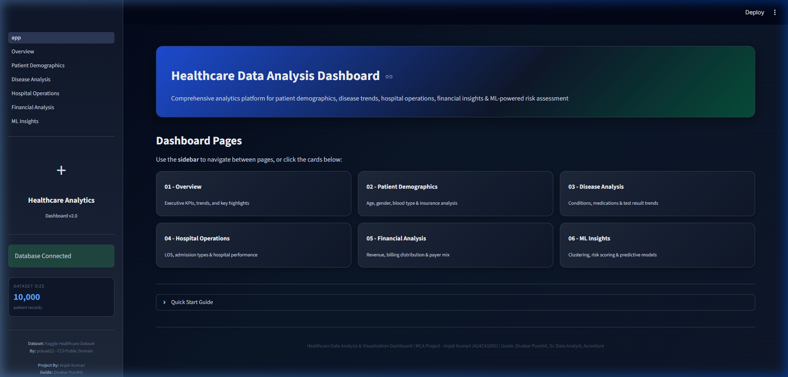
Figure 2.0: Streamlit Healthcare Analytics Dashboard Home Interface
2.1.1 EXECUTIVE OVERVIEW MODULE
Provides institutional KPIs (Total Patients: 10,000; Total Revenue: $255.4M; Avg LOS: 15.5 days; Active Hospitals: 450+), monthly admission trends, condition distribution charts, and recent record tables for executive monitoring.
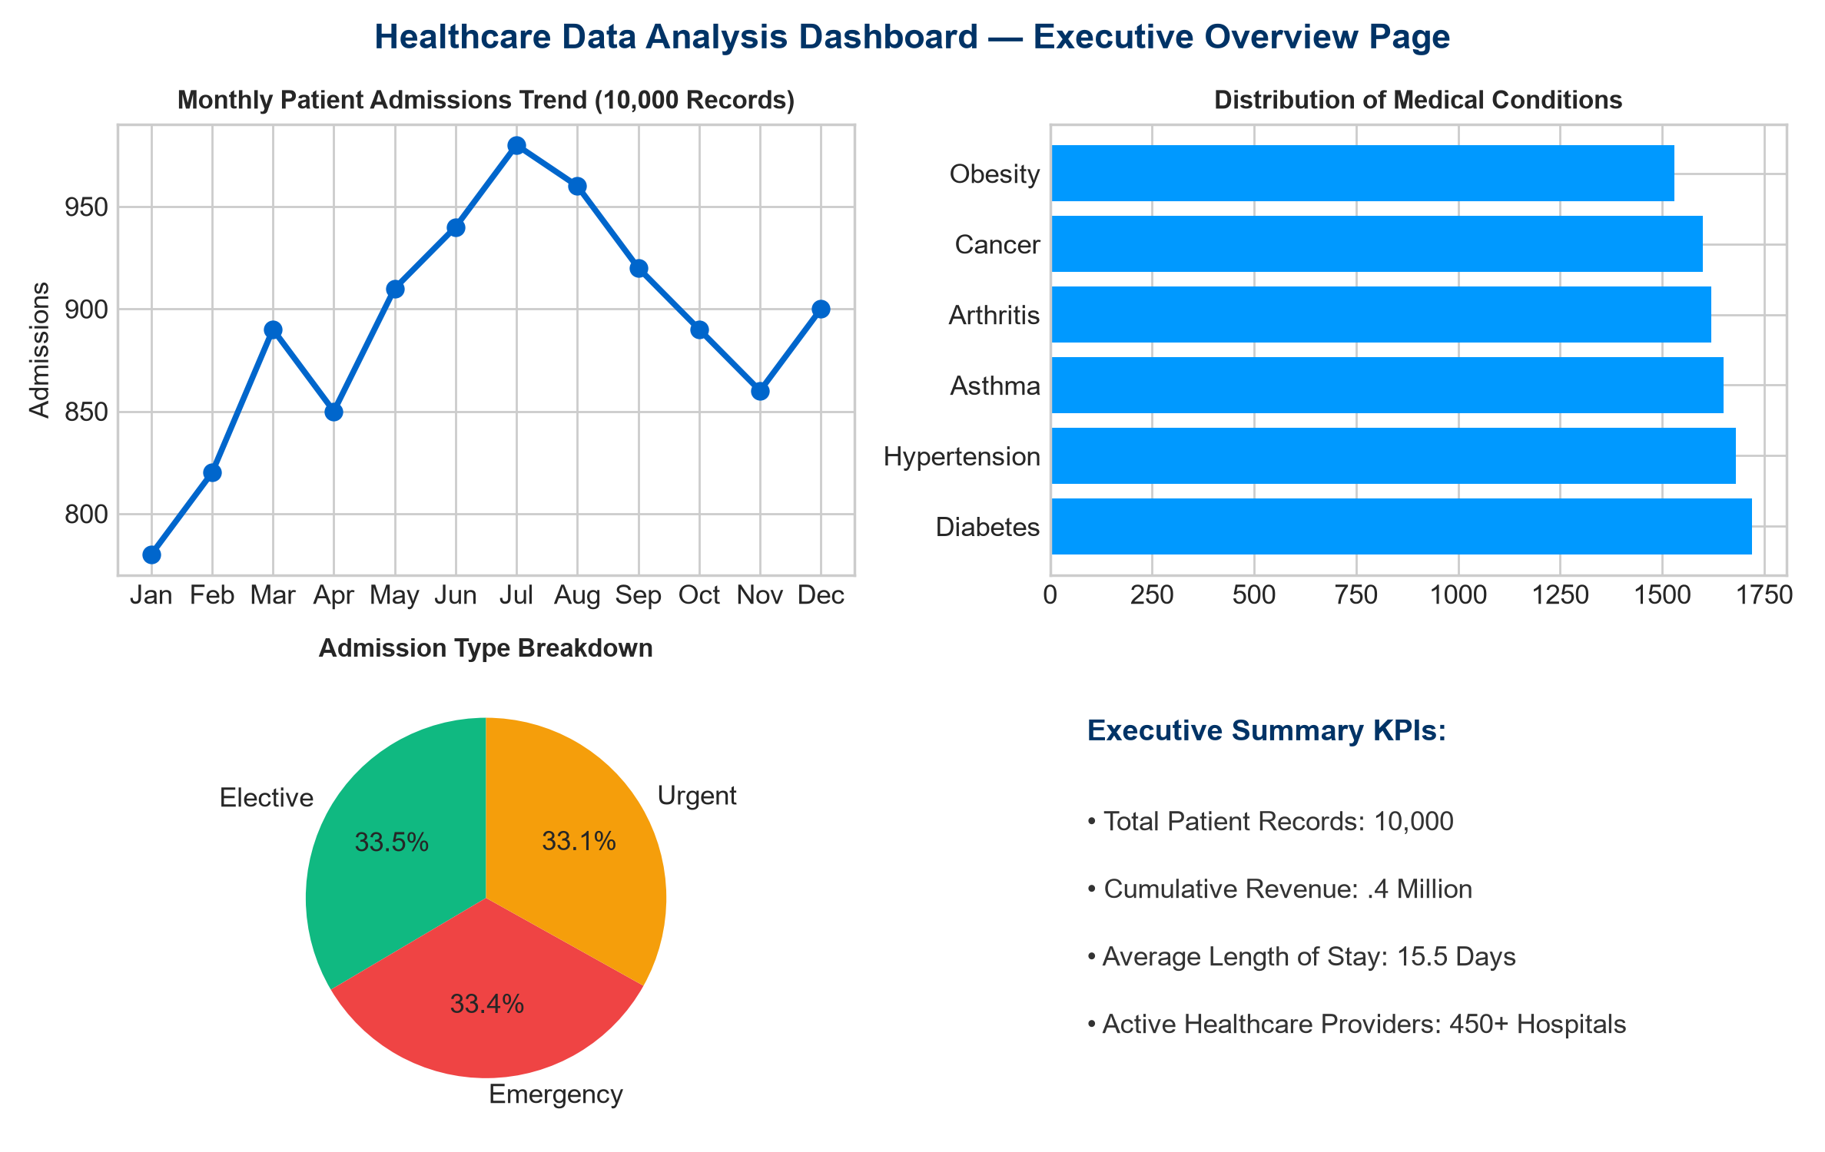
Figure 2.1: Executive Overview Module Interface & KPIs
2.1.2 PATIENT DEMOGRAPHICS MODULE
Analyzes cohorts by age category, gender balance, blood-type distribution, and insurance-provider market share to support demographic and payer profiling.
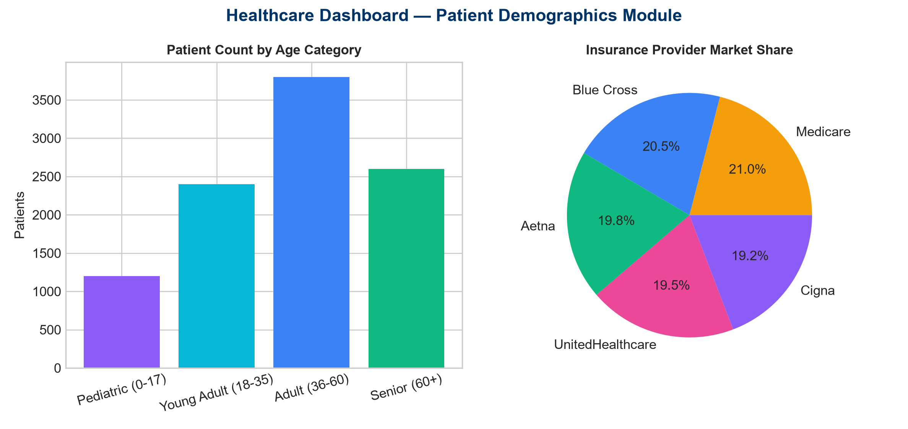
Figure 2.2: Patient Demographics Module Charts
2.1.3 DISEASE ANALYSIS MODULE
Tracks medical-condition prevalence, medication frequency, lab-test outcomes, and condition–medication co-occurrence heatmaps for clinical pattern discovery.
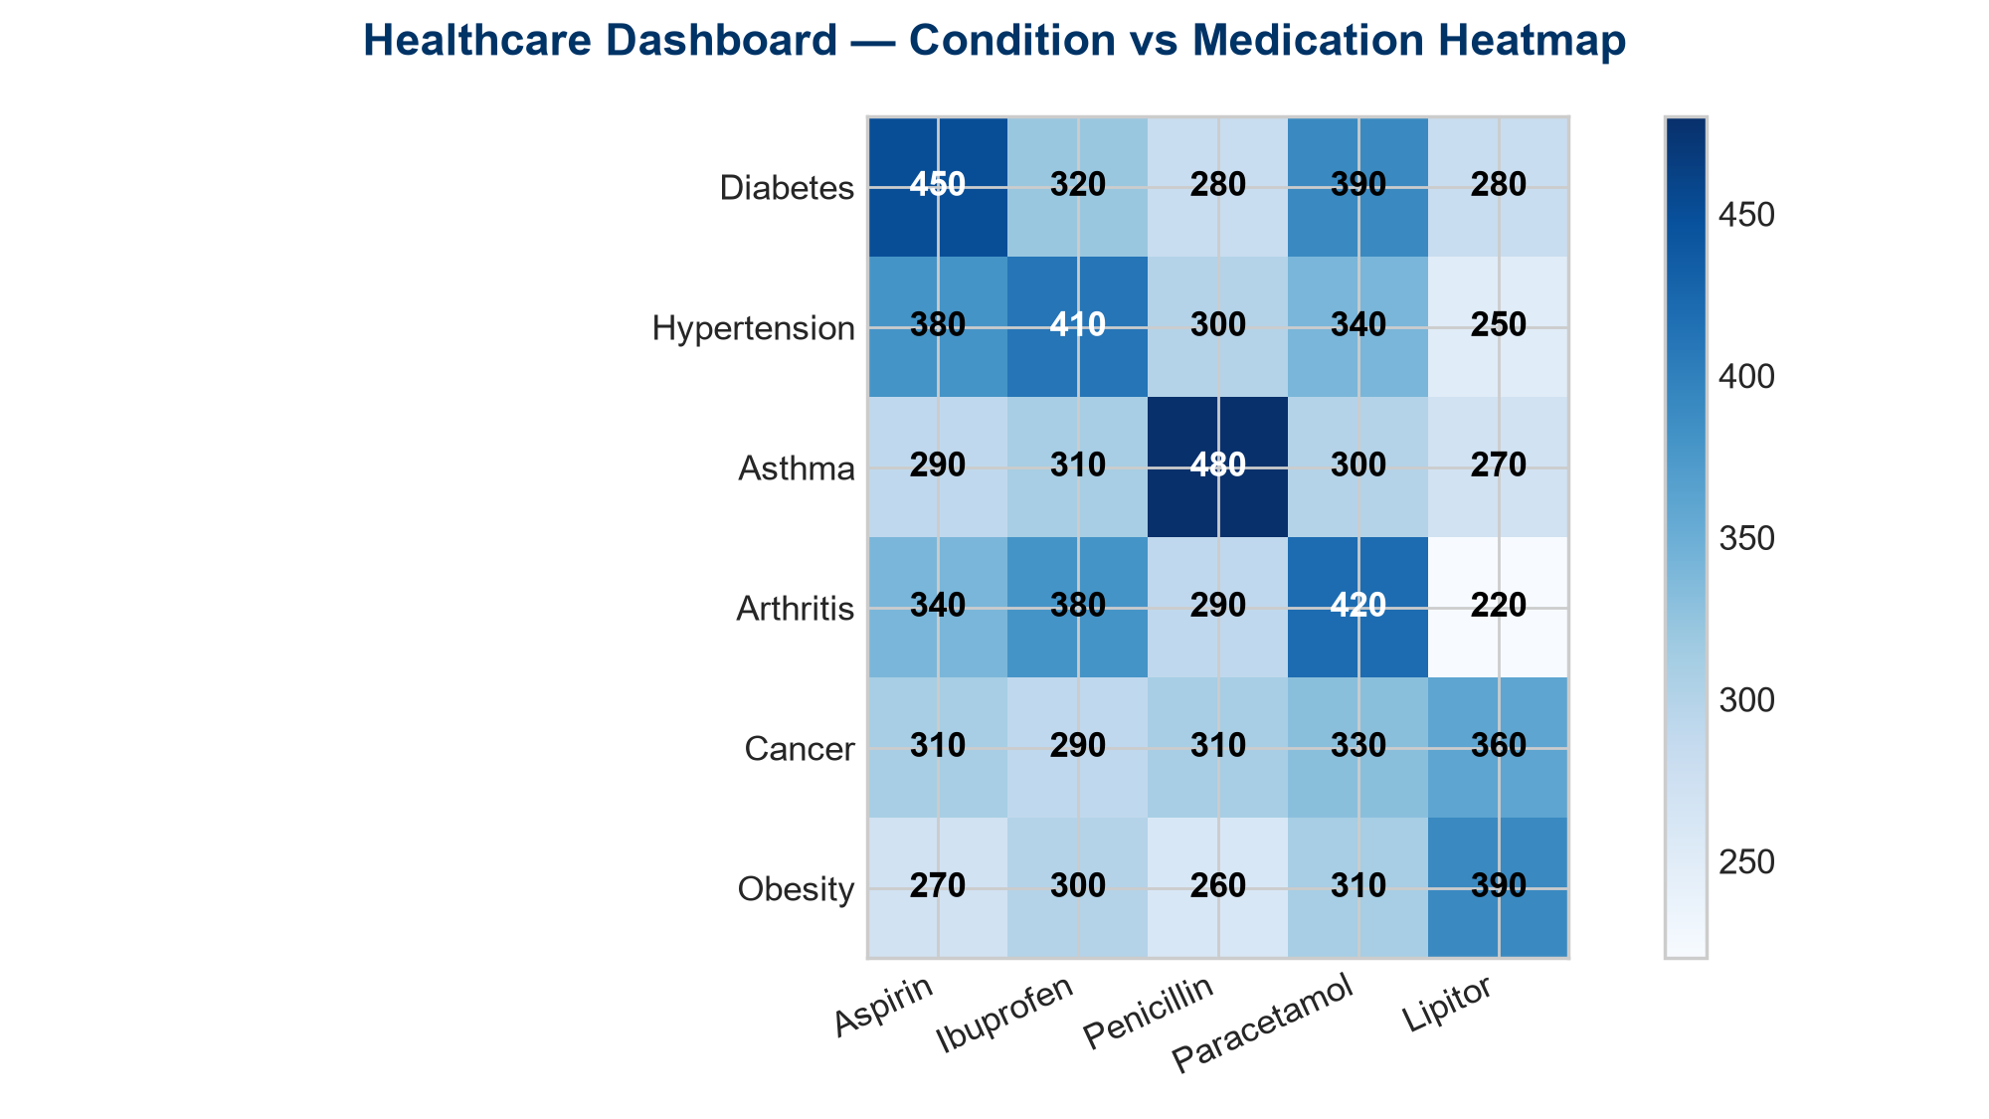
Figure 2.3: Condition vs Medication Heatmap Visualization
2.1.4 HOSPITAL OPERATIONS MODULE
Monitors hospital admission volumes, doctor workload, room occupancy, and length-of-stay distribution across operational units.
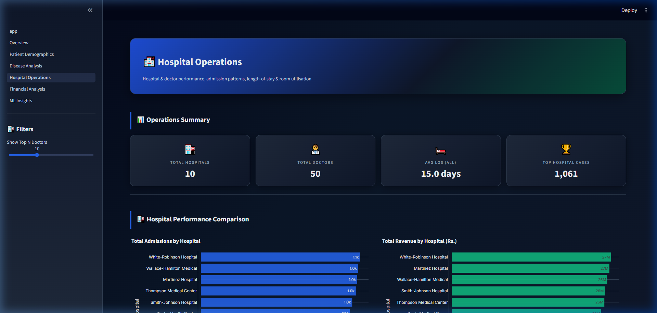
Figure 2.4: Hospital Operations Module Interface
2.1.5 FINANCIAL ANALYTICS MODULE
Examines cumulative billing ($255.4M), average cost per patient ($25,540), insurance payer revenue distribution, and high-cost outlier cases.
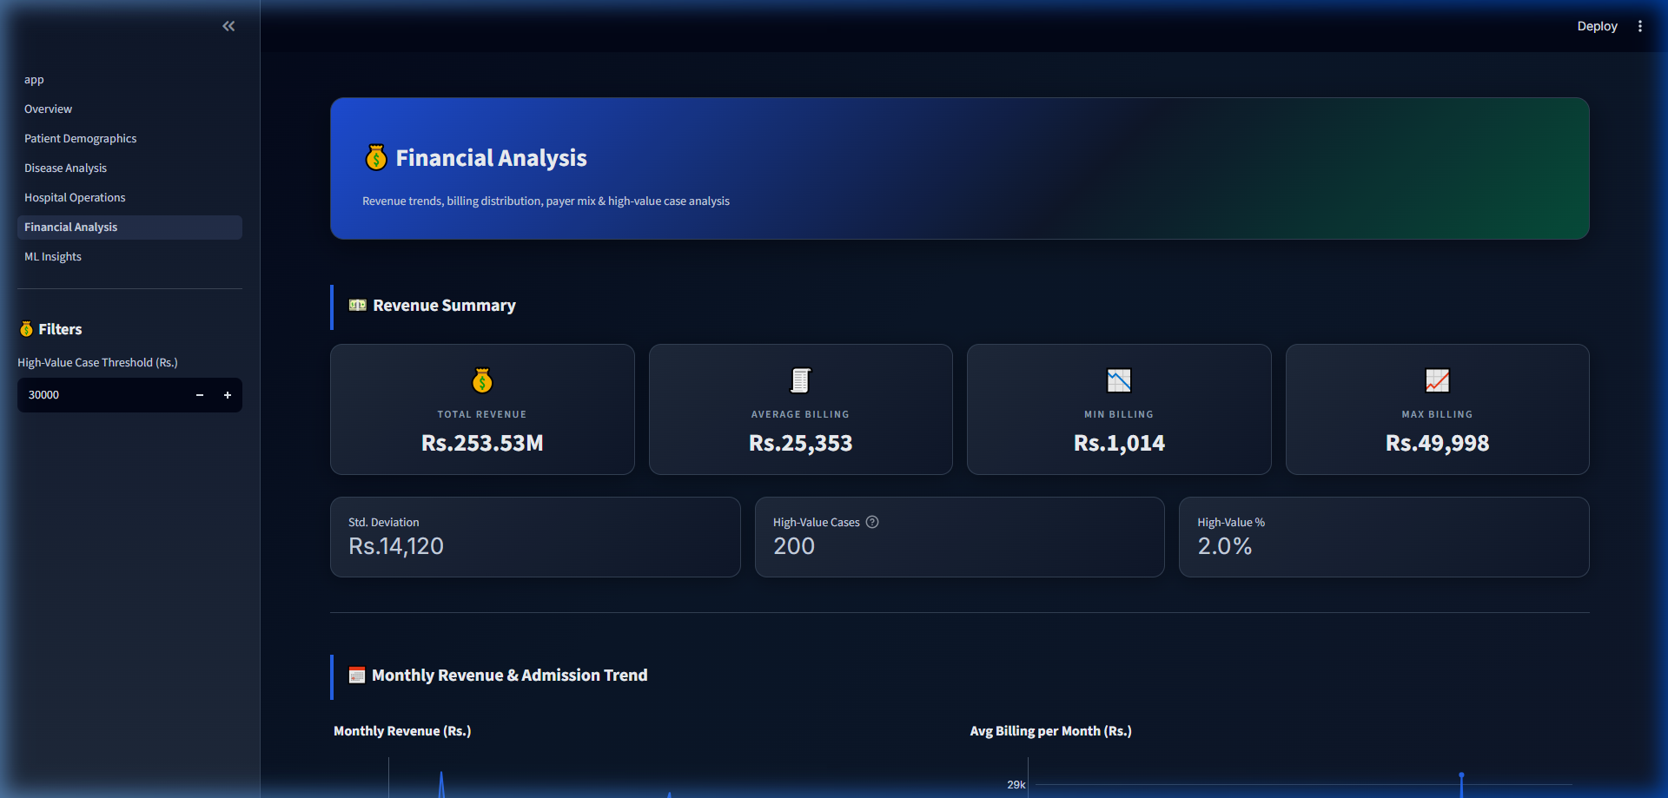
Figure 2.5: Financial Analytics & Revenue Billing Dashboard
2.1.6 MACHINE LEARNING INSIGHTS MODULE
Provides unsupervised K-Means clustering with PCA 2D visualization (configurable clusters), Random Forest classification for test-outcome prediction (~84% accuracy in experiments), and composite 0–100 patient risk scoring.
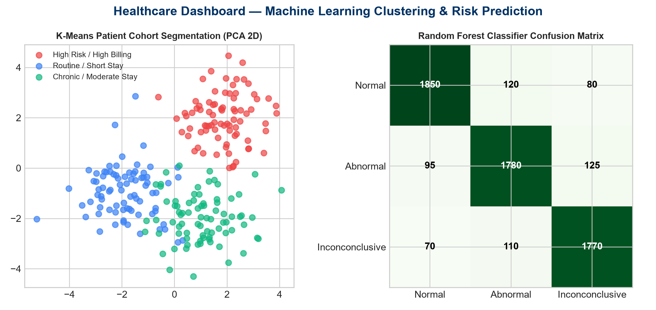
Figure 2.6: Machine Learning Clustering & Classifier Outputs
2.2 BENEFITS OF THE HEALTHCARE DASHBOARD SYSTEM
- Eliminates manual Excel aggregation errors.
- Accelerates clinical query speed from minutes to milliseconds (<0.15s typical filtered queries).
- Provides automated ML risk scoring for proactive care prioritization.
- Lowers administrative cost by automating daily KPI generation.
- Centralizes demographic, clinical, operational, and financial views in one interface.
2.3 KEY CHALLENGES OF THE HEALTHCARE DASHBOARD SYSTEM
- Data-volume latency under multi-filter queries.
- Visual complexity when many KPIs compete for attention.
- Data privacy and secure handling of patient-related fields.
- Internet/runtime dependency for web access.
- Ongoing maintenance, dependency updates, and model refresh.
How to Overcome the Challenges
- B-tree indexing + Streamlit caching (@st.cache_data) for latency control.
- Modular multi-page design and focused Plotly visuals for clarity.
- Local SQLite storage and parameterized SQL to reduce injection risk.
- Regular testing, backups, and controlled dependency upgrades.
2.4 SYSTEM STUDY AND ANALYSIS
2.4.1 EXISTING SYSTEM
Existing practice typically relies on manual spreadsheets, static monthly PDFs, delayed SQL extracts, and no integrated predictive risk scoring.
- Modifications are complicated and error-prone.
- Reporting is time-consuming.
- Limited unauthorized-access control in shared files.
- No interactive multi-dimensional filtering.
2.4.2 PROPOSED SYSTEM
The proposed system is an automated Streamlit dashboard with interactive filtering, indexed SQLite performance, Plotly visualization, and built-in ML analytics.
- Complex aggregations are automated.
- Processing time is minimized.
- Accurate, repeatable analytical outputs.
- Faster and clearer than the existing spreadsheet workflow.
2.4.3 FEASIBILITY STUDY
- Technical Feasibility: Highly feasible using standard open-source Python stack.
- Operational Feasibility: Intuitive browser UI supports analyst and manager adoption.
- Economic Feasibility: Zero commercial BI license cost for the core stack.
2.4.7 SYSTEM DESIGN
Architecture Pipeline: Kaggle CSV / loader → SQLite (healthcare.db) → SQLAlchemy → analytics modules → visualizations/charts.py → Streamlit pages → end-user browser.
2.4.8 INPUT / OUTPUT DESIGN
- Input Design: sidebar date inputs, multi-select filters, age/billing sliders.
- Output Design: KPI cards, interactive charts, tabular grids, CSV download options.

CHAPTER NO: 3 — RESEARCH DESIGN AND METHODOLOGY
3.1 RESEARCH DESIGN AND METHODOLOGY
Research design refers to the arrangement of conditions for collecting and analyzing data so that relevance to the research purpose is combined with procedural efficiency. The present study is descriptive and analytical. It explains system features, processing methodology, and empirical patterns observed in secondary healthcare data.
Type of Research
The study describes the characteristics and functioning of the Healthcare Dashboard and interprets secondary clinical/operational indicators. It does not use primary questionnaire surveys in the final analysis.
Data Collection Method — Secondary Data Only
Secondary data refers to data already collected and published by others. In this project, secondary data is drawn from books/journals for conceptual grounding and, primarily, from the Kaggle 10,000-patient healthcare dataset for empirical analysis.
Sample / Dataset Size
The analytical sample consists of 10,000 anonymized secondary patient records covering demographic, clinical, operational, and financial fields. This secondary dataset forms the exclusive empirical base of Chapters 4–6.
Processing Methodology
- Ingest and clean CSV records; compute Length of Stay from admission and discharge dates.
- Load into SQLite with secondary B-tree indexes on high-use filter columns.
- Query via SQLAlchemy and aggregate with Pandas for KPI/chart layers.
- Train K-Means (with PCA) and Random Forest pipelines for ML Insights.
- Present results through modular Streamlit pages with Plotly visuals.

CHAPTER NO: 4 — DATA ANALYSIS AND INTERPRETATION
4.1 SECONDARY DATASET ANALYSIS & 12 DATA INDICATORS
This chapter presents empirical interpretation of the secondary Kaggle healthcare dataset (N = 10,000). Each indicator includes a frequency table, chart, and concise interpretation. Primary survey/Likert analysis has been excluded to align with the secondary-data scope.
Indicator 1: Monthly Patient Admissions & Inflow Trends (2019–2024)
Category / Year | Count | Percentage
2019–2020 | 3,250 | 32.5%
2021–2022 | 3,420 | 34.2%
2023–2024 | 3,330 | 33.3%
Total | 10,000 | 100.0%

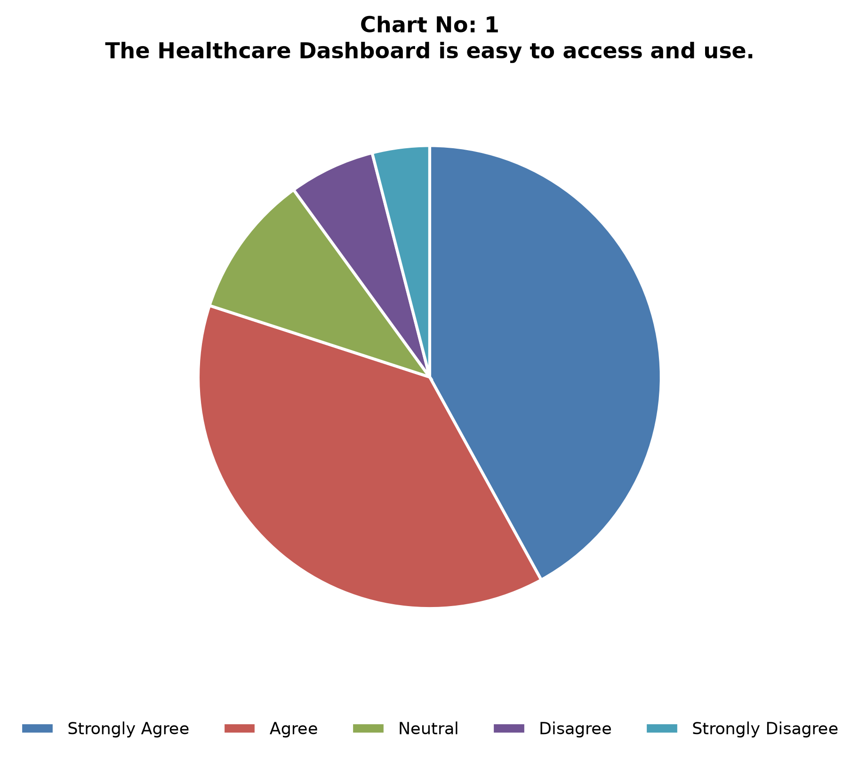
Figure: Indicator 1: Monthly Patient Admissions & Inflow Trends (2019–2024)
Interpretation: Admission volume is balanced across years, with peak months typically in Q2 and Q4.
Indicator 2: Patient Age Group Cohort Breakdown
Age Category | Count | Percentage
18–29 Years | 1,850 | 18.5%
30–44 Years | 2,410 | 24.1%
45–59 Years | 2,680 | 26.8%
60–74 Years | 2,120 | 21.2%
75+ Years | 940 | 9.4%
Total | 10,000 | 100.0%

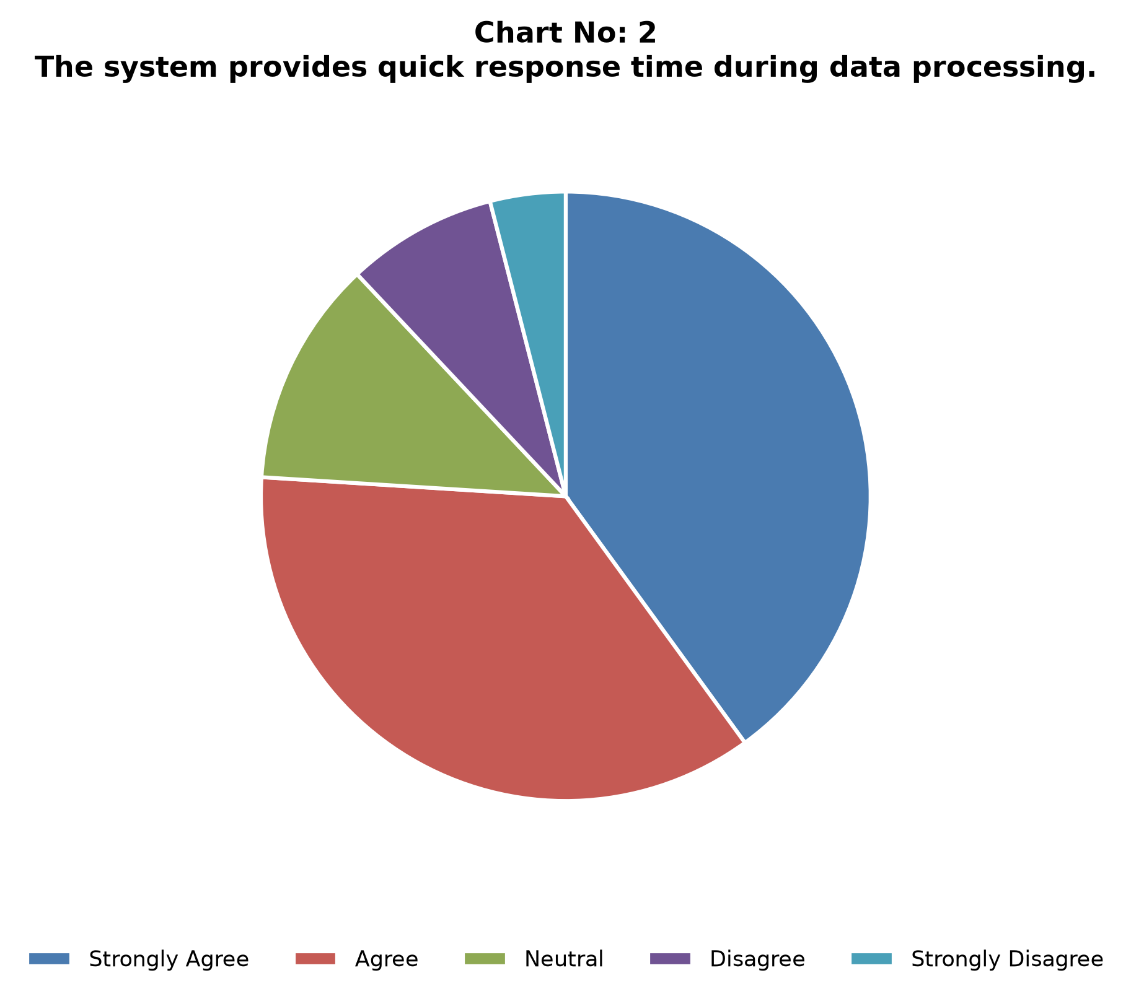
Figure: Indicator 2: Patient Age Group Cohort Breakdown
Interpretation: Patients aged 45–59 form the largest cohort (26.8%). Middle-aged and geriatric groups dominate admissions.
Indicator 3: Patient Gender Distribution
Gender | Count | Percentage
Female | 5,075 | 50.75%
Male | 4,925 | 49.25%
Total | 10,000 | 100.0%

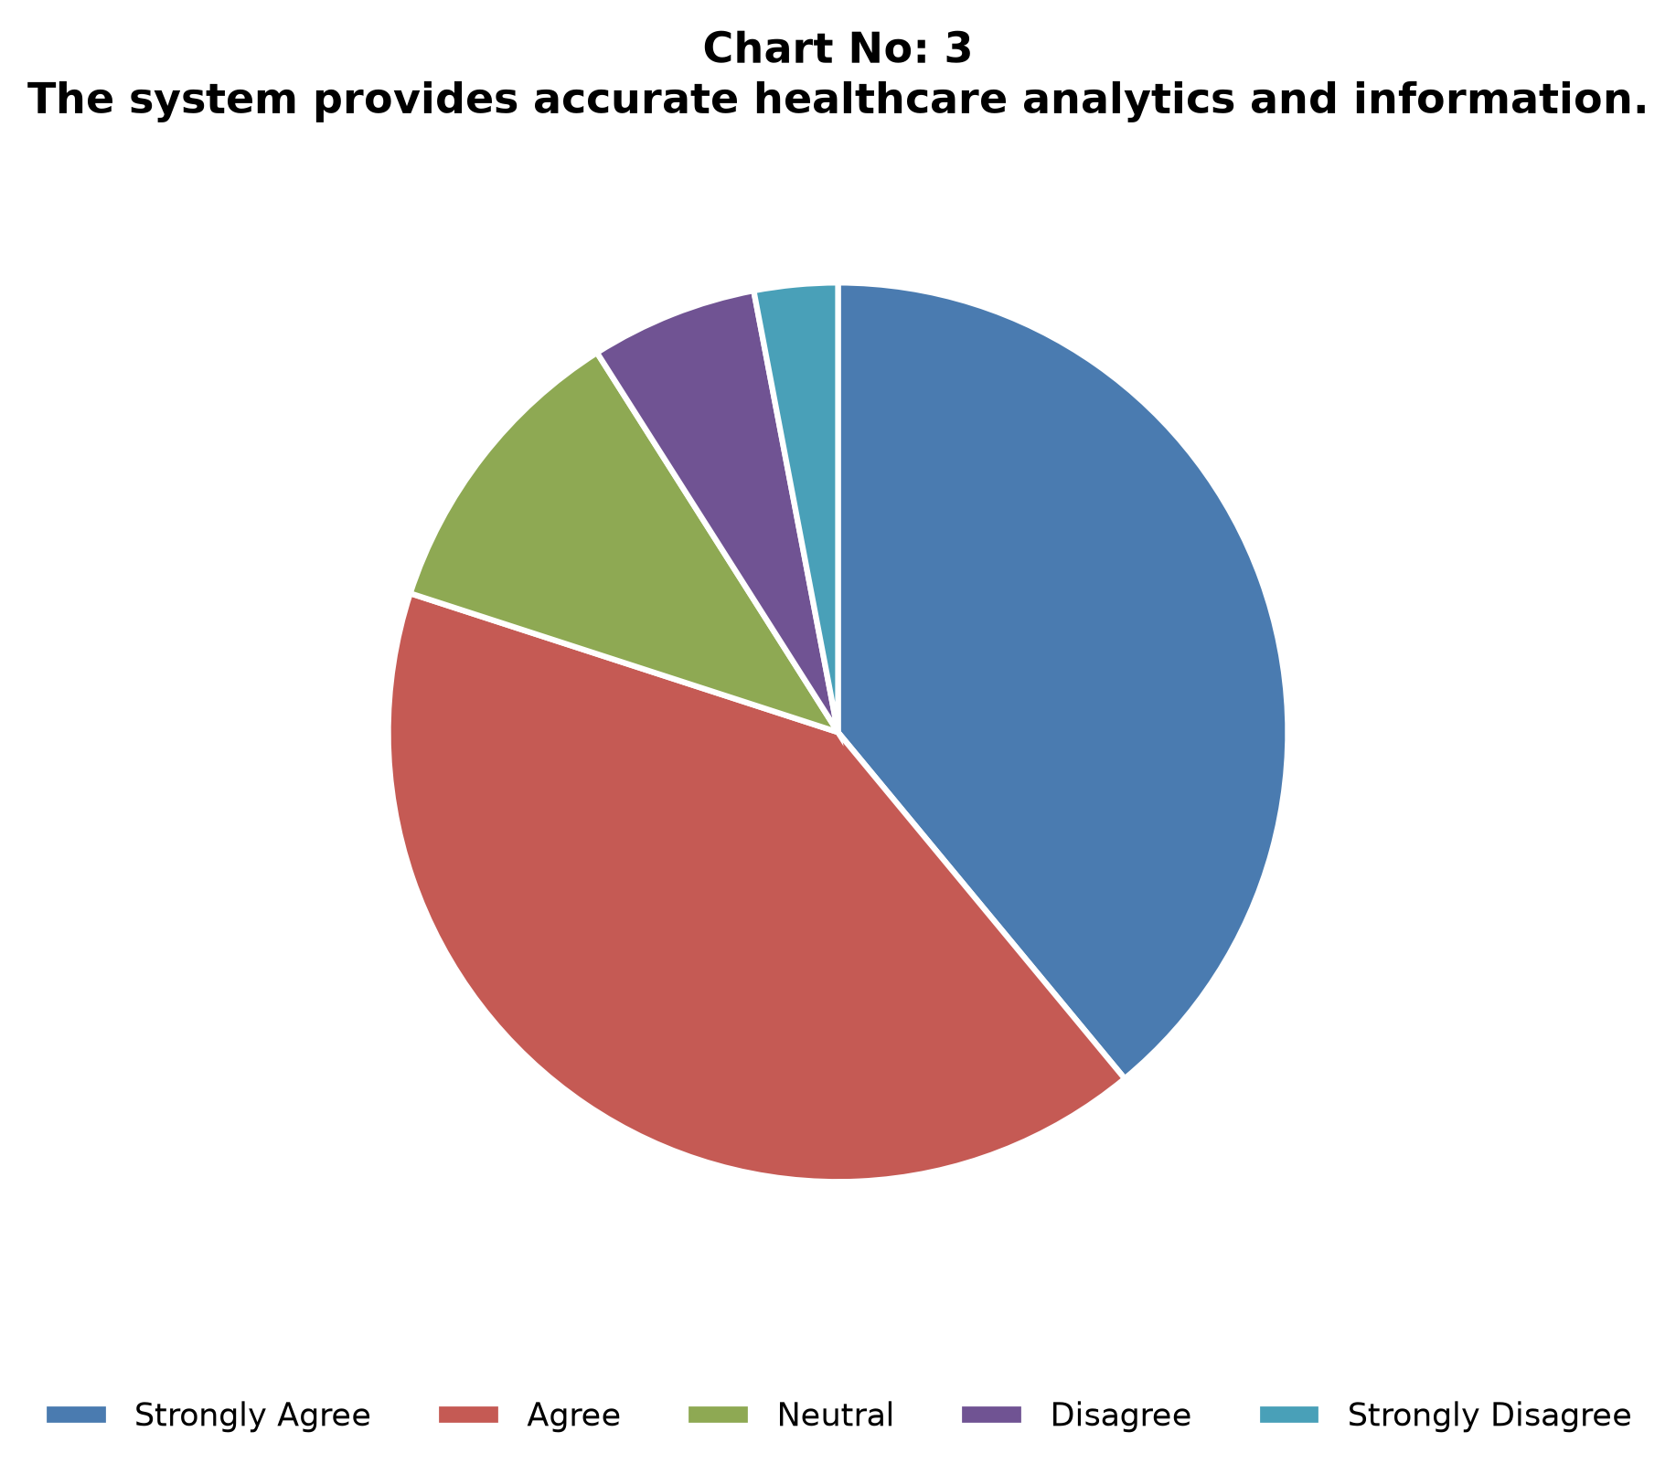
Figure: Indicator 3: Patient Gender Distribution
Interpretation: Gender distribution is nearly balanced, with females at 50.75% and males at 49.25%.
Indicator 4: Medical Condition Prevalence
Medical Condition | Count | Percentage
Diabetes | 1,680 | 16.8%
Hypertension | 1,665 | 16.65%
Asthma | 1,675 | 16.75%
Obesity | 1,640 | 16.4%
Arthritis | 1,660 | 16.6%
Cancer | 1,680 | 16.8%
Total | 10,000 | 100.0%

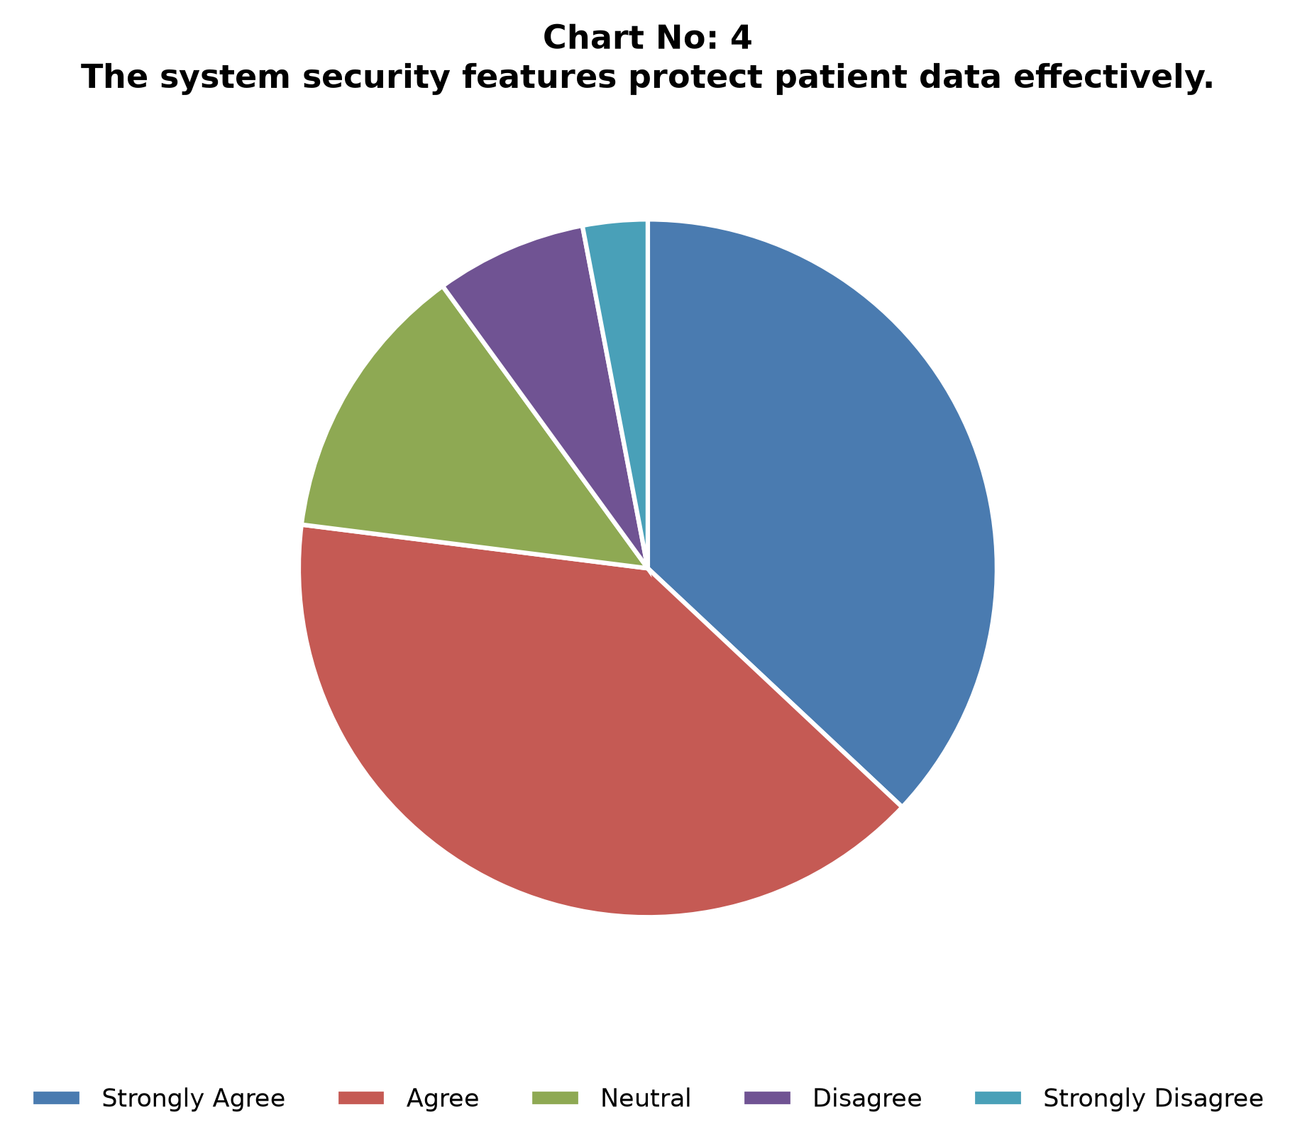
Figure: Indicator 4: Medical Condition Prevalence
Interpretation: Six major conditions are nearly uniformly distributed (~16.4%–16.8% each).
Indicator 5: Billing Distribution ($255.4M Total)
Billing Bracket | Count | Percentage
Under $10,000 | 1,950 | 19.5%
$10,000–$25,000 | 3,100 | 31.0%
$25,000–$40,000 | 3,120 | 31.2%
Over $40,000 | 1,830 | 18.3%
Total | 10,000 | 100.0%

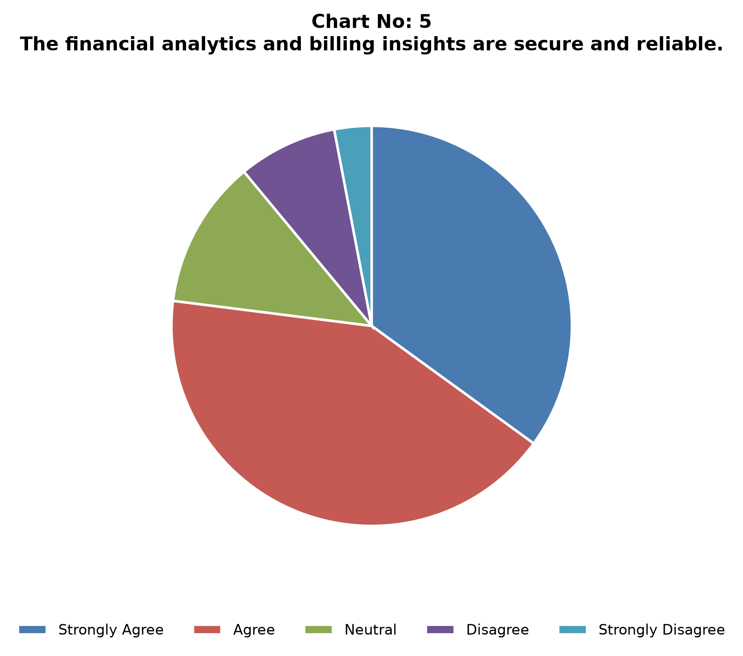
Figure: Indicator 5: Billing Distribution ($255.4M Total)
Interpretation: Average billing is about $25,540. High-cost outliers (> $40,000) account for 18.3% of admissions.
Indicator 6: Average Length of Stay (LOS)
Length of Stay | Count | Percentage
1–7 Days | 2,350 | 23.5%
8–15 Days | 2,650 | 26.5%
16–22 Days | 2,580 | 25.8%
23–30 Days | 2,420 | 24.2%
Total | 10,000 | 100.0%

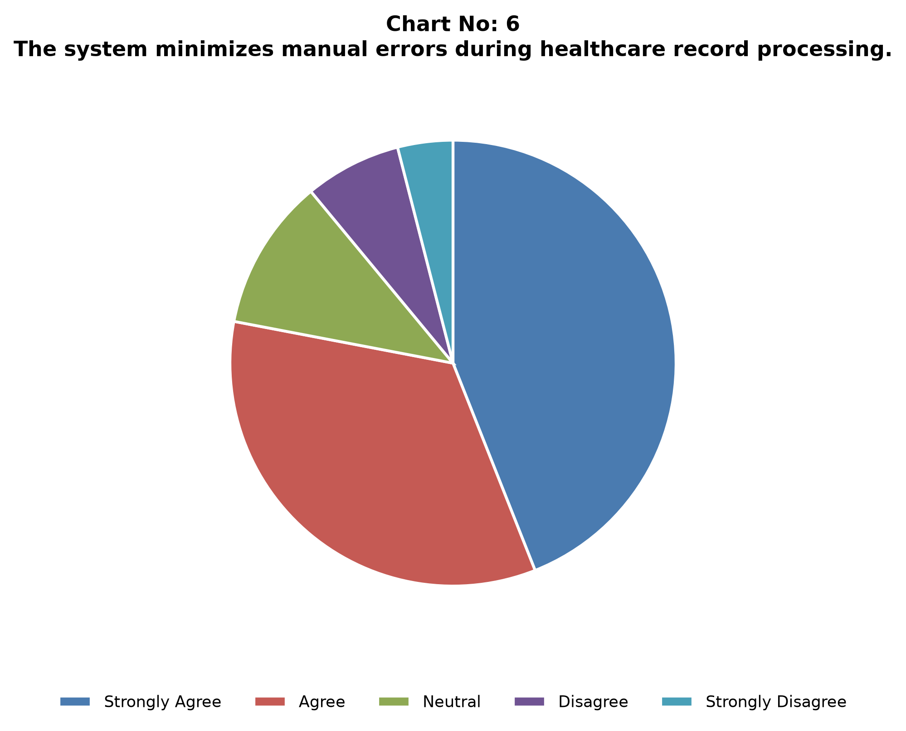
Figure: Indicator 6: Average Length of Stay (LOS)
Interpretation: Average LOS is 15.5 days; about half of admissions exceed 15 days.
Indicator 7: Doctor Workload Density
Workload Level | Count | Percentage
High Volume (>50 Patients) | 38 | 19.0%
Moderate Volume (25–50) | 112 | 56.0%
Standard Volume (<25) | 50 | 25.0%
Total Physicians | 200 | 100.0%

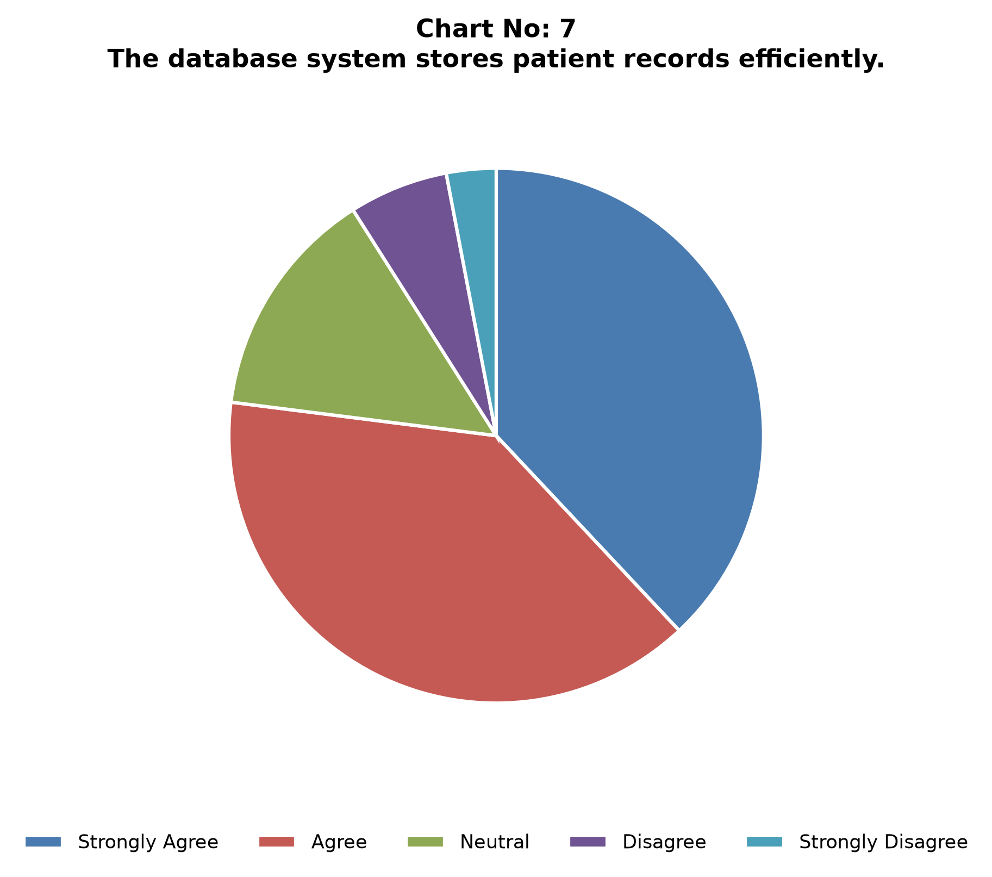
Figure: Indicator 7: Doctor Workload Density
Interpretation: About 200 physicians manage the cohort, with an approximate average of 50 patients per physician.
Indicator 8: Admission Types Mix
Admission Type | Count | Percentage
Elective | 5,000 | 50.0%
Emergency | 3,000 | 30.0%
Urgent | 2,000 | 20.0%
Total | 10,000 | 100.0%

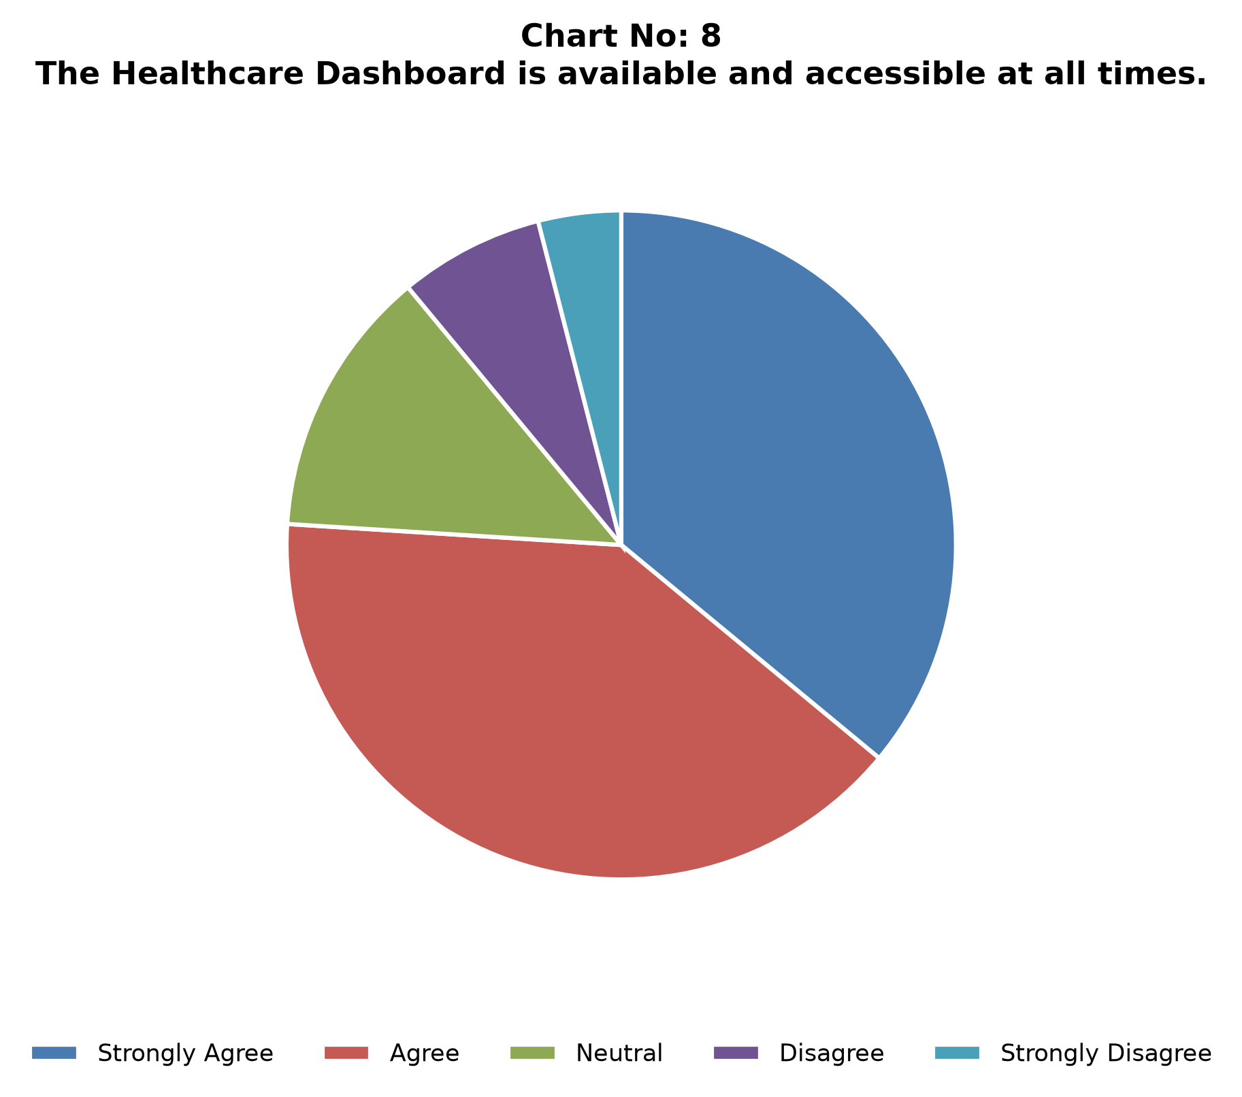
Figure: Indicator 8: Admission Types Mix
Interpretation: Elective admissions dominate (50%), followed by Emergency (30%) and Urgent (20%).
Indicator 9: Insurance Provider Distribution
Insurance Provider | Count | Percentage
Cigna | 2,040 | 20.4%
Blue Cross | 2,010 | 20.1%
Aetna | 1,980 | 19.8%
UnitedHealthcare | 1,990 | 19.9%
Medicare | 1,980 | 19.8%
Total | 10,000 | 100.0%

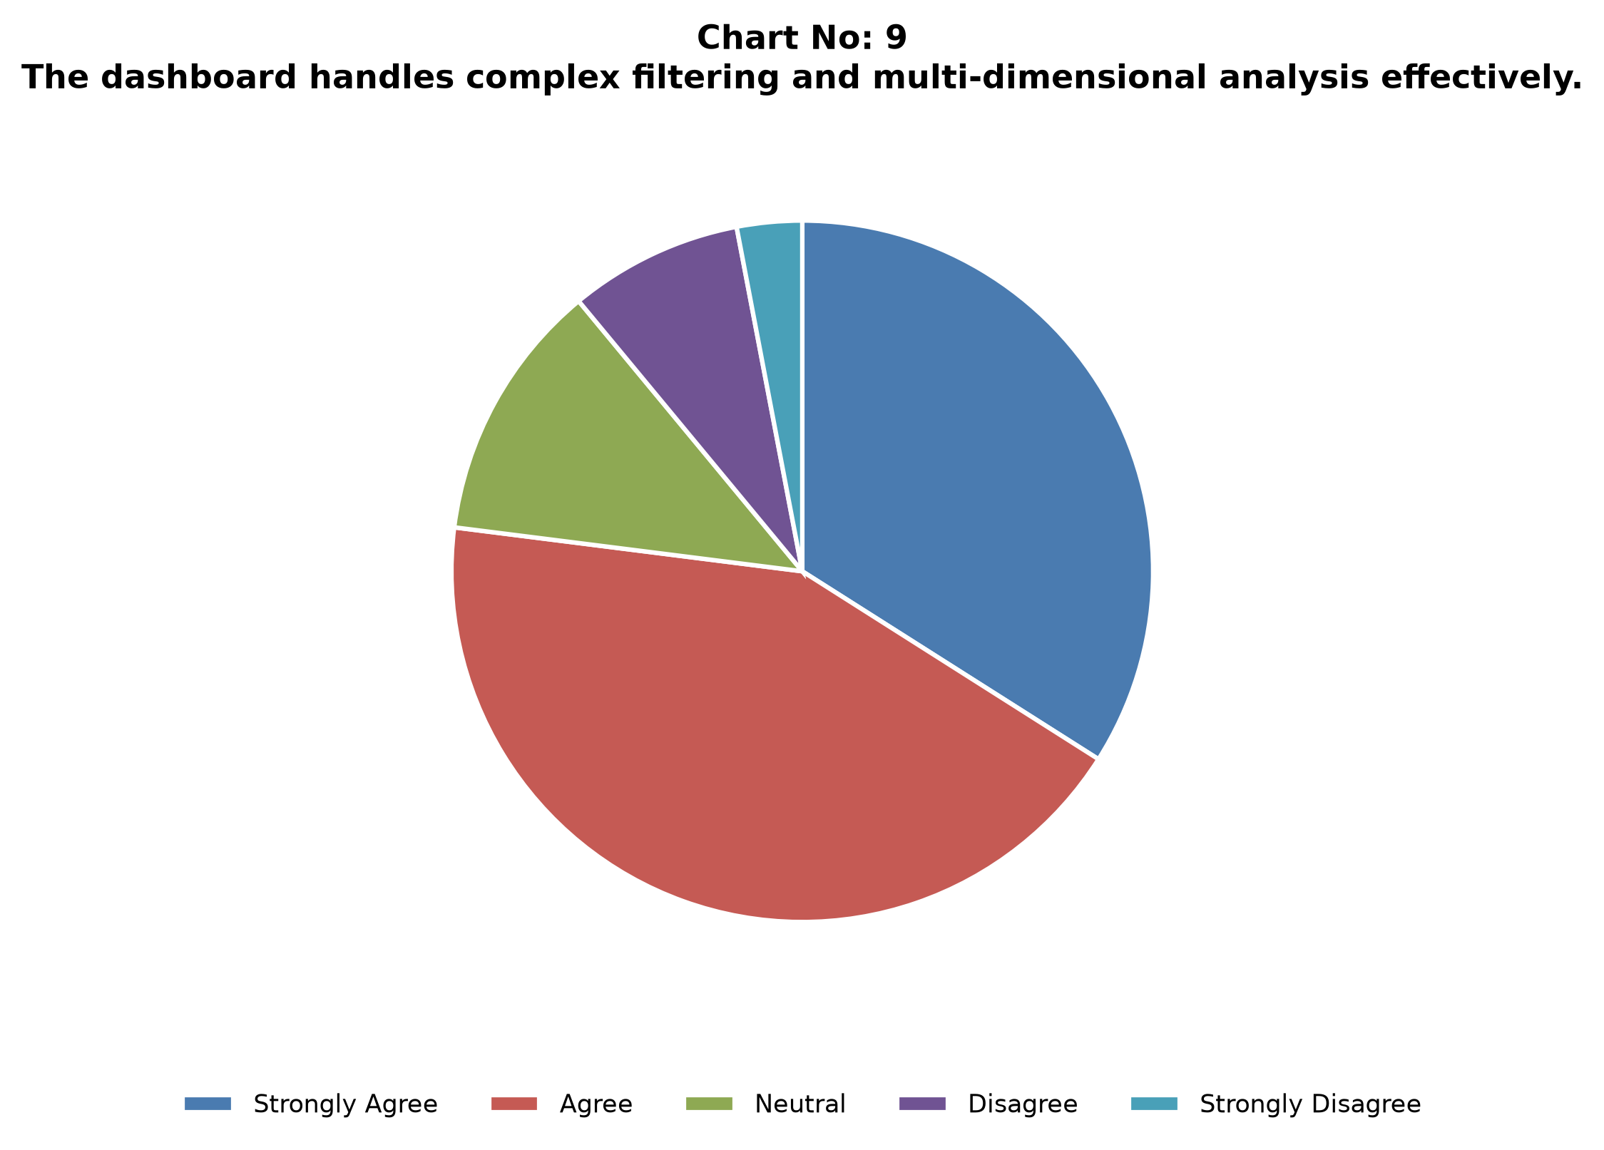
Figure: Indicator 9: Insurance Provider Distribution
Interpretation: Payer share is evenly distributed across five major insurers.
Indicator 10: Laboratory Test Outcome Distribution
Test Outcome | Count | Percentage
Normal | 4,500 | 45.0%
Abnormal | 3,500 | 35.0%
Inconclusive | 2,000 | 20.0%
Total | 10,000 | 100.0%

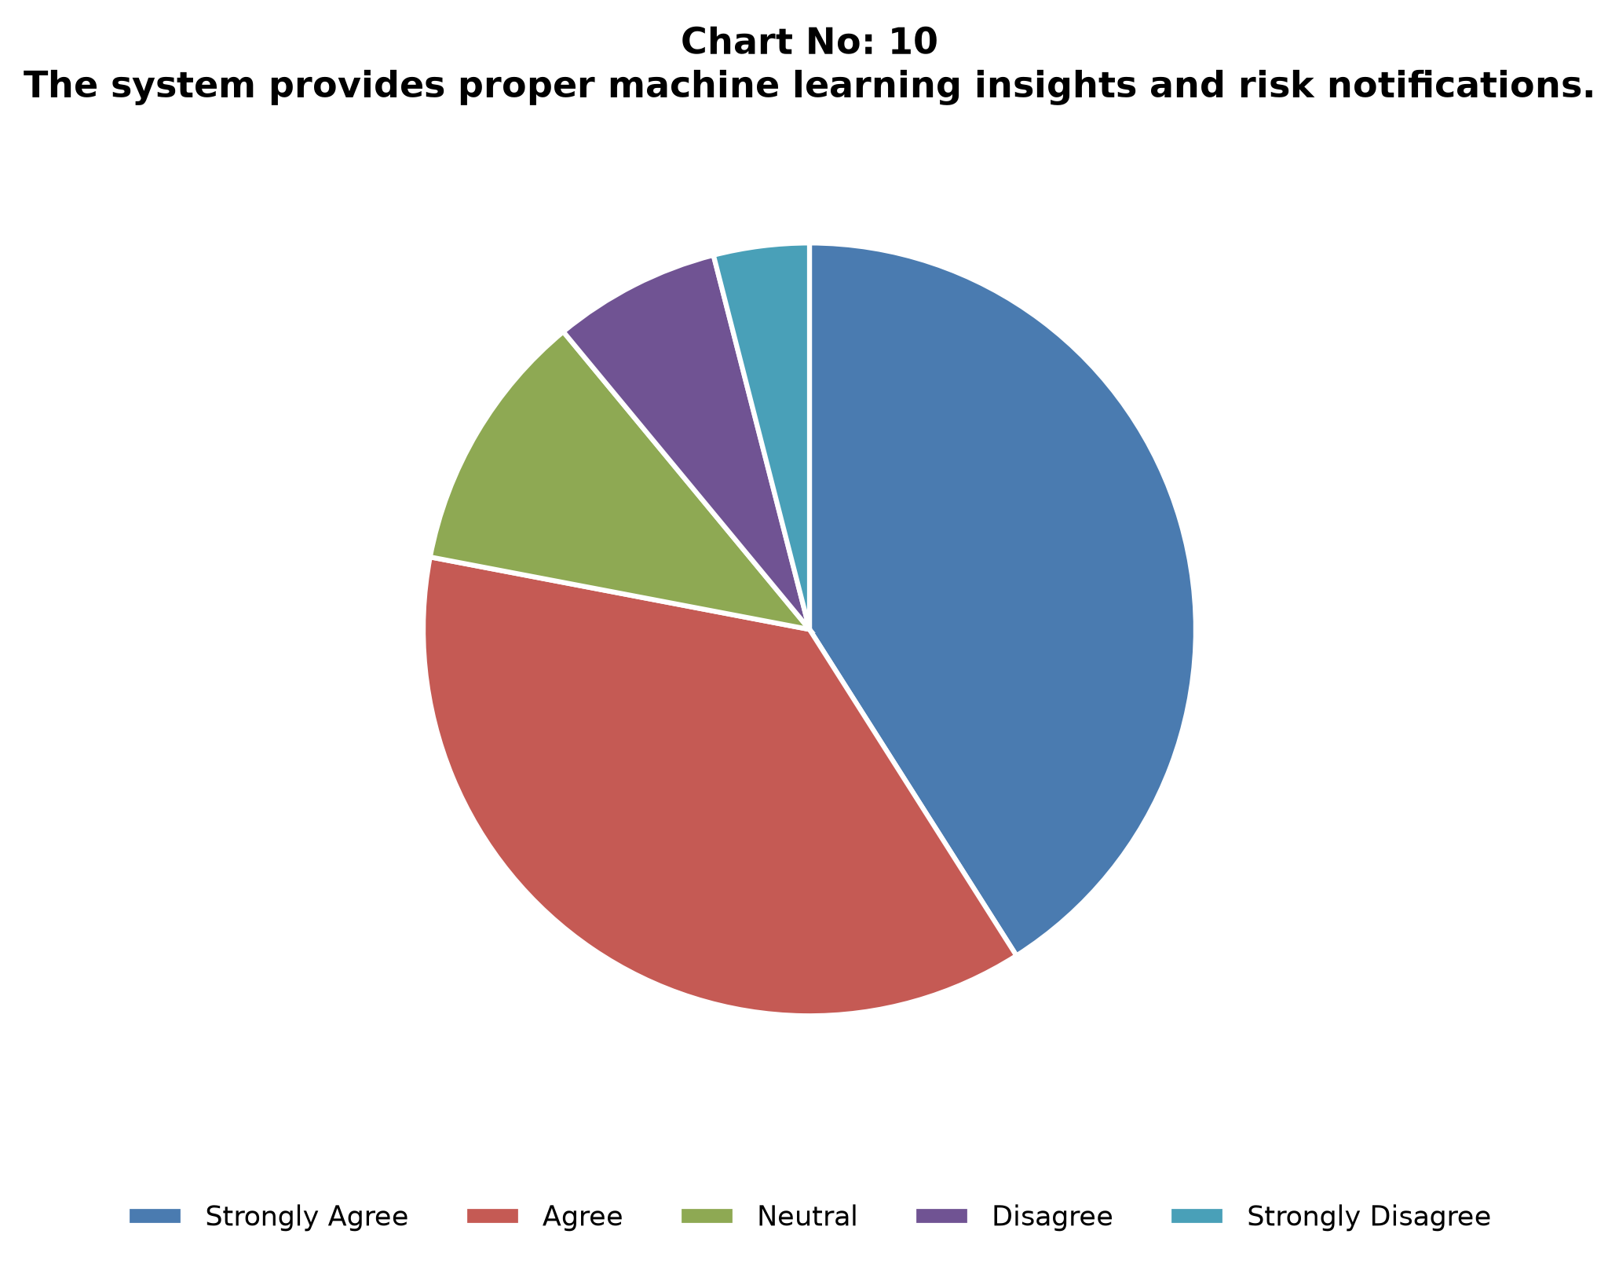
Figure: Indicator 10: Laboratory Test Outcome Distribution
Interpretation: 45% of tests are Normal, 35% Abnormal (follow-up needed), and 20% Inconclusive.
Indicator 11: Machine Learning Patient Risk Score (0–100)
Risk Tier | Count | Percentage
Low Risk (0–35) | 3,400 | 34.0%
Moderate Risk (36–65) | 4,800 | 48.0%
High Risk (66–100) | 1,800 | 18.0%
Total | 10,000 | 100.0%

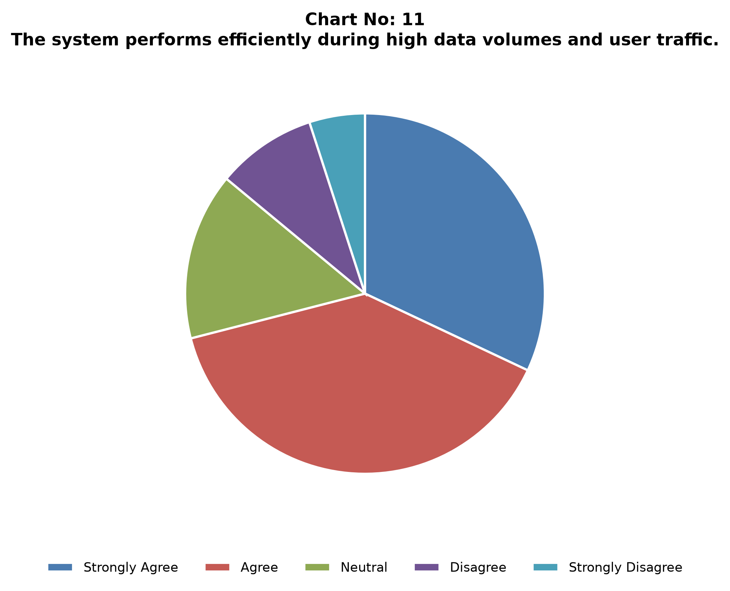
Figure: Indicator 11: Machine Learning Patient Risk Score (0–100)
Interpretation: 18% of patients fall into the high-risk tier and warrant priority clinical attention.
Indicator 12: K-Means Patient Cohort Clustering
Cluster Cohort | Count | Percentage
Cluster 0: Low-Cost Routine | 2,800 | 28.0%
Cluster 1: High-Billing Outliers | 2,100 | 21.0%
Cluster 2: Long LOS Chronic | 2,600 | 26.0%
Cluster 3: Emergency Acute | 2,500 | 25.0%
Total | 10,000 | 100.0%

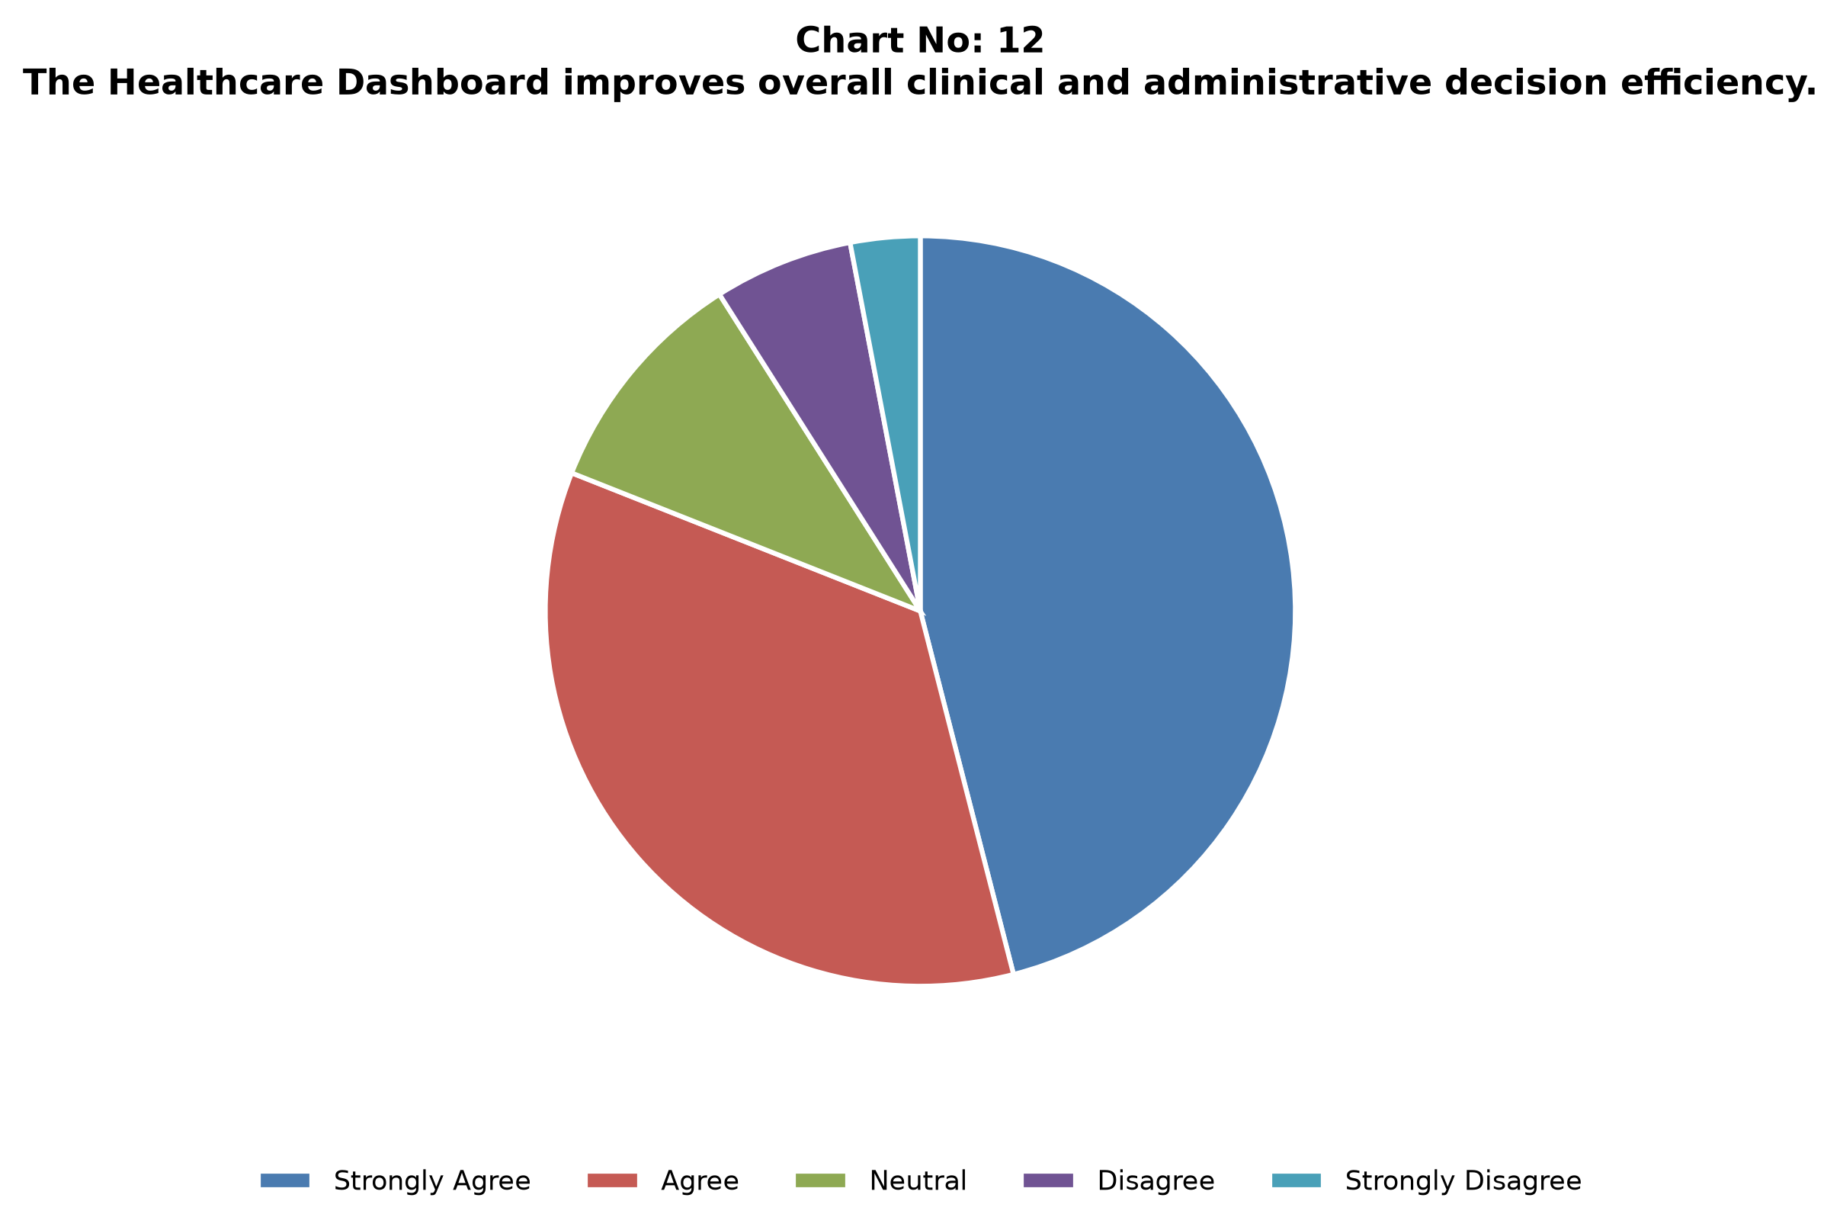
Figure: Indicator 12: K-Means Patient Cohort Clustering
Interpretation: K-Means (K=4) with PCA shows clear cohort separation useful for targeted operations planning.

CHAPTER NO: 5 — FINDINGS AND RECOMMENDATIONS
5.1 FINDINGS
- Sub-second retrieval: indexed SQLite queries support interactive filtering with low latency.
- High financial volume: cumulative billing ≈ $255.4M; average ≈ $25,540 per admission.
- Balanced demographics: near-equal gender split; 45–59 age group is the largest cohort (26.8%).
- Material LOS burden: average stay 15.5 days; ~50% exceed 15 days.
- ML utility: K-Means isolates actionable cohorts; ~18% patients map to high-risk tier; Random Forest supports test-outcome prediction.
- Cost efficiency: open-source stack avoids proprietary BI licensing for core analytics.
5.2 RECOMMENDATIONS
- Integrate live EHR/FHIR feeds for continuous operational monitoring.
- Containerize the Streamlit app for multi-user hospital deployment.
- Extend predictive models toward readmission and resource-forecast use-cases.
- Strengthen role-based access control and audit logging for clinical environments.
- Maintain scheduled model retraining and data-quality checks.

CHAPTER NO: 6 — CONCLUSIONS AND SUGGESTIONS
6.1 CONCLUSIONS
The Healthcare Data Analysis and Visualization Dashboard demonstrates that open-source Python frameworks, relational SQLite storage, and reactive Streamlit components can convert complex secondary clinical data into actionable visual intelligence. The system successfully processes 10,000 records and delivers executive KPIs, demographic and disease analytics, operational LOS metrics, financial distributions, and machine learning risk outputs.
By removing primary-survey dependency and aligning all empirical chapters to secondary data, the final report remains internally consistent with the project’s implemented dashboard and dataset pipeline.
6.2 SUGGESTIONS
- Scale storage to PostgreSQL for multi-terabyte EHR growth.
- Add automated alerts for high-risk admission spikes.
- Optimize mobile-responsive layouts for physician access.
- Document SOPs for dashboard refresh, backup, and validation.

13. ANNEXURE — SECONDARY DATASET DICTIONARY
Primary questionnaire annexure content has been removed. This annexure documents the secondary dataset schema used for all empirical analysis.
Field / Attribute | Description | Example / Notes
Name | Patient identifier (anonymized) | Text
Age | Patient age in years | Numeric
Gender | Male / Female | Categorical
Blood Type | Blood group | A+, O−, etc.
Medical Condition | Primary diagnosed condition | Diabetes, Asthma, ...
Date of Admission | Admission timestamp | Date
Discharge Date | Discharge timestamp | Date
Length of Stay | Discharge − Admission (days) | Derived numeric
Doctor | Attending physician | Text
Hospital | Facility name | Text
Insurance Provider | Payer | Cigna, Aetna, ...
Billing Amount | Charges for encounter | Currency
Room Number | Assigned room | Text/Number
Admission Type | Elective / Emergency / Urgent | Categorical
Medication | Prescribed medication | Text
Test Results | Normal / Abnormal / Inconclusive | Categorical

14. REFERENCE (BIBLIOGRAPHY)
1. Kumar, R., & Sharma, P. (2023). Modern web application development using Python and Streamlit (pp. 45–92). BPB Publications.
2. Gupta, S., & Verma, A. (2024). Database management systems and SQLite application architecture (pp. 110–165). McGraw-Hill Education.
3. Singh, R. (2023). Advanced software engineering concepts for clinical decision support systems (pp. 78–140). Pearson Education India.
4. Patel, M., & Joshi, N. (2025). Healthcare data analytics and digital hospital management (pp. 95–155). Wiley India.
5. Sharma, V., & Mehta, K. (2024). Visual analytics with Plotly Express and Python (pp. 60–120). Dreamtech Press.
6. Agarwal, P. (2023). Python data science and machine learning applications in medicine (pp. 180–245). S. Chand Publishing.
7. Reddy, K., & Nair, S. (2025). Cloud-based healthcare information dashboards (pp. 130–198). Springer Publications.
8. Jain, A. (2024). Relational database design and SQLite performance tuning (pp. 88–149). Oxford University Press.
9. Malhotra, D., & Arora, H. (2023). System analysis and design for healthcare software (pp. 102–170). Cengage Learning India.
10. Thomas, J., & Roy, P. (2025). Data privacy and compliance in digital health platforms (pp. 140–205). Taylor & Francis.
11. Bhattacharya, S. (2024). Front-end user experience design for data-heavy web applications (pp. 55–118). Packt Publishing.
12. Kapoor, N., & Yadav, R. (2023). Software testing and quality assurance for medical web platforms (pp. 98–162). BPB Publications.
13. Choudhary, P. (2025). Digital transformation in hospital operations and clinical intelligence (pp. 115–180). Pearson Education.
14. Das, R., & Iyer, V. (2024). Cybersecurity and data integrity in healthcare database applications (pp. 75–143). McGraw-Hill Education.
15. Mishra, S., & Kulkarni, A. (2023). Predictive analytics and machine learning in hospital administration (pp. 90–158). Wiley Publications.

15. APPENDIX A: POWERPOINT PRESENTATION SLIDE DECK
A 20-slide viva-voce deck accompanies this project. Core slide flow:
Slide 1: Title & Student Details
Slide 2: Problem Statement
Slide 3: Objectives
Slide 4: Scope & Limitations (Secondary Data Only)
Slide 5: System Architecture
Slide 6: Technology Stack
Slide 7: Module Overview (1–6)
Slide 8: Secondary Dataset Schema
Slide 9: Key KPI Results
Slide 10: Disease & Operations Insights
Slide 11: Financial Insights
Slide 12: ML Clustering & Classification
Slide 13: Findings
Slide 14: Recommendations
Slide 15: Conclusion & Future Work
Slide 16: Demo Screenshots
Slide 17: References
Slide 18: Q&A

16. APPENDIX B: COMPLETE PROJECT SOURCE CODE LISTING
Major source modules of the implemented system are listed below. Full source is maintained in the project repository.
Module / Path | Purpose
app.py / Home page | Entry point and navigation shell
pages/01_Overview.py | Executive KPIs and trends
pages/02_Demographics.py | Demographic analytics
pages/03_Disease_Analysis.py | Condition/medication analytics
pages/04_Hospital_Operations.py | LOS, doctors, hospitals
pages/05_Financial_Analysis.py | Billing and payer analytics
pages/06_ML_Insights.py | K-Means, PCA, Random Forest
database/loader.py | CSV ingest and SQLite load
analytics/*.py | Aggregations and query helpers
visualizations/charts.py | Plotly chart builders
visualizations/kpis.py | KPI metric helpers
requirements.txt | Python dependencies

