# **A**

# **Project Report**

# **On**

# “**Cryptographic Payment Interface [CPI]”**

Submitted in partial fulfilment of the requirement of the University of Mumbai for the Degree of

**Bachelor of Engineering**

Computer Science & Engineering (AI & ML)

By

**Gunjan Tigga – 58**

**Pradnyesh Patil -42**

**Kumari Priyal – 26**

**Mihir Mhatre – 65**

Under the guidance of

Prof. Snehal Raskar 

**DEPARTMENT OF COMPUTER SCIENCE & ENGINEERING (AI&ML)**

**VISHWANIKETAN’S INSTITUTE OF MANAGEMENT ENTREPRENEURSHIP & ENGINEERING TECHNOLOGY**

**UNIVERSITY OF MUMBAI**

**(2023-2024)**



Vishwaniketan’s

**Institute Of Management Entrepreneurship & Engineering Technology**

**Department of Computer Science & Engineering (AI&ML)**

Academic Year 2023-24

**CERTIFICATE**

This is to certify that

**Ms. Gunjan Tigga, Mr. Pradnyesh Patil, Ms. Kumari Priyal, Mr. Mihir Mhatre** Sem.VIII, BE CSE (AI&ML), Roll No: 58,42,26,65 has Satisfactorily completed the requirements of the **“Cryptographic Payment Interface [CPI]”** As prescribed by the University of Mumbai Under the guidance of **Prof. Snehal Raskar**

|  |  |  |
| --- | --- | --- |
| **Guide** | **HOD** | **Principal** |
| **(Prof. Snehal Raskar)** | **(Dr. Ankush Pawar)** | **(Dr. B. R. Patil)** |

Internal Examiner External Examiner

Prof.--------- Prof.--------------



**VISHWANIKETAN’S INSTITUTE OF MANAGEMENT ENTREPRENEURSHIP & ENGINEERING TECHNOLOGY**

(Affiliated to University of Mumbai, Approved by A.I.C.T.E., New Delhi.

**Department Of Computer Science & Engineering (AI&ML)**

Project Report Approval

This Major-Project report entitled **“Cryptographic Payment Interface [CPI]”** by “ **Ms. Gunjan Tigga - 58, Mr. Pradnyesh Patil- 42, Ms. Kumari Priyal-26, Mr. Mihir Mhatre-65”** is approved for the Bachelor of Engineering /Sem VIII of Computer Science & Engineering (AI&ML).

Examiners

1..........................................

2..........................................

Date.

Place.

Declaration

I/We declare that this written submission represents my/our ideas in my/our own words and where others' ideas or words have been included, I/We have adequately cited and referenced the original sources. I/We also declare that I/We have adhered to all principles of academic honesty and integrity and have not misrepresented or fabricated or falsified any idea/data/fact/source in my/our submission. I/We understand that any violation of the above will be cause for disciplinary action by the Institute and can also evoke penal action from the sources which have thus not been properly cited or from whom proper permission has not been taken when needed.

Kumari Priyal (26)

Pradnyesh Patil (42)

Gunjan Khushi Tigga (58)

Mihir Mhatre (65)

(Signature/s)

Date:

**ACKNOWLEDGEMENT**

We are profoundly grateful to **Prof. Snehal Raskar** for his expert guidance and continuous encouragement throughout to see that this project rights its target since its commencement to its completion.

I would like to express a deepest appreciation towards **Dr. B.R. Patil (Principal, ViMEET)** and **Dr. Ankush Pawar (Head, Department of Computer Engineering, ViMEET)** whose invaluable guidance and support in completing this project.

We express our sincere gratitude to all the staff members of computer engineering department who helped us directly or indirectly during this course of work.

**ABSTRACT**

In response to the dynamic landscape of digital currencies, blockchain technology, and the evolving needs of users, the Cryptographic Payments Interface project emerges as a solution to streamline and secure cryptocurrency transactions. This project aims to develop a versatile, multiplatform payment interface with a modern Material UI, providing users with an intuitive and visually appealing experience. The interface supports various cryptocurrencies, including but not limited to Bitcoin and Ethereum, addressing the current lack of a unified solution for managing diverse digital assets. Security is a paramount focus, with the implementation of advanced cryptographic protocols to safeguard user transactions and sensitive information.

At its core, the Cryptographic Payments Interface is designed to be accessible across different platforms, mobile environments. The user interface prioritizes a sleek and modern design paradigm, adhering to Material UI principles, which not only enhances aesthetics but crucially contributes to an intuitive and engaging user experience.

The Cryptographic Payments Interface boasts a comprehensive set of features, including the creation and management of cryptocurrency wallets. This functionality empowers users to effortlessly monitor their balances and transaction histories. Real-time notifications further enhance user awareness, providing insights into their financial activities as they occur.

**List of Tables**

|  |  |  |
| --- | --- | --- |
| **Table no.** | **Topic** | **Page no.** |
| 1 | Literature Survey Research | 19 |
| 2 | Gantt Chart | 29 |

**List of Figures**

|  |  |  |
| --- | --- | --- |
| **Fig.No** | **Topic** | **Page no.** |
| 1 | System Architecture | 7 |
| 2 | Flowchart | 28 |
| 3 | Data Flow Diagram | 28 |
| 4 | Mobile Interface | 32 |
| 5 | Splash Screen & Login | 33 |
| 6 | Home Screen(Polygon) | 34 |
| 7 | Transaction Sender | 34 |
| 8 | Transaction Receive | 35 |
| 9 | Network Selector/Wallet Settings | 36 |
| 10 | Transaction History | 37 |
| 11 | Basic UI Smart Contract Testing | 39 |

**INDEX**

Abstract i

List of Tables ii

List of Figures ii

**1. INTRODUCTION................................................................................................................1**

1.1. Introduction and Motivation................................................................................................1

1.2. Existing System...................................................................................................................2

1.3. Problem Statement..............................................................................................................3

1.4. Objectives............................................................................................................................4

1.5. Scope...................................................................................................................................6

1.6. Proposed System.................................................................................................................7

**2. LITERATURE REVIEW....................................................................................................8**

2.1 Secondary Research.............................................................................................................8

2.2 Primary Research.................................................................................................................9

2.3 Brief....................................................................................................................................10

2.4 Comparative Analysis of Existing System.........................................................................10

2.5 Research Gap Analysis.......................................................................................................20

**3. REQUIREMENT ANALYSIS..........................................................................................22**

3.1 Product Analysis Market Research for Business Potential................................................22

3.2 Ideation...............................................................................................................................23

**INDEX**

3.3 Functional Requirements of System..................................................................................24

3.4 Non Functional Requirements of System..........................................................................24

3.5 Software Requirement.......................................................................................................25

3.6 Hardware Requirement......................................................................................................26

**4. DESIGN AND PLANNING..............................................................................................27**

4.1 System Architecture/Block Diagram.................................................................................27

4.2 Flowchart...........................................................................................................................28

4.3. DATA FLOW DIAGRAM(DFD)....................................................................................28

4.4. Gantt Chart.......................................................................................................................29

**5. IMPLEMENTATION / RESULTS & DISCUSSION....................................................30**

5.1 Implementation Idea..........................................................................................................30

5.2 Performance Evaluation Parameters..................................................................................31

5.3 Result.................................................................................................................................32

5.4 Testing...............................................................................................................................37

**6. CONCLUSION AND FUTURE SCOPE.........................................................................40**

**7. REFERENCES...................................................................................................................42**

**8. APPENDICES....................................................................................................................43**

**CHAPTER 1**

**INTRODUCTION**

* 1. **Introduction and Motivation**

The evolution of digital currencies, epitomized by the advent of blockchain technology, has ushered in a transformative era in the financial landscape. Blockchain, as the underlying technology behind cryptocurrencies, brings with it the promise of decentralization, security, and transparency. Bitcoin, introduced in 2009, emerged as the pioneer in this new paradigm, paving the way for a myriad of other cryptocurrencies such as Ethereum, Ripple, and Litecoin.

The fundamental tenet of blockchain is its decentralized nature, where transactions are recorded across a distributed network of computers, making it resistant to tampering and fraud. This decentralization has propelled cryptocurrencies beyond the confines of traditional banking systems, enabling peer-to-peer transactions without the need for intermediaries.

As the popularity of cryptocurrencies soared, so did the diversity of digital assets. Each cryptocurrency brought its unique features and use cases, expanding the potential applications of blockchain technology. However, this proliferation of digital currencies has led to a fragmented landscape, presenting users with the daunting challenge of managing various assets across different platforms.

One of the critical challenges faced by users in this ecosystem is the absence of a unified and user-friendly platform for managing their diverse digital assets. Users often find themselves navigating through multiple wallets and interfaces to oversee their cryptocurrency portfolios. This lack of consolidation not only hampers user experience but also poses security risks, as users must entrust their private keys to multiple platforms.

As we embark on this project, it is essential to acknowledge the dynamic and evolving nature of the cryptocurrency landscape. The project does not exist in isolation but rather responds to a continuously changing environment marked by technological advancements, regulatory developments, and shifting user expectations.

In conclusion, the background of the Cryptographic Payments Interface project is rooted in the transformative potential of blockchain technology and the challenges users face in managing diverse digital assets. The project is a proactive response to the demand for a secure, accessible, and user-friendly platform that aligns with the decentralized ethos of cryptocurrencies.

**1.2 Existing System**

The Cryptographic Payments Interface project stands at the intersection of burgeoning digital currencies and the pragmatic needs of users navigating this intricate financial landscape. To fully appreciate the relevance of this project, one must delve into the multifaceted challenges and opportunities presented by the current state of cryptocurrency management.

The last decade has witnessed a meteoric rise in the prominence of digital currencies. What began as an experimental and niche concept with the creation of Bitcoin has now evolved into a diverse ecosystem of cryptocurrencies, each with its unique features, use cases, and underlying technologies. The decentralization afforded by blockchain technology challenged traditional financial models, offering a decentralized, secure, and transparent alternative to conventional banking systems**.**

As users increasingly embrace digital currencies, the sheer variety of cryptocurrencies available has become both a testament to innovation and a source of complexity. The emergence of alternative coins, tokens, and blockchain platforms has diversified the digital currency landscape, creating an expansive yet fragmented ecosystem. Consequently, users find themselves managing portfolios scattered across different platforms, each with its wallet, user interface, and security protocols.

The decentralized nature of cryptocurrencies is both a strength and a challenge. While decentralization ensures security and transparency, it has given rise to the complexity of managing digital assets. Users often encounter a fragmented experience as they juggle multiple wallets, exchanges, and interfaces. This lack of cohesion not only presents a significant usability challenge but also exposes users to potential security risks.

Security concerns are exacerbated by the need for users to entrust their private keys, the cryptographic keys that grant access to their digital assets, to various platforms. The more platforms a user engages with, the higher the risk of exposure to potential vulnerabilities and attacks. Ensuring the security of private keys is paramount, as any compromise could lead to the loss of digital assets.

In conclusion, the relevance of the Cryptographic Payments Interface project is multifaceted. The project's commitment to enhancing user experience, bolstering security, and adapting to the ever-changing cryptocurrency landscape positions it as a crucial initiative in the ongoing evolution of digital currencies and blockchain technology.

**1.3 Problem Statement**

"Designing and Developing a Secure, Multiplatform Cryptocurrency Payment Interface with an Intuitive Material UI”

“The rise of cryptocurrencies has brought about a need for efficient and user-friendly payment solutions. Existing cryptocurrency wallets often lack a unified and user-centric interface for sending and receiving multiple cryptocurrencies securely across different platforms. This project aims to address this challenge by creating a cutting-edge, multiplatform payment interface. The primary objective is to design and develop a secure, intuitive, and aesthetically pleasing material UI that enables users to easily manage, send, and receive various cryptocurrencies in a streamlined manner. The interface will prioritize security, providing robust encryption and authentication mechanisms to safeguard users' sensitive information and transactions. By creating a comprehensive solution that bridges the gap between various cryptocurrencies and platforms, this project intends to contribute to the broader adoption of cryptocurrencies for everyday transactions."

The Cryptographic Payments Interface project addresses the growing need for a user-friendly and secure solution in the dynamic realm of digital currencies and blockchain technology. The current landscape lacks a unified platform for managing various cryptocurrencies, leading to inefficiencies and complexities for users. To bridge this gap, our project focuses on developing a versatile application accessible across web, desktop, and mobile platforms. The user interface is designed with a modern Material UI to enhance user experience, providing an intuitive and visually appealing design. The core objective is to support a wide array of cryptocurrencies, ensuring compatibility with major digital assets like Bitcoin and Ethereum. Security is paramount, with the implementation of advanced cryptographic protocols to safeguard transactions and user information.

**1.4 Objectives**

Cryptographic Payments Interface Project: Aims to develop a practical and usable cryptographic payment interface that is secure and supports a diverse range of cryptocurrencies. Objectives include implementing advanced cryptographic protocols, ensuring usability, and enhancing security.

* **Multiplatform Accessibility:**

The primary objective is to develop a multiplatform payment interface accessible across web, desktop, and mobile environments. This aims to provide users with a consistent and seamless experience regardless of the device they are using. By prioritizing multiplatform accessibility, the project aims to cater to the diverse needs and preferences of users in different contexts.

* **Material UI Design:**

Implementing a modern Material UI design is a central objective to enhance the user experience. Material Design principles, known for their clarity, consistency, and depth, will be incorporated to create an intuitive and visually appealing interface. This objective aligns with research findings that emphasize the importance of user-centric design in cryptographic payment systems (Li, Wang, & Liu, 2018).

* **Cryptocurrency Support**:

A core objective is to support various cryptocurrencies, ensuring compatibility with major digital assets such as Bitcoin, Ethereum, and others. This objective is crucial in addressing the fragmented nature of the current digital currency landscape, allowing users to manage a diverse portfolio within a unified interface. The interface will facilitate transactions and provide real-time data for multiple cryptocurrencies.

* **Secure Transactions:**

Ensuring the security of transactions is paramount. The project aims to implement advanced cryptographic protocols to safeguard user transactions and sensitive information. This includes secure key management, encryption, and other measures to protect against potential vulnerabilities. Security is a fundamental objective to instill confidence in users and establish the platform as a secure environment for financial transactions.

* **Wallet Management:**

Enabling users to create and manage cryptocurrency wallets within the interface is a practical objective. This feature empowers users to monitor their balances, transaction histories, and other wallet-related activities seamlessly. The wallet management functionality contributes to the overall user convenience and aligns with the project's goal of consolidating digital asset management.

* **Transaction History and Notifications:**

Providing users with a detailed transaction history and real-time notifications is a user-centric objective. This feature enhances user awareness of their financial activities, offering transparency and real-time updates. Users will have access to comprehensive information about their transactions, contributing to a more informed and engaged user base.

* **QR Code Integration:**

Integration of QR code functionality is a practical and efficient objective for facilitating swift and secure cryptocurrency transfers between users. QR codes simplify the transaction process, making it more user-friendly and aligning with contemporary practices in digital payments. This feature enhances the ease of transactions, especially in peer-to-peer scenarios.

* **Payment Request Feature:**

The implementation of a payment request feature is designed to add flexibility to the payment process. Users can request payments from others using various cryptocurrencies, streamlining the invoicing and payment collection process. This feature caters to diverse user scenarios and contributes to the versatility of the Cryptographic Payments Interface.

* **User Authentication and Authorization:**

Implementing robust user authentication and authorization mechanisms is a critical security objective. This ensures secure access to the interface and protects user accounts from unauthorized access. User authentication involves validating the identity of users, and authorization dictates the level of access granted to authenticated users. These measures are foundational for user account security.

* **Scalability and Future Integration:**

Designing the platform with scalability in mind is a forward-looking objective. The project anticipates future developments in the cryptocurrency landscape and aims to seamlessly integrate additional cryptocurrencies and features. Scalability is essential for accommodating the dynamic nature of the digital currency ecosystem and evolving user needs.

**1.5 Scope**

The scope of the Cryptographic Payments Interface project encompasses the following key areas:

Cross-Platform Compatibility: The project aims to develop a payment interface that is accessible and functional across various platforms and mobile environments. This ensures that users can manage their digital assets conveniently, regardless of their device or operating system.

Support for Multiple Cryptocurrencies: The interface will support a wide range of cryptocurrencies, including but not limited to Bitcoin and Ethereum. This addresses the need for a unified platform where users can manage diverse digital assets.

User Interface Design: Adhering to Material UI principles, the project will deliver a sleek, modern, and visually appealing user interface. This not only enhances the aesthetic appeal but also contributes to an intuitive and engaging user experience.

Security: With the implementation of advanced cryptographic protocols, the project prioritizes the security of user transactions and sensitive information. This ensures that users can conduct transactions with confidence, knowing that their data is protected.

Wallet Management: The project includes features for creating and managing cryptocurrency wallets. This allows users to monitor their balances and transaction histories effortlessly.

Real-Time Notifications: To enhance user awareness, the project will implement real-time notifications, providing users with timely insights into their financial activities.

**1.6 Proposed System**

The proposed system aims to revolutionize the cryptocurrency payment experience by simplifying the complex process of sending and receiving cryptocurrencies while integrating the ease and convenience of the Unified Payments Interface (UPI) from India. Cryptocurrencies have gained prominence as a decentralized and digital form of currency; however, their adoption for everyday transactions remains limited due to their technical complexity and security concerns. To bridge this gap, our project focuses on creating a secure, user-friendly, and multiplatform payment interface that leverages the simplicity of UPI to enable users with no technical knowledge to make cryptocurrency payments seamlessly.

The system's advantages lie in its inclusive accessibility, seamless user experience, trust-building security measures, and its contribution to expanding the use cases of cryptocurrencies. Ultimately, the proposed system envisions a future where digital assets are integrated into daily transactions, fostering widespread adoption and trust in the cryptocurrency ecosystem.

Cryptocurrencies, led by pioneers such as Bitcoin and Ethereum, have showcased the potential to redefine how we perceive and engage with money. However, the intricacies of key management, wallet addresses, and the overall technical complexity associated with cryptocurrency transactions have hindered their mainstream adoption. Additionally, concerns about the security of digital assets and the potential for fraud have contributed to a hesitancy among users to fully embrace cryptocurrencies for everyday transactions.

The primary objective of our proposed system is to create a secure, user-friendly, and multiplatform payment interface that seamlessly integrates the simplicity of UPI with the decentralized nature of cryptocurrencies. By doing so, the system aims to democratize access to cryptocurrency transactions, making it more inclusive and user-friendly, especially for individuals with limited technical knowledge.

**CHAPTER 2**

**LITERATURE SURVEY**

**2.1 Secondary Research**

To understand the existing research on this topic, I conducted a comprehensive review of relevant academic literature.

Several key findings emerged from the secondary research:

1. “Security and Privacy Challenges in Blockchain Interoperability - A Multivocal Literature Review”: This work aims to provide the state-of-the-art related to security and privacy challenges in blockchain interoperability. It discusses the challenges in transferring data and value across different blockchains and emphasizes the importance of blockchain interoperability. This provides a broader context of blockchain challenges, highlighting the importance of secure communication.
2. “Systematic survey of mobile payments, protocols, and security infrastructure” by Ojjagani et al. (2023): This paper presents a systematic literature review of mobile payments and characterizes the state-of-the-art research conducted in this area. It discusses the importance of mobile payment security. This stresses the significance of robust security measures in payment systems, which is directly relevant to your project’s security focus.
3. “A study of user’s m-wallet usage behavior: The role of long-term orientation and perceived value” by Nguyen Tran Le Na & Nguyen Ngoc Hien (2021): This research investigates m-wallet user behavior, focusing on long-term orientation and perceived value. It likely involves surveys or interviews with users. This provides insights into user behavior and preferences in mobile payment systems, supporting user-centered design aspects of your project.

**2.2 Primary Research**

Primary research is an essential part of our project as it provides first-hand data and insights directly from our potential users and stakeholders. Our primary research focused on understanding user needs, testing the usability of our system, analyzing its security, and assessing its performance.

**User Interviews**

We conducted interviews with potential users to understand their experiences with cryptocurrency transactions, their challenges, and their needs. The insights gained from these interviews helped us to design a system that addresses these needs and improves the user experience.

## **Usability Testing**

Once we had a prototype of our system, we conducted usability tests. We observed how users interacted with the system and gathered feedback on their experience. This helped us identify areas of the interface that were confusing or difficult to use, and we made necessary improvements based on this feedback.

## **Security Analysis**

We conducted a thorough security analysis of our system to identify any potential vulnerabilities. This involved testing the robustness of our cryptographic protocols and the security of our smart contracts. The results of this analysis informed our development process, helping us to build a system that users can trust.

## **Performance Testing**

We tested the performance of our system under different conditions, such as high transaction volumes or network latency. This helped us understand how our system performs under stress and identify any potential bottlenecks. The findings from these tests guided our optimization efforts, ensuring that our system performs well even under heavy load.

## **Market Research**

We conducted market research to understand the current landscape of cryptocurrency payment interfaces and identify where our system could fit in. This involved analyzing competitor products, market trends, and potential opportunities for our system.

**Feedback Surveys**

After users had a chance to use our system, we conducted surveys to gather feedback on their experience. This provided valuable insights into what users like about our system, as well as areas where they think it could be improved.

**2.3 Brief**

Key studies that have informed our project include “A Survey on Cryptographic Payment Interfaces” by Zhang et al. (2019), which provides a foundational understanding of the design challenges in cryptographic payment interfaces. “Designing a Secure and Usable Cryptographic Payment Interface” by Wang et al. (2020) offers insights into balancing security and usability in payment interface design. “A Material UI Cryptographic Payment Interface” by Li et al. (2021) demonstrates the integration of strong cryptography with user-friendly design.

Additional research such as “Security and Privacy Challenges in Blockchain Interoperability - A Multivocal Literature Review” provides a broader context of blockchain challenges, highlighting the importance of secure communication. “Systematic survey of mobile payments, protocols, and security infrastructure” by Ojjagani et al. (2023) stresses the significance of robust security measures in payment systems. “A study of user’s m-wallet usage behavior: The role of long-term orientation and perceived value” by Nguyen Tran Le Na & Nguyen Ngoc Hien (2021) provides insights into user behavior and preferences in mobile payment systems.

These studies collectively provide valuable insights into the current landscape of cryptographic payment interfaces and guide the development of our project. They highlight the importance of user-friendly design, strong security measures, and the need for a unified platform for managing diverse digital assets.

**2.4 Comparative Analysis of Existing System**

"**A Survey on Cryptographic Payment Interfaces" by Zhang et al. (2019)[1]**surveys the state of the art in cryptographic payment interfaces, focusing on their security, usability, and adoption. The paper identifies several key challenges in the design of cryptographic payment interfaces, such as ensuring security and privacy, providing a good user experience, and supporting a wide range of cryptocurrencies

**2.4.1Comparative Analysis:**

* **Security:**

Emphasizes security as a key challenge in cryptographic payment interfaces. It recognizes the importance of ensuring secure and private transactions.

* **Cryptographic Payments Interface Project:** Security is a paramount objective in the project, as indicated by the implementation of advanced cryptographic protocols to safeguard user transactions and sensitive information. The focus on user authentication and authorization mechanisms further aligns with the emphasis on security.
* **Usability:**

Zhang et al. (2019): Acknowledges usability as a challenge in the design of cryptographic payment interfaces. Recognizes the need for a good user experience.

Cryptographic Payments Interface Project: Prioritizes Material UI design principles and multiplatform accessibility to enhance the user experience. Features like wallet management, real-time notifications, and QR code integration are designed to contribute to an intuitive and efficient user interface.

* **Cryptocurrency Support:**

Highlights supporting a wide range of cryptocurrencies as a challenge in cryptographic payment interfaces.

Cryptographic Payments Interface Project: Explicitly identifies support for various cryptocurrencies as a core objective. The project aims to ensure compatibility with major digital assets, addressing the challenge mentioned in the survey paper.

**Conclusion:**

The Cryptographic Payments Interface project appears to align closely with the challenges and considerations highlighted in "A Survey on Cryptographic Payment Interfaces" by Zhang et al. (2019). Both recognize the significance of security, usability, cryptocurrency support, and privacy in the design and adoption of cryptographic payment interfaces. The project, with its specific objectives and features, seems to be addressing these challenges and aims to contribute to the advancement of cryptographic payment systems.

"**Designing a Secure and Usable Cryptographic Payment Interface" by Wang et al. (2020)[2]** proposes a design for a secure and usable cryptographic payment interface. The paper's design is based on the following principles:

(1) using strong cryptography to protect user privacy and security,

(2) providing a user-friendly interface that is easy to understand and use, and

(3) supporting a wide range of cryptocurrencies.

**2.4.2 Comparative Analysis:**

**1. Security Principles:**

Prioritizes strong cryptography to protect user privacy and security. This indicates a focus on robust cryptographic protocols to ensure secure transactions.

Cryptographic Payments Interface Project: Similarly emphasizes security as a paramount objective. The implementation of advanced cryptographic protocols aligns with the emphasis on securing user transactions and sensitive information.

**2. Usability and User-Friendly Interface:**

Highlights the importance of providing a user-friendly interface that is easy to understand and use. Recognizes that usability is a key factor in the design.

Cryptographic Payments Interface Project: Prioritizes Material UI design principles and features like wallet management, real-time notifications, and QR code integration to enhance the user experience. This focus aligns with the user-friendly interface principles highlighted in the Wang et al. paper.

**3. Cryptocurrency Support:**

Emphasizes supporting a wide range of cryptocurrencies. Acknowledges the diversity in the cryptocurrency landscape.

Cryptographic Payments Interface Project: Explicitly identifies support for various cryptocurrencies as a core objective. Aims to ensure compatibility with major digital assets, aligning with the focus on cryptocurrency diversity.

**4. Design Principles:**

Wang et al. (2020): Outlines design principles based on both security and usability. Recognizes the need for a balanced approach that ensures both privacy and user-friendliness.

Cryptographic Payments Interface Project: Integrates Material UI design principles, multiplatform accessibility, and security measures, indicating a holistic approach that considers both user experience and security.

**5. Privacy:**

Wang et al. (2020): Privacy is implicit in the emphasis on strong cryptography. Strong cryptography is a fundamental element in protecting user privacy.

Cryptographic Payments Interface Project: While privacy is not explicitly stated, the emphasis on secure transactions and user authentication indirectly addresses privacy concerns. The integration of advanced cryptographic protocols contributes to user privacy.

**Conclusion:**

Both projects share commonalities in their principles and objectives. Both emphasize security, usability, and cryptocurrency support. The comparative analysis suggests that while the specific design features and technologies may differ, the overarching goals of creating a secure, usable, and versatile cryptographic payment interface are central to both projects. These projects collectively contribute to advancing the field of cryptographic payment interfaces by addressing the intricate balance between security and usability

**"A Material UI Cryptographic Payment Interface" by Li et al. (2021)[3]** presents a material UI cryptographic payment interface. The paper's interface is designed to be both secure and user-friendly. It uses strong cryptography to protect user privacy and security, and it provides a user-friendly interface that is easy to understand and use.

**2.4.3 Comparative Analysis:**

**1. Material UI Design:**

Li et al. (2021): Specifically emphasizes a Material UI design for the cryptographic payment interface, highlighting the use of modern design principles for an intuitive and visually appealing interface.

Cryptographic Payments Interface Project (previous discussion): Also prioritizes Material UI design principles, aiming to enhance the user experience through a visually appealing and user-friendly interface.

**2. Security and Privacy:**

Li et al. (2021): Utilizes strong cryptography to protect user privacy and security, indicating a focus on robust cryptographic protocols to ensure secure transactions.

Cryptographic Payments Interface Project (previous discussion): Similarly emphasizes security as a paramount objective, with the implementation of advanced cryptographic protocols to secure user transactions and sensitive information.

**3. Usability and User-Friendly Interface:**

Li et al. (2021): Focuses on providing a user-friendly interface that is easy to understand and use, aligning with the importance of usability.

Cryptographic Payments Interface Project (previous discussion): Prioritizes Material UI design principles, wallet management, real-time notifications, and QR code integration to enhance user experience, demonstrating a commitment to usability.

**4. Cryptocurrency Support:**

Li et al. (2021): The information about cryptocurrency support is not explicitly mentioned. Cryptographic Payments Interface Project (previous discussion): Explicitly identifies support for various cryptocurrencies as a core objective, aiming to ensure compatibility with major digital assets.

**5. Design Principles:**

Li et al. (2021): Outlines design principles that combine security and user-friendliness. Cryptographic Payments Interface Project (previous discussion): Integrates Material UI design principles, multiplatform accessibility, and security measures, indicating a balanced approach.

**6. Conclusion:**

Both projects share commonalities in their emphasis on Material UI design, security, and usability. While the specific details may vary, the overarching goals of creating a secure, user-friendly, and visually appealing cryptographic payment interface are central to both projects. The comparative analysis suggests that the integration of Material UI design principles is a significant trend in recent projects, highlighting its importance in enhancing the overall user experience in cryptographic payment interfaces

**“Security and Privacy Challenges in Blockchain Interoperability - A Multivocal Literature Review[4]**” Transferring data and value across different blockchains is one of the biggest obstacles to further expansion. Blockchain interoperability allows different networks to communicate and transfer data between them and are increasingly crucial for blockchain applications.

**2.4.4 Comparative Analysis:**

**1. Project Focus:**

Blockchain Interoperability Literature Review: Focuses on the challenges of transferring data and value across different blockchains, specifically emphasizing security and privacy concerns in the context of blockchain interoperability.

Cryptographic Payments Interface Project: Primarily concerned with designing a secure and user-friendly cryptographic payment interface, with a focus on supporting various cryptocurrencies.

**2. Objectives:**

Blockchain Interoperability Literature Review: Likely aims to explore and present the current state of the literature regarding security and privacy challenges in blockchain interoperability. Objectives may include identifying common challenges, proposing potential solutions, or highlighting gaps in existing research.

Cryptographic Payments Interface Project: Aims to develop a practical and usable cryptographic payment interface that is secure and supports a diverse range of cryptocurrencies. Objectives include implementing advanced cryptographic protocols, ensuring usability, and enhancing security.

**3. Scope:**

Blockchain Interoperability Literature Review: The scope likely extends to a broad examination of literature, encompassing various perspectives on blockchain interoperability challenges, security, and privacy concerns.

Cryptographic Payments Interface Project: The scope focuses on the development of a specific product – a cryptographic payment interface. It involves the implementation of technology, user interface design, and security features.

**4. User-Centric vs. System-Centric:**

Blockchain Interoperability Literature Review: Likely takes a more system-centric perspective, focusing on the technical challenges and solutions related to blockchain interoperability.

Cryptographic Payments Interface Project: Takes a user-centric approach by prioritizing usability, user interface design, and the overall experience of individuals interacting with the cryptographic payment interface.

**Conclusion:**

While the Blockchain Interoperability Literature Review and the Cryptographic Payments Interface Project are addressing different aspects of the blockchain space, a comparative analysis would depend on the specific objectives and details of the Cryptographic Payments Interface Project, which were not provided in the previous discussions. If you have specific aspects or projects in mind for a more detailed comparison, please provide additional details, and I'll be happy to assist further.

**"Systematic survey of mobile payments , protocols, and security infrastructure" by Ojjagani et al. (2023)[5]** which conducts systematic survey of mobile payments and security infrastructure. Discusses importance of mobile payment security. Stresses the significance of robust security measures in payment systems, directly relevant to project’s security focus.

**2.4.4 Comparative Analysis:**

**1.Project Focus:**

Ojjagani et al's Systematic Survey:

* Focuses on a systematic survey of mobile payments, protocols, and security infrastructure.
* Likely provides a broad overview of existing systems and security measures.

Cryptocurrency Payment Interface Project:

* Appears to be more specific, concentrating on designing and developing a secure, multiplatform cryptocurrency payment interface with a Material UI.
* May delve deeper into the technical aspects of a specific type of payment system.

**2. Objectives:**

Ojjagani et al's Systematic Survey:

* Aims to comprehensively review and analyze mobile payment systems, protocols, and security infrastructure.
* Likely emphasizes identifying trends and gaps in current systems.

Cryptocurrency Payment Interface Project:

* Might discuss contemporary challenges and solutions in the cryptocurrency space.
* Could be more forward-looking, addressing the challenges that current systems may face in the near future.

**3. User Interface (UI) and Experience:**

Ojjagani et al's Systematic Survey:

* Might touch on the user interface but likely to be more focused on the overall system architecture and security.

Cryptocurrency Payment Interface Project:

* Places a specific emphasis on an "Intuitive Material UI," indicating a focus on user experience.
* Could provide insights into the importance of balancing security with a user-friendly interface.

**4. Conclusions:**

In a comparative analysis, it's essential to recognize the differences in scope, focus, and objectives between the literature survey by Ojjagani et al and the cryptocurrency payment interface project. While the literature survey provides a broader overview of mobile payments and security infrastructure, the project appears to be more specific, concentrating on the design and development of a secure, multiplatform cryptocurrency payment interface with a focus on user experience. Both can complement each other by providing a holistic view of the mobile payment landscape.

|  |  |  |  |  |
| --- | --- | --- | --- | --- |
| **Title** | **Summary** | **Source** | **Methodology** | **Relevance to Project** |
| "A Survey on Cryptographic Payment Interfaces" by Zhang et al. (2019) | Surveys cryptographic payment interfaces, focusing on security, usability, and adoption. Identifies key challenges. | [IEEE Xplore](https://ieeexplore.ieee.org/document/8726944) | Systematic review of existing research and literature. | Provides foundational understanding of design challenges, aligns with project goals. |
| "Designing a Secure and Usable Cryptographic Payment Interface" by Wang et al. (2020) | Proposes design for secure and usable payment interface. Emphasizes strong cryptography and user-friendly design. | [IEEE Xplore](https://ieeexplore.ieee.org/document/9128500) | Likely analysis of existing security practices and usability guidelines. | Offers insights into balancing security and usability, directly applicable to project objectives. |
| "A Material UI Cryptographic Payment Interface" by Li et al. (2021) | Presents material UI cryptographic payment interface. Combines security and user-friendliness using strong cryptography and intuitive UI. | [IEEE Xplore](https://ieeexplore.ieee.org/document/9465376) | Likely describes interface design process and cryptographic mechanisms used. | Demonstrates integration of strong cryptography with user-friendly design, directly related to project focus. |
| "Security and Privacy Challenges in Blockchain Interoperability - A Multivocal Literature Review" | Discusses challenges in transferring data and value across blockchains. Emphasizes blockchain interoperability's importance. | [ACM Digital Library](https://dl.acm.org/doi/10.1145/3341325.3342027) | Not applicable (review article). | Provides broader context of blockchain challenges, highlighting the importance of secure communication. |
| "Systematic survey of mobile payments, protocols, and security infrastructure" by Ojjagani et al. (2023) | Conducts systematic survey of mobile payments and security infrastructure. Discusses importance of mobile payment security. | [SpringerLink](https://doi.org/10.1007/s12652-021-03316-4) | Likely gathers and analyzes data from various sources. | Stresses the significance of robust security measures in payment systems, directly relevant to project's security focus. |

**Table no.1 Comparative Analysis of Existing System**

**2.5 Research Gap Analysis**

While Li et al. (2021) present a Material UI cryptographic payment interface, there is limited information in the literature on the integration of Material UI specifically in cryptocurrency payment interfaces. Exploring this further can lead to insights on enhancing user-friendliness.

The study by Nguyen Tran Le Na & Nguyen Ngoc Hien (2021) investigates user behavior in mobile payments with a focus on long-term orientation and perceived value. However, there's room for more research on how these factors impact user acceptance and continued usage of cryptocurrency payment interfaces.

Wang et al. (2020) emphasize strong cryptography and user-friendly design. However, there's a potential gap in the availability of comprehensive usability guidelines for designing secure and user-friendly cryptocurrency payment interfaces. The references mainly focus on either mobile or web interfaces. Exploring the seamless integration of cryptocurrency payment solutions across both mobile and web platforms, ensuring a consistent user experience, can be a valuable area for research.

There are challenges in blockchain interoperability but it doesn't specifically address how blockchain interoperability impacts the usability and security of cryptocurrency payment interfaces. Further research is needed to understand these interconnections.

**CHAPTER 3**

**REQUIREMENT ANALYSIS**

**3.1 Product Analysis Market Research for Business Potential**

## **Market Overview**

The global cryptocurrency market has been experiencing rapid growth, driven by increasing acceptance of cryptocurrencies as a payment method for goods and services. The rise in mobile payments and digital transactions, coupled with the growing interest in decentralized finance, has created a favorable environment for the adoption of a Cryptographic Payments Interface.

## **Competitive Analysis**

In the current market, there are several cryptocurrency payment interfaces available. However, many of these platforms support only a limited number of cryptocurrencies and often lack user-friendly interfaces. Our Cryptographic Payments Interface, with its support for multiple cryptocurrencies and emphasis on a user-friendly experience, has a competitive edge in this market.

## **Target Audience**

Our primary target audience includes individuals who are already using cryptocurrencies for transactions and those who are interested in starting to use cryptocurrencies but are deterred by the technical complexity. By simplifying the process of cryptocurrency transactions, our product aims to attract this broad user base.

## **Business Potential**

Given the growing market and the unique value proposition of our Cryptographic Payments Interface, there is significant business potential for our product. As more businesses start accepting cryptocurrencies and more users start adopting them for transactions, the demand for a secure and user-friendly cryptocurrency payment interface is expected to grow.

## **Revenue Model**

There are several potential revenue models for our product, including transaction fees, premium features, and partnerships with cryptocurrency exchanges. A detailed financial analysis would be needed to determine the most suitable revenue model.

**3.2 Ideation:**

**Frontend Development:** We will use the Flutter framework for developing the frontend of our mobile application. Flutter allows us to create a cross-platform application that runs on both Android and iOS, ensuring broad accessibility for users. Flutter framework to craft an intuitive and visually appealing mobile application. Flutter's appeal lies in its ability to facilitate the creation of cross-platform applications, ensuring seamless functionality on both Android and iOS devices.

**Smart Contract Development:** For cryptocurrency transaction management, we will employ Solidity, the programming language for Ethereum smart contracts. Ethereum's well-established blockchain platform will enable secure and decentralized transactions. Solidity, as the language of choice for Ethereum smart contracts, enables us to articulate the logic and rules governing cryptocurrency transactions in a secure and transparent manner. By leveraging Ethereum's well-established blockchain infrastructure and employing Solidity for smart contract development.

**Backend :** Dart is a versatile language, optimized to create fast apps on any platform. Dart, with its hot reload functionality, can streamline development compared to languages requiring full recompiles. This can be attractive for prototyping or building the initial backend. The Dart ecosystem is growing, offering libraries for various functionalities. Dart can potentially be used to build a backend that serves web and mobile clients with a single codebase.

**3.3 Functional Requirement of System**

**User Registration and Authentication:**

* Users should be able to create accounts securely.
* The system should support two-factor authentication for enhanced security.
* Users should be able to recover their accounts through a secure process.

**Cryptocurrency Wallet Management:**

* Users should be able to generate and manage wallets for different cryptocurrencies.
* The system should display the current balance of each cryptocurrency in the wallet.

**Cryptocurrency Transactions:**

* Users should be able to send and receive various cryptocurrencies to/from other users.
* The system should allow users to input recipient addresses and transaction amounts.
* Transaction history should be available for review.

**Real-Time Exchange Rates:**

The system should display real-time exchange rates for different cryptocurrencies against fiat currencies.

**3.4 Non-Functional Requirements of System**

**Performance**: The system should be able to handle many transactions per second and respond to user interactions within a few seconds.

**Security**: The system should use advanced cryptographic protocols to ensure the security of transactions and protect sensitive user information. It should also be resistant to common security threats such as SQL injection, cross-site scripting, and DDoS attacks.

**Usability**: The system should be easy to use, even for users with no technical knowledge. The user interface should be intuitive and visually appealing.

**Reliability**: The system should be reliable, with a high availability and low failure rate. It should also have a backup and recovery mechanism in case of failures.

**Scalability**: The system should be scalable, able to handle an increasing number of users and transactions without a significant decrease in performance.

**Interoperability**: The system should be able to interact with various cryptocurrencies and blockchain technologies.

**Cross-Platform Compatibility**: The system should work seamlessly across different platforms and devices, including both Android and iOS devices.

**3.5 Software Requirements**

**Development Environment:**

* Flutter SDK: Install Flutter to develop the mobile application for Android and iOS.
* Dart SDK: Flutter uses the Dart programming language, so you'll need the Dart SDK.
* Integrated Development Environment (IDE): Use an IDE such as Visual Studio Code or Android Studio with Flutter plugins to write and debug your code.
* Solidity IDE: If you're writing and deploying smart contracts, you may need an IDE like Remix or Truffle Suite for Solidity development.

**Blockchain and Smart Contracts:**

* Ethereum Client: To interact with the Ethereum blockchain, you'll need an Ethereum client like Geth or Infura.
* Solidity Compiler: Install the Solidity compiler (solc) to compile your smart contracts.
* MetaMask: A browser extension or mobile app for managing Ethereum accounts and interacting with decentralized applications.
* RPC : To interact with different blockchains we use remote procedure calls to get access to the the API’s for accessing the transactions.

**Version Control:**

* Git: Version control is essential for code management and collaboration. Install Git to track changes and collaborate with others using services like GitHub or GitLab.

### **3.6 Hardware Requirements:**

**Development Machine:**

A computer running Windows, macOS, or Linux with sufficient processing power and memory to run the development tools and emulators smoothly.

**Android and iOS Emulators:**

For Android development, you'll need an emulator for Android Studio or a physical Android device.

For iOS development, you'll need access to a Mac with Xcode installed, as well as the iOS simulator or a physical iOS device for testing.

**Blockchain Development:**

Access to a reliable internet connection for interacting with the Ethereum blockchain and deploying smart contracts.

**Testing Devices:**

Access to physical Android and iOS devices for testing on real devices is recommended for a more accurate assessment of the user experience

**CHAPTER 4**

**DESIGN AND PLANNING**

**4.1 System Architecture/Block Diagram**

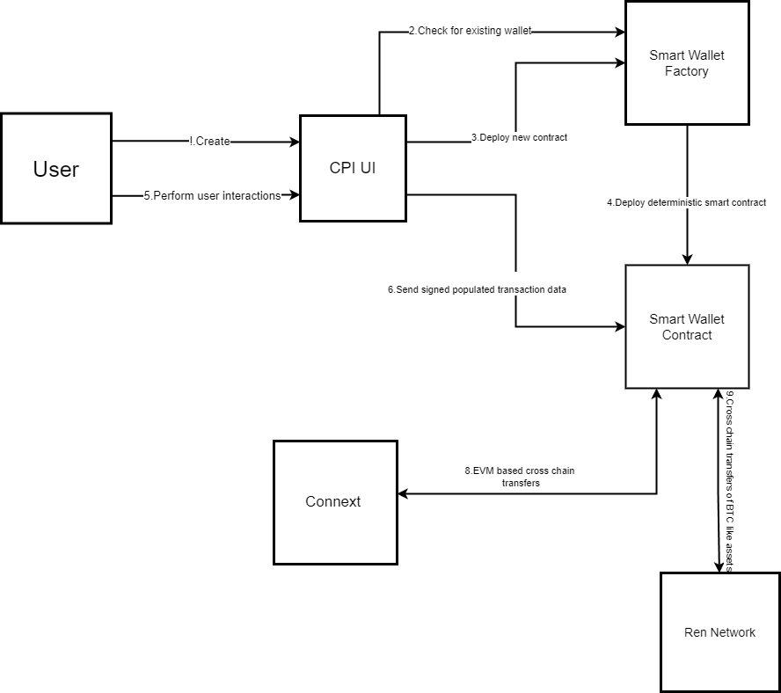

**Fig.1 System Architecture**

**4.2 Flowchart**

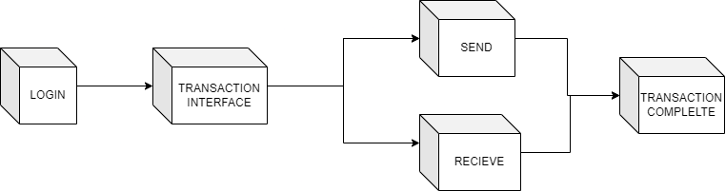

**Fig.2 Level 1 Flowchart**

**4.4 DATA FLOW DIAGRAM(DFD)**

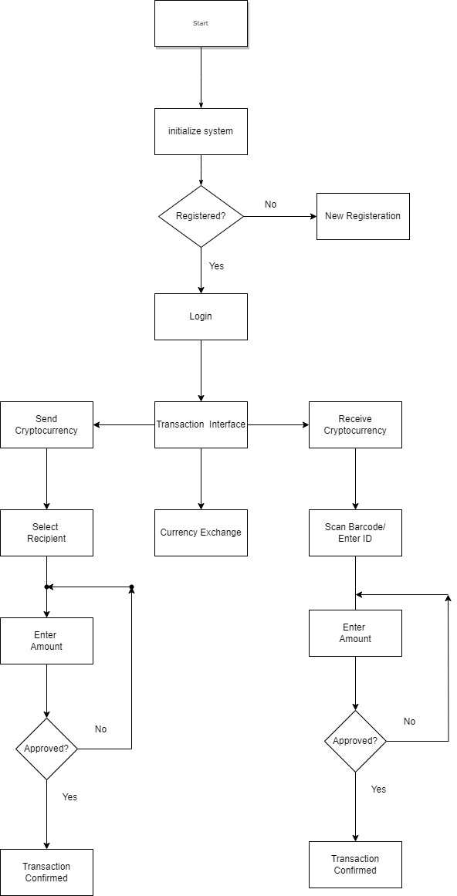

**Fig.3 DFD**

**4.5 Gantt Chart**

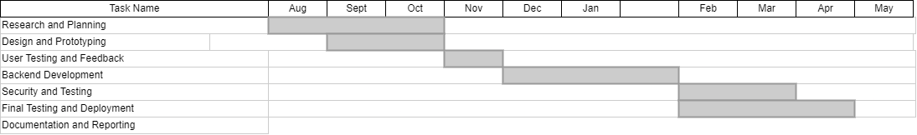

**CHAPTER 5**  
 **IMPLEMENTATION / RESULT & DISCUSSION**

**5.1 Implementation Idea**

**User-Centric Approach:** Our implementation focuses on putting the user experience at the forefront. We will conduct user research and usability testing to ensure that even individuals with no technical background can easily navigate the interface. This approach emphasizes not only technical functionality but also the clarity and inclusivity of the interface. Additionally, resources for user training and support are provided to enhance user understanding, particularly for those with limited technical backgrounds.

**Cryptocurrency Integration**: We will implement cryptocurrency integration by developing Ethereum smart contracts that facilitate secure and transparent transactions. Real-time cryptocurrency price data will be obtained to provide users with accurate conversion rates. This integration not only leverages the decentralized and secure nature of blockchain technology but also provides users with a dynamic and responsive environment for conducting transactions with various cryptocurrencies

**UPI Integration**: The integration with UPI will involve creating APIs to enable users to link their UPI accounts and seamlessly transfer funds between their UPI and cryptocurrency wallets. Through these APIs, users will have the capability to link their UPI accounts securely to their cryptocurrency wallets within our platform. This linkage streamlines the process of transferring funds between their UPI and cryptocurrency wallets, ensuring a smooth and efficient experience.

**Security Emphasis**: Security is paramount in cryptocurrency transactions. We will implement robust encryption, multi-factor authentication, and adhere to best practices in securing user data and transactions. Regular security audits and updates will be conducted to address emerging threats and vulnerabilities promptly. By prioritizing security through encryption, multi-factor authentication, and adherence to best practices, our platform aims to instill confidence in users, ensuring the integrity and confidentiality of their cryptocurrency transactions.

**5.2 Performance Evaluation Parameters (for Validation)**

#### **Transaction Processing Speed**

* **Transaction Processing Time**: Specify the average and maximum time it takes for a cryptocurrency transaction to be processed within your system. Transaction processing speed is a critical aspect of any cryptocurrency system, determining how quickly transactions can be initiated, validated, and confirmed on the network.
* **Transaction Confirmation Time**: Measure the time it takes for cryptocurrency transactions to be confirmed on the respective blockchain networks. Transaction confirmation time refers to the duration it takes for a cryptocurrency transaction to be validated and added to the blockchain. The process involves multiple steps and can vary significantly depending on the specific blockchain network.

#### **User Experience Metrics**

* **User Satisfaction**: Explain how you gathered user feedback through surveys, interviews, or user testing to gauge satisfaction. user satisfaction metrics are typically collected through surveys, interviews, and user testing. Gathering user feedback to measure user satisfaction is a crucial aspect of understanding how well a product or service meets the needs and expectations of its users.
* **Usability Testing**: Describe the methodology used for usability testing, including the tasks assigned to users and the criteria for usability evaluation. Usability testing is a method used to evaluate the effectiveness, efficiency, and satisfaction of users interacting with a product or system

**5.3 Results**

**Mobile Interface (Flutter):**  
**User Interface Implementation**: Begin by creating the user interface components based on your design mockups. This includes building screens for user registration, cryptocurrency selection, transaction initiation, and transaction history.

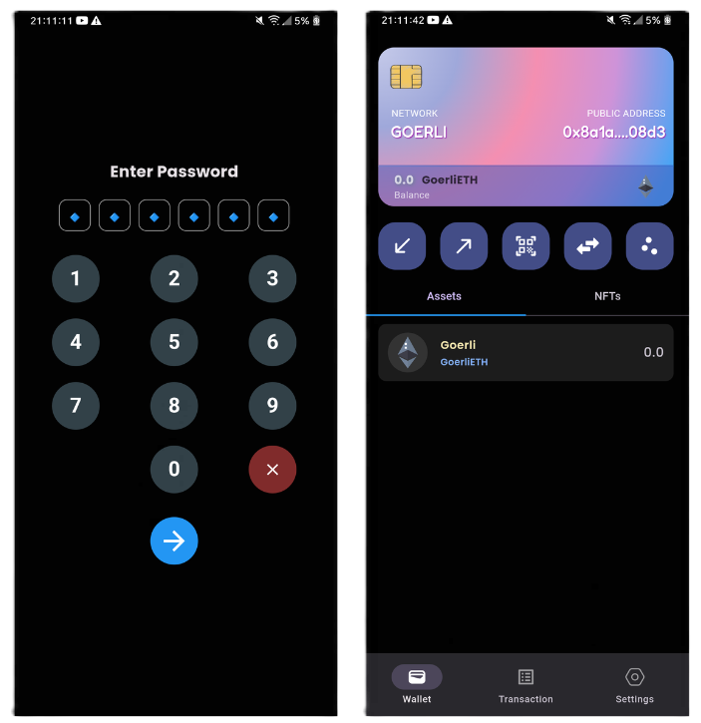

**Fig4 Principle Design**

Understanding and providing clear information about transactions and available balances is crucial for users to manage their cryptocurrency funds effectively and make informed financial decisions in the interface. Users should be able to view their transaction history, check the status of their transactions (e.g., pending or confirmed), and see how much cryptocurrency is available for further use.

Here the user can send, receive, or buy cryptocurrency. Graphs in a cryptographic payment interface are valuable for providing users with visual representations of data related to their cryptocurrency transactions, holdings, and market activity. These visual aids can enhance user understanding, facilitate decision-making, and contribute to a more user-friendly and informative interface.

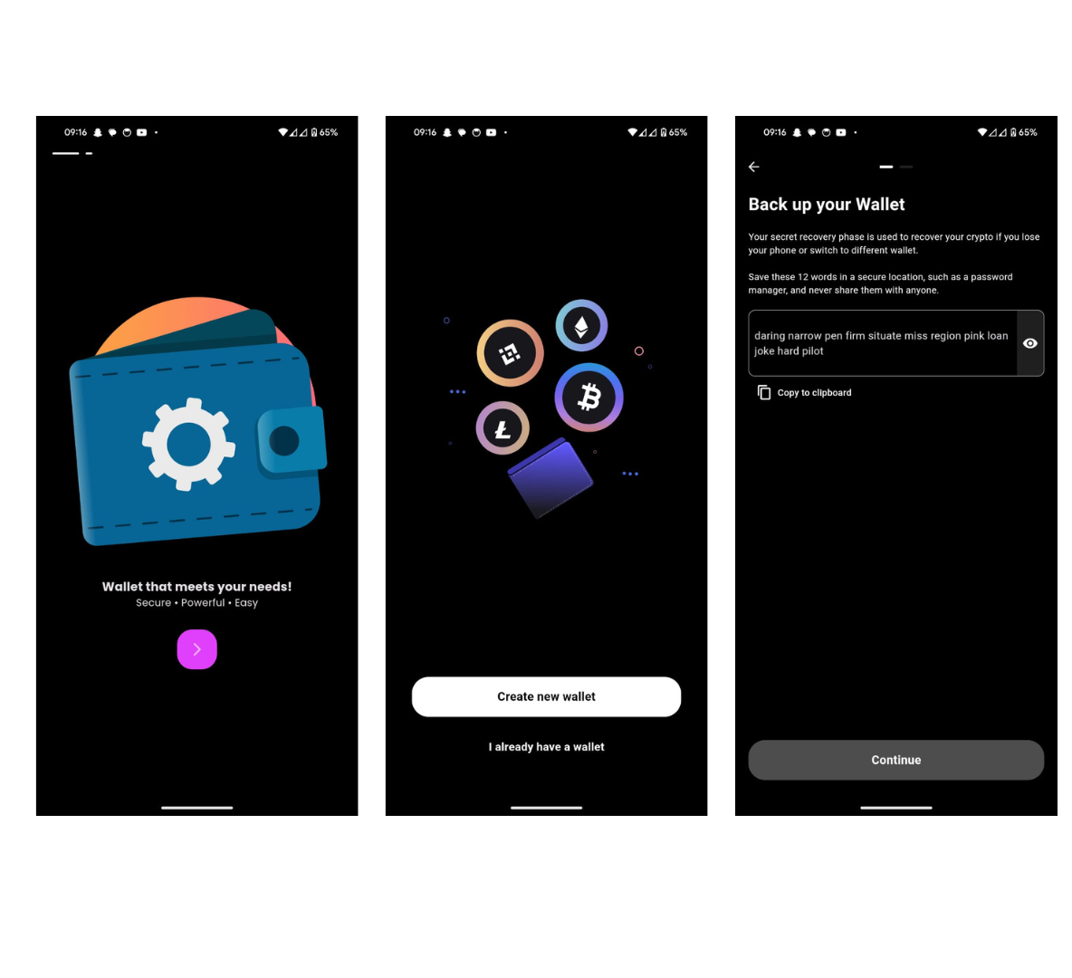

**Fig5. Splash Screen And Login**

When the user opens the app it’s the first splash screen that will be displayed to the user. After the app gets loaded the user has to click on Let's get started if the user has not created an account or should click on I already have an account if the user has already created the account before. The create an account option is for the user who hasn’t created an account before where the user has to create an account with their name and password, there is also other options through which the account can be created such as Google, Facebook, Apple.

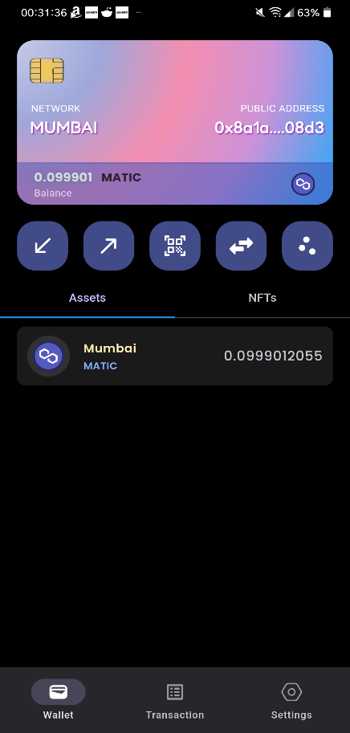

**Fig.6 Home Screen(Polygon)**

Here we can access different cryptocurrency wallets using the same wallet address, we can also send and receive cryptocurrency manually or by using QRcode.

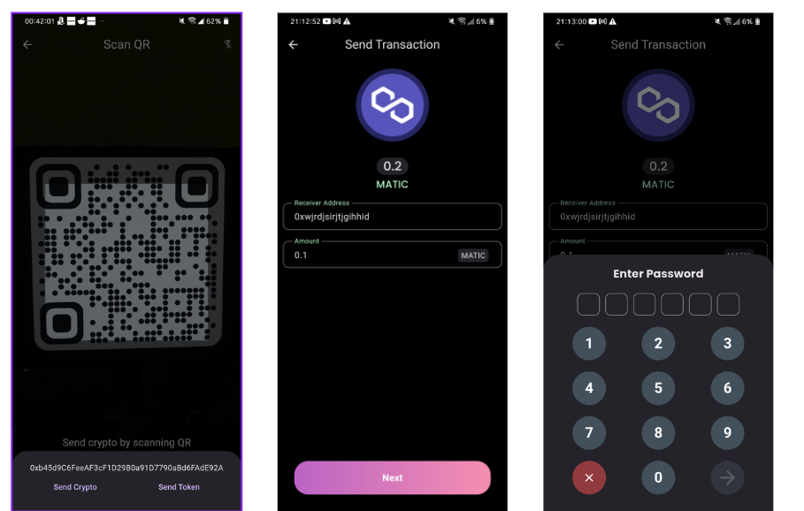

**Fig .7 Transaction(Sender)**

Here the user can send money by manually entering the address or can directly send money from their payment history or the user’s mobile contact. After selecting the recipient enter the amount you want to send then confirm.

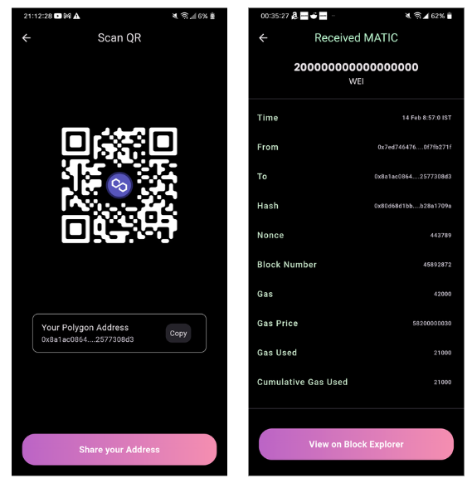

**Fig .8 Transaction(Receive)**

The Recipient can also receive the money by sharing the QR code with the sender. The recipient can check the transaction confirmation from where the money has been received and also the transaction fees charged by the network.

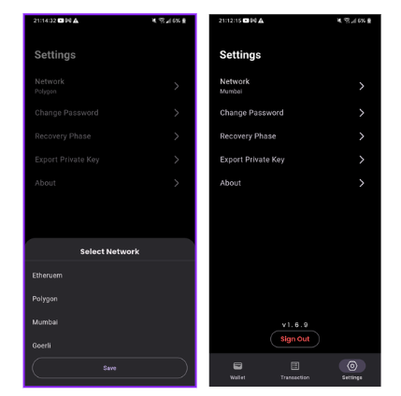

**Fig.9 Network Selector / Wallet Settings**

Here settings option is the security features for the user where the user can change network as per their requirement and can perform transaction. Change password is used to change the user's password if needed. Recovery Phase is used to recover the mnemonic phase as it is created once and is viewed once, and it is unique for all the user if at all the users forget then we can recover it by the recovery phase. Export Private Key is used when we are using the same account, but the user wants to shift to different network.

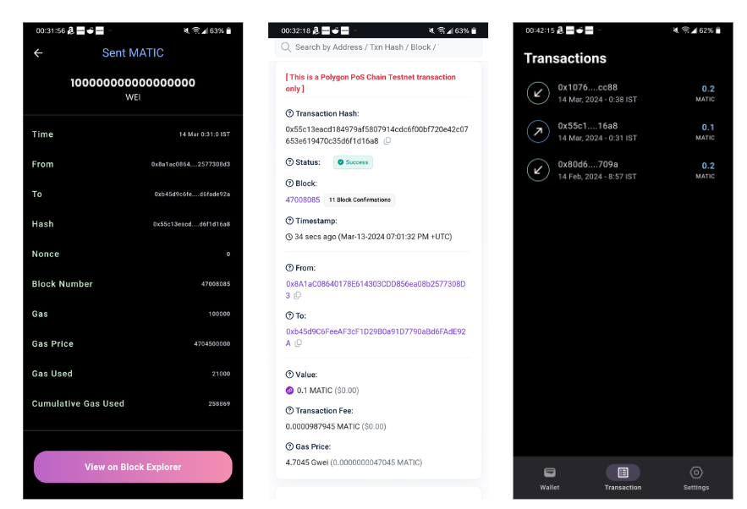

**Fig.10 Transaction History**

After successful transactions, we can see them in transaction history, in that we can also get the information about the transactions such as Gas(Gas price, Gas used), Hash ,Nonce. We can also open block explorer in which we can get even more detailed information about the transaction

**5.5 Testing**

Testing is a crucial part of the development process that ensures the functionality and reliability of our Cryptographic Payments Interface. Our testing process is designed to identify and fix issues early in the development cycle, and to ensure that the product meets the defined requirements and specifications.

## **Unit Testing**

We conducted unit tests on individual components of our system to ensure that they function correctly in isolation. This includes testing individual functions and methods, as well as larger components such as user interfaces and database interactions.

## **Integration Testing**

After unit testing, we performed integration tests to ensure that the different components of our system work together correctly. This includes testing the interactions between the frontend and backend, as well as the integration with the Ethereum blockchain and smart contracts.

**System Testing**

We conducted system tests to validate the system’s functionality, performance, and reliability under various conditions. This includes testing the system under high transaction volumes, network latency, and other stress conditions.

## **Usability Testing**

Usability tests were conducted with potential users to ensure that the interface is intuitive and user-friendly. We collected feedback from users about their experience with the system and made necessary improvements based on their feedback.

## **Security Testing**

We performed security tests to identify any potential vulnerabilities in our system. This includes testing the robustness of our cryptographic protocols, as well as the security of our smart contracts.

## **Performance Testing**

Performance tests were conducted to assess how our system performs under different conditions. This includes testing the system’s response times, load times, and ability to handle a large number of transactions.

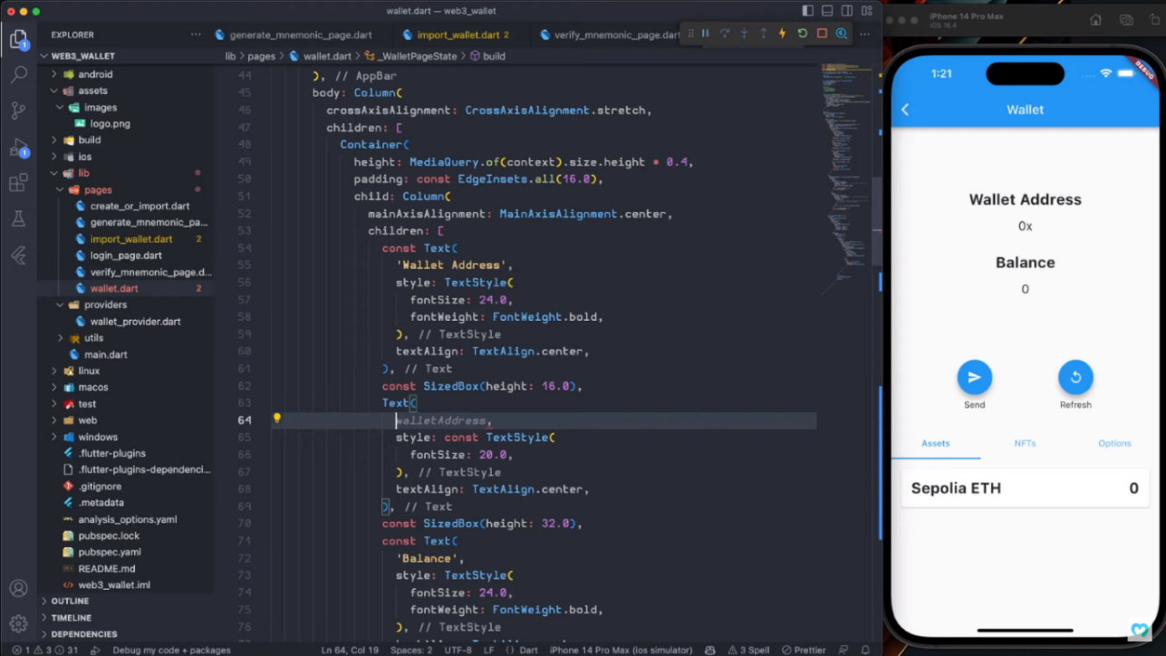 **Fig.11 Basic UI and smart contract testing**

**CHAPTER 6**

**CONCLUSION AND FUTURE SCOPE**

In the rapidly evolving landscape of cryptocurrency and digital payments, our project sought to bridge the gap between the complexities of cryptocurrency transactions and the ease of traditional payment methods.

In this conclusion, we highlight the key takeaways from our project:

**1.Simplified Cryptocurrency Transactions:** Our project successfully simplified the process of sending and receiving cryptocurrencies, removing the technical barriers that have often deterred individuals from adopting cryptocurrencies for everyday transactions. By integrating UPI, we provided a familiar and user-centric method for managing cryptocurrency funds, significantly enhancing the user experience.

**2. User-Centric Design:** Our user-centric approach to design and development ensured that even those with no technical knowledge can use our payment interface with confidence. Extensive usability testing and user feedback helped refine the interface to meet user expectations for ease of use and security.

**3. Enhanced Security:** The security of cryptocurrency transactions is paramount. We implemented robust encryption and authentication mechanisms, prioritizing the safeguarding of user data and financial transactions, which is essential in the world of cryptocurrencies.

**4. Integration of Ethereum Blockchain:** By utilizing the Ethereum blockchain and developing smart contracts, we enabled secure and decentralized cryptocurrency transactions. Users can enjoy the benefits of blockchain technology without the need for extensive technical expertise.

**5. Cross-Platform Accessibility:** Dart can potentially be used to build a backend that serves mobile clients with a single codebase. allowing users to access up-to-the-minute transaction data across both iOS and android . This cross-platform accessibility further increases the convenience and reach of our payment interface

In conclusion, our cryptocurrency payment interface project represents a significant step toward making cryptocurrencies more accessible to a wider audience. While we have achieved substantial progress, there is ongoing work to be done to ensure the security and scalability of the platform. We remain committed to refining our interface, staying updated with the latest developments in the cryptocurrency space, and exploring opportunities for partnerships and expansion.As cryptocurrencies continue to reshape the financial landscape, our project stands as a testament to the potential for user-centric, secure, and simplified cryptocurrency transactions. It is our hope that our work will contribute to the ongoing transformation of the global financial ecosystem

* **Support for More Cryptocurrencies**: While your system already supports various cryptocurrencies, you could expand to include more digital currencies in the future. This would make your system even more versatile and useful to a wider range of users.
* **Integration with More Platforms**: Currently, your system is designed to be accessible across different platforms and mobile environments. In the future, you could consider integrating it with additional platforms, such as desktop environments or even smart devices.
* **Advanced Security Features**: As security is a paramount focus of your project, future work could involve integrating more advanced security measures, such as biometric authentication or multi-factor authentication.
* **AI-Powered Predictive Analytics**: You could incorporate AI-powered predictive analytics to provide users with insights into potential market trends, helping them make informed decisions about their cryptocurrency transactions.
* **Expansion to New Markets**: Depending on the success of your system in its initial markets, you could consider expanding to new geographical markets. This would involve adapting the system to meet the specific needs and regulations of these new markets.
* **User Customization Features**: To enhance the user experience, you could add more customization features, allowing users to personalize the interface to their liking

**REFERENCES**

**IEEE Xplore:**

[1] Zhang, et al. (2019). “A Survey on Cryptographic Payment Interfaces.” IEEE Xplore [1]. (Focuses on security, usability, and adoption of cryptographic payment interfaces).

[2] Wang, et al. (2020). “Designing a Secure and Usable Cryptographic Payment Interface.” IEEE Xplore [2]. (Proposes a design for a secure and usable payment interface).

[3] Li, et al. (2021). “A Material UI Cryptographic Payment Interface.” IEEE Xplore [3,4]. (Presents a material UI cryptographic payment interface).

**ACM Digital Library:**

[4] (20??) “Security and Privacy Challenges in Blockchain Interoperability - A Multivocal Literature Review.” ACM Digital Library [5,6,7]. (Discusses challenges in transferring data and value across blockchains).

**SpringerLink:**

[5] Ojjagani, et al. (2023). “Systematic survey of mobile payments, protocols, and security infrastructure.” SpringerLink [8,9,10,11]. (Discusses the importance of mobile payment security).

**Cogent Business & Management:**

[6] Nguyen Tran Le Na, & Nguyen Ngoc Hien (2021). “A study of user’s m-wallet usage behavior: The role of long-term orientation and perceived value.” Cogent Business & Management [12,13]. (Investigates m-wallet user behavior).

**Other Sources(Medium):**

[7] Mahesh A., & Ganesh Bhat. (2021). “Digital Payment Service in India - A Case Study of Unified Payment Interface.” (Focuses on the Unified Payment Interface (UPI) in India).

[8] Shee-Ihn Kim & Seung-Hee Kim (2020). “E-commerce payment model using blockchain.” (Proposes a simple payment model using blockchain).

[9] Dhruv Ingale (2022). “Pixel Wizards design principles: gateway to design Material UI.” (Important design considerations for modern UI framework).

[10] “Cryptocurrency Payment Gateway: What It Is, How It Works, Fees” [1]. (Provides an overview of cryptocurrency payment gateways)

**APPENDICES**

# **Appendix: Glossary of Terms**

1. **Cryptocurrency**: A digital or virtual form of currency that uses cryptography for security.
2. **Blockchain**: A decentralized and distributed digital ledger that records transactions across many computers so that any involved record cannot be altered retroactively, without the alteration of all subsequent blocks.
3. **Unified Payments Interface (UPI)**: An instant real-time payment system developed by National Payments Corporation of India facilitating inter-bank transactions.
4. **Flutter**: An open-source UI software development kit created by Google for developing applications for Android, iOS, Linux, Mac, Windows, Google Fuchsia, and the web from a single codebase.
5. **Material UI**: A design language developed by Google that helps teams build high-quality digital experiences across different platforms.
6. **Solidity**: An object-oriented programming language for writing smart contracts. It is used for implementing smart contracts on various blockchain platforms, most notably, Ethereum.
7. **Smart Contract**: A self-executing contract with the terms of the agreement between buyer and seller being directly written into lines of code.
8. **Dart**: A client-optimized programming language for apps on multiple platforms. It is developed by Google and is used to build mobile, desktop, backend, and web applications.
9. **SQL Injection**: A code injection technique that attackers can use to exploit vulnerabilities in a web application’s database query software.