**THYROID DISEASE CLASSIFICATION**

**USING ML**

**SYNOPSIS**

**1.INTRODUCTION**

**1.1 Overview**

**1.2 Purpose**

**2.PROBLEM DEFINATION&DESIGN THINKING**

**2.1 Empathy Map**

**2.2 Ideation & Brainstorming Map**

**3.RESULT**

**4.ADVANTAGES&DISADVANTAGE**

**5.APPLICATION**

**6.CONCLUSION**

**7.FUTURE SCOPE**

**8.APPENDIX**

1. **INTRODUCTION**

**1.1Overview**

* Thyroid disease is a subset of endocrinology which is one of the most misunderstood and undiagnosed diseases
* Thyroid gland diseases are among the most prevalent endocrine disorders in the world, second only to diabetes, according to the World Health Organization. Hyper function hyperthyroidism and hypothyroidism affect about 2% and 1% of individuals, respectively. Men have about a tenth of the prevalence of women. Hyper-and hypothyroidism may be caused by thyroid gland dysfunction, secondary to pituitary gland failure, or tertiary to hypothalamic malfunction. Due to dietary iodine deficiency, goiter or active thyroid nodules may become prevalent in some regions, with a prevalence of up to 15%. The thyroid gland can also be the location of different kinds of tumors and can be a dangerous place where endogenous antibodies wreak havoc (autoantibodies)
* Early disease detection, diagnosis, and care, according to doctors, are vital in preventing disease progression and even death. For several different forms of anomalies, early identification and differential diagnosis raises the odds of good treatment. Despite multiple trials, clinical diagnosis is often thought to be a difficult task.
* The thyroid gland is a butterfly-shaped gland situated at the base of the throat. It comprises two active thyroid hormones, levothyroxine (T4) and triiodothyronine (T3), which are involved in brain functions such as body temperature control, blood pressure management, and heart rate regulation. algorithms play a significant role in classifying thyroid disease and because these algorithms are high performing and efficient and aid in classification disorder in which the thyroid gland releases so many thyroid hormones. Hyperthyroidism is caused by an increase in thyroid hormone levels [10].

**1.2 Purpose**

The goal of thyroid hormone treatment is to closely replicate normal thyroid functioning. Thyroid hormone is available as levothyroxine, which is biologically equivalent to your own thyroid hormone, thyroxine (T4). It is most commonly prescribed in tablet form but is now also available in gel capsule or liquid forms.

2.PROBLEM DEFINITION &DESIGN THINKING

**2.1 Empathy Map**

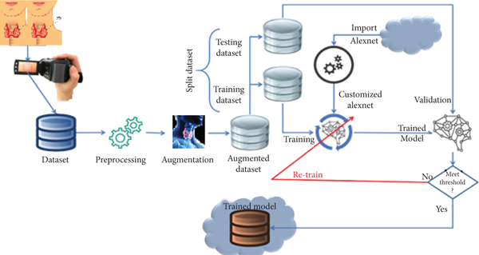

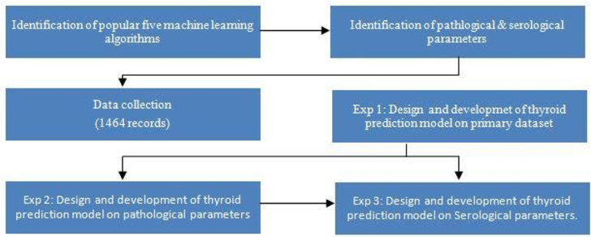

2.2 IDEATION&BRAINSTORMING MAP

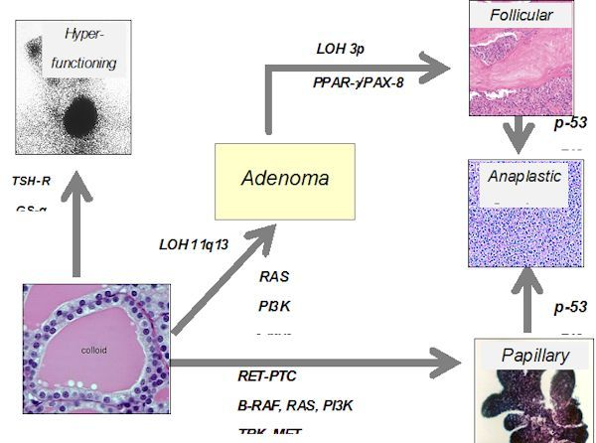

**3.Result**

Problems with the thyroid include a variety of disorders that can result in the gland producing too little thyroid hormone (hypothyroidism) or too much (hyperthyroidism). Thyroid disorders can affect heart rate, mood, energy level, metabolism, bone health, pregnancy and many other functions

.

**4.ADVANTAGES & DISADVANTAGE**

1.Advantages

It helps to regulate many body functions by constantly releasing a steady amount of thyroid hormones into the bloodstream. If the body needs more energy in certain situations – for instance, if it is growing or cold, or during pregnancy – the thyroid gland produces more hormones

2.Disvantages

When the thyroid makes too much thyroid hormone, your body uses energy too quickly. This is called hyperthyroidism. Using energy too quickly will do more than make you tired — it can make your heart beat faster, cause you to lose weight without trying and even make you feel nervous.

**5.APPLICATION**

The thyroid gland is a vital hormone gland: It plays a major role in the metabolism, growth and development of the human body. It helps to regulate many body functions by constantly releasing a steady amount of thyroid hormones into the bloodstream.

**6.CONCLUSION**

Thyroid disease is one of the diseases that afflict the world’s population, and the number of cases of this disease is increasing. Because of medical reports that show serious imbalances in thyroid diseases, our study deals with the classification of thyroid disease between hyperthyroidism and hypothyroidism. This disease was classified using algorithms. Machine learning showed us good results using several algorithms and was built in the form of two models. In the first model, all the characteristics consisting of 16 inputs and one output were taken, and the result of the accuracy of the random forest algorithm was 98.93, which is the highest accuracy among the other algorithms.

**7. FUTURE SCOPE**

The dataset consists of 30 features and some features are not important for the good-fit of learning models to improve the performance of machine learning models. We deployed several feature selection techniques such as forward feature selection, backward feature elimination, bi-directional elimination, and machine learning feature selection. These techniques help to extract the important features from the dataset to train the machine learning models.

[An external file that holds a picture, illustration, etc.
Object name is cancers-14-03914-g002.jpg](https://www.ncbi.nlm.nih.gov/core/lw/2.0/html/tileshop_pmc/tileshop_pmc_inline.html?title=Click%20on%20image%20to%20zoom&p=PMC3&id=9405591_cancers-14-03914-g002.jpg)

Feature impact on models performance.

In machine learning, feature selection is crucial to designing a good model and obtaining the best model performances [[24](https://www.ncbi.nlm.nih.gov/pmc/articles/PMC9405591/#B24-cancers-14-03914)]. The redundant and undesired features may need to be removed from the original datasets to train the model faster, easily interpret the data, and avoid overfitting problems. We have considered the wrapper method for feature selection, as determining the right set of features for thyroid disease classification is essential as follows.

**8.APPENDIX**

* Source code

Coding for Thyroid Diseases in ICD-10-CM

In ICD-10-CM, disorders of the thyroid gland are classified to categories E00 to E07. The categories are as follows:

• E00, Congenital iodine-deficiency syndrome;

• E01, Iodine-deficiency related thyroid disorders and allied conditions;

• E02, Subclinical iodine-deficiency hypothyroidism;

• E03, Other hypothyroidism;

• E04, Other nontoxic goiter;

• E05, Thyrotoxicosis [hyperthyroidism];

• E06, Thyroiditis; and

• E07, Other disorders of thyroid.

Currently, the coding directives related to thyroid diseases are the same in ICD-10-CM as in ICD-9-CM, although some conditions are classified to different chapters or different blocks. For example, in ICD-9-CM, postsurgical hypothyroidism is classified to code 244.0, which is in the hypothyroidism category. However, in ICD-10-CM, postsurgical hypothyroidism is not located under category E03, Other hypothyroidism. Instead, it is classified to code E89.0. Category E89 is titled “Postprocedural endocrine and metabolic complications and disorders, not elsewhere classified.”

*— Audrey Howard*



Great Valley Publishing