Product table in MySql;  
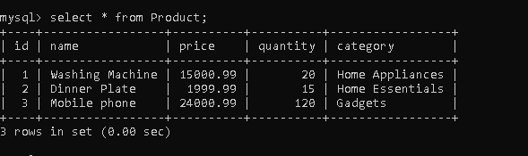  
  
  
  
Get Request in Postman for Search Product end point:  
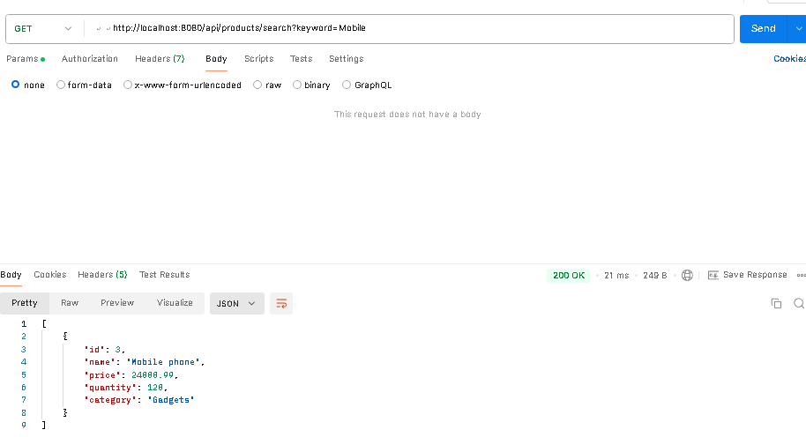

Post Request in Postman for Buy Product end point:  
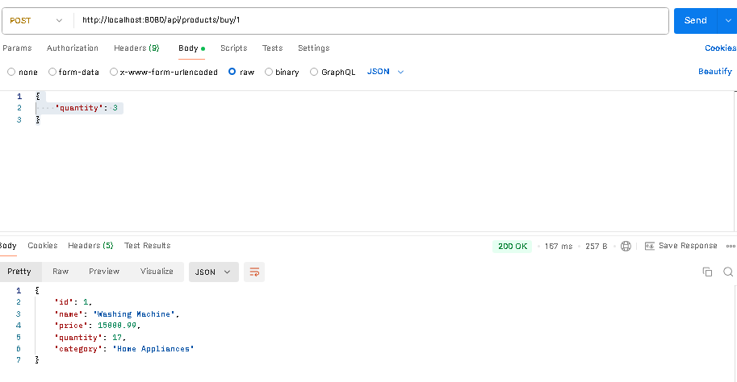  
  
Scenario1 :All Test Cases passed:  
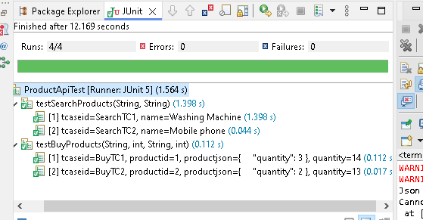  
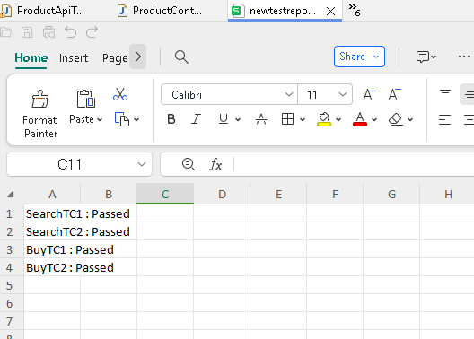

Scenario2 :When few Test Cases are failed:  
