**Display Available Products:**

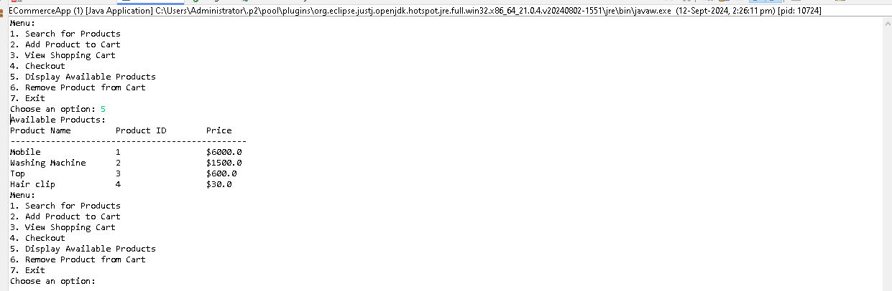

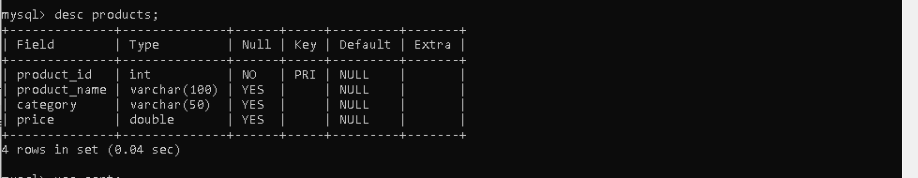

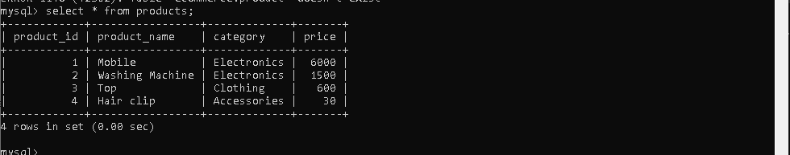

**Search for Products:**

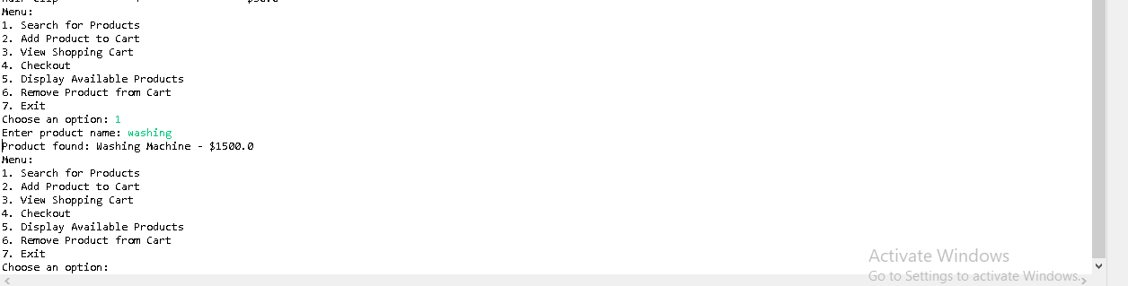

**Add Product to Cart:**

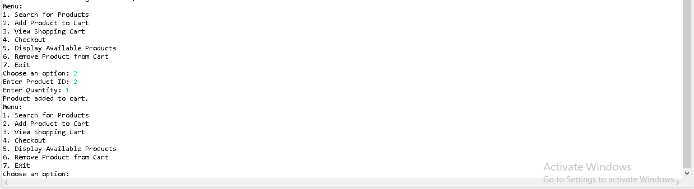

**Add 2nd Product to Cart:**

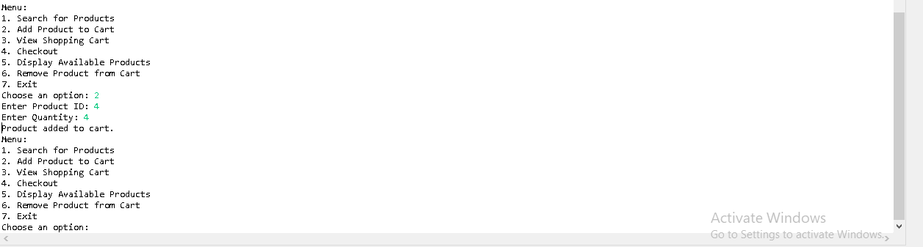

**View Shopping Cart :**

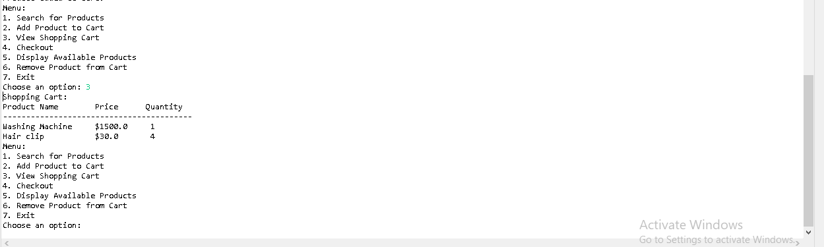

**Remove Product and View Cart :**

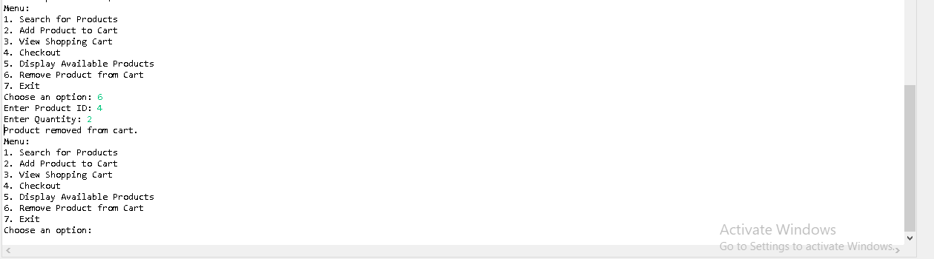

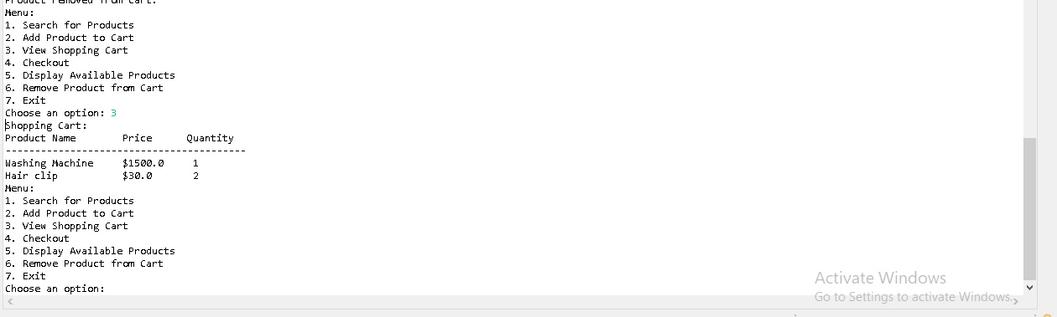

**Checkout:**

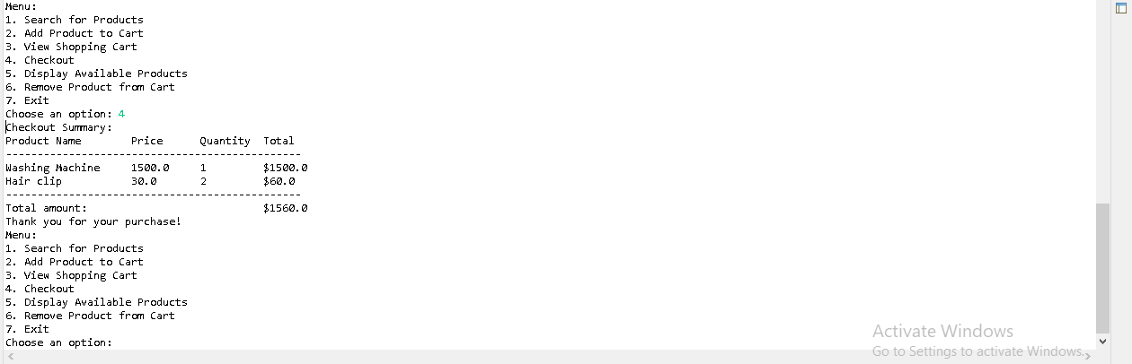

**Invalid option:  
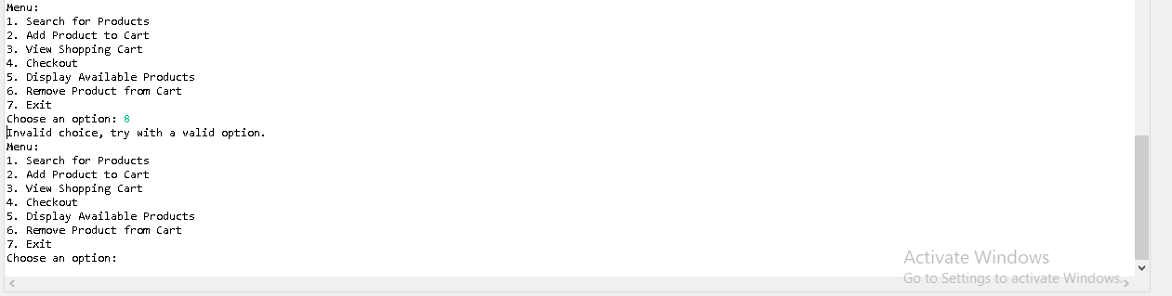**

**Exception handling when string value is provided instead of int as option**

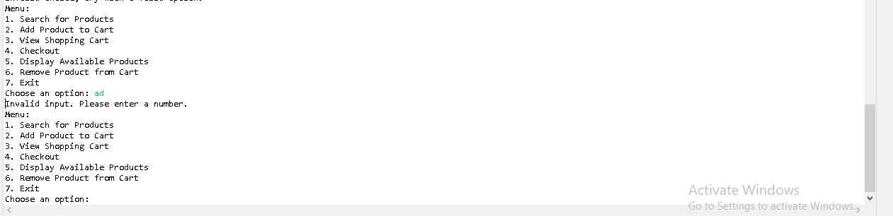

**Exit:**

