**Implementation of Lexical Analyser**

Code:

kw = ("int","float","double","main","return","printf","if","else","for","while","do","break","continue","scanf")

op = ("+","-","/","*","%","=","<",">","<=",">=","!=","==")

spsym = ("(",")","{","}",",",";","?","")

c=0

with open("c.txt","r") as f:

    with open("target.txt","w") as f1:

        for line in f:

            for k in line.split():

                if k[0] =="#":

                    f1.write(k+" is a macro\n")

                elif k in op:

                    f1.write(k+" is a operator\n")

                elif k in spsym:

                    f1.write(k+" is a special symbol\n")

                elif k in kw:

                    f1.write(k+" is a keyword\n")

                elif k.isdigit():

                    f1.write(k+" is a integer\n")

                elif "%" in k:

                    f1.write(k+" is a format specifer\n")

                elif k.isalnum() and k[0].isalpha():

                    f1.write(k+" is a Variable\n")

                else:

                    f1.write("Lexical error encountered\n")

            c = c+1

        f1.write("Total number of lines in code "+str(c))

input file

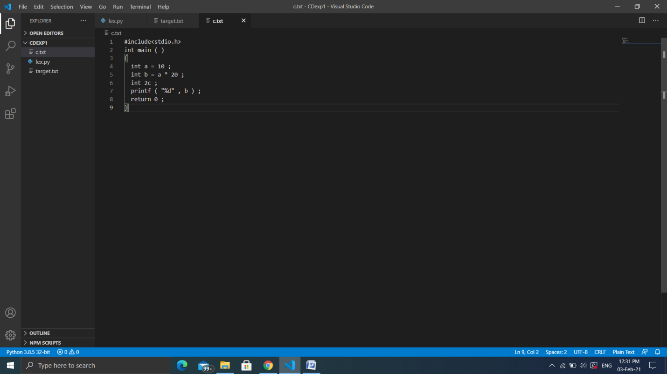

Output

