APAC network optimization: Data

Contents
Introduction 1
Critical points to understand 2
Detailed dataset 3
NER diagram 3
Input file: Demand 3
Output files: Current_Lines, Current_Lines_Details, Demand routing and KPI 3
Current Lines 4
Current Lines Details 4
Example 4
KPI 4
Demand_routing 4
Other files 4
Port Information 5
Vessel_class 5

Introduction

The goal of the project is finding the best lines for a given demand.
The project is divided into a POC and a production phase that includes some enhancements, so some columns in the data are useless for the moment but will be useful in future iterations.
The dataset is divided in 5 main categories
- Demand: the input
- Current Line: what the output should look like
- Vessel: vessel characteristics, vessels are classified by how many containers they can carry and the bigger they get, the more fuel they consume and the less ports they can enter
- Port: ports characteristics include how much it costs to transship (move a container from one vessel to another vessel) and which vessel can enter and at which price.
- Distance: maritime distance between all ports.

Critical points to understand
The main idea of the project is quite classical. It is a line creation with a fixed demand and a cost to transport the demand based on the vessel size and the port to transship chosen.
Some points are a bit more specific to maritime and need clarifications:
- Draft
  - Condition: port draft > vessel draft
  - The higher the draft of a port is, the more vessels can go there
  - Some ports are missing draft information, a dummy value of 100 was put. Meaning all vessels can call them.
- Transshipment cost and capacity
  - The first version should be with transshipment capacity = 1 for all ports
  - If it is too complex, it will be reduced to transshipment capacity = 1 for only 12 ports. The idea is to see how the model optimize and one to make it more realistic.
  - Some ports don’t have transshipment cost, a dummy value of 5 000 was put instead
  - Some ports don’t have storage transshipment cost, a dummy value of 1,000,000 per day and 7 free days was put instead.
- Max daily port call
  - Condition: number of vessels calling a port < max daily port call
  - Some ports have cheap transshipment and call cost, so this constraint was added to make sure the optimization doesn’t make something too unrealistic. For instance, it is not desired to have 100 000 vessels calling Singapore in one day.
- Berth moves per hour
  - This is one of the most critical parts of the optimization
  - The time a vessel spends at a port loading or unloading containers is dependent on
    - Vessel class: for instance, on some bigger vessels, it is possible to deploy more cranes to discharge faster
    - Number of containers to be loaded/unloaded: this is critical. It means that the time a vessel spends at a port can’t be known before the flow is known. It means that the line characteristics (voyage duration, service speed, …) can’t be known at the line creation time.
    - For a given vessel class, stay time at port = berth moves per hour * (number of containers being loaded and unloaded at this port)
- Line speed
  - This is highly critical for this study.
  - The lines need to be weekly, for instance for line 1, there is a vessel going to Singapore on Monday. It will go to Singapore every Monday.
  - The voyage duration of the line needs to be calculated by adding
    - the time loading and unloading containers at the ports
    - the time sailing from ports to ports
      - If the sailing is slower, then the cost is lower because the vessel consumes less bunker
      - but the containers arrive later at destination and there is a time constraint for every container in demand of
        - New transit day < current transit day + 4 days
  - Considering all of these constraintsts, the line will have a speed that will make sure that the Voyage Duration is a multiple of 7.
  - All vessels class can go at all speeds but at different costs.
    - So, for a given service, the speed of vessels deployed will be constant.
- Line Capacity
  - How much TEU at maximum the line will carry
    - This determines the choice of the vessel class to deploy on this line.
- Vessel costs
  - Daily vessel costs = chartering cost + bunker consumption * bunker price
  - The bigger the vessel, usually the higher the cost. Thus, there is a need to balance between taking a bigger vessel and the higher cost that comes with it.
- Demand
  - The demand file contains a lot of rows with TEUs < 10
  - If the project becomes too complex, it will be possible to check if by removing some part of the demand, it is easier to converge.
- Frozen
  - Some lines are frozen, meaning that they need to be part of the new network. These are mainly the big lines going from Asia to the US or to Europe.
  - All lines in Intra-Asia and 2 lines from Australia to Asia are to be forgotten. The point of the POC is to see how they can be built better.
  - FYI, this is an Asia project, but CMA is a French company. We are freezing those lines which we do not have full control over, which is why they are frozen.
- Storage cost
  - A container staying at a port waiting for its vessel, for instance after a transshipment, needs to pay a price depending on how long it stays
    - The port offers a certain number of free days (Days Free)
    - Storage cost is by day
      - For instance, if Days Free = 7 and the container stays 9 days, the cost will be
        - (9-7) * Storage cost
    - The data is not available for all ports so a dummy of 1 000 000$ was put to forbid to stay too long in these ports.
- Max capacity vs Vessel class
  - Max capacity is with containers full of products
  - Vessel class capacity is the min and max of a given class, min and max defined for empty containers.
  - Only the Max capacity makes sense in our study, the Vessel class is just a classification.
- All the prices are in USD

Detailed dataset

NER diagram

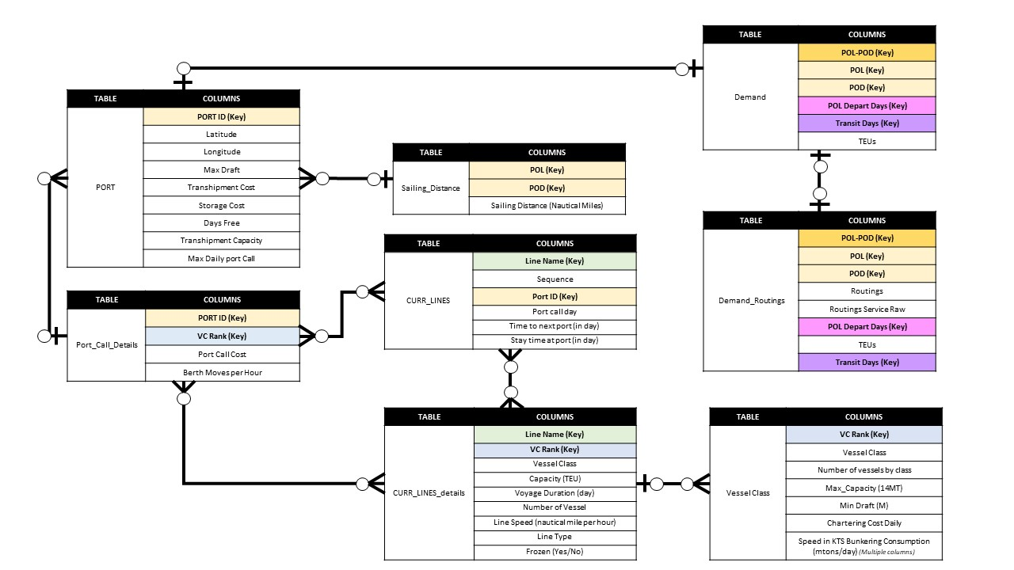

Input file: Demand
The demand depends on the 4 keys.
- POL: where the containers are loaded
- POD: where the containers are discharged
- POL_departure_day: which day the containers leaves the POL, this impacts the day the service should call the port. For instance, if Singapore clients are used to be able to get their containers to the port on Wednesday, it is ok to have a line on Wednesday, Thursday or Friday but to have it on Tuesday mean that the line must be really fast to get back the 6 days lost.
- Transit_days: even by departing the same day, it is possible that containers go on different lines, meaning different transit days (the faster it is, the more expensive it is for the clients).
- TEUs
  - The TEUs discharged in the last 3 months were aggregated to form a weekly demand.
    - TEUs = Number of TEUs over 3 months / 12
    - If TEUs < 1, then it is removed from the demand

Output files: Current_Lines, Current_Lines_Details, Demand routing and KPI
The output is separated into 4 files.
These files show our current network, and the new network should match the same representation.
- Current_line
- Current_line_detail

Current Lines
This file specifies the rotation of the line and the time at each port and between each port.

Current Lines Details
This file specifies the characteristics of the current lines.
- Some can be calculated from the current lines file such as voyage duration or line speed (using the distance file)
- Some are specific to the flow such as Capacity.
- 2 columns are not to be calculated by the model
  - Line Type is not to be predicted by the model. It is historical information for business knowledge.
  - Frozen is not to be predicted. It indicates which lines need to be used and which can be forgotten.

Example
For instance, let’s look at BBXCNC
- The vessel goes to SGSIN then MYPKG then BDCGP then back to SGSIN.
  - It takes the vessel 2 weeks to come to Singapore as the Voyage Duration is 14 days.
  - Voyage duration = time to next port + stay time at port
    - In some situations, time to next port + stay time at port doesn’t match Voyage duration for physical or business reasons. But for the calculated version, it needs to be the case.
    - Voyage duration should be a multiple of 7 by definition
- It is interesting to notice that some “Stay time at port” is longer than some Time to next port
  - The main goal of a line is to load/unload containers. The time spent sailing is always a choice between faster but more expensive or slower and cheaper.
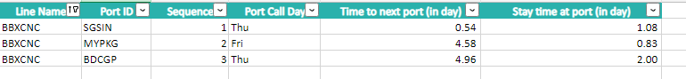

KPI
The KPI is a way to compare the new lines calculated vs the existing ones.
They should be calculated for the existing one by demand_routing file with the flow following the given lines.

Demand_routing
This file needs to show the route used by the containers, which will be used to understand how the suggested network flow the demand and help business teams validate how realistic it is.
- Routing: all the ports by which the container is
  - Loaded
  - Transshipped
  - Discharged
- Routing_Service: all the ports and the services used between the ports
  - Routing_Service is more unique than Routing. For example there could be 100 TEUs going from CNSHA > NLRTM, but it could be split up to 30TEUs taking FAL, 70TEUs taking FAL6.

Other files
The other files are about Port and Vessel. They are the key elements of the network.
Vessel is a bit special compared to other network problem because the flow of containers doesn’t just go on the network, it goes on the network on vessel.

Port Information
The port information is present in 3 files
- Port
  - All information related to a port
  - Some drafts were not present in the data so a dummy value of 100 was put, meaning all vessels can be deployed there
  - Some transshipment costs were not present so a dummy value of 100 000 was put to stop transshipment from happening. Transshipment capacity is another way to achieve this result, but it was not selected as the current option.
  - Transshipment capacity is 1 for 12 ports. 2 versions are expected
    - 1 with all ports as 1
    - 1 with only these 12 ports as 1
    - It is desired to analyze the difference between the 2.
- Port_Call_Details
  - All information related to a port and a vessel class.
    - The bigger vessels pay more to enter a port.
      - Not all combination of port/vessel class exist, meaning that some vessels can’t call a port. This is not an explicit constraint like the draft linked to a real reason but more a data limitation constraint.
    - Usually the bigger the vessel, the faster they can load/unload because more cranes can be used but it is not always the case.
- Sailing_distance
  - Not all ports pair have a value
  - It is not symmetrical meaning d(A->B) != d(B->A)

Vessel_class

Vessels are classified by the amount of TEUs they can carry. That influence their size and so the fuel the consume and the port they can call. If the port is too small, the big vessels can't call it. Multiply the consumption with the bunker price to get the bunkering price.

