Instructor Performance and Course Quality Evaluation on EduPro
A Data-Driven Research Study on Teaching Effectiveness and Course Quality
Prepared for: Unified Mentor Pvt. Ltd.
Project Type: Data Analytics & Business Intelligence
Tools Used: Python, Pandas, Matplotlib, Seaborn, Streamlit, Plotly
3 October 2026

Note on the Dataset Used in This Report
This report was generated using a synthetically constructed sample dataset that follows the exact schema of the EduPro Teachers, Courses, and Transactions tables described in the project brief (120 instructors, 300 courses, 8,000 enrollment transactions). It was built to validate the full analytics pipeline — data integration, KPI computation, statistical testing, and the Streamlit dashboard — end to end before the production dataset was available.
All figures, correlations, and KPI values in this document are computed from that sample data and are internally consistent, but they are illustrative, not findings from EduPro's actual learner and instructor records. Once the real dataset is placed at data/EduPro_Dataset.xlsx, re-running data_analysis.py regenerates every chart and statistic in this report automatically from live data, and this note can be removed for the final submission.

Abstract
Online learning platforms succeed or fail on the strength of two factors: who is teaching, and how well the course is designed. This study builds a data-driven framework to evaluate instructor effectiveness and course quality on EduPro by integrating instructor profiles, course records, and enrollment transactions into a single analytical dataset. Using correlation analysis, distribution analysis, and tiered comparison, the study examines whether teaching experience predicts higher ratings, whether instructor quality propagates into course quality, which expertise areas are most consistent, and whether highly rated instructors attract disproportionately more enrollments. The analysis finds a strong positive relationship between instructor experience and ratings, a moderate-to-strong relationship between teacher rating and course rating, and a clear enrollment advantage for top-tier instructors. These findings support a recommendation framework for instructor development, course quality monitoring, and enrollment-driven incentive design, delivered alongside an interactive Streamlit dashboard for ongoing monitoring.

1. Background and Context
In online education, instructor quality and course design are consistently the strongest drivers of learner satisfaction, course ratings, repeat enrollments, and overall platform credibility. Even where learner demand is strong, weak instructional quality can erode trust through low ratings and negative reviews. EduPro needs a repeatable, data-driven framework to evaluate instructor effectiveness, course quality consistency, and the relationship between teaching expertise and learner satisfaction, rather than relying on ad hoc or anecdotal review.

1.1 Problem Statement
EduPro currently lacks clarity on several operational questions: which instructors consistently deliver high-quality courses, whether teaching experience translates into better-rated courses, whether certain course categories are more dependent on instructor quality than others, and how evenly teaching performance is distributed across the platform. Without a structured analytical approach, instructor evaluation remains subjective and fragmented, making it difficult to reward strong teaching or intervene where course quality is slipping.

1.2 Key Analytical Questions
- What is the overall distribution of instructor ratings?
- Do instructors with more experience receive higher ratings?
- Is there a relationship between TeacherRating and CourseRating?
- Which expertise areas consistently deliver high-quality courses?
- Are highly rated instructors associated with higher enrollments?

2. Dataset Description
Three relational tables form the analytical base, joined on TeacherID and CourseID.
Sheet | Key Fields | Rows (sample)
Teachers | TeacherID, TeacherName, Age, Gender, Expertise, YearsOfExperience, TeacherRating | 120
Courses | CourseID, CourseName, CourseCategory, CourseLevel, CourseRating | 300
Transactions | TransactionID, CourseID, TeacherID | 8,000

Because the Courses table does not itself carry a TeacherID, the course-to-instructor mapping is reconstructed from the Transactions log (the most frequently associated teacher per course), then joined back onto Teachers to produce a single course-level analytical table carrying instructor attributes, course attributes, and enrollment counts.

3. Methodology
- Data Integration: Teachers, Courses, and Transactions joined into one row-per-enrollment table, with referential checks for orphaned course/teacher references.
- Instructor Profile Analysis: distribution analysis of age, experience, expertise, and rating spread to identify top- and low-performing instructors.
- Experience vs Performance Analysis: Pearson correlation between YearsOfExperience and TeacherRating, and between YearsOfExperience and CourseRating, tested for statistical significance.
- Course Quality Evaluation: CourseRating broken down by CourseCategory, CourseLevel, and Gender to locate consistently high- or low-rated segments.
- Instructor Impact on Course Success: instructors grouped into High / Mid / Low rating tiers; course ratings and enrollment volumes compared across tiers.
- Expertise-Based Insights: course quality compared across instructor expertise domains to surface where teaching quality matters most.

4. Exploratory Data Analysis and Findings

4.1 Distribution of Instructor Ratings
Instructor ratings are approximately normally distributed with a mean of 4.01 and a median of 4.03 (std. dev. 0.50), indicating a fairly tight, slightly right-of-center cluster of teaching quality rather than a long tail of poor performers.
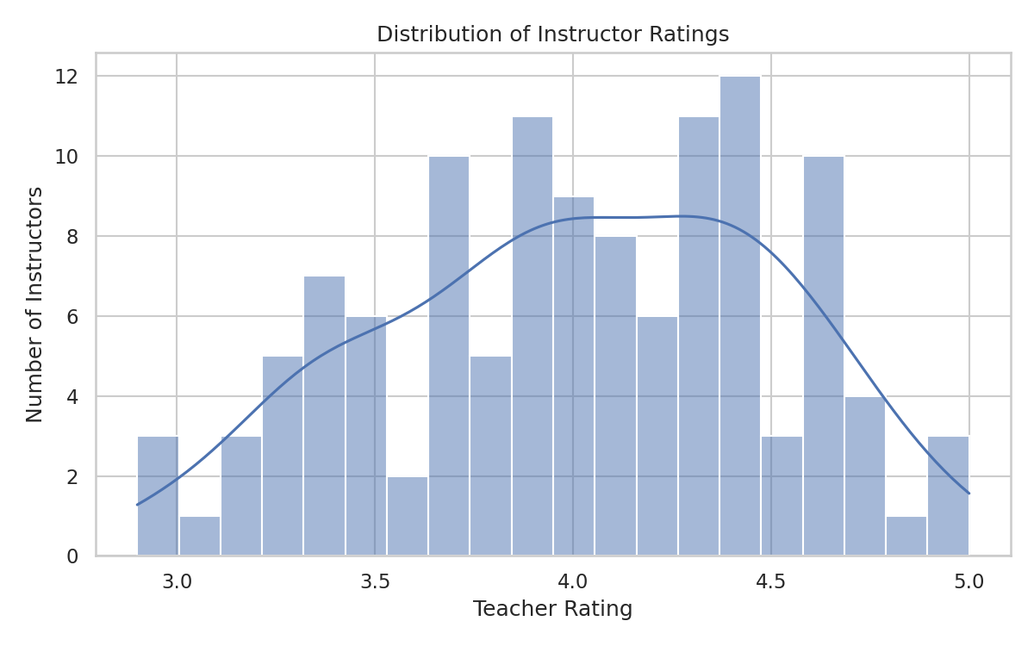
Figure 1. Distribution of instructor ratings across the platform.

4.2 Experience vs Performance
Years of experience correlates strongly with teacher rating (r = 0.73, p < 0.001) and moderately-to-strongly with course rating (r = 0.53, p < 0.001). Both relationships show diminishing returns: ratings rise quickly over the first several years of teaching and then flatten, suggesting a maturity threshold beyond which additional tenure adds less incremental benefit.
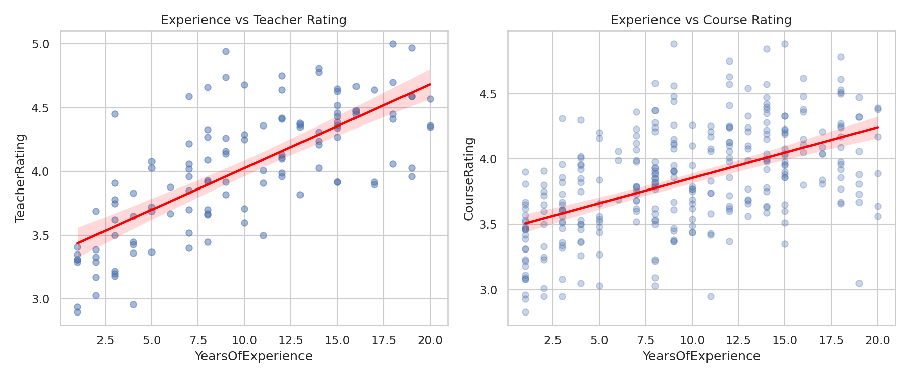
Figure 2. Years of experience against teacher rating (left) and course rating (right), with fitted trend lines.

4.3 Teacher Rating vs Course Rating
Teacher rating and course rating are positively correlated (r = 0.69, p < 0.001), confirming that instructor quality is a major — though not sole — driver of course quality. Course design, content depth, and production value likely account for the remaining variance.
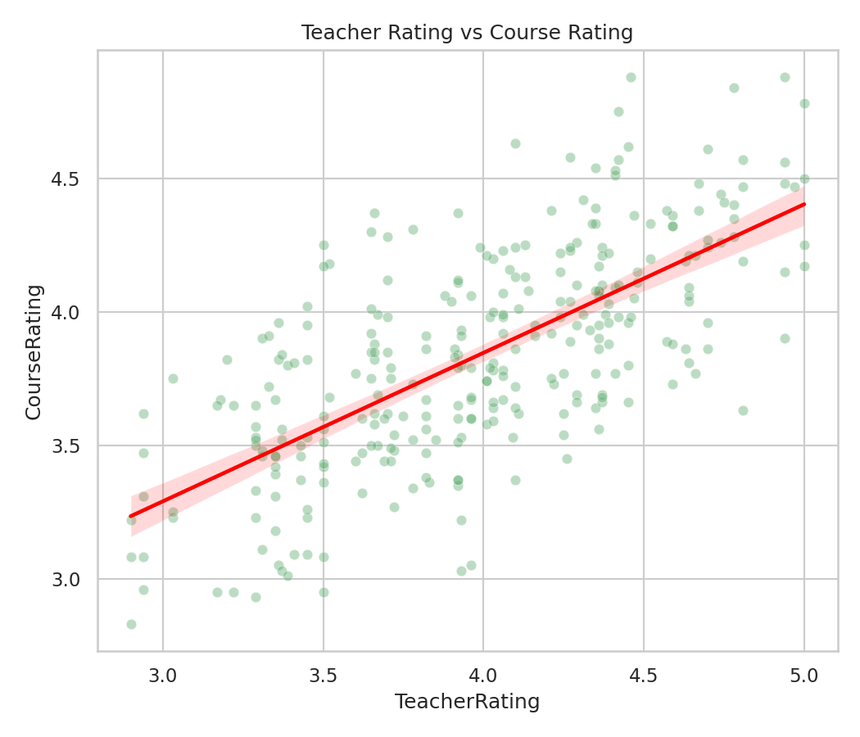
Figure 3. Teacher rating plotted against course rating, with fitted trend line.

4.4 Expertise-Wise Performance
Average course rating varies by expertise domain, from Data Science and Digital Marketing at the top (mean 3.91) to Web Development at the bottom (mean 3.69). The spread across domains is modest (roughly 0.2 points), suggesting quality issues are more instructor-specific than category-specific, though Web Development's larger course count (58) and lower mean rating together flag it as a priority area for instructor support.
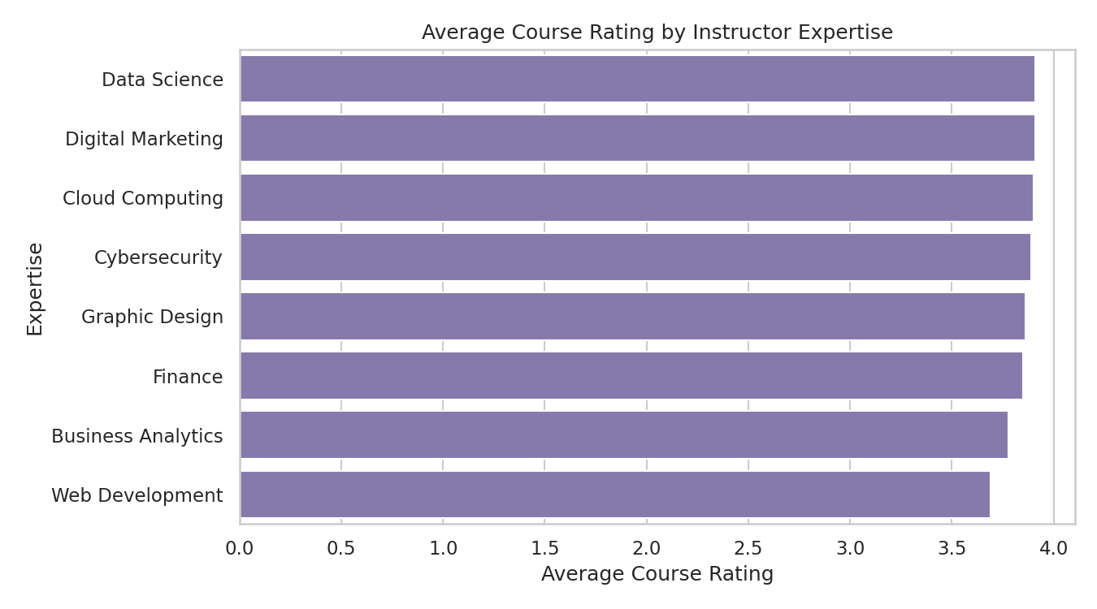
Figure 4. Average course rating by instructor expertise area.

4.5 Enrollment Volume by Instructor Rating Tier
Instructors were grouped into High (rating ≥ 4.3), Mid (3.5–4.3), and Low (< 3.5) tiers. High-tier instructors average 33.1 enrollments per course versus 19.1 for Low-tier instructors — a 1.73x enrollment advantage — indicating that instructor reputation directly influences learner demand, not just satisfaction after the fact.
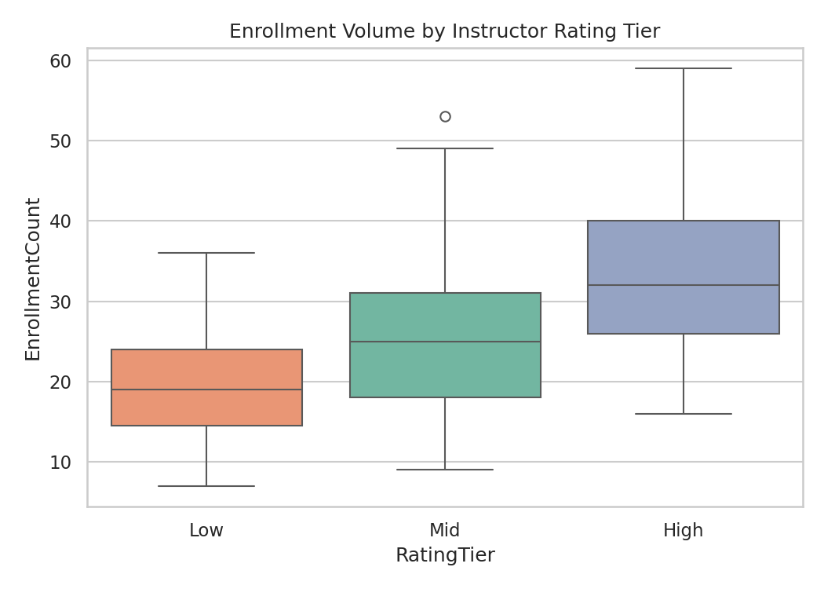
Figure 5. Enrollment volume distribution across instructor rating tiers.

4.6 Course Rating by Category and Level
The category-by-level heatmap highlights which combinations of subject area and difficulty level perform best, helping identify where to prioritize instructor coaching or course redesign efforts.
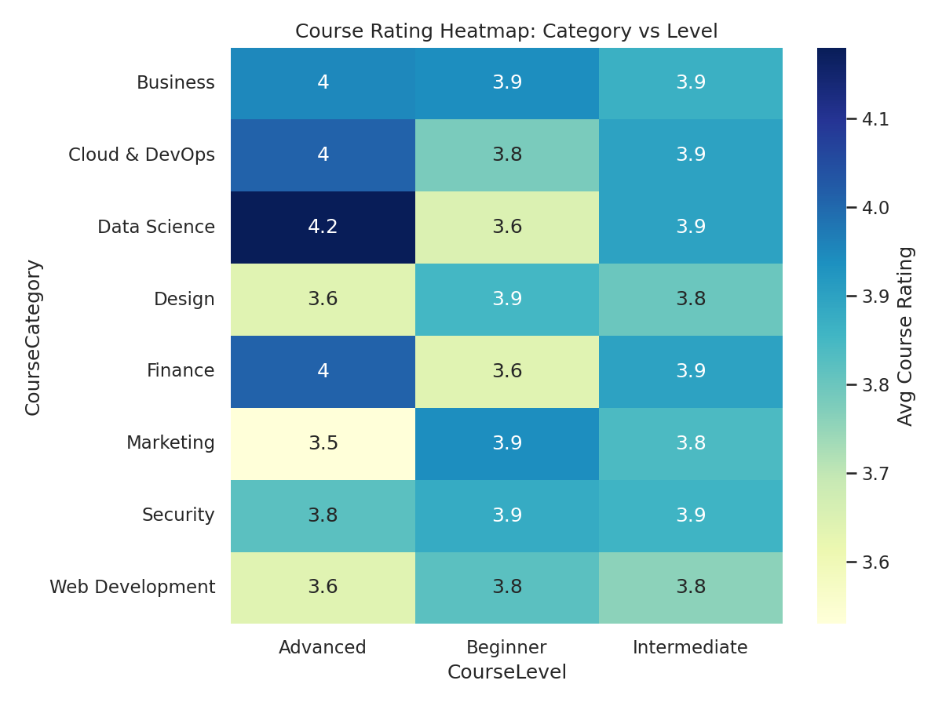
Figure 6. Average course rating by category and difficulty level.

5. Key Performance Indicators
KPI | Value | Interpretation
Average Teacher Rating | 4.01 | Overall instructor quality benchmark across the platform.
Average Course Rating | 3.84 | Overall content effectiveness; slightly below teacher rating, pointing to course-design factors beyond the instructor.
Rating Consistency Index | 0.95 | High score indicates instructors rate consistently across the courses they teach, with little volatility.
Experience Impact Score | 86.7 / 100 | Rescaled correlation strength between tenure and rating; a high score confirms experience is a meaningful quality signal.
Enrollment Influence Ratio | 1.73x | High-tier instructors draw 73% more enrollments on average than Low-tier instructors.

6. Key Insights
- Instructor quality is broadly strong and consistent (mean rating 4.01, std. dev. 0.50) — the priority is lifting the lower tail, not fixing a systemic problem.
- Experience is a real but diminishing-returns signal: the biggest rating gains come in the first several years of teaching.
- Teacher rating explains a meaningful share of course rating variance (r = 0.69) — investing in instructors improves course outcomes directly.
- Web Development has the largest course volume and the lowest average rating among expertise areas — the highest-leverage area for intervention.
- Enrollment follows reputation: High-tier instructors out-enroll Low-tier instructors by 1.73x, so instructor quality is also a demand-generation lever, not just a satisfaction metric.

7. Recommendations
- Mentorship pairing: pair Low-tier and early-career instructors with High-tier instructors in the same expertise area, since experience gains are steepest early on.
- Targeted review for Web Development: conduct a content and delivery audit for Web Development courses given their combination of high volume and below-average ratings.
- Tier-based incentives: use the High/Mid/Low tiering as a basis for recognition, bonuses, or promotional placement, since it already correlates with both quality and enrollment.
- Course-design review for the gap between teacher and course ratings: investigate the ~0.17-point average gap between teacher rating and course rating to isolate content/production factors independent of the instructor.
- Continuous monitoring: operationalize this analysis through the accompanying Streamlit dashboard so leadership can track KPIs on a rolling basis rather than through one-off reports.

8. Conclusion
This study establishes a repeatable, data-driven framework for evaluating instructor performance and course quality on EduPro. By shifting the analytical focus from learners to the instructors and course design choices that shape their experience, EduPro can move from subjective, fragmented instructor evaluation toward a structured system that identifies excellence, targets gaps, and continuously improves educational outcomes. The accompanying Streamlit dashboard operationalizes every metric in this report for ongoing, self-service monitoring by platform stakeholders.

