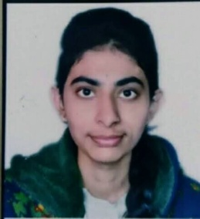 RESUME

Name-Anjali Birla

Mob NO.- 8815636590

Email id – anjalibirlabirla@gmail.com

Linkedin id - https://www.linkedin.com/in/anjali-birla-63b2b7249/

Github id- https://github.com/anjalib24

OBJECTIVE

An engaging and passionate college student pursuing a professional degree MCA seeking a position in a company where I can utilize and improve my skills and technical knowledge which helps me in both individual and organization’s growth.

Personal skills

I am punctual, obey rule ,Enthusiastic, career minded ,positive, responsible,learning quickly and working safely. Capable of solving problems and having good communication skill.

Academic qualification

|  |  |  |  |  |  |
| --- | --- | --- | --- | --- | --- |
| S.N0 | Qualification | Name of institute | University/Board | Percentage | Year of Passing |
| 1. | MCA | IPS Academy school of computers,Indore | R.G.P.V. | 8.20 cgpa | 2024 |
| 2. | BCA | KK college of science & professional studies,Indore | D.A.V.V | 71.71 | 2020 |
| 3. | 12th | Govt. Bal vinay mandir  H.S. Exellence School,Indore | M.P. Board | 82.6 | 2017 |
| 4. | 10th | Saraswati vidhyamandir  H.S. school,Sanawad | M.P.Board | 85 | 2015 |

Technical skills

* Efficient in internet and basic Computer Application.
* Operating system : windows 7/8/10.
* Computer Language skills: c,java, HTML, CSS, SQL,javascript.
* Problem solving skill: data structure & algorithm.
* Version control : git,github.
* Software Skills: MS word ,MS powerpoint, MS excel.

Strengths

* Sincere ,hardworking and honest.
* Ability to grasp new skills quickly.
* Team work skills.
* Can execute a task within given time.

Hobbies And Interest

* Coding.
* Reading.
* Writing .
* Cooking.
* Watching T.V.
* Solving aptitude.

Personal Details

Father’s Name: Mr. Rameshchand Birla

Mother’s Name: Mrs Sunita Birla.

Date of Birth: Aprail 06,2000

Nationality: Indian

Sex: Female

Languages: Hindi , English

Declaration

I hereby declare that all of the details furnished are true to best of my knowledge .

ANJALI BIRLA

Place- INDORE(M.P.)