

WeatherWise: Temperature Prediction Using LSTM
A Mini Project Report on Deep Learning

Submitted by | Pankti Akhaja  Krishna Patel  Anjali Bhalala  Diya Chande
Submitted to | Mr. Nir Gandhi
Department | Computer Science & Engineering
Institute | Karnavati University UIT
Academic Year | 2026–27

Abstract
Accurate short-term temperature forecasting supports agriculture, energy management, transport and everyday planning. Traditional numerical weather prediction is computationally expensive, while simple statistical methods struggle with the non-linear and time-dependent nature of weather data. This project, WeatherWise, uses a deep learning approach based on a Long Short-Term Memory (LSTM) network to predict the temperature of the next hour from the previous 24 hourly temperature readings.
The model is trained on the Jena Climate Dataset (2009–2016), which contains 420,551 ten-minute records with 14 weather features. The temperature column was extracted, converted to hourly averages, cleaned of missing values, split chronologically into training (70%), validation (15%) and test (15%) sets, and normalised using Min-Max scaling. A single-layer LSTM with 50 units, followed by a Dropout layer (0.2) and a Dense output layer, was trained for 10 epochs using the Adam optimiser and Mean Squared Error loss. On the unseen test set the model achieved a Mean Absolute Error of 0.637 °C and a Root Mean Squared Error of 1.186 °C. The trained model was deployed as an interactive web application using Streamlit, which displays the predicted next-hour temperature and a plot of the last seven days of temperature.
Keywords: Deep Learning, LSTM, Time-Series Forecasting, Temperature Prediction, Jena Climate Dataset, Streamlit

1. Introduction
Weather affects almost every human activity. Short-term temperature forecasts help farmers schedule irrigation, power utilities estimate electricity demand, and people decide what to wear or when to travel. Weather data is a time series: each reading depends on the values that came before it, and patterns such as daily heating and cooling cycles and seasonal trends repeat over time.
Classical approaches such as persistence forecasts, moving averages and ARIMA models capture part of this behaviour but are limited when the relationship is non-linear. Recurrent Neural Networks (RNNs) were designed for sequential data, but plain RNNs suffer from the vanishing gradient problem and cannot remember long-range patterns. Long Short-Term Memory (LSTM) networks solve this with a gated memory cell that can decide what to keep, forget and output, which makes them well suited to time-series forecasting.
In this mini project we build WeatherWise, an end-to-end system that covers data preprocessing, LSTM model training, evaluation, and deployment through a web interface.

2. Problem Statement and Solution

2.1 Problem Statement
To design and implement a deep learning model that predicts the temperature of the next hour using the temperature readings of the previous 24 hours, and to present the prediction through a simple web application.

2.2 Proposed Solution
WeatherWise solves this problem with an end-to-end deep learning pipeline built around a Long Short-Term Memory (LSTM) network. Instead of relying on hand-written forecasting rules, the network learns the temporal pattern of temperature directly from eight years of historical data.
- Collect the Jena Climate Dataset and keep only the temperature column.
- Convert the 10-minute readings into hourly averages and fill any gaps by interpolation.
- Normalise the values and convert the series into 24-hour input windows with the next hour as the target.
- Train an LSTM model (LSTM, Dropout, Dense) and evaluate it on unseen test data using MAE and RMSE.
- Deploy the trained model in a Streamlit web application that shows the next-hour prediction and the last seven days of temperature.

2.3 Objectives
- To collect and preprocess a real-world climate dataset for time-series learning.
- To convert 10-minute readings into a clean hourly temperature series.
- To build and train an LSTM network for one-step-ahead temperature prediction.
- To evaluate the model on unseen data using MAE and RMSE.
- To deploy the trained model as an interactive Streamlit web application.

2.4 Scope
The project focuses on univariate forecasting (temperature only) for a single step (one hour ahead) at a single location (Jena, Germany).

3. Literature Background
The LSTM architecture was introduced by Hochreiter and Schmidhuber in 1997 to overcome the vanishing gradient problem in recurrent networks. It uses an input gate, a forget gate and an output gate to regulate the flow of information through a cell state. Since then, LSTMs have been widely applied to speech recognition, language modelling, stock prediction, energy load forecasting and weather forecasting.
The Jena Climate Dataset, recorded by the Max Planck Institute for Biogeochemistry, is a popular benchmark for time-series forecasting tutorials, including the Keras documentation, because it is long, regularly sampled and contains several correlated meteorological variables. Compared with statistical models, LSTM networks learn temporal dependencies directly from data without requiring manual feature engineering or stationarity assumptions.

4. Dataset Description
Property | Details
Name | Jena Climate Dataset
Source | Max Planck Institute for Biogeochemistry, Jena, Germany
Period | 2009 – 2016
Sampling interval | Every 10 minutes
Size | 420,551 rows × 15 columns (date/time plus 14 features)
Target used | T (degC) — air temperature in degrees Celsius
The 14 recorded features include air pressure (p), temperature (T), potential temperature (Tpot), dew point (Tdew), relative humidity (rh), vapour pressure values (VPmax, VPact, VPdef), specific humidity (sh), water vapour concentration (H2OC), air density (rho), wind speed (wv), maximum wind speed (max. wv) and wind direction (wd). This project uses only the temperature column.

5. System Requirements

5.1 Software
Component | Tool / Library
Language | Python 3
Environment | Google Colab (Jupyter Notebook)
Deep learning | TensorFlow / Keras 2.21
Data handling | Pandas, NumPy
Preprocessing and metrics | scikit-learn (MinMaxScaler, MAE, MSE)
Visualisation | Matplotlib
Model/scaler saving | Keras .keras format, Joblib
Web interface | Streamlit
Public access to the app | Cloudflare Tunnel (trycloudflare)

5.2 Hardware
The project was executed on a Google Colab cloud runtime. Training took roughly 20–40 seconds per epoch, so the model can also be trained on an ordinary laptop with a modest CPU.

6. Methodology (Workflow of the Project)
The workflow of the project, from raw dataset to deployed application, is shown as a flow diagram in Figure 1 (Section 8.1). The steps are described in detail below.
The project follows the pipeline below.
Dataset → Preprocessing → Chronological split → Scaling → Sequence creation → LSTM training → Evaluation → Deployment

6.1 Data Loading
The dataset CSV is downloaded and loaded with Pandas. Its shape is (420551, 15). The temperature column T (degC) is selected as the single input variable.

6.2 Data Cleaning and Resampling
The Date Time column is converted to a datetime index. The 10-minute readings are resampled to hourly means using resample("1h").mean(), which reduces noise and shortens the series to roughly 70,000 points. Any remaining gaps are filled using linear interpolation, and the clean series is saved as processed_temperature.csv.

6.3 Chronological Train / Validation / Test Split
Because the data is a time series, it is split in time order, never shuffled, to avoid leaking future information into training.
Set | Share of data | Purpose
Training | First 70% | Learn model weights
Validation | Next 15% | Monitor generalisation during training
Test | Last 15% | Final unbiased evaluation

6.4 Normalisation
Neural networks train better on small, consistent value ranges, so temperatures are scaled to [0, 1] using MinMaxScaler. The scaler is fitted only on the training set and then applied to the validation and test sets, which prevents data leakage. The fitted scaler is saved as scaler.pkl so the web app can apply the same transformation.

6.5 Sliding-Window Sequence Creation
The series is converted into a supervised learning problem with a window of 24 hours. For every index i, the input X is the 24 readings from i−24 to i−1, and the target y is the reading at i. The input shape for the model is therefore (samples, 24, 1). To keep the first predictions of the validation and test sets valid, the last 24 values of the preceding set are prepended before windows are created.

7. Model Specification
This section lists the specification of the model. The architecture diagram is given in Figure 3 (Section 8.3).
The network is a compact, three-stage Sequential model.
Layer | Output shape | Parameters
LSTM (50 units) | (None, 50) | 10,400
Dropout (rate 0.2) | (None, 50) | 0
Dense (1 unit) | (None, 1) | 51
Total |  | 10,451 (≈ 40.8 KB)
- LSTM layer: reads the 24-hour sequence and compresses the temporal pattern into a 50-dimensional state.
- Dropout layer: randomly switches off 20% of units during training to reduce overfitting.
- Dense layer: produces a single value, the scaled next-hour temperature.
Summary of model specification:
- Model type: Keras Sequential, many-to-one LSTM for one-step-ahead regression.
- Input: the previous 24 hourly temperatures, scaled to 0 to 1, with shape (24, 1). Output: one scaled value, converted back to degrees Celsius.
- Parameters: 10,451 in total, all trainable (LSTM 10,400, Dense 51, Dropout 0).
- Activations: Keras defaults inside the LSTM cell (tanh for the cell state and output, sigmoid for the gates) and a linear output in the Dense layer.

7.1 Training Configuration
Hyperparameter | Value
Optimiser | Adam
Loss function | Mean Squared Error (MSE)
Metric | Mean Absolute Error (MAE)
Epochs | 10
Batch size | 32
Input window | 24 hours
Steps per epoch | 1,534

8. Diagrams
This section collects the diagrams that explain how the project works: the workflow, the data preparation step, the model architecture and the overall system.

8.1 Workflow Diagram
Figure 1 shows the complete workflow, from the Jena dataset to the evaluated and deployed model.
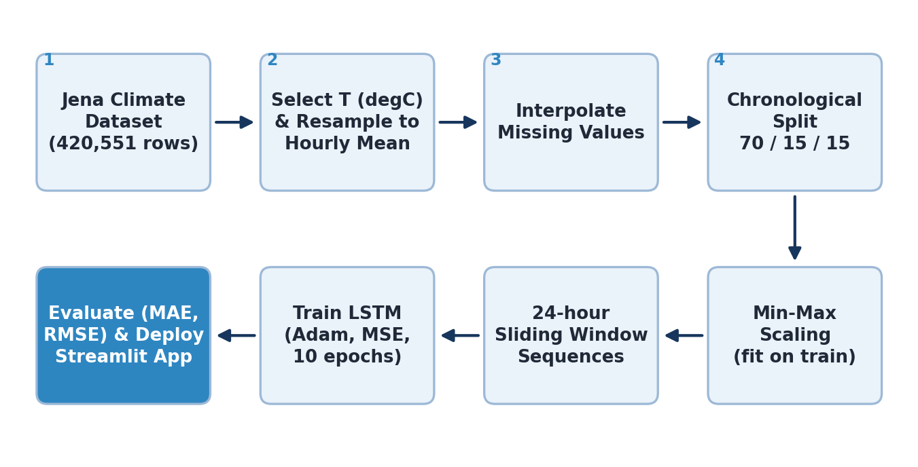
Figure 1: Workflow of the WeatherWise project.

8.2 Data Preparation Diagram
Figure 2 shows how the hourly series is turned into training samples. Each sample uses 24 consecutive hours as input and the following hour as the target; the window then moves forward by one hour.
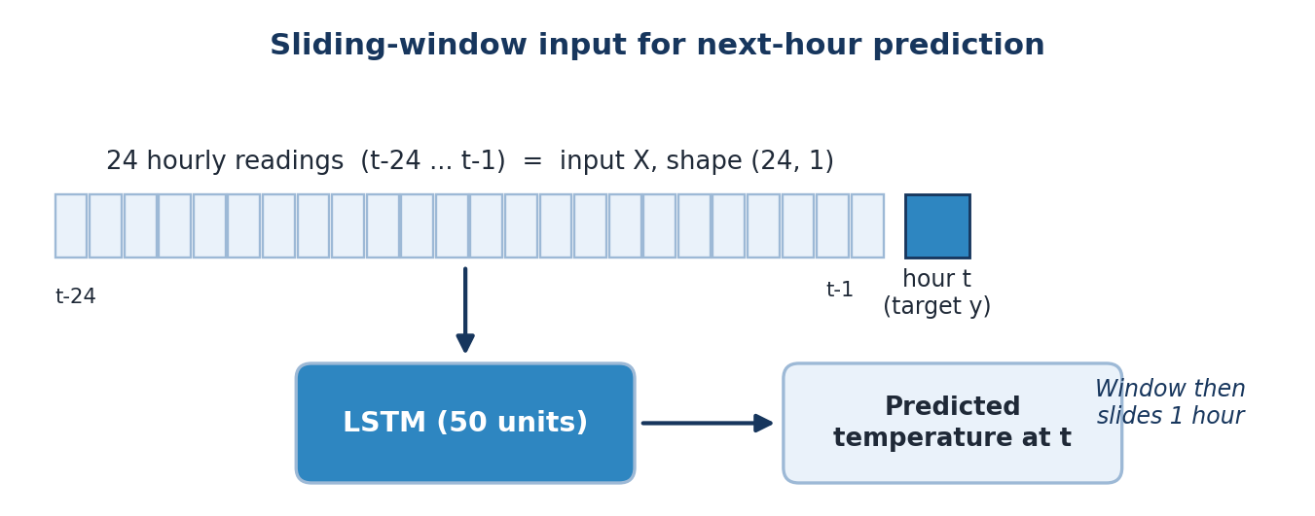
Figure 2: Sliding-window input for next-hour prediction.

8.3 Model Architecture Diagram
Figure 3 shows the layers of the LSTM model with the number of parameters in each layer.
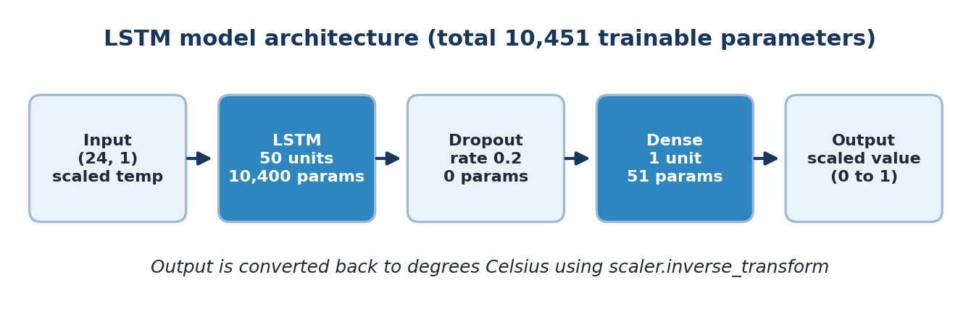
Figure 3: Architecture of the LSTM model.

8.4 System Architecture Diagram
Figure 4 shows how the trained model and scaler are used by the Streamlit application, which is made available to users through a Cloudflare tunnel.
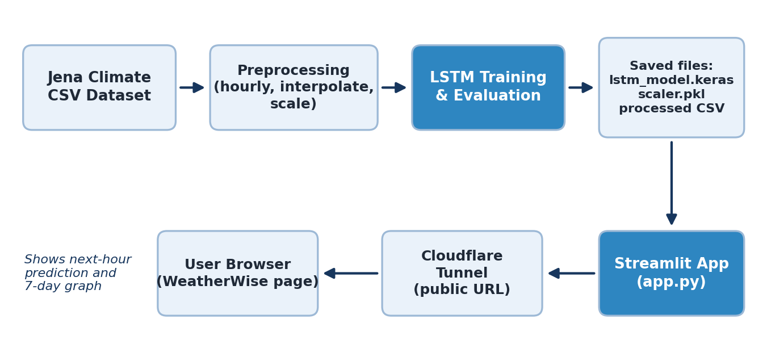
Figure 4: System architecture of WeatherWise.

9. Implementation
The notebook is organised into three stages.
Stage 1 — Dataset collection and preprocessing.
Download and load the Jena dataset, select the temperature column, convert to datetime, resample to hourly means, interpolate missing values, plot the first 168 hours (one week) as a sanity check, and save the processed CSV.
Stage 2 — LSTM model development.
Load the processed data, split chronologically, scale, generate sequences, build the Sequential LSTM model, train it for 10 epochs with validation monitoring, and save the model as lstm_model.keras.
Stage 3 — Testing, evaluation and frontend.
Reload the saved model and scaler, predict on the test set, inverse-transform predictions back to °C, compute MAE and RMSE, plot actual vs predicted temperature and training vs validation loss, predict the next hour, and build the Streamlit app (app.py).
The key design choice at prediction time is inverse scaling: model outputs are in the range [0, 1], so scaler.inverse_transform converts them back to real degrees Celsius before computing metrics or showing results to the user.

9.1 Source Code
The complete source code of the notebook is given below in the order of execution. Shell commands used only for setup are omitted.
(a) Dataset collection and preprocessing
import pandas as pd
import numpy as np
import matplotlib.pyplot as plt

from sklearn.preprocessing import MinMaxScaler

#Select temperature column
temperature = df["T (degC)"]

print(temperature.head())

#Handle missing values
temperature = temperature.interpolate()

print(temperature.isnull().sum())

#Convert 10-minute readings into hourly readings
df["Date Time"] = pd.to_datetime(df["Date Time"], format='mixed')

df = df.set_index("Date Time")

hourly_temp = df["T (degC)"].resample("1h").mean()

hourly_temp = hourly_temp.interpolate()

hourly_temp.to_csv("processed_temperature.csv")

# Load the dataset
df = pd.read_csv("jena_climate_2009_2016.csv")
(b) Splitting, scaling and sequence creation
#Load the processed dataset
df = pd.read_csv("processed_temperature.csv")

data = df.iloc[:, -1].values.reshape(-1, 1)

#Split the dataset chronologically
n = len(data)

train_end = int(n * 0.70)
val_end = int(n * 0.85)

train = data[:train_end]
val = data[train_end:val_end]
test = data[val_end:]

#Normalize the data
scaler = MinMaxScaler()

train_scaled = scaler.fit_transform(train)

val_scaled = scaler.transform(val)
test_scaled = scaler.transform(test)

joblib.dump(scaler, "scaler.pkl")

#Create time sequences
def create_sequences(data, window=24):

X = []
y = []

for i in range(window, len(data)):

X.append(data[i-window:i])
y.append(data[i])

return np.array(X), np.array(y)

#Prepare training and testing data:
X_train, y_train = create_sequences(train_scaled)

X_val, y_val = create_sequences(
np.concatenate([train_scaled[-24:], val_scaled])
)

X_test, y_test = create_sequences(
np.concatenate([val_scaled[-24:], test_scaled])
)
(c) LSTM model building, training and saving
import pandas as pd
import numpy as np

from sklearn.preprocessing import MinMaxScaler

from tensorflow.keras.models import Sequential
from tensorflow.keras.layers import LSTM, Dense, Dropout

import joblib

#Build the LSTM model
model = Sequential([
LSTM(50, input_shape=(24, 1)),
Dropout(0.2),
Dense(1)
])

model.compile(
optimizer="adam",
loss="mean_squared_error",
metrics=["mae"]
)

model.summary()

#Train the model
history = model.fit(
X_train,
y_train,
epochs=10,
batch_size=32,
validation_data=(X_val, y_val),
verbose=1
)

model.save("lstm_model.keras")
(d) Testing and evaluation
#Load the trained model
from tensorflow.keras.models import load_model
import joblib
import numpy as np

model = load_model("lstm_model.keras")

scaler = joblib.load("scaler.pkl")

#Predict temperature
predictions = model.predict(X_test)

predictions = scaler.inverse_transform(predictions)

actual = scaler.inverse_transform(y_test)

#Calculate MAE and RMSE
from sklearn.metrics import mean_absolute_error
from sklearn.metrics import mean_squared_error

mae = mean_absolute_error(actual, predictions)

rmse = np.sqrt(
mean_squared_error(actual, predictions)
)

print("MAE:", mae)
print("RMSE:", rmse)

#Predict the next hour
last_24 = test_scaled[-24:]

last_24 = last_24.reshape(1, 24, 1)

next_prediction = model.predict(last_24)

next_temperature = scaler.inverse_transform(
next_prediction
)

print("Next hour temperature:", next_temperature[0][0])
(e) Result graphs
#Create actual vs predicted graph
import matplotlib.pyplot as plt

plt.figure(figsize=(12,5))

plt.plot(actual[:200], label="Actual Temperature")

plt.plot(predictions[:200], label="Predicted Temperature")

plt.title("Actual vs Predicted Temperature")

plt.xlabel("Time")
plt.ylabel("Temperature (°C)")

plt.legend()

plt.savefig("prediction_graph.png")

plt.show()

#Create training and validation loss graph
plt.figure(figsize=(10,5))

plt.plot(history.history["loss"], label="Training Loss")

plt.plot(history.history["val_loss"], label="Validation Loss")

plt.title("Model Training Performance")

plt.xlabel("Epoch")

plt.ylabel("Loss")

plt.legend()

plt.savefig("training_loss.png")

plt.show()
(f) Streamlit web application (app.py)

import streamlit as st
import pandas as pd
import numpy as np
import joblib
import matplotlib.pyplot as plt

from tensorflow.keras.models import load_model

st.set_page_config(
page_title="WeatherWise",
page_icon="🌤️",
layout="wide"
)

# Title
st.title("🌤️ WeatherWise")
st.subheader("Temperature Prediction Using LSTM")

st.write(
"A Deep Learning Based Temperature Forecasting System"
)

# Load model and scaler
@st.cache_resource
def load_resources():
model = load_model("lstm_model.keras")
scaler = joblib.load("scaler.pkl")
return model, scaler

model, scaler = load_resources()

# Load dataset
df = pd.read_csv("processed_temperature.csv")

temperature = df.iloc[:, -1].values.reshape(-1, 1)

# Prepare last 24 hours
last_24 = temperature[-24:]

scaled_data = scaler.transform(last_24)

X = scaled_data.reshape(1, 24, 1)

# Prediction
prediction = model.predict(X, verbose=0)

result = scaler.inverse_transform(prediction)[0][0]

# Display prediction
st.markdown("## 🌡️ Predicted Temperature")

st.markdown(
f"""
<div style="
background-color:#17365D;
padding:25px;
border-radius:15px;
text-align:center;
color:white;">
<h1 style="font-size:45px;">{result:.2f} °C</h1>
<p>Next Hour Temperature Prediction</p>
</div>
""",
unsafe_allow_html=True
)

# Historical temperature graph
st.subheader("📈 Historical Temperature")

fig, ax = plt.subplots(figsize=(12, 4))

ax.plot(temperature[-168:])

ax.set_title("Last 7 Days Temperature")
ax.set_xlabel("Hourly Readings")
ax.set_ylabel("Temperature (°C)")
ax.grid(True)

st.pyplot(fig)
plt.close(fig)

# Project information
st.subheader("About This Project")

st.write("""
- Deep Learning Model: LSTM
- Dataset: Jena Climate Dataset
- Input: Previous 24 hourly temperature readings
- Output: Next hour temperature prediction
""")

st.success("Temperature prediction completed successfully!")
(g) Running the application
streamlit run app.py --server.address 0.0.0.0 --server.port 8501
./cloudflared tunnel --url http://127.0.0.1:8501

10. Results and Evaluation

10.1 Training Behaviour
The loss fell sharply in the first few epochs and then flattened. Validation loss stayed below training loss, which is expected because dropout is active only during training.
Epoch | Training loss (MSE) | Training MAE | Validation loss (MSE) | Validation MAE
1 | 0.0050 | 0.0489 | 0.00097 | 0.0208
4 | 0.00081 | 0.0181 | 0.00045 | 0.0118
7 | 0.00067 | 0.0154 | 0.00043 | 0.0107
10 | 0.00065 | 0.0148 | 0.00044 | 0.0114
(Loss and MAE values in this table are on the scaled 0–1 range.) Training and validation losses are close and stable, which suggests the model is not overfitting.
Figure 5 shows the training and validation loss for each epoch.
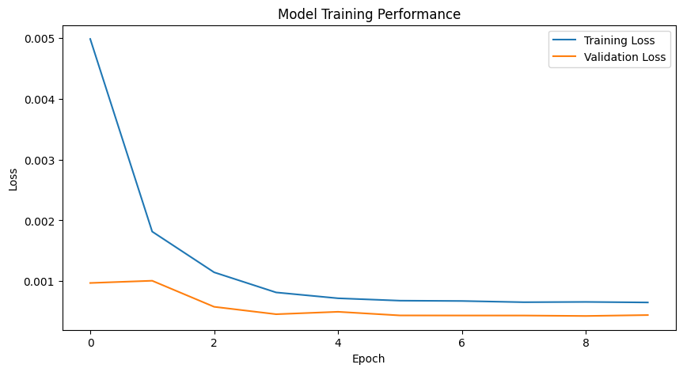
Figure 5: Training loss vs validation loss over 10 epochs.

10.2 Test-Set Performance
Predictions on the unseen test set were converted back to °C and compared with the actual values.
Metric | Value
Mean Absolute Error (MAE) | 0.637 °C
Root Mean Squared Error (RMSE) | 1.186 °C
On average, the next-hour prediction differs from the real temperature by about 0.64 °C. RMSE is higher than MAE because it penalises large errors more heavily; it indicates that a few sudden temperature changes are harder to predict than the smooth parts of the series.
Figure 6 compares the actual and predicted temperature for the first 200 test samples. The two curves follow each other closely.
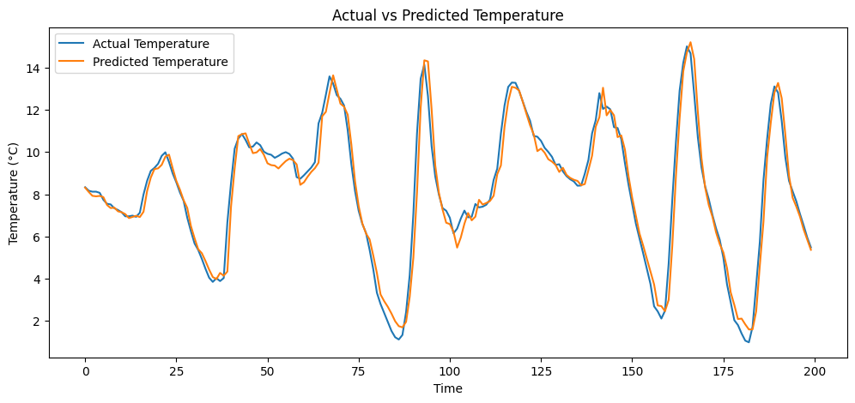
Figure 6: Actual vs predicted temperature on the test set.

10.3 Next-Hour Prediction
Using the last 24 hourly readings of the dataset as input, the model predicted a next-hour temperature of −4.59 °C. This matches the value shown in the web application (Figure 7).

11. Deployment: WeatherWise Web Application
To make the model usable by non-programmers, it was wrapped in a Streamlit application (app.py). The app:
- Loads the saved lstm_model.keras and scaler.pkl once, using Streamlit's resource cache.
- Reads processed_temperature.csv and takes the last 24 hourly readings.
- Scales them, reshapes to (1, 24, 1), runs the model, and inverse-transforms the output.
- Displays the result in a highlighted card: "−4.59 °C — Next Hour Temperature Prediction".
- Plots the last 168 hourly readings (the last 7 days) as a line graph with grid, axis labels and title.
- Shows an "About This Project" section (model, dataset, input and output) and a success message.
The app was run on port 8501 inside Colab and exposed publicly through a Cloudflare quick tunnel, so that it could be opened from any browser during the demonstration.
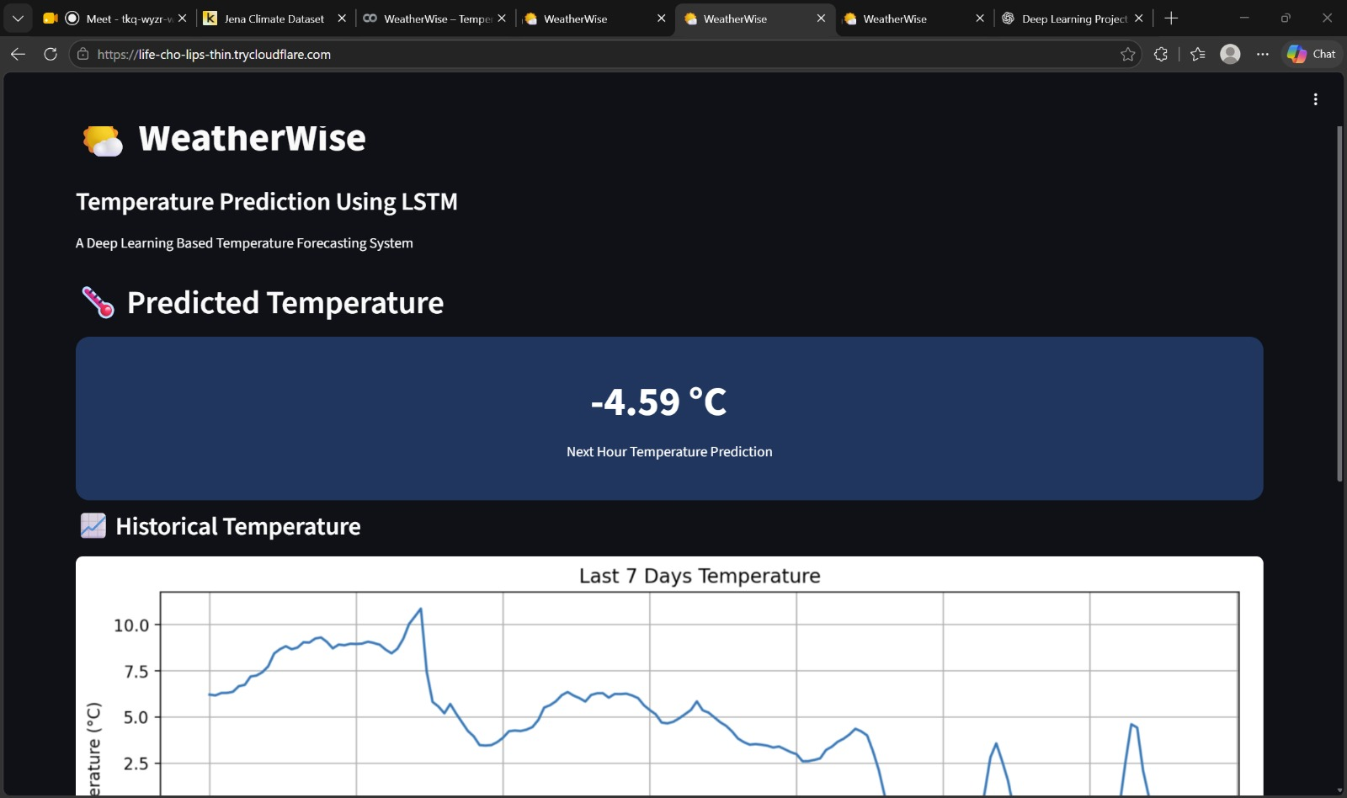
Figure 7: WeatherWise home page showing the predicted temperature card.
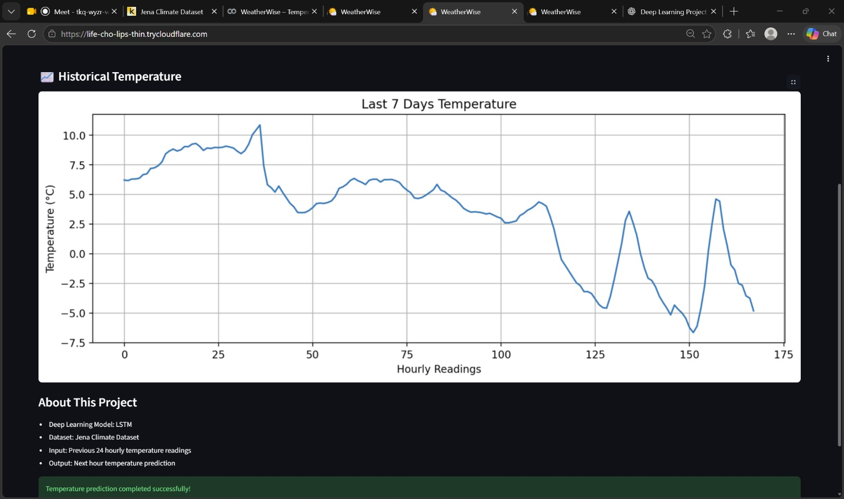
Figure 8: Last-7-days temperature graph and project information section of the app.

11.1 Interpretation of the Last-7-Days Graph
The graph shows 168 hourly readings. Temperature gradually falls from about 10 °C to below −5 °C over the week, with two clear daily peaks near readings 134 and 157, reflecting the day–night temperature cycle. The predicted value of −4.59 °C follows naturally from the final readings, which were falling towards about −5 °C.

12. Limitations
- Univariate input: only past temperature is used; humidity, pressure and wind, which strongly influence temperature, are ignored.
- Single-step forecast: the model predicts only one hour ahead.
- Single location: the model is trained on data from Jena only and may not generalise to other climates.
- Not live: the app predicts from the last 24 hours stored in the processed dataset (which ends in 2016), not from real-time sensor or API data.
- Short training: only 10 epochs were used, with no hyperparameter tuning or comparison against baseline models.
- Temporary hosting: the Cloudflare quick tunnel has no uptime guarantee and works only while the Colab session is running.

13. Future Scope
- Use all 14 meteorological features (multivariate LSTM) to improve accuracy.
- Forecast multiple hours or days ahead (multi-step forecasting).
- Compare against baselines and other models such as a persistence forecast, ARIMA, GRU, stacked or bidirectional LSTM and Transformer-based models.
- Tune hyperparameters (window length, number of units, learning rate) and add early stopping.
- Connect the app to a live weather API so predictions use real-time data for the user's location.
- Host the app permanently on Streamlit Community Cloud or a cloud server, and add features such as date selection and downloadable forecasts.

14. Conclusion
This mini project demonstrated the complete life cycle of a deep learning application: data collection, preprocessing, model design, training, evaluation and deployment. An LSTM network with only 10,451 parameters, trained on the previous 24 hours of temperature, predicted the next hour's temperature on unseen data with an MAE of 0.637 °C and an RMSE of 1.186 °C. Wrapping the model in the WeatherWise Streamlit app showed how a trained model can be made accessible to end users. The work also highlighted good practices for time-series learning, namely chronological splitting, fitting the scaler on training data only, and sliding-window sequence generation. With multivariate inputs and live data, the system can be extended into a more capable forecasting tool.

15. References
- Max Planck Institute for Biogeochemistry, Jena Climate Dataset 2009–2016, available on Kaggle and in the Keras example datasets.
- TensorFlow / Keras documentation, https://www.tensorflow.org/
- Streamlit documentation, https://docs.streamlit.io/
- scikit-learn documentation, https://scikit-learn.org/

