How to run the Staff Leave Management System Django Python
1. Download the zip file
2. Extract the file , copy staffleave folder and paste on the desktop

3. Open PyCharm and click on the terminal
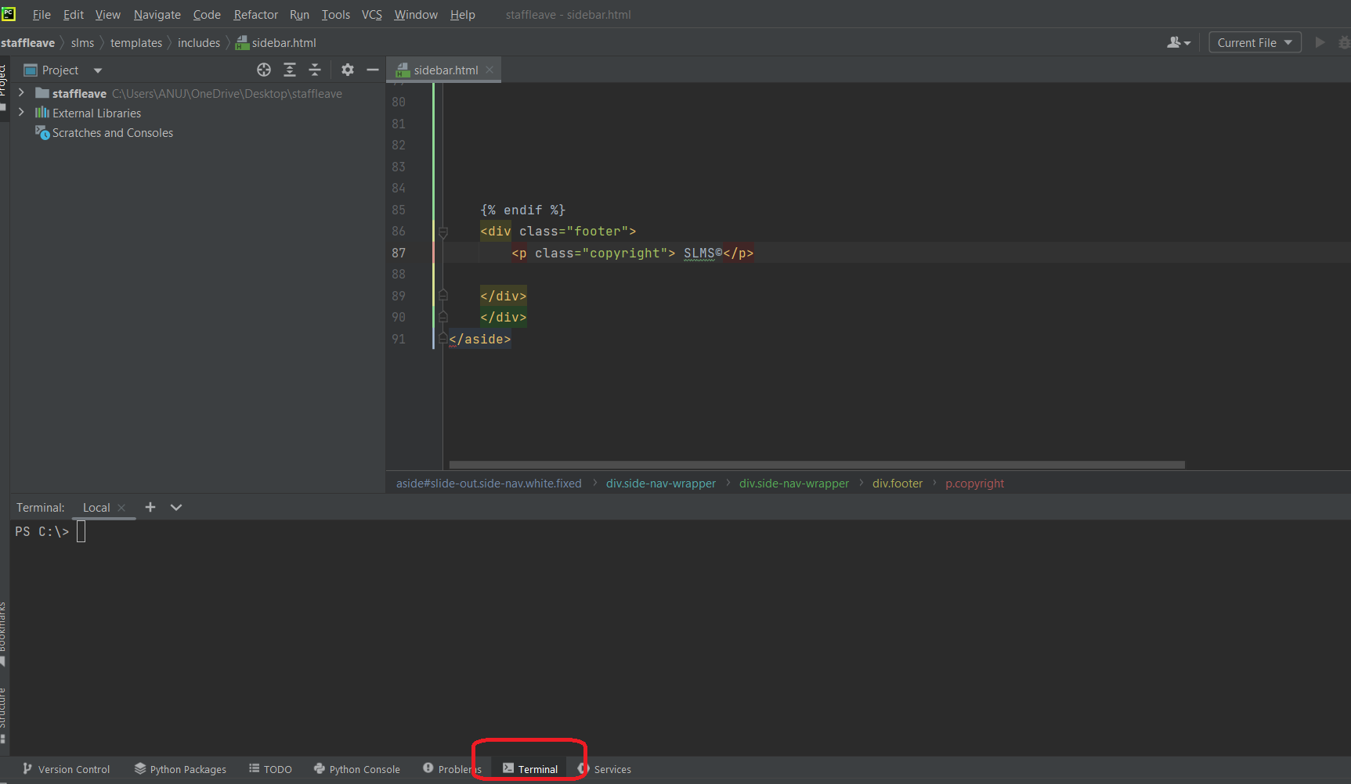

4. Go to the desktop->staffleave->slms directory using cd command as below

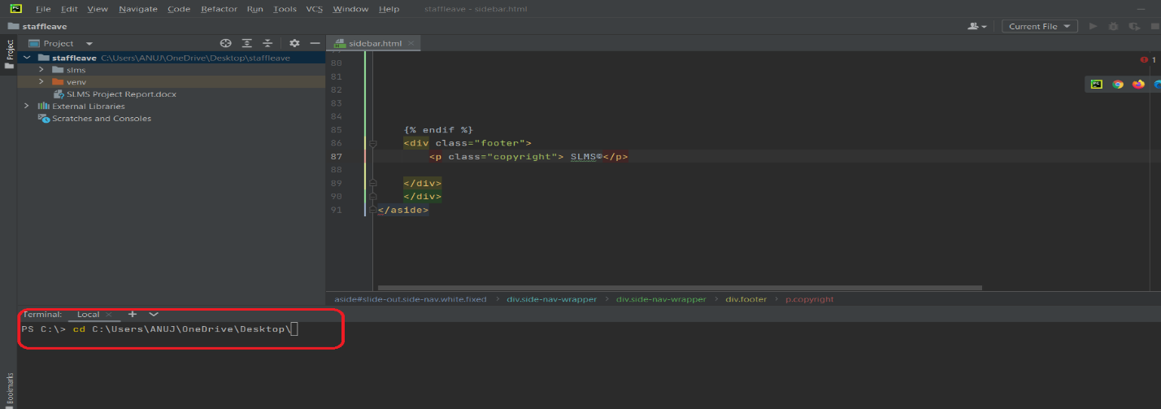
5. Go to the desktop->staffleave->slms directory using cd command and run the server using command

Python manage.py runserver

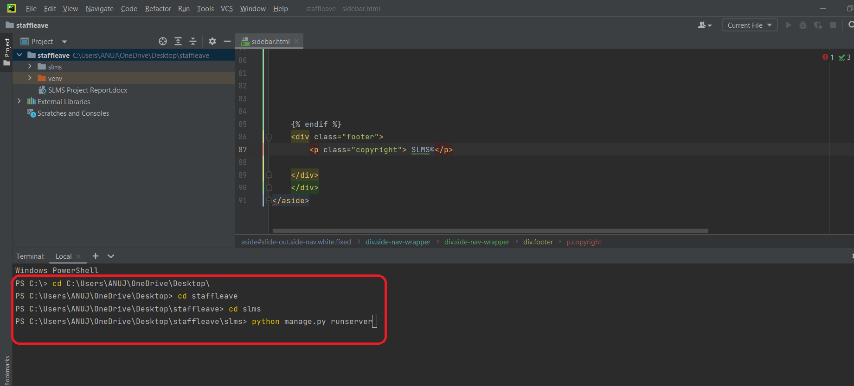

After running the above command you will get the below screen
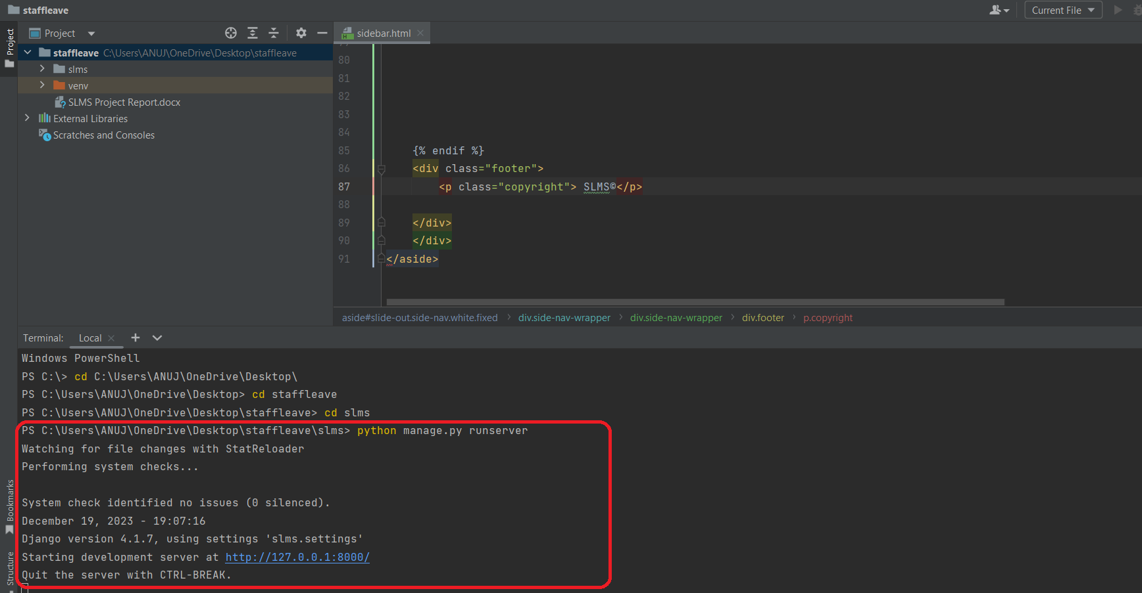

Now click the url http://127.0.0.1:8000 and Project will Run
