
Tribhuvan University
Faculty of Humanities and Social Sciences

A PROJECT REPORT ON
CHATTING SYSTEM

Submitted to:
Department of Computer Application
JANA BHAWANA CAMPUS

In partial fulfillment of the requirement for the Bachelor in
Computer Application

Submitted by:

Anjali Deshar (T.U 6-2-253-2-2022)

08 February , 2026

Abstract
This project report presents the design and implementation of a Chatting System aimed at enabling efficient real-time communication between users. The system focuses on managing user interactions, message exchange, and friend relationships in a secure and organized manner. It consists of two primary entities: admin and user, where the admin oversees user management and system monitoring, while users can send, receive, and manage messages.
The report includes the Entity–Relationship (ER) diagram, database schema, and SQL operations that support core functionalities such as user registration, friend requests, message sending, message retrieval, and chat history management. The system ensures data consistency and integrity through the use of primary and foreign key relationships, enabling reliable storage and retrieval of chat records.
This project demonstrates the practical application of database management and web application concepts, highlighting the importance of relational databases in developing real-time communication systems. The simplicity and modularity of the design ensure the system’s scalability and adaptability, allowing for future enhancements such as group chats, multimedia messaging, and notification systems.

Acknowledgement
We would like to express our sincere gratitude to our lecturer, Mr. Sanam Dangol, for his invaluable guidance and support throughout the preparation of this lab report on the "Chatting website." His insights and encouragement have greatly enhanced our understanding of database management concepts and their practical applications.
We are also thankful to our classmates and peers for their constructive feedback and collaboration during this project. This project has been a significant learning experience for both of us, helping us bridge theoretical knowledge with practical implementation.
Thank you for your support and encouragement.

LIST OF ACRONYMS
AES: Advanced Encryption Standard
BCA : Bachelor’s in Computer Application
CSS: Cascading Style Sheets
DES: Data Encryption Standard
HTML: Hyper Text Markup Language
MySQL: My Structured Query Language
PHP: Hypertext Pre-processor
RAM: Random Access Memory
RSA: Rivest-Shamir-Adleman
SHA-1: Secure Hash Algorithm 1

LIST OF FIGURES
Figure 1: Agile Methodology Workflow 4
Figure 2: Use Case diagram of Chatting System 8
Figure 3: ER Diagram of Chatting System 10
Figure 4: 0 level DFD 10
Figure 5: 1 level DFD 11
Figure 6: Architecture Design 11
Figure 7: Database Schema Design 12
Figure 8: Interface Design Login page 13
Figure 9: Interface Design Register page 13
Figure 10: Interface Design Dashboard page 14

LIST OF TABLE
Table 1: tools/languages used 16
Table 2: Registration Table 19
Table 3: Login table 19
Table 4: Search users 20
Table 5: Send and accept friend request 20
Table 6: System testing 20

Table of Contents
CHAPTER 1: INTRODUCTION 1
1.1 Introduction 1
1.2 Problem Statement 2
1.3 Objectives 2
1.4 Scope and Limitation 3
1.5 Development Methodology 4
1.6 Report Organization 5
CHAPTER 2: BACKGROUND STUDY AND LITERATURE REVIEW 6
2.1 Background Study 6
2.2 Literature Review 6
CHAPTER 3: METHODOLOGY 7
3.1 System Analysis 7
3.1.1 Requirement Analysis 7
3.1.2 Feasibility Analysis 9
3.1.3 Data modelling: ER Diagram 10
3.1.4 Process Modelling: DFD 10
3.2 System Design 11
3.2.1 Architecture Design 11
3.2.2 Database Schema Design 12
3.2.3 Interface Design 13
3.2.4 Physical DFD 14
3.3 Description of Algorithms 15
3.3.1 SHA-1 Algorithm: 15
3.3.2 RSA Algorithm: 15
Chapter 4: Implementation and Testing 16
4.1 Implementation 16
4.1.1 Tools used 16
4.1.2 Implementation details of modules 16
4.2. Testing 18
4.2.1. Test Cases for Unit Testing 18
4.2.2. Test Cases for System Testing 20
CHAPTER 5: CONCLUSION AND FUTURE RECOMMENDATIONS 22
5.1 Conclusion 22
5.2 Lesson learnt/Outcome 22
5.3 Future Recommendations 23
7.References 24

.

CHAPTER 1: INTRODUCTION

1.1 Introduction
In the modern digital age, communication has transformed dramatically, shifting from traditional face-to-face interactions to instantaneous digital exchanges. This evolution is particularly evident in the development of chatting systems, which have become integral to personal and professional communication. As part of our sixth-semester project, we propose to design and implement a sophisticated chatting system that not only facilitates real-time messaging but also incorporates features that enhance user experience and security.
The primary objective of this project is to create a user-friendly chatting application that caters to the needs of diverse users, including students, professionals, and casual users. The proposed system will allow users to send text messages. By focusing on intuitive design and functionality, we aim to ensure that users can easily navigate the application and communicate effectively.
One of the key features of our chatting system will be its emphasis on security and privacy. In an era where data breaches and privacy concerns are prevalent, it is crucial to implement robust security measures. Our system will utilize end-to-end encryption, ensuring that messages are only accessible to the intended recipients. Additionally, we will incorporate user authentication protocols to prevent unauthorized access, thereby fostering a safe environment for users to communicate.
Moreover, our chatting system will be designed to be platform-independent, allowing users to access it from various devices, including smartphones, tablets, and desktops. This cross-platform capability is essential in today's multi-device world, where users expect seamless transitions between devices. By leveraging web technologies and responsive design principles, we will create a cohesive user experience across all platforms.
To enhance user engagement, we plan to integrate features such as emojis, stickers, and customizable chat themes. These elements not only make conversations more lively and enjoyable but also allow users to express themselves in unique ways. Furthermore, we will include options for users to create and join chat groups, fostering a sense of community and collaboration.
In addition to standard messaging features, our system will incorporate advanced functionalities such as message search, chat history, and notifications. Users will be able to search for specific messages or keywords, making it easier to retrieve important information from past conversations. Notifications will keep users informed about new messages and updates, ensuring they remain connected and engaged with their contacts.
The implementation of a chatting system also presents an opportunity to explore various technologies and programming languages. We plan to utilize a combination of front-end and back-end technologies, including HTML, CSS, JavaScript, and PHP Laravel framework, to build a robust and scalable application. This project will not only enhance our technical skills but also provide valuable insights into software development processes and project management.
Lastly, I believe that our chatting system can serve as a valuable tool for education and collaboration among peers. By enabling students to communicate effectively, share resources, and collaborate on projects, I hope to foster a more interactive and supportive learning environment. As I embark on this project, I am excited about the potential impact of our chatting system on users' communication experiences and look forward to the challenges and learning opportunities that lie ahead.

1.2 Problem Statement
Despite the proliferation of chat applications, users continue to face significant issues related to privacy, security, and functionality. Many existing platforms do not offer adequate protection for user data, leading to concerns about unauthorized access and data breaches. Additionally, users often find these applications lacking in features that enhance communication, such as customizable interfaces, multimedia sharing, and seamless integration with other tools. This project seeks to develop a chatting system that addresses these shortcomings by providing a secure, user-friendly, and feature-rich platform for communication.

1.3 Objectives
The main objectives of this project are mentioned below:
- To develop a user-friendly chatting system that facilitates communication among friends.
- To incorporate features that support academic collaboration, such as study groups and file sharing.
- To ensure the privacy and security of users through robust encryption and authentication methods.

1.4 Scope and Limitation
Scope:
- User registration and authentication
- One-to-one and group chatting
- Sending and receiving text messages
- Friend request and contact management
- Chat history and message storage
- Notifications for new messages
Limitations:
- Limited user roles (admin and user only)
- No voice or video calling features
- Limited multimedia sharing support
- Dependent on internet connectivity
- Scalability issues for large numbers of users

1.5 Development Methodology
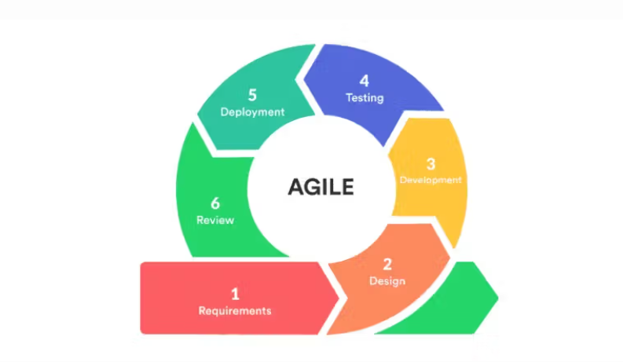
Figure 1: Agile Methodology Workflow
Chatting systems require accuracy, security, and adaptability to meet the needs of students. Traditional development methods may be too rigid to accommodate changes or improvements during the development process. The Agile methodology allows for flexibility and iterative development, making it easier to respond to changing requirements, security considerations, and user feedback effectively.
Agile focuses on early detection and mitigation of potential issues through continuous testing, validation, and integration of system features. By frequently testing modules such as authentication, registration, message sending, editing, deleting, searching messages, search users , problems can be identified and resolved early, reducing the risk of errors or system failures during chatting.
We used Agile methodology in this project because it ensures the Chatting System can evolve based on user feedback, security needs, and system performance. This approach leads to a more reliable, secure, and user-friendly solution that can efficiently handle the chatting process while maintaining transparency and trust.

1.6 Report Organization
This Report is Organized into 5 chapters:
- Chapter 1: “Introduction” – In this chapter, I have introduced the problem statement, Objectives, limitation and the scopes of the project.
- Chapter 2: “Background Study and Literature Review” – In this chapter, I have described about the background of the study and literature reviews done.
- Chapter 3: “System Analysis and Design” – In this chapter, I have described about the functional and non-functional requirements, and system feasibility.
- Chapter 4: “Implementation and Testing” – In this chapter, I have illustrated the methods and tools used to implement the project.
- Chapter 5: “Conclusion and Future Recommendation” – In this concluding chapter, I have successfully completed the project and discussed our future endeavors and plans for its expansion.

CHAPTER 2: BACKGROUND STUDY AND LITERATURE REVIEW

2.1 Background Study
Chatting systems have become essential tools for communication in the digital age, as traditional methods such as face-to-face interaction, SMS, and email are often slow and limited in functionality. With the rapid growth of internet technologies, the need for instant, real-time communication has increased, leading to the development of modern chatting systems. These systems automate message exchange, user management, and conversation storage, enabling fast, secure, and efficient communication. Chatting systems support real-time interaction, group discussions, and cross-platform access, reducing communication delays, improving collaboration, and enhancing the overall user experience.

2.2 Literature Review
A considerable research effort has been devoted to Chatting Application in the last few years. Many new researches have been proposed in recent times.
S. Karthick, R. J. Victor, S. Manikandan and B. Goswami (2018) [1] This paper proposed a mechanism for creating professional chat application that will not permit the user to send inappropriate or improper messages to the participants by using natural language processing (NLP). The message typed by user is evaluated to find any inappropriate terms in it that may include foul/negative words, etc., using NLP. If the context of the message is negative, then the user not permitted to send the message.
Bhadoria, Ishani, Pavankumar Patel, and Jinan Fiaidhi (2020) [2] This paper introduced the working and implementation of encrypted chat application. It describes how the messages are encrypted on device before moving to server using various cryptographic algorithms like DES, AES and RSA. Computer vision techniques can be used for encrypting images. The performance of the application over hundreds of users is not tested yet. Performance testing and image encryption are in the list of future tasks.

CHAPTER 3: System Analysis and Design

3.1 System Analysis

3.1.1 Requirement Analysis
- Functional Requirements
- User Registration and Authentication:
The system must allow users to create an account and securely log in before accessing the chat features.
- One-to-One Messaging:
Users can send and receive private messages to and from other registered users in real time.
- Message Delivery and Status Tracking:
The system should ensure reliable message delivery and provide status indicators such as sent, delivered, and seen.
- User Presence and Activity Status:
The system should display whether users are online, offline, or typing, helping improve communication flow.
- File and Media Sharing:
Users can send images, documents, videos, and other supported files within chats.
- Search and Message Retrieval:
Users should be able to search previous messages, contacts, and chat groups efficiently.
- Notification System:
The system should notify users of new messages, group updates, or mentions even when the app is running in the background.
- Blocking and Reporting:
Users must be able to block other users and report inappropriate behavior to maintain a safe chat environment.
Use Case Diagram
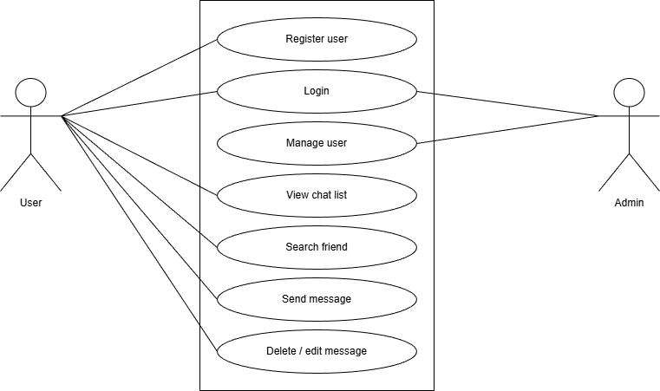
Figure 2: Use Case diagram of Chatting System

- Non-Functional Requirements
Non-Functional Requirements define system attributes such as security, reliability, performance, scalability, and usability. The non-functional requirements of the Chatting System are:
- Security: Messages, user data, and shared files must be encrypted and stored securely to prevent unauthorized access.
- Reliability: The system must operate consistently, ensuring messages are delivered without failures or loss.
- Usability: The interface should be user-friendly, intuitive, and accessible for users of all ages and technical levels.
- Scalability: The system should efficiently support a large number of concurrent users and multiple chat groups without performance degradation.
- Performance: Messages, notifications, and media files should be transmitted and displayed quickly, ensuring a smooth real-time communication experience.
- Portability: The system should be compatible across multiple devices, including desktops, smartphones, and tablets, providing a seamless user experience.

3.1.2 Feasibility Analysis
i) Technical
The Chatting System is technically feasible as it can be developed using widely supported and reliable technologies such as PHP, the Laravel framework, HTML, CSS, JavaScript, and MySQL. These technologies are easily accessible, cost-effective, and compatible with standard hardware, ensuring that all required development resources and technical expertise are readily available. Laravel provides built-in features such as authentication, routing, and encryption, which support secure, real-time messaging and efficient system development. Since the software and hardware requirements are minimal and affordable, and the tools used allow for a smooth and responsive interface across multiple devices, the proposed system can be implemented without any technical limitations.
ii) Operational
The Chatting System is operationally feasible because it is user-friendly, intuitive, and requires minimal training. Features such as real-time messaging, group chat, notifications, file sharing, and search functions simplify communication for all users. Its well-designed interface and automated processes ensure smooth operation, reduce manual work, and provide a seamless communication experience. The system can be easily managed and maintained in the intended environment, making it practical for both personal and academic use.
iii) Economic
The development of this Chatting System is economically feasible because all the technologies used—PHP, Laravel, MySQL, HTML, CSS, and JavaScript—are open-source and freely available, eliminating software costs. No additional hardware components are required beyond standard computers and mobile devices. As this project is developed as part of the academic requirements for the BCA under Tribhuvan University, the overall cost is minimal, involving only incidental expenses such as printing or minor error corrections. Therefore, the proposed system is cost-effective and economically viable.

3.1.3 Object Modelling: Object & Class Diagram
The Object and Class Diagram for the Digital Voting System depicts key entities and their relationships, including Citizenship, District, Palika, Ward, User, OTP, Candidate, Election, and Vote. Each entity has attributes and is linked to others, such as users being associated with citizenship, OTPs for verification, and votes for election participation. Candidates are linked to districts, palikas, wards, and elections, while elections store details about voting posts, dates, and results. The diagram showcases the structure and interactions of these entities to enable efficient voting and election management.
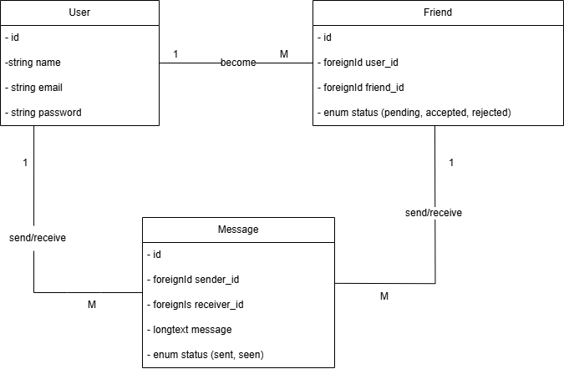
Figure 3: Object Modelling: Class diagram

3.1.4 Dynamic Modelling: State & Sequence diagram
The dynamic model of the Digital Voting System is represented through two sequence diagrams: one for the user and one for the admin. The user sequence starts with registration, email verification, login, OTP generation, voting, and result viewing, followed by logout. The admin sequence covers login, state management, citizen and election management, viewing results, and logout. These diagrams outline the interactions between the user, admin, and system components, ensuring secure and efficient voting and administrative processes.

3.3 Description of Algorithms

3.3.1 SHA-1 Algorithm:
The SHA-1 (Secure Hash Algorithm 1) algorithm is used in the chatting system to protect messages and user data from being tampered with. When a user sends a message, SHA-1 converts the message into a unique fixed-length hash value. For example, if a user sends “Hello,” the system generates a hash like “f7ff9e8b7bb2…” which cannot be reversed back to the original text. Even a small change in the message creates a completely different hash. This ensures that chats remain secure, and administrators can verify that no message has been altered during transmission, maintaining integrity and trust within the system.

3.3.2 RSA Algorithm:
The RSA algorithm is used to secure messages exchanged between users in the chatting system. It encrypts a message using a public key, ensuring that only the intended recipient who holds the matching private key can decrypt and read it. For example, when User A sends a message to User B, the message is converted into encrypted text that cannot be understood by anyone else, even if intercepted. When the encrypted message reaches User B, their private key unlocks and converts it back into readable form. This process ensures confidentiality, prevents unauthorized access, and maintains privacy throughout communication.

Chapter 4: Implementation and Testing

4.1 Implementation
In this stage, physical system specifications are converted into working and reliable solution. This is a stage where the system is developed. On the receiving the system design documents, the work is divided in modules/units and actual coding is started. It is flowed by testing. Several tools are used in this phase if software development.

4.1.1 Tools used
Table 4.1: tools/languages used
Table 1: tools/languages used
Tools/languages | Purpose
VS code | To write and compile code
Mysql | For Database
Draw.io | For making Diagrams
Html | For Framing the application
CSS | For Designing the application
PHP | For Client-side Functionality of the application
JS | For Server-side Functionality of the application
XAMMP | For local server environment

4.1.2 Implementation details of modules
The implementation of the Chatting System involved the development of several key modules, each designed to perform specific functionalities to ensure smooth communication between users. The major modules implemented in the system are described below:
Login Module
The Login Module allows registered users to securely access the chatting system. The login form consists of fields such as email/username and password. When the user enters valid credentials, the system verifies the information from the database and grants access to the user dashboard. If incorrect login details are entered, an error message is displayed, and the user is prompted to re-enter the correct credentials.
Registration Module
The Registration Module enables new users to create an account in the chatting system. The registration form includes fields such as full name, username, email address and password. After submitting valid information, the user account is successfully created and stored in the database. Once registered, users can log in to the system using their registered email/username and password.
User Module
The User Module allows users to interact with other users in the system. Users can search for other registered users, send friend requests, and accept or reject incoming requests. After becoming friends, users can send and receive messages in real time. This module also allows users to view their chat history, see online/offline status of friends, update profile information, and log out of the system.
Chat Module
The Chat Module is the core component of the chatting system. It enables users to exchange text messages with their friends. Messages sent by a user are stored in the database and instantly displayed to the receiver. The module supports one-to-one communication and maintains proper message timestamps. Users can view previous messages whenever they open a chat conversation.
Friend Request Module
The Friend Request Module manages the process of connecting users. Users can send friend requests to other users, which can be accepted or rejected by the receiver. Once a friend request is accepted, both users are added to each other’s friend list and can start chatting. Rejected requests are removed from the system.
Admin Module
The Admin Module provides administrative control over the chatting system. The admin can view all registered users, manage user accounts, and monitor chat activities if required. The admin has the authority to block or remove users who violate system rules and ensure smooth functioning of the system.

4.2. Testing

4.2.1. Test Cases for Unit Testing
Unit testing is a software development process in which the smallest testable parts of an application, called units, are individually and independently scrutinized for proper operation. Unit testing is an important step in the development process, because if done correctly, it can help detect early flaws in code which may be more difficult to find in later testing stages. The main objectives of unit testing is to isolate written code to test and determine if it works as intended. Some other objectives of unit testing are given below:
- To verify the correctness of the code.
- To test every function and procedure.
- To fix bugs early in the development cycle and to save costs.
- To help the developers to understand the code base and enable them to make changes quickly.
- To isolate a section of code.

Table 2: Registration Table
S.N | Action | Input | Expected Outcome | Actual Outcome | Test Result
1. | User Enter all the detail | Name: Anjali Deshar  Email:anjalideshar748@gmail.com  Password:12345678  Confirm password: 12345678 | Register | As expected | Pass
2. | User enters a detail that  Already exists | Name: Anjali Deshar  Email:anjalideshar748@gmail.com  Password:12345678  Confirm password: 12345678 | Output: Email Address Already Exists ! | As expected | pass

Table 3: Login table
S.N | Action | Input | Expected Output | Actual Output | Test Result
1. | User enters correct email and password | Email:anjalideshar748@gmail.com  Password:12345678 | Login to the system | As expected | Pass
2. | User enters incorrect email and password | Email:anjalideshar123@gmail.com  Password:12345678 | Wrong email or password | As expected | Fail

Table 4: Search users
S.N | Action | Input | Expected Output | Actual Output | Test Result
1. | Enter registered username | Sudip Lo | Show user | As expected | Pass
2. | Enter unregistered username | Ram KC | Invalid username | As expected | Fail

Table 5: Send and accept friend request
S.N | Action | Input | Expected Output | Actual Output | Test Result
1. | Send friend request | Click on button | Request sent | As expected | Pass
2. | Accept friend request | Click on button | friend | As expected | Pass

4.2.2. Test Cases for System Testing
System testing involves testing the complete system to ensure it meets the specified requirements and functions correctly. Below are some of the test cases used for system testing.
Table 6: System testing
S.N | Test case Description | Tested data | Expected result | Actual Result | Test result
1. | Test end-to-end user registration and login process | Valid registration details | Users should be successfully registered and logged in | Users registered and logged in successfully | Pass
2. | Test search users | Valid username | Show users | Users shown | Pass
3. | Test send and accept request | Send and accept request | Request sent and friend | Request sent and friend | Pass

CHAPTER 5: CONCLUSION AND FUTURE RECOMMENDATIONS

5.1 Conclusion
In conclusion, developing the Chatting System has been an incredibly rewarding and educational experience. It allowed me to apply and enhance my technical skills in web development, database management, and system integration. I gained hands-on experience in building a fully functional communication platform, from managing user accounts and friend connections to implementing real-time message exchange.
Through this project, I also strengthened my problem-solving, debugging, and project management skills, ensuring the system’s reliability, security, and user-friendliness. Designing an intuitive interface and integrating front-end and back-end components helped me better understand how modern chatting applications function.
The successful completion of this project not only improved my overall understanding of full-stack web development but also provided valuable insights into building real-world communication systems that meet user needs effectively. This experience has increased my confidence in developing scalable and interactive web applications.

5.2 Lesson learnt/Outcome
Developing the Chatting System was a valuable learning experience that helped me gain practical knowledge of modern web application development. Through this project, I strengthened my understanding of core web technologies such as HTML, CSS, JavaScript, PHP (Laravel), and MySQL, which are essential for building interactive and real-time communication systems.
One of the major lessons learnt was working with databases to manage users, friend requests, messages, and chat histories. I learned how to design efficient database schemas, create relational tables, and write optimized queries to store and retrieve chat data accurately. Implementing CRUD operations was essential for handling user accounts, sending messages, and managing friend connections.
This project also improved my understanding of authentication and authorization. I learned how to securely register users, validate login credentials, and restrict access to authorized users only. Managing sessions and ensuring data privacy were important aspects of the system.
Additionally, I gained experience in designing a user-friendly interface. Applying UI/UX principles helped me create a clean and responsive chat interface that allows users to easily send messages, view chat history, and manage their profiles. Handling forms, input validation, and real-time updates enhanced my front-end and back-end integration skills.
Debugging and error handling played a crucial role during development. I learned how to identify system errors, fix logical issues, and test different modules to ensure smooth communication and system reliability. This project also taught me the importance of code optimization for better performance and scalability.
Through this project, I developed project management and problem-solving skills by organizing tasks, managing time effectively, and integrating different system modules efficiently. The successful completion of the Chatting System provided me with a deeper understanding of real-world communication platforms and strengthened my confidence in developing full-stack web applications.

5.3 Future Recommendations
- Audio and video calling integrations
Integrating audio and video calling features would allow users to communicate more effectively and enhance real-time interaction within the chatting system.
- Mobile Application Development
Developing a mobile application would provide users with easy and convenient access to the chatting system anytime and anywhere.
- Group chat and channel feature
Introducing group chats and channels would allow multiple users to communicate simultaneously, making the system suitable for group discussions and teamwork.
- End-to-End Message Encryption
Implementing advanced security measures such as end-to-end encryption would ensure message privacy and protect user data from unauthorized access.
- File and Media Sharing
Allowing users to share images, documents, and other media files would enhance communication and make the system more interactive.
- Admin monitoring and analysis
Providing admins with detailed chat analytics and user activity reports would help in monitoring system usage and improving performance and security.

7.References
[1] S. Karthick, R. J. Victor, S. Manikandan and B. Goswami, "Professional chat application based on natural language processing," 2018 IEEE International Conference on Current Trends in Advanced Computing (ICCTAC), 2018, pp. 1-4, doi: 10.1109/ICCTAC.2018.8370395.
[2] Bhadoria, Ishani, Pavankumar Patel, and Jinan Fiaidhi. "ChatApp with Encryption using Firebase." (2020).
[3] Tribhuvan University (TU) Logo source: https://seeklogo.com/vector-logo/393475/tribhuvan-university-tu
[4] Agile Methodology in System Development source: https://targettrend.com/agile-methodology-meaning-advantages-disadvantages-more/

