**INTRODUCTION**

* Sardar Vallabhbhai Patel was an Indian politician who served as the first Home Minister of India and the first Deputy Prime Minister of India.
* He was a barrister and a very active member of the Indian National Congress. His actual date of birth was never formally recorded. But, as per his matriculation examination papers, he was born on 31 October 1875.
* He was born in Nadiad, Gujarat. His father’s name was Jhaverbhai Patel and his mother’s name was Ladba. Vallabhbhai Patel had five siblings.
* He was highly influenced by Mahatma Gandhi’s views on non-violence. He was an ardent follower of Gandhi’s principles. He strongly emphasized the need for unity of the Indian masses in order to achieve independence from the British rule.
* He played the most pivotal role in the integration of India as he was the one who convinced almost all the princely states to become a part of India post India’s independence.
* He became popularly known as Sardar Patel, Iron Man of India, Bismarck of India, Unifier of India, etc.
* Since 2014, his birth anniversary, 31st October is annually celebrated as “Rashtriya Ekta Diwas” i.e. the “National Unity Day” in India.
* On 31st October 2018, his birth anniversary, the tallest statue in the world was inaugurated and dedicated to him. The statue is called the “Statue of Unity”. Located in the Indian state of Gujarat, the Statue of Unity is approximately 182 meters in height.
* He was posthumously awarded the highest civilian award of the Republic of India- the Bharat Ratna, in 1991.
* Sardar Patel’s health deteriorated rapidly in the 1950 summer. He suffered a massive heart attack and died on 15 December 1950 at Birla House in Bombay.

The provided short essay on Sardar Vallabhbhai Patel in English 250 words and more will help kids get an understanding of the kind of struggle that Sardar Patel underwent in his journey to achieve India’s independence.

The topic 10 lines on Sardar Vallabhbhai Patel essay is common and frequently asked in primary classes. You can check out more such on other topics that are very popular in the formative years of learning in children.

Essay writing develops sound creativity and imagination prowess in students. It works on the overall advancement of linguistic skills. It enhances vocabulary and sentence formation understanding.

The given essay about Sardar Vallabhbhai Patel will instil interest in kids to know more about Sardar Vallabhbhai Patel’s life and how he made it possible for almost all the princely states to become a part of India. If it was not for Sardar Patel, India would have divided into numerous miniature nations. Thus, we must never forget the contributions Sardar Vallabhbhai Patel made in shaping today’s India.

We also have a plethora of engrossing learning resources for kids- intriguing worksheets, brain-tickling general knowledge questions, interesting stories from most popular genres, poems for children, NCERT solutions, easy trivia questions, etc. on our  Visit the linked article now and help your child excel in studies.

**SOFTWARE & HARDWARE REQUIREMENTS**

**SOFTWARE:**

FRONT END TOOL : HTML, CSS & JQuery Language

REPORTING TOOL : MS-Office

DEVELOPMENT TOOL : Adobe Dreamweaver CC

PLATFORM : Web

BACKEND TOOL : None

**HARDWARE:**

PROCESSOR : Core 2 Duo or above

RAM : 1 GB or above

HDD : 160 GB or above

**SOURCE CODE**

**<!DOCTYPE html>**

**<html lang="en">**

**<head>**

**<title>SARDAR VALLABHBHAI PATEL | Home ::NIELIT Team</title>**

**<!-- custom-theme -->**

**<meta name="viewport" content="width=device-width, initial-scale=1">**

**<meta http-equiv="Content-Type" content="text/html; charset=utf-8" />**

**<meta name="keywords" content="Mug house Responsive web template, Bootstrap Web Templates, Flat Web Templates, Android Compatible web template,**

**Smartphone Compatible web template, free webdesigns for Nokia, Samsung, LG, SonyEricsson, Motorola web design" />**

**<script type="application/x-javascript"> addEventListener("load", function() { setTimeout(hideURLbar, 0); }, false);**

**function hideURLbar(){ window.scrollTo(0,1); } </script>**

**<!-- //custom-theme -->**

**<link href="css/bootstrap.css" rel="stylesheet" type="text/css" media="all" />**

**<link href="css/style.css" rel="stylesheet" type="text/css" media="all" />**

**<!-- js -->**

**<script type="text/javascript" src="js/jquery-2.1.4.min.js"></script>**

**<script src="js/main.js"></script>**

**<!-- //js -->**

**<!-- font-awesome-icons -->**

**<link href="css/font-awesome.css" rel="stylesheet">**

**<!-- tabs -->**

**<link href="css/easy-responsive-tabs.css" rel='stylesheet' type='text/css'/>**

**<!-- //tabs -->**

**<!-- //font-awesome-icons -->**

**<link href="//fonts.googleapis.com/css?family=Prompt:100,100i,200,200i,300,300i,400,400i,500,500i,600,600i,700,700i,800,800i,900,900i&amp;subset=latin-ext,thai,vietnamese" rel="stylesheet">**

**<link href="//fonts.googleapis.com/css?family=Merriweather" rel="stylesheet">**

**</head>**

**<body>**

**<!-- banner -->**

**<div class="banner">**

**<div class="header-bottom">**

**<div class="header">**

**<div class="container">**

**<div class="w3_agile_logo">**

**<h4><a href="index.html"><span>SARDAR VALLABHBHAI PATEL</span></a></h4>**

**</div>**

**<div class="header-nav">**

**<nav class="navbar navbar-default">**

**<div class="navbar-header navbar-left">**

**<button type="button" class="navbar-toggle collapsed" data-toggle="collapse" data-target="#bs-example-navbar-collapse-1">**

**<span class="sr-only">Toggle navigation</span>**

**<span class="icon-bar"></span>**

**<span class="icon-bar"></span>**

**<span class="icon-bar"></span>**

**</button>**

**</div>**

**<!-- Collect the nav links, forms, and other content for toggling -->**

**<div class="collapse navbar-collapse navbar-right" id="bs-example-navbar-collapse-1">**

**<nav class="link-effect-12">**

**<ul class="nav navbar-nav w3_agile_nav">**

**<li class="active"><a href="index.html"><span>Home</span></a></li>**

**<li><a href="gallery.html"><span>Gallery</span></a></li>**

**<li><a href="Sardar vallabh Bhai Patel.html"><span>Sardar vallabh Bhai Patel</span></a></li>**

**</ul>**

**</nav>**

**</div>**

**</nav>**

**</div>**

**<div class="clearfix"> </div>**

**</div>**

**</div>**

**<!-- header -->**

**<!-- w3-banner -->**

**<div class="w3-banner">**

**<div id="typer"></div>**

**<div class="top-banner-right">**

**<ul>**

**<li><a class="facebook" href="#"><i class="fa fa-facebook" aria-hidden="true"></i></a></li>**

**<li><a class="facebook" href="#"><i class="fa fa-twitter" aria-hidden="true"></i></a></li>**

**<li><a class="facebook" href="#"><i class="fa fa-dribbble" aria-hidden="true"></i></a></li>**

**<li><a class="facebook" href="#"><i class="fa fa-google-plus" aria-hidden="true"></i></a></li>**

**</ul>**

**</div>**

**</div>**

**<!-- //w3-banner -->**

**</div>**

**</div>**

**<!-- //banner -->**

**<!-- welcome -->**

**<div class="about">**

**<div class="container">**

**<div class="w3ls-heading">**

**<h2>INTRODUCTION</h2>**

**</div>**

**<div class="w3-about-grids">**

**<div class="col-md-6 w3-about-left">**

**<h5>SARDAR VALLABHBHAI PATEL</h5>**

**<p>Sardar VALLABHBHAIbhai Jhaverbhai Patel (31 October 1875 – 15 December 1950), popularly known as Sardar Patel, was an Indian statesman. He served as the first Deputy Prime Minister of India. He was an Indian barrister, and a senior leader of the Indian National Congress who played a leading role in the country's struggle for independence and guided its integration into a united, independent nation. He was one of the conservative members of the Indian National Congress. In India and elsewhere, he was often called Sardar, meaning "chief" in Hindi, Urdu, and Persian. He acted as Home Minister during the political integration of India and the Indo-Pakistani War of 1947</span></p>**

**<div class="w3l-button">**

**<a href="#" data-toggle="modal" data-target="#myModal">More</a>**

**</div>**

**</div>**

**<div class="col-md-6 w3-about-right">**

**<div class="about-img-grids">**

**<div class="col-md-7 about-img">**

**<img src="images/SBBP1.jpg" alt=" " />**

**</div>**

**<div class="col-md-5 about-img about-img1">**

**<img src="images/SBBP2.jpg" alt=" " />**

**</div>**

**<div class="clearfix"> </div>**

**</div>**

**<div class="about-img-grids">**

**<div class="col-md-5 about-img about-img1">**

**<img src="images/SBBP3.jpg" alt=" " />**

**</div>**

**<div class="col-md-7 about-img">**

**<img src="images/SBBP4.jpg" alt=" " />**

**</div>**

**<div class="clearfix"> </div>**

**</div>**

**</div>**

**<div class="clearfix"> </div>**

**</div>**

**</div>**

**</div>**

**<!-- //welcome -->**

**<!-- modal -->**

**<div class="modal about-modal fade" id="myModal" tabindex="-1" role="dialog">**

**<div class="modal-dialog" role="document">**

**<div class="modal-content">**

**<div class="modal-header">**

**<button type="button" class="close" data-dismiss="modal" aria-label="Close"><span aria-hidden="true">&times;</span></button>**

**<h4 class="modal-title">SARDAR VALLABHBHAI BHAI PATEL</h4>**

**</div>**

**<div class="modal-body">**

**<div class="agileits-w3layouts-info">**

**<img src="images/SBBP3.jpg" class="img-responsive" alt="" />**

**<p>Sardar VALLABHBHAIbhai Jhaverbhai Patel (31 October 1875 – 15 December 1950), popularly known as Sardar Patel, was an Indian statesman. He served as the first Deputy Prime Minister of India. He was an Indian barrister, and a senior leader of the Indian National Congress who played a leading role in the country's struggle for independence and guided its integration into a united, independent nation. He was one of the conservative members of the Indian National Congress. In India and elsewhere, he was often called Sardar, meaning "chief" in Hindi, Urdu, and Persian. He acted as Home Minister during the political integration of India and the Indo-Pakistani War of 1947</p>**

**</div>**

**</div>**

**</div>**

**</div>**

**</div>**

**<!-- //modal -->**

**<!-- popular -->**

**<!-- //popular -->**

**<!-- choose-us -->**

**<!-- //choose-us -->**

**<!-- team -->**

**<!-- //team -->**

**<!-- news-letter -->**

**<!-- //news-letter -->**

**<!-- footer -->**

**<div class="w3-agile-footer">**

**<div class="container">**

**<div class="agileits-w3layouts-copyright">**

**<p>© 2021 Sardar Vallabh Bhai Patel. All Rights Reserved | Design by <a href="#">NIELIT Team</a> </p>**

**</div>**

**</div>**

**</div>**

**<!-- //footer -->**

**<!-- start-smooth-scrolling -->**

**<script type="text/javascript" src="js/move-top.js"></script>**

**<script type="text/javascript" src="js/easing.js"></script>**

**<script type="text/javascript">**

**jQuery(document).ready(function($) {**

**$(".scroll").click(function(event){**

**event.preventDefault();**

**$('html,body').animate({scrollTop:$(this.hash).offset().top},1000);**

**});**

**});**

**</script>**

**<!-- start-smooth-scrolling -->**

**<!-- for bootstrap working -->**

**<script src="js/bootstrap.js"></script>**

**<!-- //for bootstrap working -->**

**<!-- here stars scrolling icon -->**

**<script type="text/javascript">**

**$(document).ready(function() {**

**/\***

**var defaults = {**

**containerID: 'toTop', // fading element id**

**containerHoverID: 'toTopHover', // fading element hover id**

**scrollSpeed: 1200,**

**easingType: 'linear'**

**};**

**\*/**

**$().UItoTop({ easingType: 'easeOutQuart' });**

**});**

**</script>**

**<!-- //here ends scrolling icon -->**

**<script src='js/jquery.typer.js'></script>**

**<script>**

**var win = $(window),**

**foo = $('#typer');**

**foo.typer(['SARDAR', 'VALLABHBHAI', 'BHAI PATEL']);**

**// unneeded...**

**win.resize(function(){**

**var fontSize = Math.max(Math.min(win.width() / (1 * 10), parseFloat(Number.POSITIVE_INFINITY)), parseFloat(Number.NEGATIVE_INFINITY));**

**foo.css({**

**fontSize: fontSize * .8 + 'px'**

**});**

**}).resize();**

**</script>**

**<!--tabs-->**

**<script src="js/easy-responsive-tabs.js"></script>**

**<script>**

**$(document).ready(function () {**

**$('#horizontalTab').easyResponsiveTabs({**

**type: 'default', //Types: default, vertical, accordion**

**width: 'auto', //auto or any width like 600px**

**fit: true, // 100% fit in a container**

**closed: 'accordion', // Start closed if in accordion view**

**activate: function(event) { // Callback function if tab is switched**

**var $tab = $(this);**

**var $info = $('#tabInfo');**

**var $name = $('span', $info);**

**$name.text($tab.text());**

**$info.show();**

**}**

**});**

**$('#verticalTab').easyResponsiveTabs({**

**type: 'vertical',**

**width: 'auto',**

**fit: true**

**});**

**});**

**</script>**

**<!--//tabs-->**

**</body>**

**</html>**

**<!DOCTYPE html>**

**<html lang="en">**

**<head>**

**<title>SARDAR VALLABHBHAI PATEL | Home ::NIELIT Team</title>**

**<!-- custom-theme -->**

**<meta name="viewport" content="width=device-width, initial-scale=1">**

**<meta http-equiv="Content-Type" content="text/html; charset=utf-8" />**

**<meta name="keywords" content="Mug house Responsive web template, Bootstrap Web Templates, Flat Web Templates, Android Compatible web template,**

**Smartphone Compatible web template, free webdesigns for Nokia, Samsung, LG, SonyEricsson, Motorola web design" />**

**<script type="application/x-javascript"> addEventListener("load", function() { setTimeout(hideURLbar, 0); }, false);**

**function hideURLbar(){ window.scrollTo(0,1); } </script>**

**<!-- //custom-theme -->**

**<link href="css/bootstrap.css" rel="stylesheet" type="text/css" media="all" />**

**<link href="css/style.css" rel="stylesheet" type="text/css" media="all" />**

**<link rel="stylesheet" href="css/lightbox.css">**

**<!-- js -->**

**<script type="text/javascript" src="js/jquery-2.1.4.min.js"></script>**

**<script src="js/main.js"></script>**

**<!-- //js -->**

**<!-- font-awesome-icons -->**

**<link href="css/font-awesome.css" rel="stylesheet">**

**<!-- tabs -->**

**<link href="css/easy-responsive-tabs.css" rel='stylesheet' type='text/css'/>**

**<!-- //tabs -->**

**<!-- //font-awesome-icons -->**

**<link href="//fonts.googleapis.com/css?family=Prompt:100,100i,200,200i,300,300i,400,400i,500,500i,600,600i,700,700i,800,800i,900,900i&amp;subset=latin-ext,thai,vietnamese" rel="stylesheet">**

**<link href="//fonts.googleapis.com/css?family=Merriweather" rel="stylesheet">**

**</head>**

**<body>**

**<!-- banner -->**

**<div class="banner-1">**

**<div class="header-bottom">**

**<div class="header">**

**<div class="container">**

**<div class="w3_agile_logo">**

**<h4><a href="index.html"><span>SARDAR VALLABHBHAI PATEL</span></a></h4>**

**</div>**

**<div class="header-nav">**

**<nav class="navbar navbar-default">**

**<div class="navbar-header navbar-left">**

**<button type="button" class="navbar-toggle collapsed" data-toggle="collapse" data-target="#bs-example-navbar-collapse-1">**

**<span class="sr-only">Toggle navigation</span>**

**<span class="icon-bar"></span>**

**<span class="icon-bar"></span>**

**<span class="icon-bar"></span>**

**</button>**

**</div>**

**<!-- Collect the nav links, forms, and other content for toggling -->**

**<div class="collapse navbar-collapse navbar-right" id="bs-example-navbar-collapse-1">**

**<nav class="link-effect-12">**

**<ul class="nav navbar-nav w3_agile_nav">**

**<li><a href="index.html"><span>Home</span></a></li>**

**<li class="active"><a href="gallery.html"><span>Gallery</span></a></li>**

**<li><a href="Sardar vallabh Bhai Patel.html"><span>Sardar vallabh Bhai Patel</span></a></li>**

**</ul>**

**</nav>**

**</div>**

**</nav>**

**</div>**

**<div class="clearfix"> </div>**

**</div>**

**</div>**

**<!-- header -->**

**</div>**

**</div>**

**<!-- //banner -->**

**<!-- gallery -->**

**<div class="gallery">**

**<div class="container">**

**<div class="w3ls-heading">**

**<h2>Gallery</h2>**

**</div>**

**<div class="gallery-grids">**

**<div class="col-md-4 gallery-grid">**

**<div class="grid">**

**<figure class="effect-apollo">**

**<a class="example-image-link" href="images/41.jpg" data-lightbox="example-set" data-title="">**

**<img src="images/41.jpg" alt="" />**

**<figcaption>**

**<p>SARDAR VALLABHBHAI PATEL</p>**

**</figcaption>**

**</a>**

**</figure>**

**</div>**

**</div>**

**<div class="col-md-4 gallery-grid">**

**<div class="grid">**

**<figure class="effect-apollo">**

**<a class="example-image-link" href="images/51.jpg" data-lightbox="example-set" data-title=".">**

**<img src="images/51.jpg" alt="" />**

**<figcaption>**

**<p>SARDAR VALLABHBHAI PATEL</p>**

**</figcaption>**

**</a>**

**</figure>**

**</div>**

**</div>**

**<div class="col-md-4 gallery-grid">**

**<div class="grid">**

**<figure class="effect-apollo">**

**<a class="example-image-link" href="images/91.jpg" data-lightbox="example-set" data-title="">**

**<img src="images/91.jpg" alt="" />**

**<figcaption>**

**<p>SARDAR VALLABHBHAI PATEL</p>**

**</figcaption>**

**</a>**

**</figure>**

**</div>**

**</div>**

**<div class="col-md-4 gallery-grid">**

**<div class="grid">**

**<figure class="effect-apollo">**

**<a class="example-image-link" href="images/99.jpg" data-lightbox="example-set" data-title="">**

**<img src="images/99.jpg" alt="" />**

**<figcaption>**

**<p>SARDAR VALLABHBHAI PATEL</p>**

**</figcaption>**

**</a>**

**</figure>**

**</div>**

**</div>**

**<div class="col-md-4 gallery-grid">**

**<div class="grid">**

**<figure class="effect-apollo">**

**<a class="example-image-link" href="images/111.jpg" data-lightbox="example-set" data-title="">**

**<img src="images/111.jpg" alt="" />**

**<figcaption>**

**<p>SARDAR VALLABHBHAI PATEL</p>**

**</figcaption>**

**</a>**

**</figure>**

**</div>**

**</div>**

**<div class="col-md-4 gallery-grid">**

**<div class="grid">**

**<figure class="effect-apollo">**

**<a class="example-image-link" href="images/121.jpg" data-lightbox="example-set" data-title="">**

**<img src="images/121.jpg" alt="" />**

**<figcaption>**

**<p>SARDAR VALLABHBHAI PATEL</p>**

**</figcaption>**

**</a>**

**</figure>**

**</div>**

**</div>**

**<div class="col-md-4 gallery-grid">**

**<div class="grid">**

**<figure class="effect-apollo">**

**<a class="example-image-link" href="images/131.jpg" data-lightbox="example-set" data-title="">**

**<img src="images/131.jpg" alt="" />**

**<figcaption>**

**<p>SARDAR VALLABHBHAI PATEL</p>**

**</figcaption>**

**</a>**

**</figure>**

**</div>**

**</div>**

**<div class="col-md-4 gallery-grid">**

**<div class="grid">**

**<figure class="effect-apollo">**

**<a class="example-image-link" href="images/55.jpg" data-lightbox="example-set" data-title="">**

**<img src="images/55.jpg" alt="" />**

**<figcaption>**

**<p>SARDAR VALLABHBHAI PATEL</p>**

**</figcaption>**

**</a>**

**</figure>**

**</div>**

**</div>**

**<div class="col-md-4 gallery-grid">**

**<div class="grid">**

**<figure class="effect-apollo">**

**<a class="example-image-link" href="images/99.jpg" data-lightbox="example-set" data-title="">**

**<img src="images/99.jpg" alt="" />**

**<figcaption>**

**<p>SARDAR VALLABHBHAI PATEL</p>**

**</figcaption>**

**</a>**

**</figure>**

**</div>**

**</div>**

**<div class="clearfix"> </div>**

**<script src="js/lightbox-plus-jquery.min.js"> </script>**

**</div>**

**</div>**

**</div>**

**<!-- //gallery -->**

**<!-- footer -->**

**<div class="w3-agile-footer">**

**<div class="container">**

**<div class="agileits-w3layouts-copyright">**

**<p>© 2021 Sardar Vallabh Bhai Patel. All Rights Reserved | Design by <a href="#">NIELIT Team</a> </p>**

**</div>**

**</div>**

**</div>**

**<!-- //footer -->**

**<!-- start-smooth-scrolling -->**

**<script type="text/javascript" src="js/move-top.js"></script>**

**<script type="text/javascript" src="js/easing.js"></script>**

**<script type="text/javascript">**

**jQuery(document).ready(function($) {**

**$(".scroll").click(function(event){**

**event.preventDefault();**

**$('html,body').animate({scrollTop:$(this.hash).offset().top},1000);**

**});**

**});**

**</script>**

**<!-- start-smooth-scrolling -->**

**<!-- for bootstrap working -->**

**<script src="js/bootstrap.js"></script>**

**<!-- //for bootstrap working -->**

**<!-- here stars scrolling icon -->**

**<script type="text/javascript">**

**$(document).ready(function() {**

**/\***

**var defaults = {**

**containerID: 'toTop', // fading element id**

**containerHoverID: 'toTopHover', // fading element hover id**

**scrollSpeed: 1200,**

**easingType: 'linear'**

**};**

**\*/**

**$().UItoTop({ easingType: 'easeOutQuart' });**

**});**

**</script>**

**<!-- //here ends scrolling icon -->**

**<script src='js/jquery.typer.js'></script>**

**<script>**

**var win = $(window),**

**foo = $('#typer');**

**foo.typer(['Luxury Hotels', 'Hotels & Resorts', 'Luxury Resorts']);**

**// unneeded...**

**win.resize(function(){**

**var fontSize = Math.max(Math.min(win.width() / (1 * 10), parseFloat(Number.POSITIVE_INFINITY)), parseFloat(Number.NEGATIVE_INFINITY));**

**foo.css({**

**fontSize: fontSize * .8 + 'px'**

**});**

**}).resize();**

**</script><!--tabs-->**

**<script src="js/easy-responsive-tabs.js"></script>**

**<script>**

**$(document).ready(function () {**

**$('#horizontalTab').easyResponsiveTabs({**

**type: 'default', //Types: default, vertical, accordion**

**width: 'auto', //auto or any width like 600px**

**fit: true, // 100% fit in a container**

**closed: 'accordion', // Start closed if in accordion view**

**activate: function(event) { // Callback function if tab is switched**

**var $tab = $(this);**

**var $info = $('#tabInfo');**

**var $name = $('span', $info);**

**$name.text($tab.text());**

**$info.show();**

**}**

**});**

**$('#verticalTab').easyResponsiveTabs({**

**type: 'vertical',**

**width: 'auto',**

**fit: true**

**});**

**});**

**</script>**

**<!--//tabs-->**

**</body>**

**</html>**

**<!DOCTYPE html>**

**<html lang="en">**

**<head>**

**<title>SARDAR VALLABHBHAI PATEL | Home ::NIELIT Team</title>**

**<!-- custom-theme -->**

**<meta name="viewport" content="width=device-width, initial-scale=1">**

**<meta http-equiv="Content-Type" content="text/html; charset=utf-8" />**

**<meta name="keywords" content="Mug house Responsive web template, Bootstrap Web Templates, Flat Web Templates, Android Compatible web template,**

**Smartphone Compatible web template, free webdesigns for Nokia, Samsung, LG, SonyEricsson, Motorola web design" />**

**<script type="application/x-javascript"> addEventListener("load", function() { setTimeout(hideURLbar, 0); }, false);**

**function hideURLbar(){ window.scrollTo(0,1); } </script>**

**<!-- //custom-theme -->**

**<link href="css/bootstrap.css" rel="stylesheet" type="text/css" media="all" />**

**<link href="css/style.css" rel="stylesheet" type="text/css" media="all" />**

**<!-- js -->**

**<script type="text/javascript" src="js/jquery-2.1.4.min.js"></script>**

**<script src="js/main.js"></script>**

**<!-- //js -->**

**<!-- font-awesome-icons -->**

**<link href="css/font-awesome.css" rel="stylesheet">**

**<!-- tabs -->**

**<link href="css/easy-responsive-tabs.css" rel='stylesheet' type='text/css'/>**

**<!-- //tabs -->**

**<!-- //font-awesome-icons -->**

**<link href="//fonts.googleapis.com/css?family=Prompt:100,100i,200,200i,300,300i,400,400i,500,500i,600,600i,700,700i,800,800i,900,900i&amp;subset=latin-ext,thai,vietnamese" rel="stylesheet">**

**<link href="//fonts.googleapis.com/css?family=Merriweather" rel="stylesheet">**

**</head>**

**<body>**

**<!-- banner -->**

**<div class="banner-1">**

**<div class="header-bottom">**

**<!-- header -->**

**<div class="header">**

**<div class="container">**

**<div class="w3_agile_logo">**

**<h4><a href="index.html"><span>SARDAR VALLABHBHAI PATEL</span></a></h4>**

**</div>**

**<div class="header-nav">**

**<nav class="navbar navbar-default">**

**<div class="navbar-header navbar-left">**

**<button type="button" class="navbar-toggle collapsed" data-toggle="collapse" data-target="#bs-example-navbar-collapse-1">**

**<span class="sr-only">Toggle navigation</span>**

**<span class="icon-bar"></span>**

**<span class="icon-bar"></span>**

**<span class="icon-bar"></span>**

**</button>**

**</div>**

**<!-- Collect the nav links, forms, and other content for toggling -->**

**<div class="collapse navbar-collapse navbar-right" id="bs-example-navbar-collapse-1">**

**<nav class="link-effect-12">**

**<ul class="nav navbar-nav w3_agile_nav">**

**<li><a href="index.html"><span>Home</span></a></li>**

**<li><a href="gallery.html"><span>Gallery</span></a></li>**

**<li class="active"><a href="Sardar vallabh Bhai Patel.html"><span>Sardar vallabh Bhai Patel</span></a></li>**

**</ul>**

**</nav>**

**</div>**

**</nav>**

**</div>**

**<div class="clearfix"> </div>**

**</div>**

**</div>**

**<!-- header -->**

**</div>**

**</div>**

**<!-- //banner -->**

**<!-- about -->**

**<!-- courses -->**

**<div class="courses">**

**<div class="container">**

**<div class="w3ls-heading">**

**<h2>Sardar vallabh Bhai Patel</h2>**

**</div>**

**<div class="agileits_w3layouts_team_grids w3ls_courses_grids">**

**<div class="col-md-6 w3ls_banner_bottom_left w3ls_courses_left">**

**<div class="w3ls_courses_left_grids">**

**<div class="w3ls_courses_left_grid">**

**<h3><i class="fa fa-pencil-square-o" aria-hidden="true"></i>Early life and legal career</h3>**

**<p>Patel was born into a self-sufficient landowning family of the Leva Patidar caste. Reared in an atmosphere of traditional Hinduism, he attended primary school at Karamasad and high school at Petlad but was mainly self-taught. Patel married at the age of 16, matriculated at 22, and passed the district pleader’s examination, which enabled him to practice law. In 1900 he set up an independent office of district pleader in Godhra, and two years later he moved to Borsad.</p>**

**</div>**

**<div class="w3ls_courses_left_grid">**

**<h3><i class="fa fa-pencil-square-o" aria-hidden="true"></i>Political philosophy</h3>**

**<p>Patel, however, was no revolutionary. In the crucial debate over the objectives of the Indian National Congress during the years 1928 to 1931, Patel believed (like Gandhi and Motilal Nehru, but unlike Jawaharlal Nehru and Subhas Chandra Bose) that the goal of the Indian National Congress should be dominion status within the British Commonwealth—not independence. In contrast to Jawaharlal Nehru, who condoned violence in the struggle for independence, Patel ruled out armed revolution, not on moral but on practical grounds. Patel held that it would be abortive and would entail severe repression. Patel, like Gandhi, saw advantages in the future participation of a free India in a British Commonwealth, provided that India was admitted as an equal member. He emphasized the need to foster Indian self-reliance and self-confidence, but, unlike Gandhi, he did not regard Hindu-Muslim unity as a prerequisite for independence.</p>**

**</div>**

**<div class="w3ls_courses_left_grid">**

**<h3><i class="fa fa-pencil-square-o" aria-hidden="true"></i>Life after India’s Independence</h3>**

**<p>After Independence, he played a prominent role in the Integration of India. He persuaded the rulers of princely states to be united and be part of One India – One Nation, by traveling to far-flung areas and border areas. Initially, after Independence, he was appointed as 1st Home Minister of India and simultaneously the Commander in Chief of Indian Armed Forces.**

**Later he also became the 1st Deputy Prime Minister of India. He is among one of the three leaders who led India from 1947 to 1950. Sardar Patel started keeping unwell rapidly since the summer of 1950 and Patel died on 15th December 1950 after suffering a massive heart attack at Birla House in Bombay, now Mumbai in Maharashtra, India**

**</p>**

**</div>**

**</div>**

**</div>**

**<div class="col-md-6 agileits_courses_right">**

**<img src="images/ab1.jpg" alt=" " class="img-responsive" />**

**</div>**

**<div class="clearfix"> </div>**

**</div>**

**</div>**

**</div>**

**<!-- //courses -->**

**<!-- //about -->**

**<!-- footer -->**

**<div class="w3-agile-footer">**

**<div class="container">**

**<div class="agileits-w3layouts-copyright">**

**<p>© 2021 Sardar Vallabh Bhai Patel. All Rights Reserved | Design by <a href="#">NIELIT Team</a> </p>**

**</div>**

**</div>**

**</div>**

**<!-- //footer -->**

**<!-- start-smooth-scrolling -->**

**<script type="text/javascript" src="js/move-top.js"></script>**

**<script type="text/javascript" src="js/easing.js"></script>**

**<script type="text/javascript">**

**jQuery(document).ready(function($) {**

**$(".scroll").click(function(event){**

**event.preventDefault();**

**$('html,body').animate({scrollTop:$(this.hash).offset().top},1000);**

**});**

**});**

**</script>**

**<!-- start-smooth-scrolling -->**

**<!-- for bootstrap working -->**

**<script src="js/bootstrap.js"></script>**

**<!-- //for bootstrap working -->**

**<!-- here stars scrolling icon -->**

**<script type="text/javascript">**

**$(document).ready(function() {**

**/\***

**var defaults = {**

**containerID: 'toTop', // fading element id**

**containerHoverID: 'toTopHover', // fading element hover id**

**scrollSpeed: 1200,**

**easingType: 'linear'**

**};**

**\*/**

**$().UItoTop({ easingType: 'easeOutQuart' });**

**});**

**</script>**

**<!-- //here ends scrolling icon -->**

**<!-- stats -->**

**<script src="js/jquery.waypoints.min.js"></script>**

**<script src="js/jquery.countup.js"></script>**

**<script>**

**$('.counter').countUp();**

**</script>**

**<!-- //stats -->**

**</body>**

**</html>**

**SCREENSHOTS**

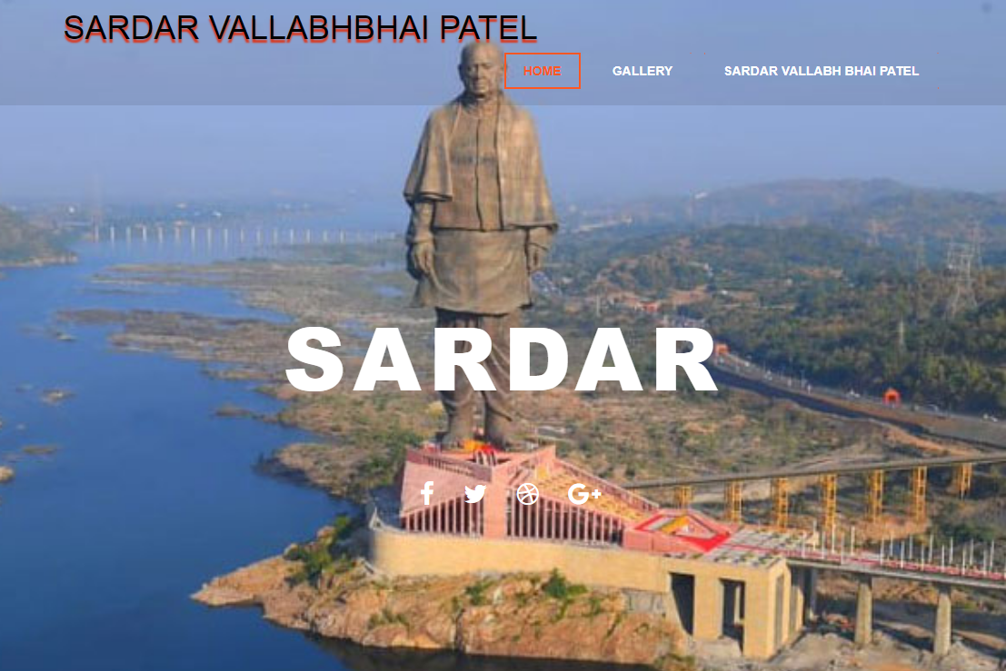

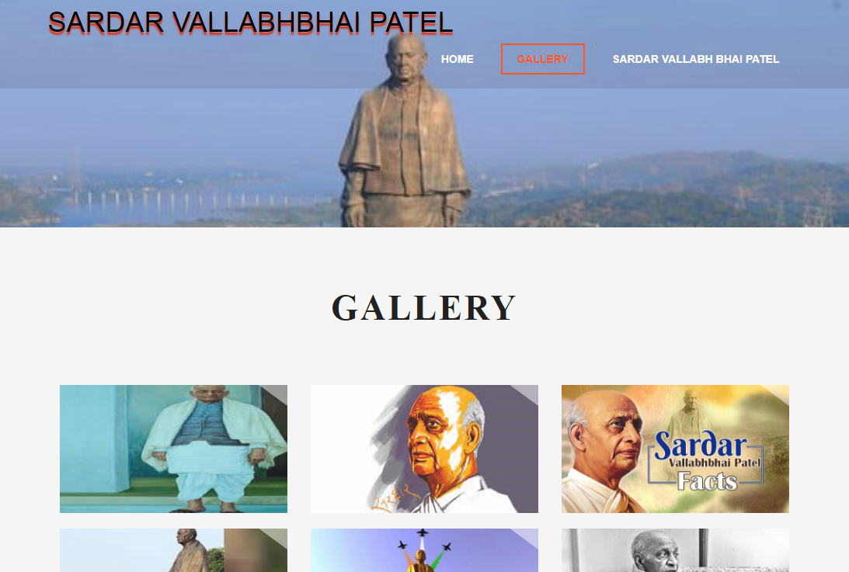

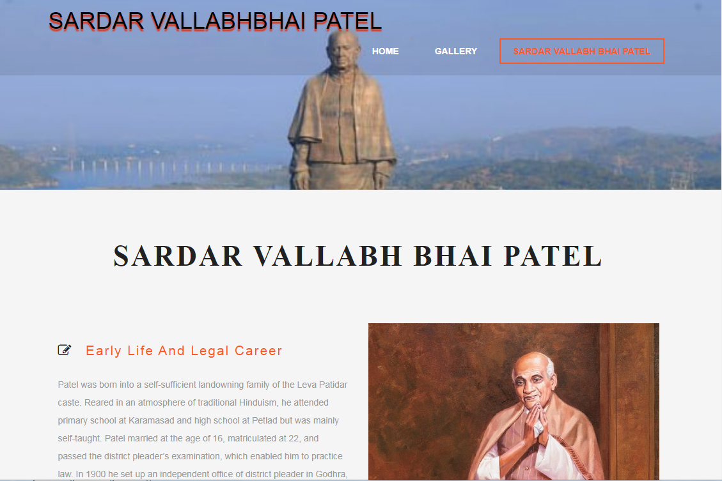

**CONCLUSION**

The goal accomplished in designing/ developing of the system are-

**User Friendliness:**

The system is totally user friendly by simply clicking user can navigate easily through on form to another form one record to another record.

**Duplicity:**

As data is entered are different modules so consideration is made so that no duplicate entry exists in the system.

**Menu Driven:**

The system is made totally menu driven for the best result by simply we can navigate through program.

**Reports:**

To print or see all information regarding specified record report are provided

**Security:**

A high level security at different level has been incorporated in to the system on the basis of user requirement.

**BIBLIOGRAPHY**

**BOOKS USED:**

* Programming in HTML (E. Balaguruswami)
* Introducing HTML (Sumita Arora)
* Software Engineering (Shalini Puri)
* Software Engineering (Pressman)

**SITES USED:**

* www.slideshare.com
* www.programinggreek.com
* www.htmllanguageinfo.net
* www.wikipedia.org