F1 Race Strategy Intelligence
Task 9 & Task 10 Report — System Integration, Deployment, Evaluation and Responsible AI
This report documents how the ten-task computational-intelligence platform was integrated into one deployable system (Task 9) and evaluated end to end (Task 10). Task 9 combines symbolic reasoning (Tasks 1-3), classical machine learning (Task 6) and deep learning (Task 7) into a single POST /api/strategy/predict call that runs eight pipeline stages and a combining recommendation engine that states explicitly when ML and DL disagree, plus a downloadable strategy report (Markdown or HTML) and Docker deployment. Task 10's evaluation — functional testing, performance, a real-race domain-validation backtest, explainability validation, a responsible-AI assessment and a deployment-readiness checklist — is produced by scripts/evaluate_system.py and written to artifacts/evaluation/*.json; every figure in this document is read from those files or from other generated artifacts, never typed in by hand.

Task 9 — System Integration & Deployment

9.1 Architecture — the strategy pipeline
One POST to /api/strategy/predict runs all eight stages below and returns every stage's output in one response; the recommendation engine combines the expert system, ML, DL and the A* search plan, flagging disagreement explicitly rather than silently picking a model.
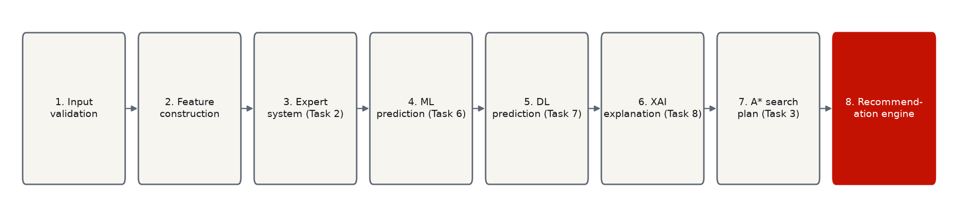

9.2 Integrated source code
Module | Task | Role
app/intelligence/expert_system/ | 2 | Forward-chaining rule base (32 rules)
app/intelligence/search/ | 3 | A* / BFS / DFS / UCS / Greedy over pit strategies
app/intelligence/ml/ | 6 | 10 classical models, chronological holdout
app/intelligence/dl/ | 7 | 2 Keras networks, tuned decision threshold
app/intelligence/xai/live.py | 8 | Live SHAP + point-prediction cache (shared by stages 5 & 6)
app/services/strategy_service.py | 9 | Orchestrates all stages + the recommendation engine
app/services/strategy_report.py | 9 | Markdown/HTML strategy report generator
app/api/routers/ | 9 | FastAPI routers — one per task/concern
frontend/app/*/page.tsx | 9 | 6-page Next.js dashboard, fetch-only, no hard-coded figures
Dockerfile, docker-compose.yml | 9 | Containerized deployment, additive to ./run.sh
scripts/evaluate_system.py | 10 | Testing, performance, domain validation, responsible AI

9.3 Dashboard
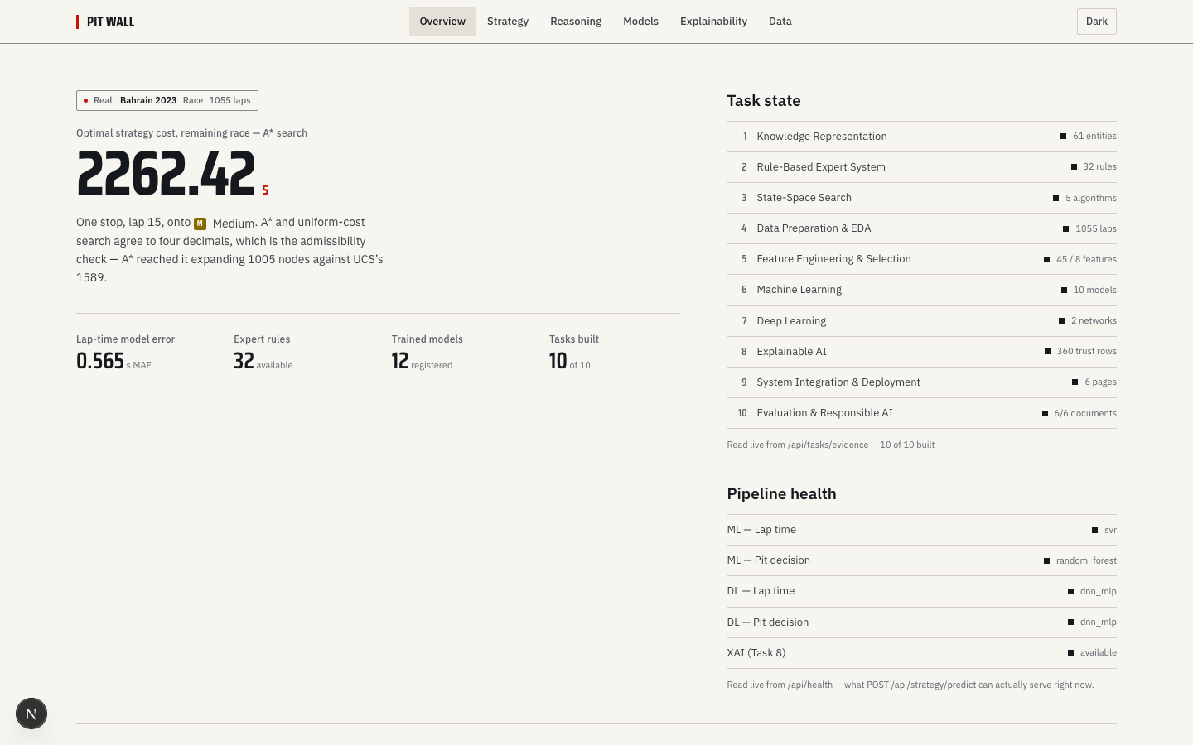  Overview — pipeline health + task ledger (10/10 built) | 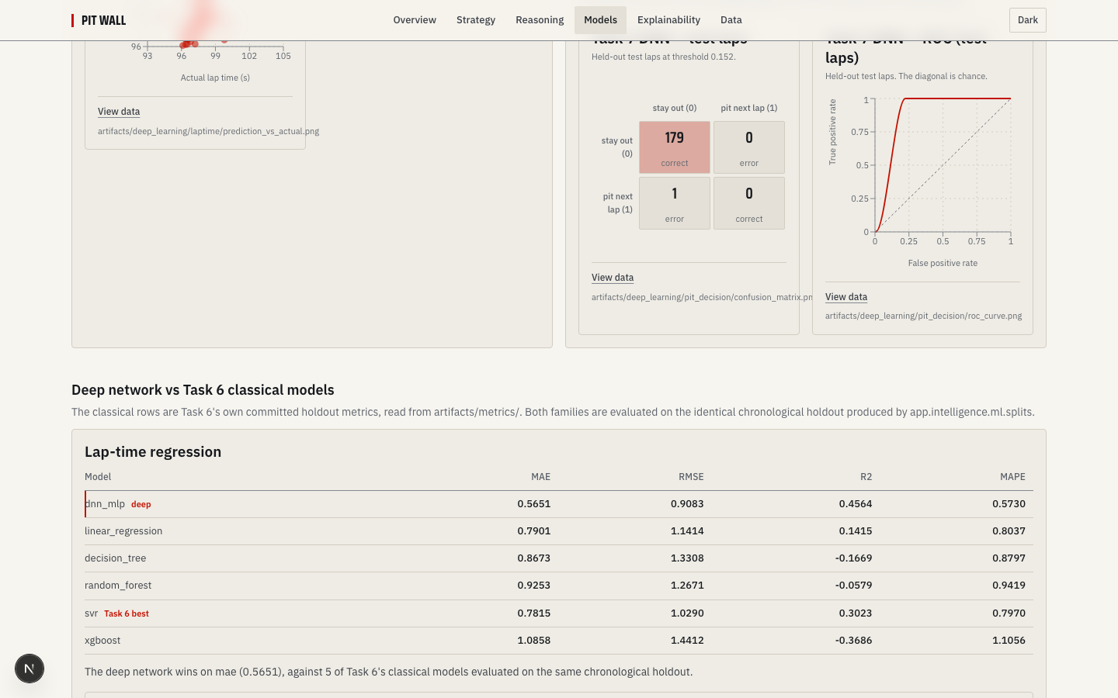  Models — Task 6 vs Task 7 on the identical holdout
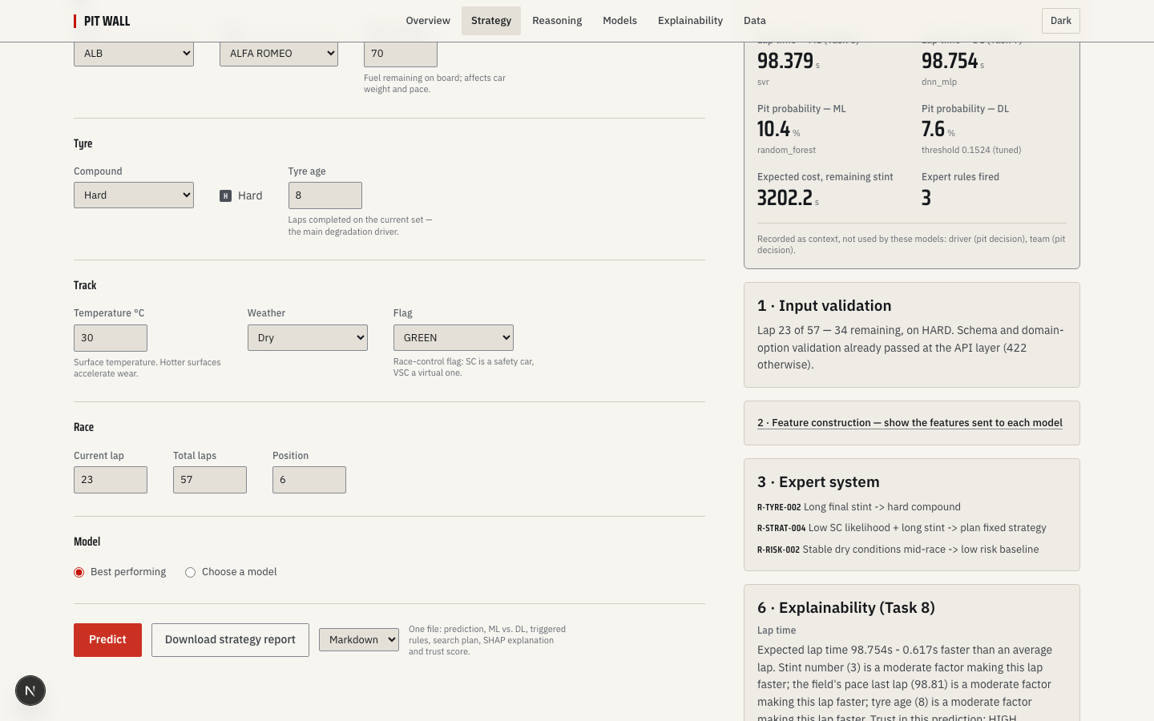  Strategy Simulator — recommendation + ML/DL + stage cards | 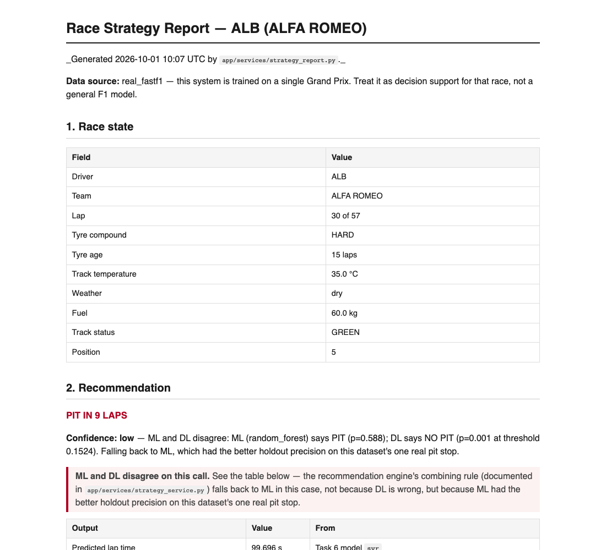  Downloadable strategy report (HTML format)

9.4 Race Strategy Report Generator
Excerpt from a real generated report (POST /api/strategy/report), ALB at lap 30/57 on HARD tyres — ML and DL disagree on the pit call, and the report states this explicitly:
"PIT IN 9 LAPS — Confidence: low — ML and DL disagree: ML (random_forest) says PIT (p=0.588); DL says NO PIT (p=0.001 at threshold 0.1524). Falling back to ML, which had the better holdout precision on this dataset's one real pit stop."

9.5 Deployment
Local: ./run.sh builds any missing stage, starts both servers, warms the API and opens the dashboard. Containerized: docker compose build && docker compose up — both images are code-only (artifacts/ and data/ bind-mounted, not baked in). Verified end to end in this session: both images build; the backend container reaches "healthy" via its own GET /api/health and serves the full per-model breakdown from inside the container network; the frontend (remapped to host port 3001, since 3000 is commonly held by an unrelated local dev server) comes up and server-renders real data fetched from the backend container.
Endpoint | Purpose
GET /api/health | status + per-model (ML/DL/XAI) availability breakdown
POST /api/strategy/predict | 8-stage pipeline: validation → ... → recommendation
POST /api/strategy/report?format=html|markdown | downloadable strategy report
GET /api/tasks/evidence | task-level build ledger (1-10), scanned from disk

Task 10 — System Evaluation, Responsible AI & Documentation

10.1 Testing report
pytest: 301 passed, 0 failed, 0 errors, 0 skipped (301 total), 64.5% statement coverage, 64.3s. Every scenario Task 10's brief calls out by name is a real, collected test (tests/test_api.py): end to end predict returns all stages: present; input validation rejects bad inputs: present; dl uses tuned threshold not 0.5: present; report endpoint returns non empty file: present; not available when ml model missing: present; not available when dl model missing: present.

10.2 Performance evaluation
Confirmed: Task 6 and Task 7 call the identical holdout function with the identical 0.2 fraction on frames built by the identical build_task_frame(load_and_validate(), target) call, so for a given target their test laps are the same laps by construction, not by coincidence.
Lap time (regression), chronological holdout — selected best per family:
Family | Model | Test MAE (s) | Test R²
ML (Task 6) | svr | 0.781 | 0.302
DL (Task 7) | dnn_mlp | 0.565 | 0.456
Pit decision (classification), same holdout — one real positive lap, so treat as illustrative:
Family | Model | Test PR-AUC | Test F1
ML (Task 6) | random_forest | 0.250 | 0.083
DL (Task 7) | dnn_mlp | 0.024 | 0.000
API latency, /api/strategy/predict (200 requests, explain=false): p50 100.73ms, p95 125.05ms, p99 189.7ms. With explain=true (50 requests): p50 257.77ms, p95 291.64ms. Model cold-load: ML 0.0173s, DL+classical bundle 0.0201s.

10.3 Domain validation — 2023 Bahrain backtest
Replayed 934 real laps through the live recommendation engine lap-by-lap (121 laps excluded — early-race TyreLife-before-LapNumber data quirk, see methodology). Against the real pit-stop labels: 34 hits, 5 misses, 237 false calls, 664 correct stay-outs — precision 0.125, recall 0.872. This measures agreement with what the real teams did, not proof of optimal strategy.
Expert-system rule-coverage fix: an earlier audit found 14 of 32 Task 2 rules could never fire through the live pipeline (missing inputs such as in_pit_window and safety_car_probability), which is exactly why that audit found 0 safety-car rule firings despite 31 real VSC laps in this race. After adding the 4 genuinely-derivable inputs to strategy_service._run_expert_system, R-SC-002/R-SC-003/R-PIT-004/R-STRAT-004 became reachable: this backtest now shows 8 safety-car rule firings out of 31 real VSC laps, with zero false positives (Every R-SC-* rule firing happened on a lap this script mapped to SC or VSC — no false positives against the real track-status history.). 10 rules remain documented limitations (rival-car telemetry, multi-circuit data, or a graining model this project doesn't have) — not worked around with invented numbers; see app/services/strategy_service.py and docs/sdd.md §7 for the full per-rule reasoning.

10.4 Explainability validation
SHAP top-feature bootstrap stability (200 resamples): lap time → field_median_lag1 (92% of resamples); pit decision → tracktemp_dev_x_tyrelife (100%). Faithfulness check: ablating the top feature moved the prediction more than ablating a random feature for both targets.

10.5 Responsible AI
Robustness — recommendation flip rate under small perturbations: track temp +5°C 0, -5°C 0.778; tyre age +2 laps 0, -2 laps 0.778. Fairness: per-driver/team/compound MAE and pit recall read from Task 8's own stratification (59 groups flagged small-sample, descriptive only). Transparency: 0 synthetic files found in data/raw (checked directly); single-race limitation stated throughout; the pit model's CV-vs-holdout gap is an evaluation-design artifact of one positive test lap, not underfitting. Human oversight: "Decision support for engineers, not an autonomous strategy system, and not for betting." (present: true).

10.6 Deployment readiness checklist
Check | Result
Dockerfiles + compose present | yes
docker compose build/up | verified: both images build; backend healthy; frontend (host port 3001) serves real backend-fetched data
GET /api/health passes | true
pytest passes | true
No hard-coded metrics in frontend | 4 regex matches, all reviewed and confirmed to be CSS/layout constants, not metrics
README reflects current status | 995 rows: true; Task 9/10 sections present: true

10.7 Limitations & future enhancements
Single race (2023 Bahrain GP); one labelled pit stop in the holdout; 10 of 32 expert-system rules remain structurally unreachable via the live pipeline (rival-car telemetry, multi-circuit data, or a tyre-graining model this project doesn't have — see docs/sdd.md §7 for the full per-rule list); this document's exact PDF page count was not verified with LibreOffice in this environment (not installed, by instruction) — see the covering reply for a content-based estimate instead.
Future work: More races; Multi-session Task 4/5; QAOA / quantum optimisation vs. the A* baseline; Live FastF1 timing feed.

Appendix — deliverables index
Deliverable | File
User Manual | docs/user_manual.md
Software Requirements Specification | docs/srs.md
Software Design Document | docs/sdd.md
Deployment Guide | docs/deployment_guide.md / docs/DEPLOYMENT.md
Testing Report | docs/TESTING_REPORT.md
Final Project Report | README.md, docs/task7_task8.md, docs/QML_README.md
Evaluation results (raw) | artifacts/evaluation/*.json
Deliverables checklist (Tasks 1-10) | docs/DELIVERABLES_CHECKLIST.md
This report | artifacts/reports/Task9_Task10_Report.docx

