5.3 Resolving Merge Conflicts on Delete

This section will guide you to:

* Resolve merge conflicts on delete

This lab has four subsections, namely:

5.3.1 Navigating to the local Git repository that has the merge conflict

5.3.2 Generating a list of the files affected by the merge conflict

5.3.3 Adding the removed file back to the repository

5.3.4 Committing the changes with a comment

**Please note**: The following commands can be executed in any repository that we created earlier.

**Step 5.3.1:** Navigating to the local Git repository that has the merge conflict

1. In the terminal, execute the following commands to navigate to the local repository:

**$ git status**

**$ ls -lrt**

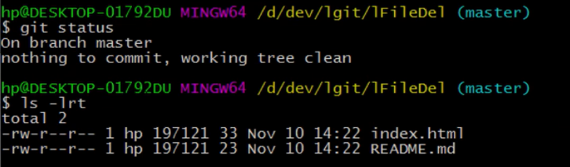

1. Use the following command to create an empty file and save it:

**$ vi index.html**

**Step 5.3.2:** Generating a list of the files affected by the merge conflict

1. Run the following commands in the terminal:

**$ git branch**

**$ git branch feature-one**

**$ git checkout feature-one**

**$ git log --oneline --decorate --graph**

**$ ls -lrt**

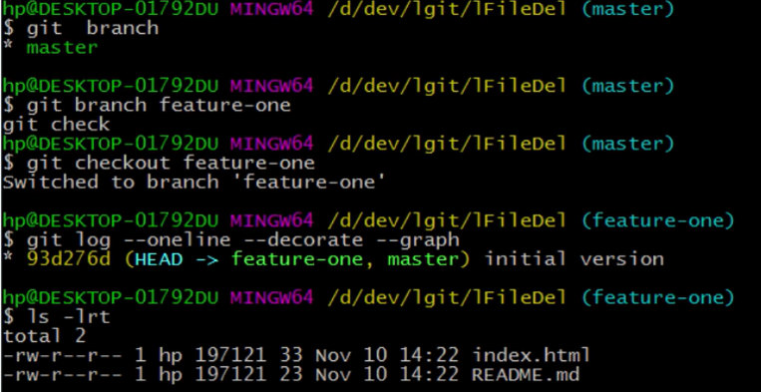

1. Run the following command in the terminal to remove the index.html file:

**$ git rm index.html**

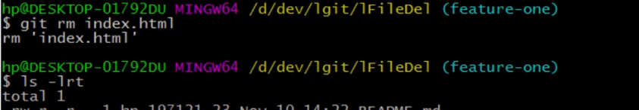

1. Use the following command to check the Git status:

**$ git status**

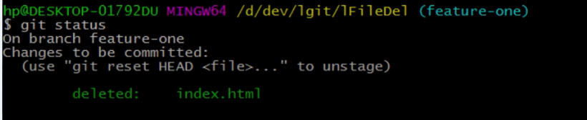

**Step 5.3.3:** Adding the removed file back to the repository

* Use the following command to add the removed file back in the repository:

**$ git add .**

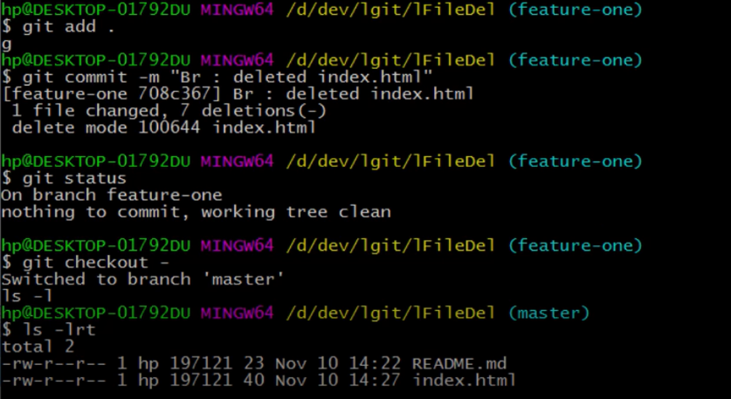

**Step 5.3.4:** Committing the changes with a comment

* Commit the changes using the following command:

**$ git commit -m “Br : deleted index.html”**

