Lesson 2 Demo 4: Clone a GitHub Repository

This section will guide you to:

* Clone a github repository

This lab has one subsections, namely:

1. Cloning a GitHub repository

**Note**: You should already have a GitHub repository which you created in Lesson 2 Demo 2. If not, first complete that demo and then proceed with this demo. After cloning the github repository ie. After completing this demo, please keep this repository handy as we will be using this in the next chapter.

**Step 1:** Cloning a GitHub repository

* Open the browser in your lab, Go to **github.com** and login to your account
* Open the **sample-repository** repo and click on the **Code** button
* Click on the icon as shown in the following image to copy the **url** provided under **HTTPS**

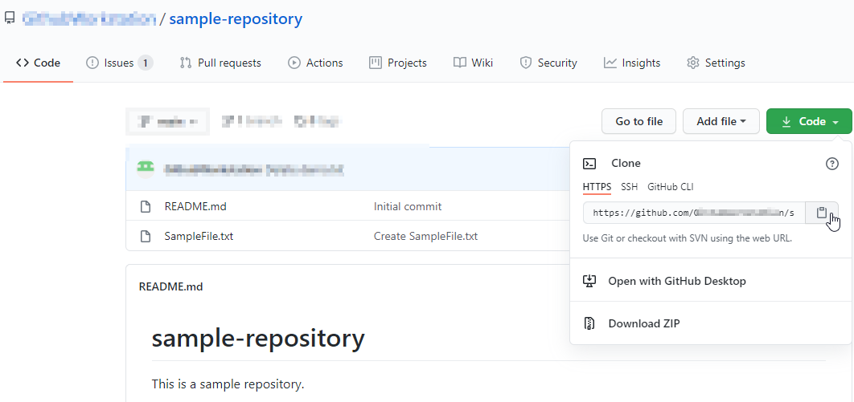

* Open the **Terminal** tab on your lab and use the following command to clone the repository:

**git clone URL**

**Note:** Replace URL with the copied url from the repository

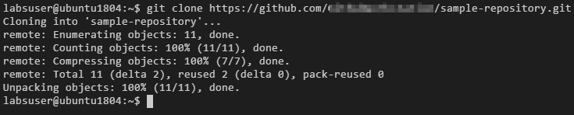

* Use the following command to check the cloned repository:

**ls**

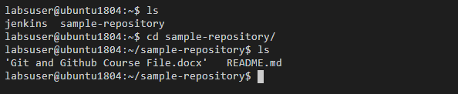

* Navigate to the **sample-repository** and check the files inside the repository

**cd sample-repository**

**ls**

