Lesson 2 Demo 5: Create Git Aliases

This section will guide you to:

* Create Git aliases

This lab has one subsections, namely:

1. Creating aliases for common Git commands

**Step 1:** Creating aliases for common Git commands

* Open the terminal and execute the following commands to create the respective aliases:

**git config --global alias.co checkout**

**git config --global alias.br branch**

**git config --global alias.ci commit**

**git config --global alias.st status**

**git config --global alias.ad add**

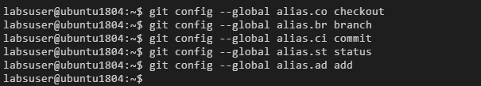

* Use the following command to list all the git aliases:

**git config -l | grep alias**

