Lesson 3 Demo 2: Tracking File Changes

This section will guide you to:

* Track the changes in a file

This lab has four subsections, namely:

1. Updating a file from the repository
2. Tracking the changes in the file
3. Adding the file to the staging area
4. Comparing git commits to track file changes

**Please note**: Make sure you have successfully completed the first demo from the third lesson before you start this demo.

**Step 1:** Updating a file from the repository

* Check the status of the repository that you have created and cloned in the first demo of the third lesson

**git status**

* Open a file from the local repository in **vi editor,** and make some changes in the file

**vi demo.txt**

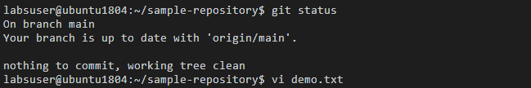

* Add some sample content in the file **demo.txt**, for instance:

**This is a Demo.txt file**

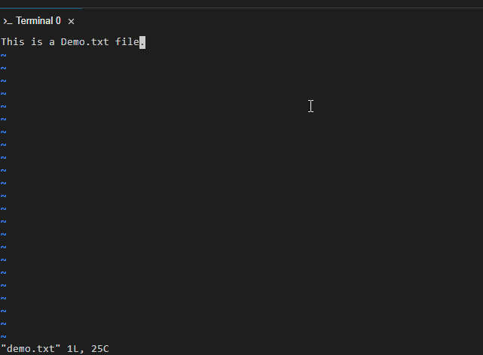

* Save the file, and exit by pressing **esc** key and **shift+: wq**
* Check the status of the repository again

**git status**

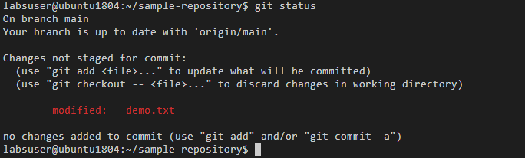

**Step 2:** Tracking the changes in the file

* Use the following command to compare the file in the working directory with its last staging area:

**git diff demo.txt**

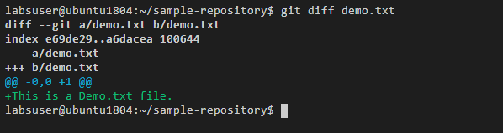

**Note:** The **+** statement is showing the changes in the file.

**Step 3:** Adding the file to the staging area

* Use the **git add** command to add the file to the staging area

**git add demo.txt**

* Use the **git diff** command to track any changes

**git diff demo.txt**



**Step 4:** Comparing git commits to track file changes

* Use the following command to check the recent log of commits with **--oneline** flag

**git log --oneline**

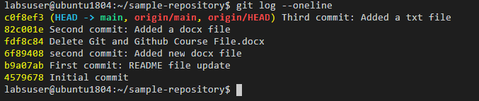

* Use the **git commit** command to commit the changes from the staged area

**git commit -m "Fourth commit: Modified the txt file"**

* Use the **git push** command to push the file to the main or master branch depending on your repository structure

**git push -u origin master** or **git push -u origin main**

* Use the **git log** command again to see the latest commit

**git log --oneline**

