Lesson 3 Demo 4: Cleaning the Working Directory

This section will guide you to:

* Clean the working directory

This lab has one subsection, namely:

1. Cleaning the working directory

**Please note**: Make sure you have successfully completed the third demo from the third lesson before you begin this one.

**Step 1:** Cleaning the working directory

* In the terminal, add a file in the repository and keep it in the staging area

**touch demo1.txt**

**git add -A**

**git status**

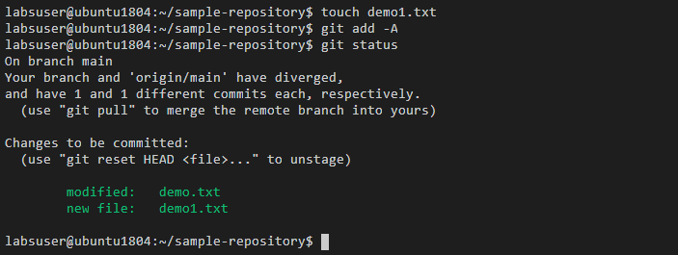

* Use the following command to perform a dry run on cleaning the untracked files:

**git clean -n**

* Use the following command to force clean the untracked files:

**git clean -f**

* Use the following command to clean the untracked directories:

**git clean -f -d**

