Lesson 3 Demo 6: Deleting Files in Git

This section will guide you to:

* Delete a file in Git

This lab has five subsections, namely:

1 Checking the list of files in the repository

2 Removing a file from the repository

3 Checking the list of files again

4 Executing git status, to show that the removal of the file is still in staging and needs to be committed to the repository

5 Committing the changes

**Please note**: Make sure you have successfully completed all the previous demos of Lesson 3

**Step 1:** Checking the list of files in the repository

* In the terminal first go to your repository that you have cloned in Lesson 2 Demo 4. If you have not cloned the repository, ensure that you clone the repository as mentioned in Lesson 2 Demo 4 and then enter the cloned repository directory using **cd** command. Refer to Lesson 3 Demo 1 to check the steps for the same. Now, execute the following command to list all the files

**git ls-files**

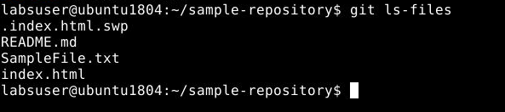

**Step 2:** Removing a file from the repository

* Use the following commandto remove the file from the repository

**rm <YourFileName>**



**Step 3:** Checking the list of files again.

* Use git ls command to check that the file is removed from the list

**git ls-files**

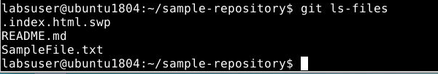

**Step 4:** Executing **git status**, where you will notice that the removal of the file is still in staging and needs to be committed to the repository

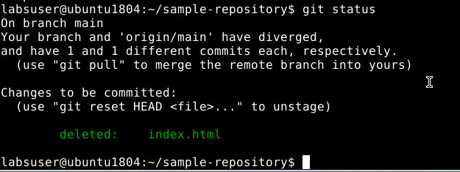

**Step 5:** Committing the changes

* Execute the **git add .** Command
* Use git commit command to commit the changes

**git commit -m “Removed file name”**

**Note**: Ensure that you provide the name of the file that you have deleted

