Lesson 3 Demo 8: Renaming Files in Git

This section will guide you to:

* Rename files in Git

This lab has three subsections, namely:

1 Executing **git mv <old file name> <new file name>** to rename the file

2 Checking the status of the repository

3 Commit the changes

**Please note**: Execute the below commands in a sample git repository that you have created in the previous demos. Ensure that you complete all the 7 demos of lesson 3 before you jump into this.

**Step 1:** In the terminal, execute **git mv <old file name> <new file name>** to rename the file

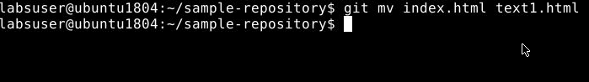

**Note**: New file name is the file name that was not created before.

**Step 2:** Checking the status of the repository by executing **git status**

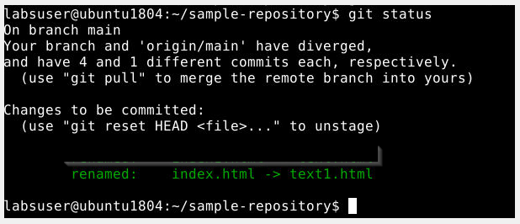

**Step 3:** Commit the changes by executing **git commit -m “file renamed”**

