Lesson 4 Demo 1: Create a Repository in GitHub Using HTTPS

This section will guide you to:

* Create a repository in GitHub using HTTPS

This lab has five subsections, namely:

1. Creating a repository on the local machine
2. Creating a GitHub repository
3. Adding a remote repository using the HTTPS URL
4. Pushing the changes in the local repository to GitHub
5. Checking the status of the local and remote repository

**Step 1:** Creating a repository on the local machine

* In the terminal execute the following commands to create and initialize a Git repository

**mkdir creating-repository-in-github-using-https**

**cd creating-repository-in-github-using-https**

**echo "# creating-repository-in-github-using-https" >> README.md**

**git init**

**git add README.md**

**git commit -m "first commit"**

**git branch -M main**

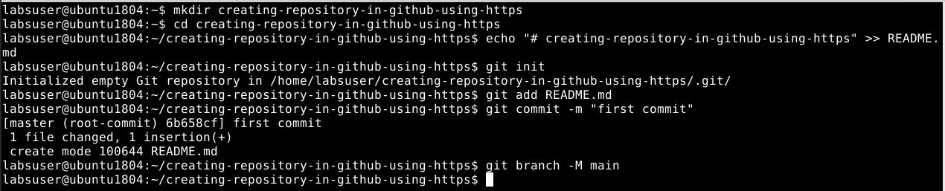

**Step 2:** Creating a GitHub repository

* Go to **github.com** and log in to your account
* Click on the **New** button to create a new repository and give the repository name as *creating-repository-in-github-using-https*

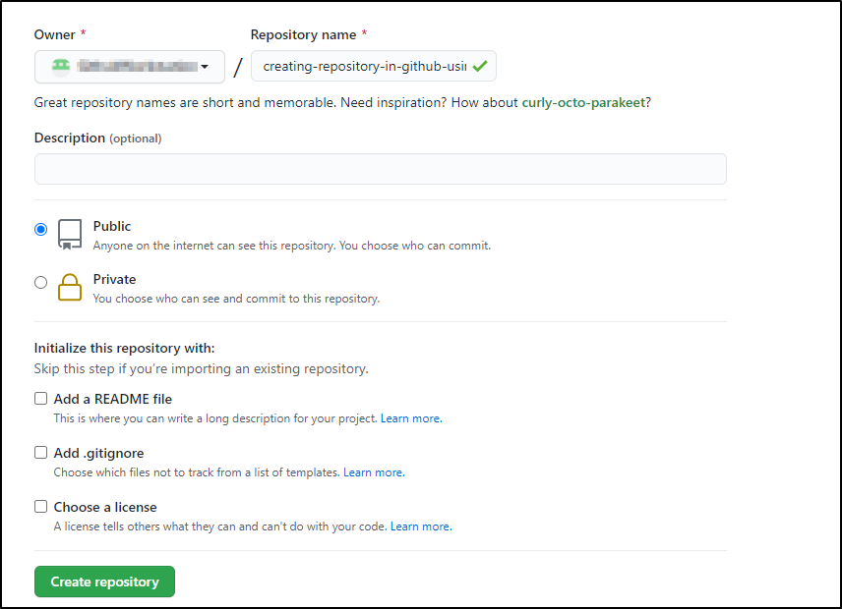

**Step 3:** Adding a remote repository using the HTTPS URL

* Copy the HTTPS URL from the newly created repository

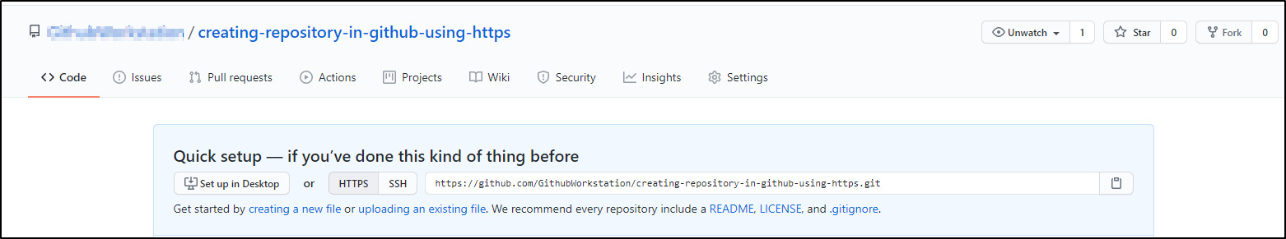

* Open the **Terminal** on the local machine and use the following command to add a remote repository:

**git remote add origin <Your HTTPS_URL>**

Replace HTTPS_URL with the copied URL

* Execute the **git remote -v** command to check remote repository



**Step 4:** Pushing the changes in the local repository to GitHub

* Use the following command to push the changes to remote repository:

**git push -u origin main**

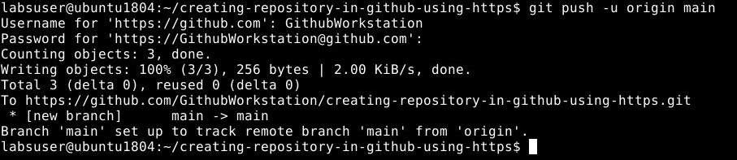

**Note**: In case you get an authentication error, you will need to configure your GitHub username and email address as mentioned in the Lesson 2 Demo 3.

**Step 5** Checking the status of the local and remote repository

* Use the following command to check the status of the local repository

**git status**

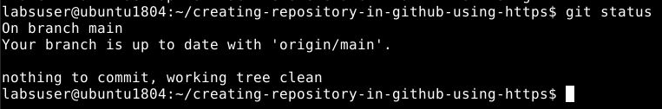

* Go to **github.com** and check the remote repository

