Lesson 4 Demo 2: Create a Repository in GitHub Using SSH

This section will guide you to:

* Create a repository in GitHub using SSH

This lab has seven subsections, namely:

1. Generating a new SSH key
2. Adding the SSH key to the GitHub account
3. Creating a repository on the local machine
4. Creating a GitHub repository
5. Adding a remote repository using the SSH URL
6. Pushing the changes in the local repository to GitHub
7. Checking the status of the local and remote repository

**Step 1:** Generating a new SSH key

* Open the Terminal and use the following command to generate a new SSH key

**ssh-keygen -t rsa -b 4096 -C "<your_email@example.com>"**

**Note:** Replace **<your_email@example.com>** with your GitHub email address and press **Enter** for **Enter a file in which to save the key** and **Enter passphrase**

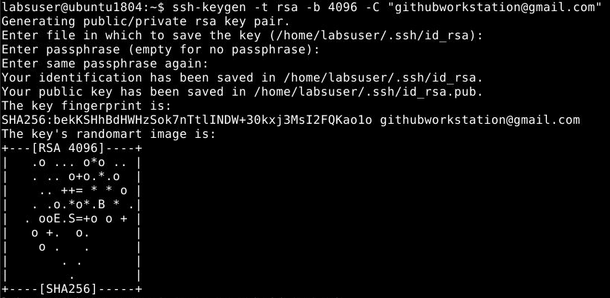

**Step 2** Adding the SSH key to the GitHub account

* Use the following command to open the **id_rsa.pub** file and copy the SSH key to the clipboard

**cat < ~/.ssh/id_rsa.pub**

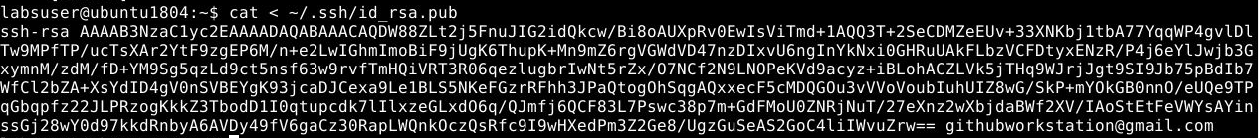

* Go to **github.com** and click on the profile photo in the upper-right corner
* Click on the **Settings** button and navigate to **SSH and GPG Keys**
* Click on the **New SSH Key** button

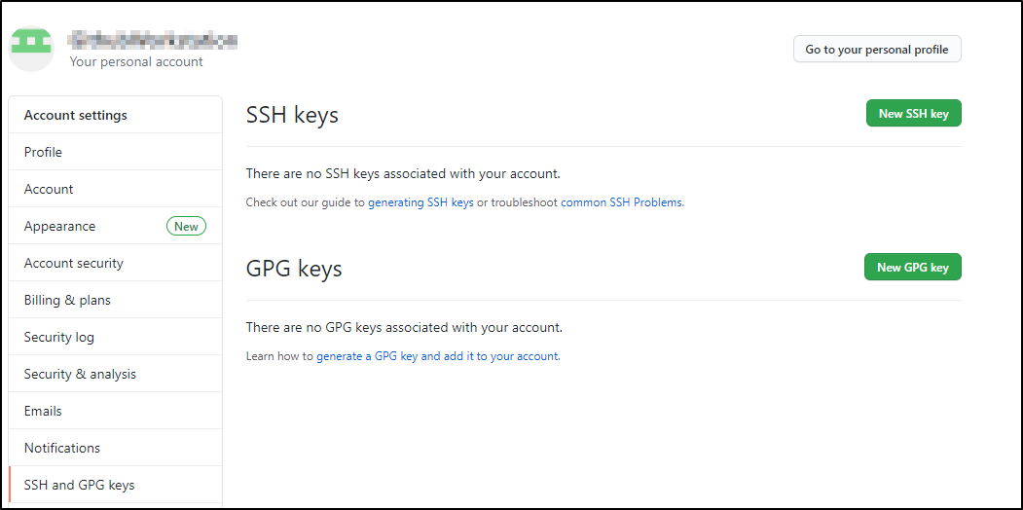

* Enter the Title as **mySSHKey** and **Key** (copy paste the key that is displayed in your terminal)and click on the **Add SSH key** button

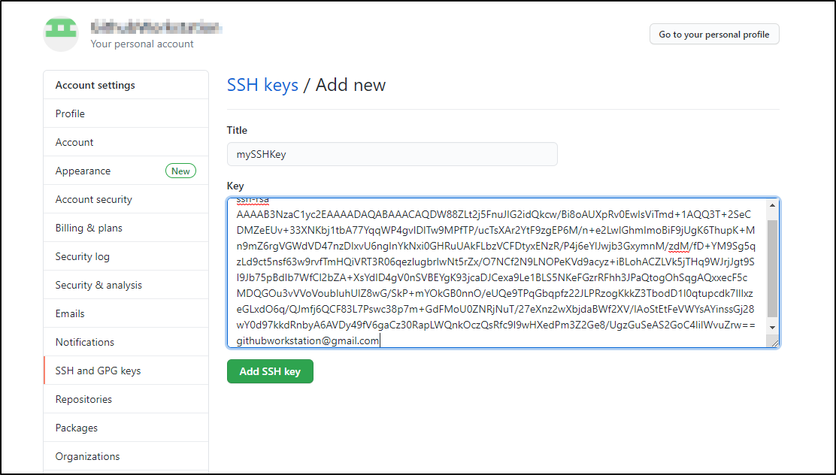

**Step 3:** Creating a repository on the local machine

* Use the following commands to create and initialize a Git repository

**mkdir creating-repository-in-github-using-ssh**

**cd creating-repository-in-github-using-ssh**

**echo "# creating-repository-in-github-using-ssh" >> README.md**

**git init**

**git add README.md**

**git commit -m "first commit"**

**git branch -M main**

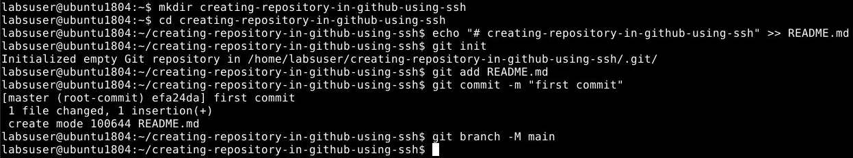

**Step 4.2.4:** Creating a GitHub repository

* Go to **github.com** and log in to your account
* Click on the **New** button to create a new repository named as *creating-repository-in-github-using-ssh*

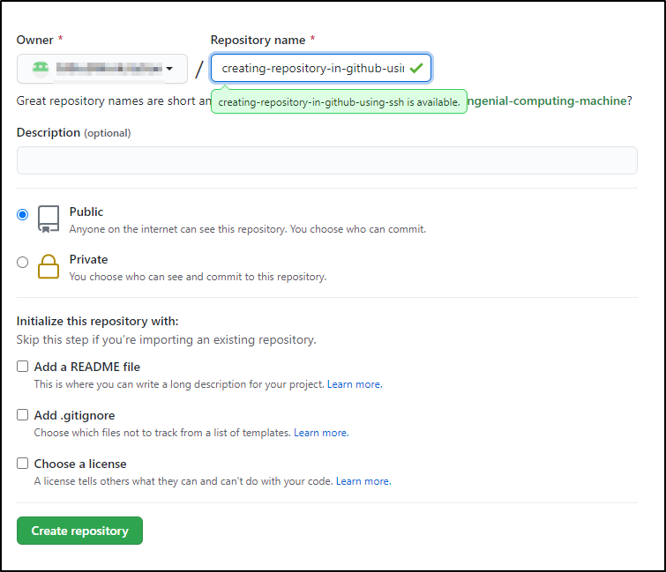

**Step 5:** Adding a remote repository using the SSH URL

* Copy the SSH URL from the newly created repository

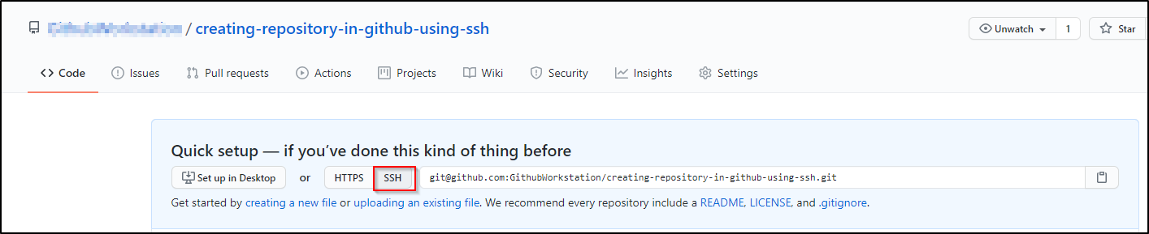

* Open the **Terminal** on the local machine and use the following command to add a remote repository:

**git remote add origin SSH_URL**

Replace SSH_URL with the copied URL

* Execute **git remote -v** command to check the remote repository



**Step 6:** Pushing the changes in the local repository to GitHub

* Use the following command to push the changes to remote repository

**git push -u origin main**

Type *yes*when prompted as shown below:

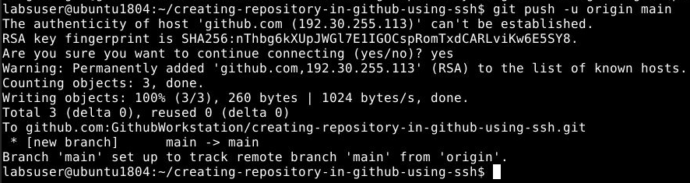

**Note**: In case you get an authentication error, you will need to configure your Github username and email address as mentioned in the Lesson 2 Demo 3.

**Step 7** Checking the status of the local and remote repository

* Use the following command to check the status of the local repository

**git status**

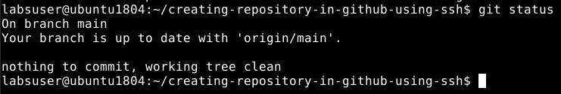

* Go to **github.com** and check the remote repository

