Lesson 4 Demo 3: Managing Multiple Commits in Git

This section will guide you to:

* Manage multiple commits in Git

This lab has eleven subsections, namely:

1. Checking the status of repository
2. Checking the logs for commits history
3. Editing the index.html file
4. Adding an extra header in the index.html file
5. Checking the repository status for any updates
6. Adding the updated file in the staging area and committing the changes
7. Checking the logs for the latest commits
8. Pushing the changes to the remote repository
9. Editing file on the remote repository
10. Fetching the changes from remote repository
11. Checking the logs for all the commits history

**Please note**: Make sure you have successfully completed the previous demo (Lesson 4 Demo 2) in order to proceed with this demo.

**Step 1:** Checking the status of the repository

**git status**

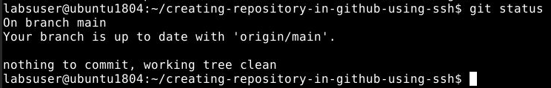

**Step 2:** Checking the logs for commits history

**git log --oneline**

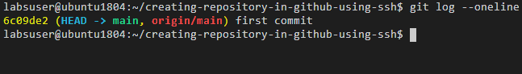

**Step 3:** Editing the **index.html** file

Create **index.html** in your working directory as shown in the screenshot below:

**vi index.html**

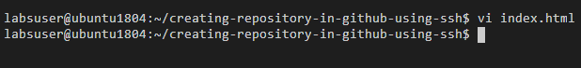

Add the following code in the index.html file:

**<html>**

**<head>**

**<style>**

**H1 {color: blue; font-size: 300%}**

**P {color: black}**

**</style>**

**</head>**

**<body>**

**<H1> This is a header! </H1>**

**<P> This is paragraph one </P>**

**</body>**

**</html>**

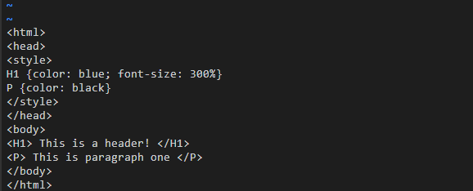

Save the file using **[esc] shift:wq**

**Step 4:** Adding an extra header in the **index.html** file.

**<H1> This is header 2! </H1>**

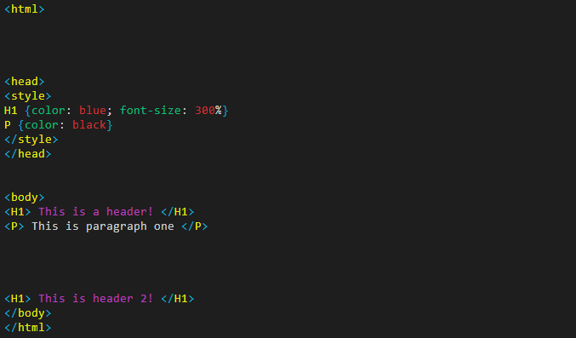

Save the file using **[esc] shift:wq**

**Step 4.3.5:** Checking the repository status for any updates

**git status**

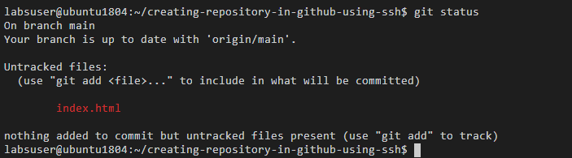

**Step 6:** Adding the updated file in the staging area and committing the changes

**git add .**

**git commit -m “Added 2nd header in the file”**

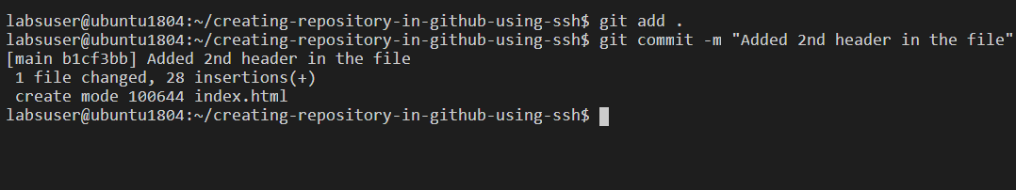

**Note**: There might be chances of getting an error on executing the git commit command. This is because of the format of the quotes which may change during copy paste. Type the quotes on the terminal to resolve it.

**Step 7:** Checking the logs for the latest commits

**git log --oneline**

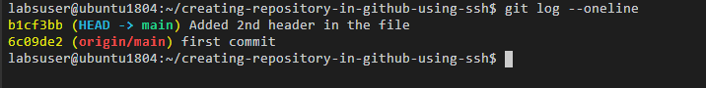

**Step 8:** Pushing the changes to the remote repository

**git push -u -f origin main**

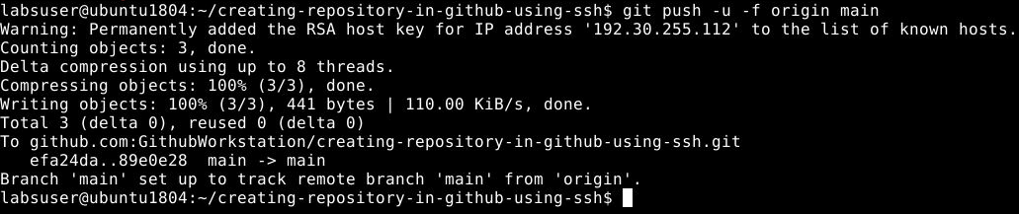

**Note**: In case you get an authentication error, you will need to configure your GitHub username and email address as mentioned in the Lesson 2 Demo 3.

**Step 9**: Editing file on the remote repository. Add the following line of code in the index.html file:

**H2 { color: red; font-size: 150%} <!-- added at remote -->**

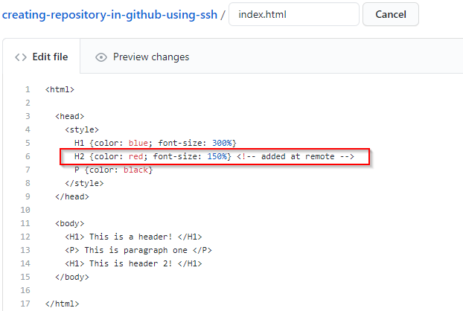

Check the commits for the latest commit

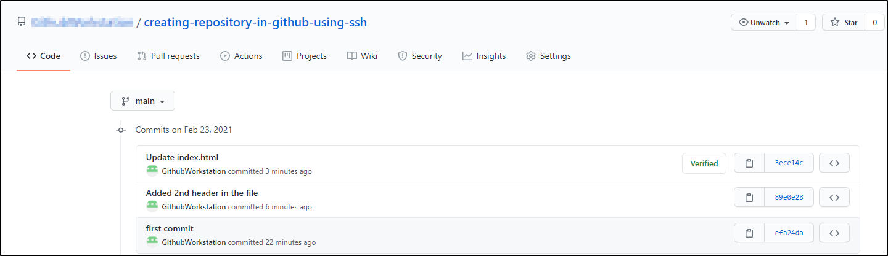

**Step 10:** Fetching the changes from remote repository

**git fetch**

**git rebase origin/main**

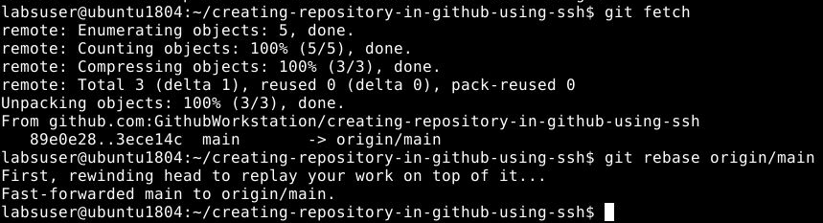

**Step 11:** Checking the logs for all the commits history

**git log --oneline**

