Lesson 4 Demo 4: Create a Fork and Pull Request

This section will guide you to:

* Create a Fork and Pull Request

This lab has five subsections, namely:

1. Creating a Fork
2. Cloning your Fork
3. Syncing fork with the original repository
4. Pushing your Changes
5. Creating a Pull Request

**Step 1:** Creating a Fork

* Log in to your Github account
* From your browser navigate to the following repository **https://github.com/GithubResources1/Source-repository.git**
* In the top-right corner of the page, click **Fork** button

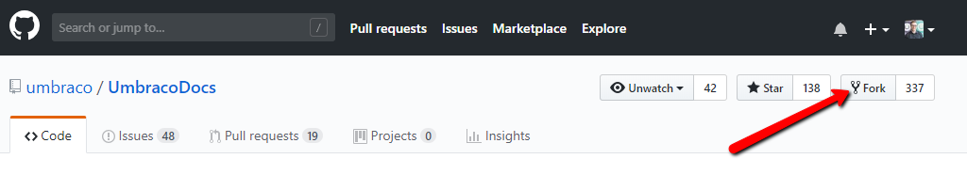

**Step 2:** Cloning your Fork

* On GitHub, click on the **code** button on your repository
* Copy the URL from under Clone with HTTPS option

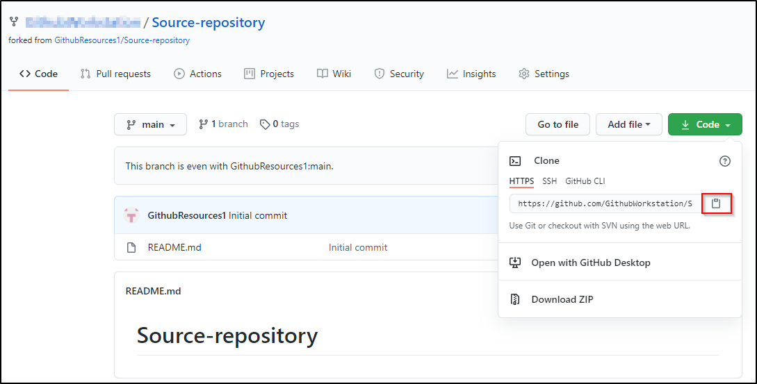

* Type the following command on your terminal:

**git clone [the copied HTTPS URL]**

**Note:** Replace [the copied HTTPS URL] in the above command with the URL you copied from the Github page. The final command should look like the following:

**git clone https://github.com/GithubWorkstation/Source-repository.git**

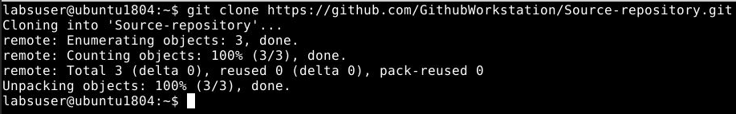

* The **clone**command creates a local git repository from your remote fork on GitHub.

**Step 3:** Syncing fork with the original repository

* Navigate to the directory where the fork has been cloned using the following command in the terminal:

**cd Source-repository**

* Use the following command to see the configured remote repository for your fork:

**git remote -v**

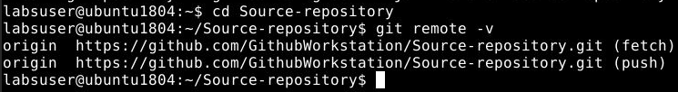

* Use **git remote add upstream** command, and paste the URL you copied in Step 2 as shown below:

**git remote add upstream [the copied HTTPS URL]**

* Use the following command to verify the new upstream repository you have specified for your fork:

**git remote -v**

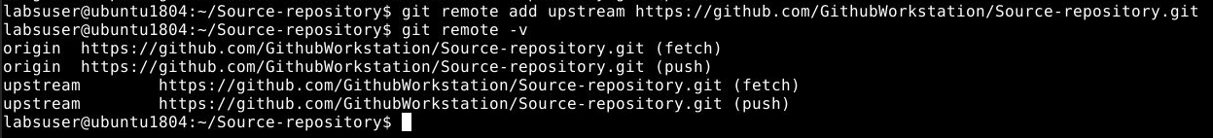

**Step 4.4.4:** Pushing your Changes

* Use the **git push** command to upload your changes to your remote fork on GitHub:

**git push**

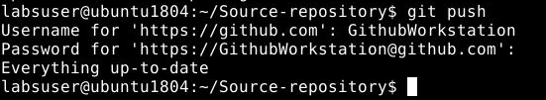

**Step 4.4.5:** Creating a Pull Request

* On the GitHub page of your remote fork, click the **pull request** button
* Wait for the owner to merge or comment on your changes
* If the owner suggests some changes before merging, you can simply push these changes into your fork by repeating steps 3 and 4 and the pull request is updated automatically.

