Lesson 4 Demo 5: Pulling Commits from GitHub

This section will guide you to:

* Pull commits from GitHub

This lab has six subsections, namely:

1. Updating the remote repository
2. Checking the commits
3. Checking the status of the local repository
4. Checking the logs for commits history
5. Pulling the main branch from the remote repository
6. Checking the logs for the latest commits

**Please note**: Make sure you have successfully completed Demo 1 of Lesson 4 as these steps are to be performed on the same repository (creating-repository-in-github-using-https)

**Step 1:** Updating the remote repository

* Update the **README.md** file and commit the changes

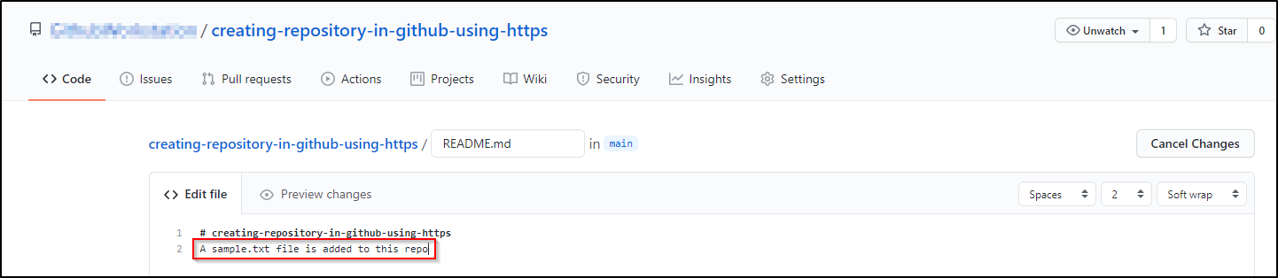

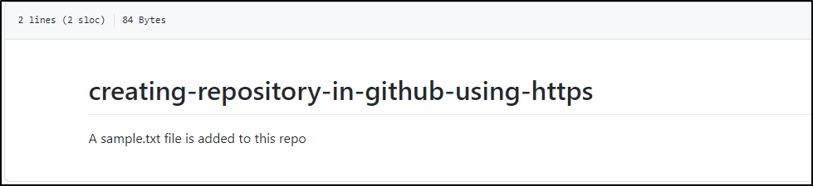

* Click on the **Add file** button to create a new **sample.txt** file in the repository and commit the changes

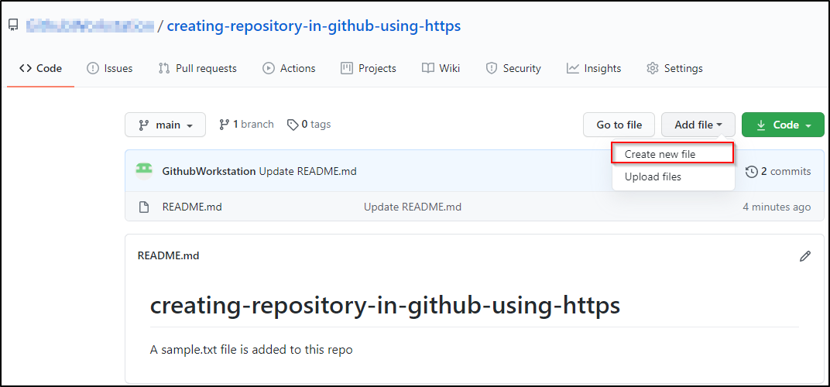

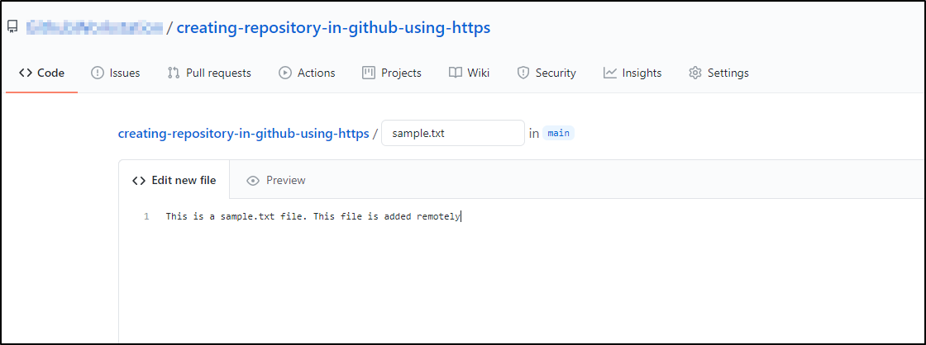

**Step 2:** Checking the commits

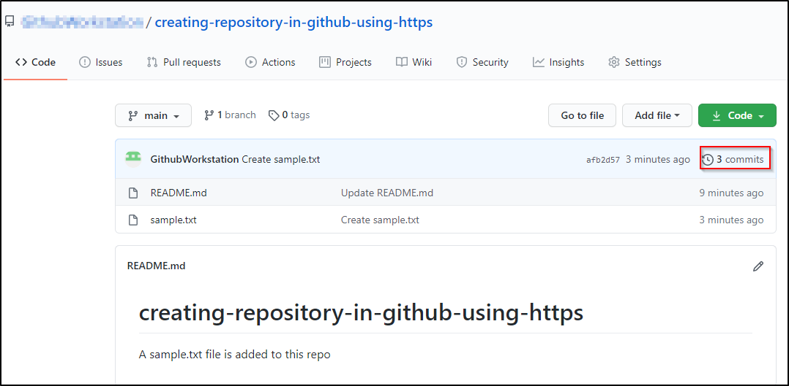

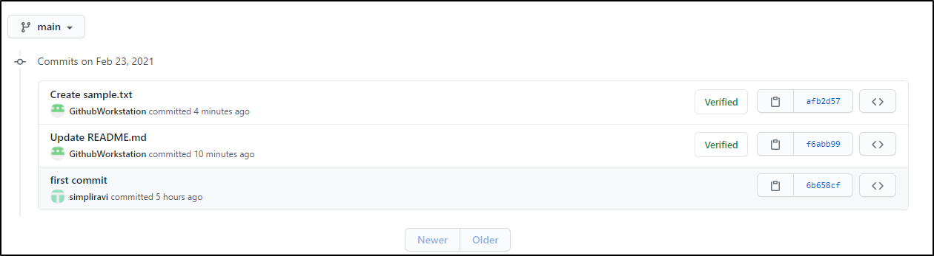

**Step 3:** Checking the status of the repository

**cd /home/labsuser/creating-repository-in-github-using-https**

**git status**

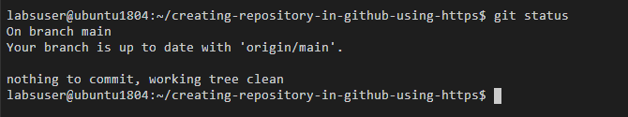

**Step 4:** Checking the logs for commits history

**git log --oneline**



**Step 5** Pulling the main branch from the remote repository

**git pull origin main**

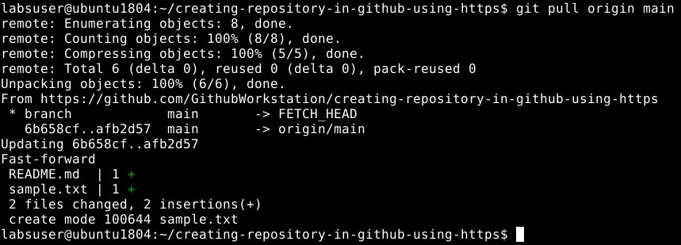

**Step 6:** Checking the logs for the latest commits

**git log --oneline**

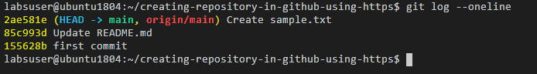

**Note:** Latest commits from the remote repository are also displayed.