Lesson 4 Demo 6: Merging Files Changes in Git

This section will guide you to:

* Merge file changes in Git

This lab has four subsections, namely:

1. Verifying the setup of the remote repository
2. Pulling files from remote repository
3. Editing a file in remote repository
4. Merging the changes in edited file in the local and remote repository

**Step 1:** Verifying the setup of the remote repository

* Create a Git repository on the local machine by executing the following commands in the terminal:

**mkdir sample-repo**

**cd sample-repo**

**git init**

* Create a remote repository on GitHub
* Go to **GitHub.com** and log in to your account
* Click on the **New** button to create a new repository and give the repository name as ***sample-repo***

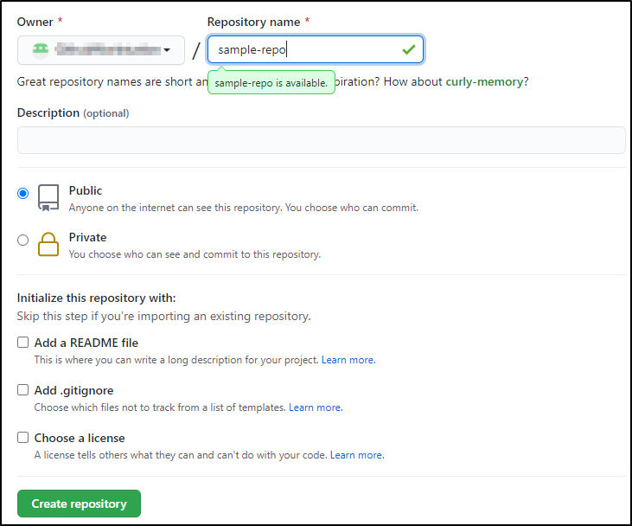

* Add a file in the remote repository on GitHub:  
    
  Create a **demo.txt** file in your GitHub remote repository  
    
  Add the following lines in the **demo.txt** file:

***This is a Demo.txt file***

***This is the second line***

Commit the changes in the GitHub remote repository

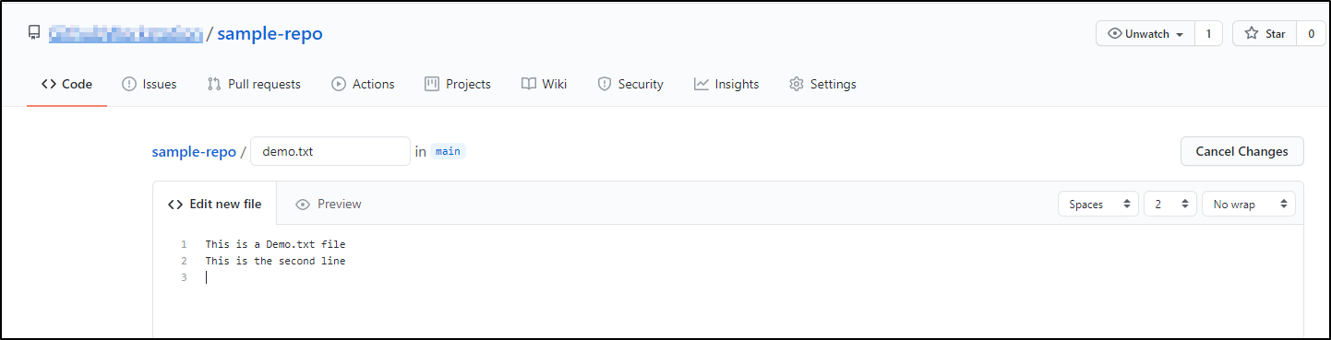

* Add the remote repository to the local repository using HTTPS url
* Copy the HTTPS URL from the sample-repo

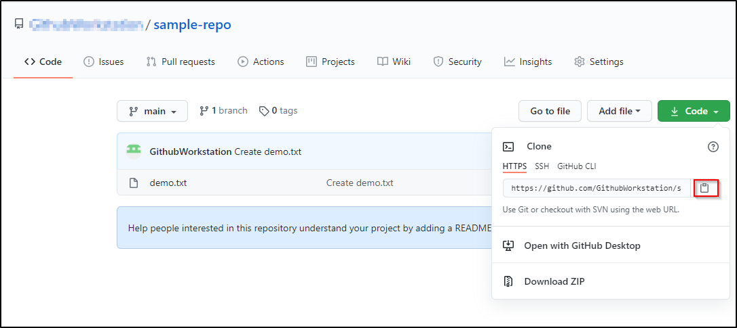

* Open the **Terminal** on the local machine and use the following command to add a remote repository:  
    
  **git remote add origin <Your HTTPS_URL>**Replace HTTPS_URL with the copied URL
* Run the following command to verify the setup of remote repository:

**git remote -v**



**Step 2:** Pulling files from remote repository

* Run the following command to download files from the remote repository

**git pull origin main --allow-unrelated-histories**

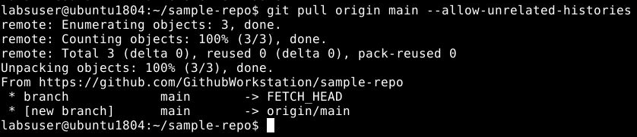

**Note:** Please modify the above command to use the *main* or *master* branch depending on your repository structure.

**Step 3**: Editing a file in the remote repository

* Add extra lines in a file in the remote repository

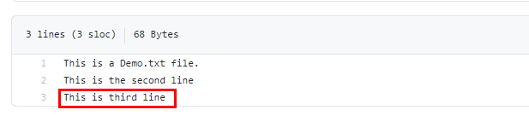

* Changes will not yet reflect in the local repository

**cat demo.txt**

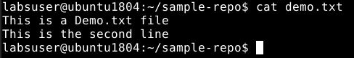

**Step 4**: Merging the changes in edited file in the local and remote repository

* Run the following commands to update the local repository file:

**git fetch**

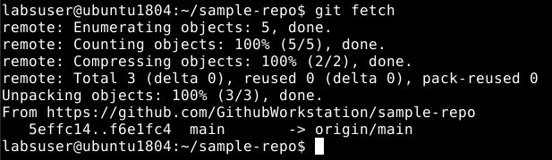

**git checkout origin/main -- demo.txt**

* View the local repository file

**cat demo.txt**

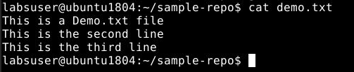

* Finalize the merge by creating a new commit using the following command:

**git commit -m "'Merge' demo.txt from"**

