Lesson 4 Demo 7: Creating and Tracking Issues

This section will guide you to:

* Track Issues in GitHub

This lab has five subsections, namely:

1. Selecting issues tab
2. Creating a new label
3. Creating a milestone
4. Creating a new issue
5. Commenting on the issue created

**Please note**: Execute the below steps in the **sample repository** that you created in the previous demos (Lesson 2 Demo 2).

**Step 1:** Selecting issues tab

* Open the browser, Navigate to the main page of your repository
* Click on the **Issues** tab

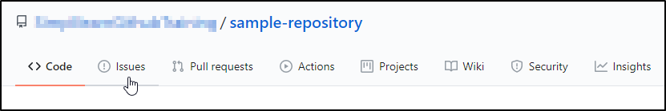

* Select **Your issues** from the **Filters** dropdown

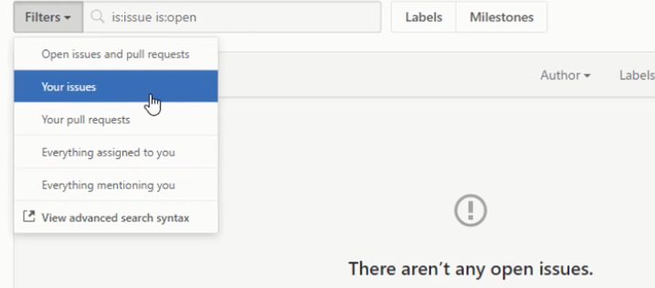

**Step 2:** Creating a new label

* Click on the **Labels** button

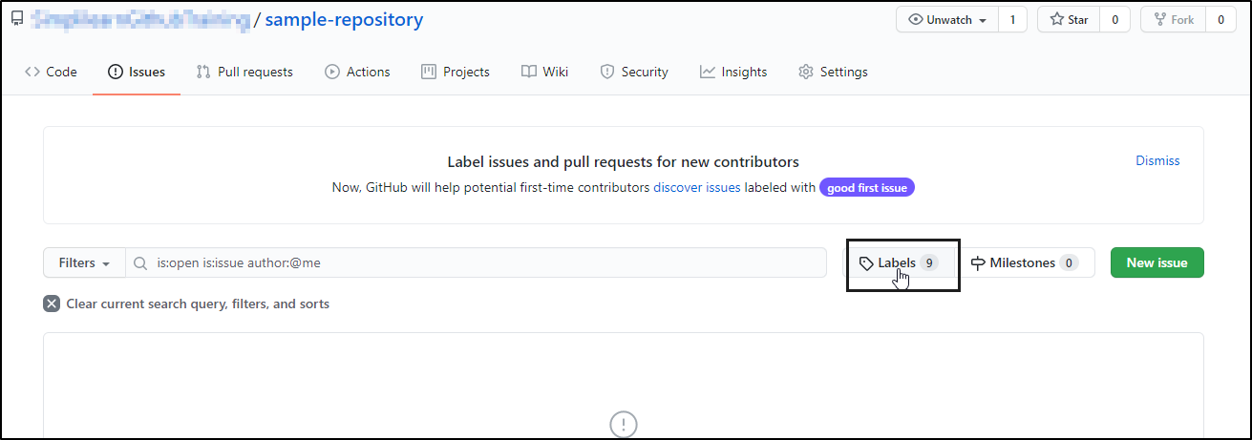

* Type a name and description for your label and then click on the **Create label** button

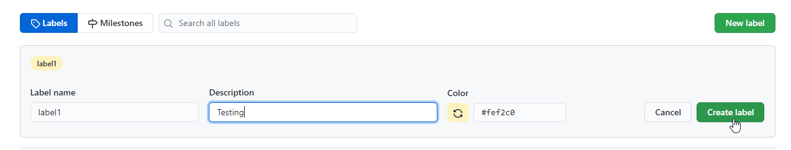

**Step 3:** Creating a milestone

* In the main page of your repository, click on the **Issues** tab and then click on **Milestones**
* Click on the **New Milestone** button
* Type a title and description for your milestone and click on the **Save changes** button

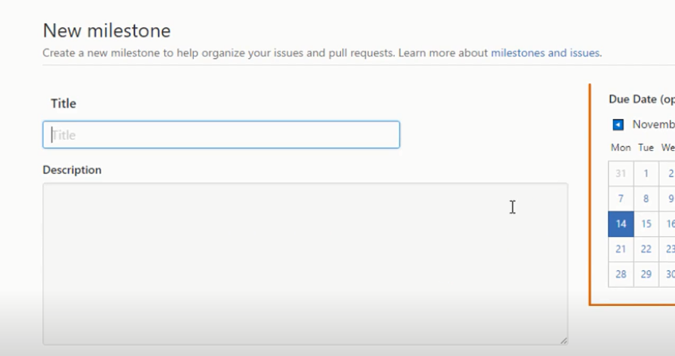

**Step 4:** Creating a new issue

* In the main page of your repository, click on the **Issues** tab and then click on **New issue**

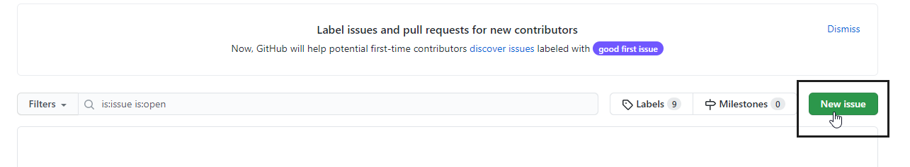

* Type a title and description for your issue and click on the **Submit new issue** button

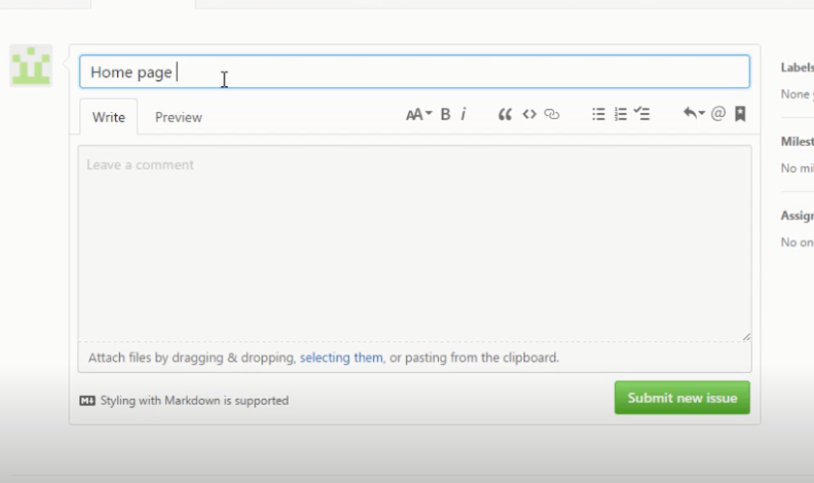

**Step 5:** Commenting on the issue created

* Open the issue where you want to add a comment
* Type the comment in the given field and click on the **Comment** button

