Lesson 4 Demo 8: Getting Started with Git Upstream

This section will guide you to:

* Start with Git Upstream

This lab has five subsections, namely:

1. Verifying the setup of remote repository
2. Adding upstream to the remote repository
3. Verifying if the remote repository is added correctly
4. Fetching upstream
5. Updating local branch with respect to the upstream branch

**Step 1:** Verifying the setup of remote repository

* Create a repository on the local machine by executing the following commands in the terminal

**mkdir repository1**

**cd repository1**

**git init**

* Create a remote repository on GitHub
* Go to **github.com** and log in to your account
* Click on the **New** button to create a new repository and give the repository name as ***repository1***

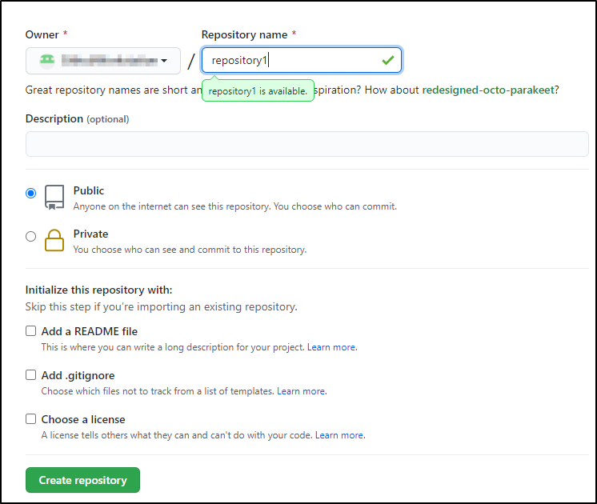

* Add the remote repository to the local repository using HTTPS url
* Copy the HTTPS URL from the repository1

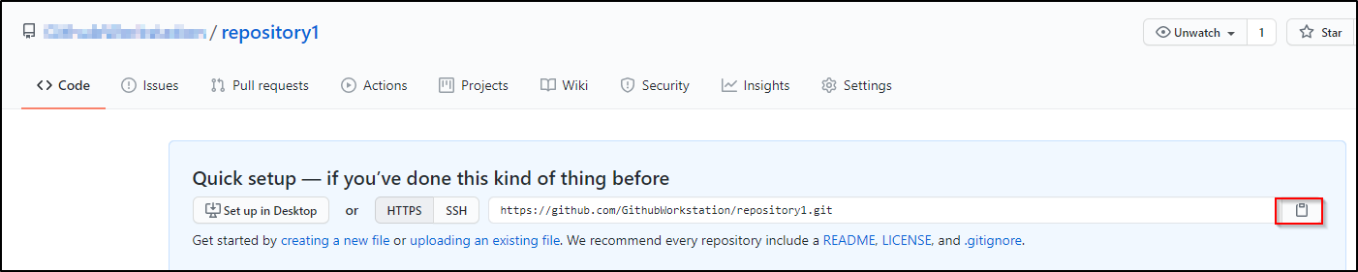

* Open the **Terminal** on the local machine and use the following command to add a remote repository:  
    
  **git remote add origin <Your HTTPS_URL>**Replace HTTPS_URL with the copied URL
* Run the following command to verify the setup of remote repository:

***git remote -v***



**Step 2:** Adding upstream to the remote repository by executing the below command:

**git remote add upstream <Your HTTPS_URL>**

**Note:** Replace the url in the above command with your HTTPS url

Add a **sample.txt** file to the remote repository and commit the changes

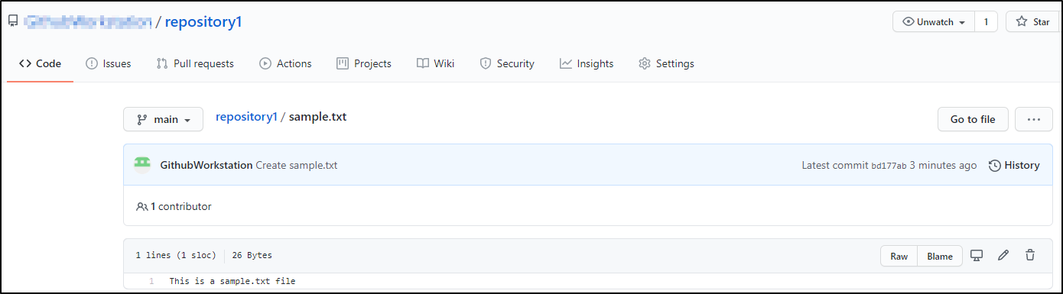

**Step 3**: Verifying if the remote repository is added correctly

**git remote -v**

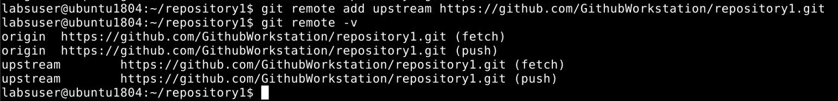

**Step 4**: Fetching upstream

**git fetch upstream**

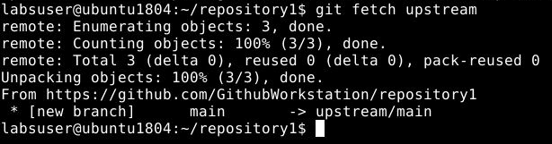

**Step 5**: Updating the local branch with respect to the upstream branch

**git checkout main**

**git merge upstream/main --allow-unrelated-histories**

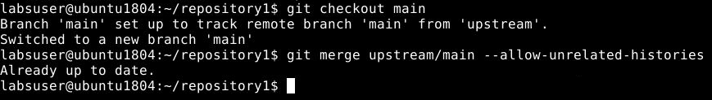

**Note:** Please modify the above command to use the *main* or *master* branch depending on your repository structure.