Lesson 4 Demo 9: Create and Delete Tag

This section will guide you to:

* Create and delete tag

This lab has four subsections namely:

1. Creating a tag
2. Listing all the tags
3. Adding a description to your tag
4. Deleting a tag

**Please Note:** Execute the following commands in a git repository (sample-repo) that you have created in the previous demo (Lesson 4 Demo 6). However these steps can be executed in any repository.

**Step 1:** Creating a tag

Execute the following command in your terminal:

**git tag <tagname>**

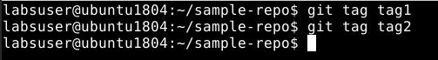

**Step 2:** Listing all the tags

**git tag**

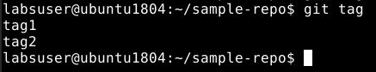

**Step 3:** Adding a description to your tag

**git tag <tagname> -a**



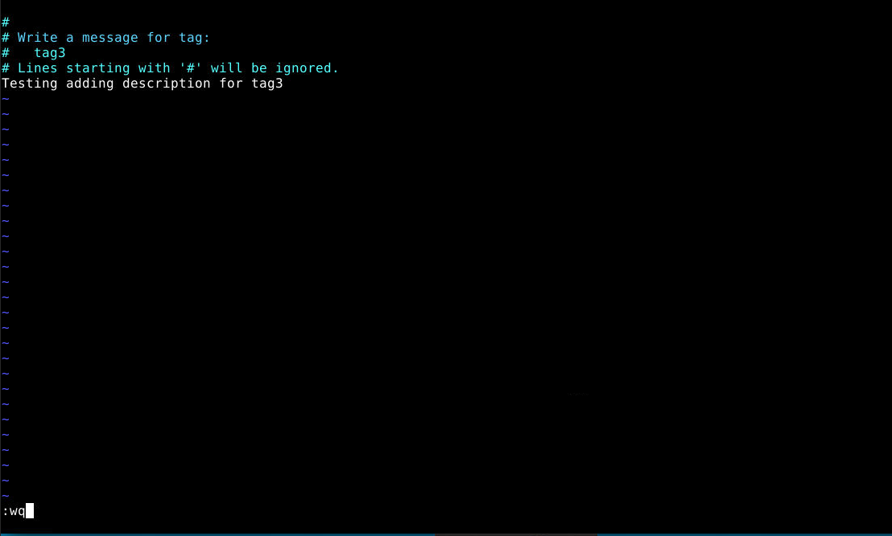

**Step 4:** Deleting a tag

**git tag -d <tagname>**

