Lesson 5 Demo 1: Switching Between Branches

This section will guide you to:

* Switch between branches in Git

This lab has six subsections, namely:

1. Creating a new branch
2. Switching to the new branch
3. Creating a file and committing the changes
4. Checking the status of the new branch
5. Reviewing the git logs
6. Switching back to main branch

**Note**: A **sample-repository** is already created in Lesson 2 Demo 2. If you do not have a sample-repository, first perform that demo and then execute the steps from this demo.

**Step 1:** Creating a new branch

* Open the Terminal in your lab and navigate to the **sample-repository** folder

**cd sample-repository**

* Execute the following command to create a new branch:

**git branch text_branch**

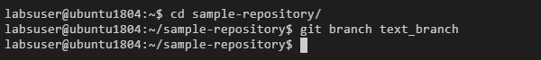

**Step 2:** Switching to the new branch

* Use the following command to switch to the newly created **text_branch**:

**git checkout text_branch**



**Step 3:** Creating a file and committing the changes

* Use the following command to create a file:

**vi index.html**



* Add the following code in the **index.html** file  
    
  **<html>**

**<body>**

**<p> This is a Test HTML file. </p>**

**</body>**

**</html>**

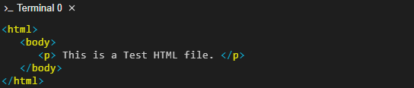

**Note:** Press **Esc** button and enter **:wq** to save the file.

* Use the following commands to add the file to the **text_branch** and commit the changes:

**git add index.html**

**git commit -a -m "file modified"**

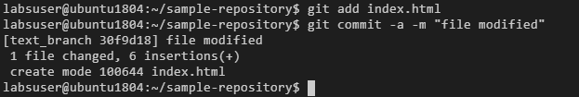

**Step 4:** Checking the status of the new branch

* Check the status of the new branch using the following command:

**git status**

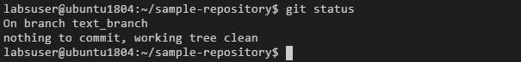

**Step 5:** Reviewing the git logs

* Use the following command to check the git logs:

**git log --oneline**

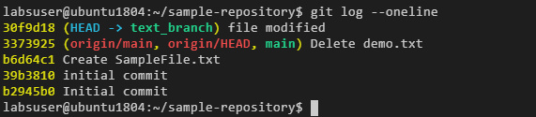

**Step 6:** Switching back to the **main** branch

* Check the current branch using the following command:

**git branch**

* Use the following command to switch back to the main branch:

**git checkout master**

