Lesson 5 Demo 2: Merging Branches in Git

This section will guide you to:

* Merge branches in Git

This lab has four subsections, namely:

1. Creating a new branch
2. Creating a new file in the new branch
3. Switching to the main branch
4. Merging the branches

**Note:** A **sample-repository** is already created in Lesson 2 Demo 2. If you do not have the sample-repository, first perform that demo and then execute the steps from this demo.

**Step 1:** Creating a new branch

* Open the Terminal in your lab and navigate to the sample-repository folder

**cd sample-repository**

* Execute the following command on the terminal to create a new branch:

**git branch test_branch**

**git branch**

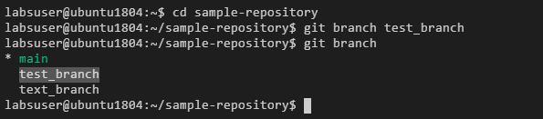

**Step 2:** Creating a new file in the **test_branch**

* Use the following command to switch to the test_branch:

**git checkout test_branch**

* Use the following commands to create an empty html file **index1.html** and add it to the test_branch:

**touch index1.html**

**git add index1.html**

**git commit -a -m "index1.html added to the test_branch"**

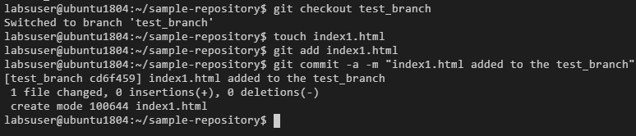

**Step 3:** Switching back to the main branch

* Use the following command to switch back to the main branch:

**git checkout main**

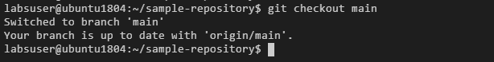

**Step 4:** Merging the branches

* Use the following command to merge the test_branch to the main branch:

**git merge test_branch**

